**SECTION-A [14 MARKS]**

**Q1.)(A)** Fill in the blanks by choosing the appropriate word(s) from those given in the brackets:

(hexaaqua iron(III) chloride, aldehyde, ketone sp3,sp , diichlorohexahydrate , anode , urotropin,dsp2,linear,squareplanar,tetrahaedral,cathode )

(i) In a galvanic cell the movement of electrons in the external circuit is from ………………..to …………………

(ii)The IUPAC name of [Fe(H2O)6]Cl2 is …………………………….

(iii)When formaldehyde is kept in contact with ammonia it forms …………………………….

(iv)Tetracyanocuprate (II) ion involves ………………………….hybridisation and its geometry is …………………..

**[B]** Select and write the correct alternative from the choices given below.

(i)[Co(F)6]3- is :

(a)A double ion (b)An inner orbital complex (c)An outer orbital complex (d)Low spin complex

(ii) The correct order of the increasing basic nature is :

(a)C6H5NH2> C6H5N(Me)2>CH3NH2>(C2H5)2NH (b) C6H5NH2< C6H5N(Me)2<CH3NH2<(C2H5)2NH (c) C6H5N(Me)2> C6H5NH2>CH3NH2>(C2H5)2NH (d) C6H5NH2< C2H5NH2 <CH3NH2< C6H5N(Me)2

(iii)Which of the following compounds is oxidised to give ethyl methyl ketone ?

(a)propan-2-ol (b)propyl hydrogen sulphate (c)butan-2-ol (d)tert-butyl alcohol.

(iv)The base residues common to both RNA and DNA are

(a)A,G and C (b)A, G and T (c)A, G and Cl (d)G,C and T.

(v)Consider the following plots of rate constant versus 1/T for four different reactions. Which of the following order is correctly for the activation energy of these reactions ?

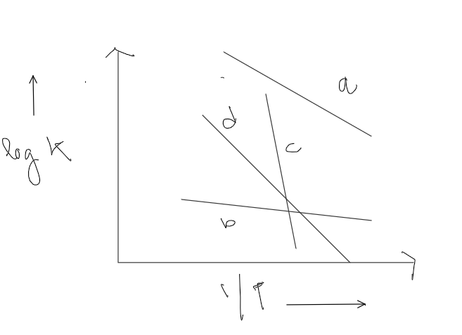

(a)*Ea>Ec>Ed>Eb*(b) *Ea<Ec<Ed<Eb*(c) *Ea<Ec<Eb<Ed*(d) *Ec>Ed>Ea>Eb*.

(vi) Given below are two statements marked Assertion and Reason. Read the two statements carefully and select the correct option.

**Assertion:** Tertiary amines have lower boiling point than those of primary and secondary amines of comparable molecular masses.

**Reason:** Tertiary amines are unable to form intermolecular Hydrogen bonds .

(a) Both Assertion and Reason are true and Reason is the correct explanation of Assertion. (b) Both Assertion and Reason are true but Reason is not the correct explanation for assertion. (c) Assertion is true but Reason is false. (d) Both Assertion and Reason are false.

(vii) Given below are two statements marked Assertion and Reason. Read the two statements carefully and select the correct option.

**Assertion:** Copper can displace zinc from the solution of zinc sulphate .

**Reason :** Copper is placed below zinc in electrochemical series.

(a) Both Assertion and Reason are true and Reason is the correct explanation of Assertion. (b) Both Assertion and Reason are true but Reason is not the correct explanation for assertion. (c) Assertion is true but Reason is false. (d) Both Assertion and Reason are false.

**[C]** Read the passage carefully and answer the questions that follow:

Geet has set-up the following galvanic cell by taking the electrolyte solution of Pb(NO)3 and CrCl3

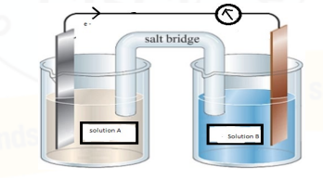

Eo = – 0.13 V Eo = – 0.74 V

(a) How will you design the feasible cell by taking appropriate salt solution in place of solution A and B? (b) What is the applicability of the above cell? (c) Consider, salt bridge is filled with Potassium Chloride (KCl) solution. How does salt bridge maintain electrical neutrality

**SECTION-B[20 MARKS]**

**Q2.)** 50 mg of Na2SO4 is dissolved in 3 litres of water at 27o Celsius. What would be the osmotic pressure for the solution?

**Q3.)** A student has carried out a suitable test to differentiate between (a) ethyl amine and diethyl amine and (b) ethanol and ethyl amine. What could that chemical test be to differentiate the pairs in (a) and (b).

**Q4.)**At 3800C the half life period for the first order decomposition of H2O2 is 360 min. The energy of activation of the reaction is 200 Kj/mol . Calculate the time required for 75% decomposition at 450OC?

**Q5.)** The standard reduction potentials of the following electrodes are given below. Answer the questions that follow:

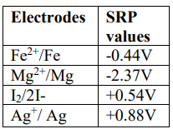

(a)Which substance/s could be used to convert iodide ions to iodine? (b) From the given reactions which reaction is spontaneous and why?

**(I):** Fe2++2Ag2Ag++Fe

**(II):** Fe2++Mg2Mg2++Fe

**Q6.)** An organic compound ‘X’ with molecular formula C4H10O is found to be soluble in conc.H2SO4 and does not react with sodium metal or KMnO4. Compound ‘X’ when heated with excess of HI gives a single alkyl halide. Deduce the structure of the compound ‘X’. Explain all the reactions involved.

**Q7.)** How will you prepare the following compounds? Give chemical reaction for: (a) Butan-2-one from propanoic acid. (b) m-chlorotoluene from benzaldehyde.

**Q8.)**The resistance of a conductivity cell containing 0.001 M KCL soln at 298K is 1500 ohm. What is the cell constant and molar conductivity of 0.001M KCL son if the conductivity of the solution is 0.146 10-3ohm-1cm-1.

**Q9.)** An organic compound A has the molecular formula C7H6O when A is treated with NaOH followed by hydrolysis it gives two product B and C . When B is oxidised it gives A. When A and C are each separately treated with PCl5,they give two different product D and E.

(a)Identify A to E with proper reactions

**Q10.)** Identify the compounds [A] and [B ] and [C] in the following reactions

(i)acetylene [A] [C]

(ii.)C6H5CH3[A][B]+[C]

OR

An alcohol [A] when heated with conc. H2SO4 gives an alkene [B]. When B is bubbled through bromine water and the product obtained is dehydrohaloginated using sod.amide , a new compound [C] is formed. The compound [C] gives [D]with warm dil. H2SO4 in presence of Hg2SO4. [D]can also be obtained either by oxidising [A] with KMnO4 or from acetic acid using calcium salt.

Write the structures of the compounds A, B and C with proper reactions involved .

**Q11.)** Explain the following :

(a)[ Ti(H2O)6]3+is coloured while [ Sc(H2O)6]3+is colourless.

(b) [ Fe(CN)6]3-is weakly paramagnetic while [ Fe(CN)6]4-is diamagnetic.

**SECTION-C[21 MARKS]**

**Q12.)** Identify the compounds [A], [B] and [C] in the following reactions.

(a) C6H5CONH2[A][B][C]

(b)Convert Acetic acid to Methane.

(c) Convert Propanoic acid to Ethanol.

**Q13.)** The rate constant for the first order decomposition of a certain reaction is described as

$$\log\left(k\right)=14.34-1.25×{10}^{4}\frac{K}{T}$$

(i)What is the energy of activation of the reaction?

(ii)At what temperature will the half-period be 256 mins.

**Q14.) (a)** ) Except glycine, all other naturally occurring ἀ-amino acids are optically active.

(b)Give 2 examples of fat soluble and water-soluble vitamins.

(c)Give 2 differences between fibrous and globular protein

**Q15.)** A very small amount of a non-volatile solute is dissolved in 56.8 cc of benzene (density .899 gm/cc). At room temperature ,vapour pressure of this solution is 98.88 mm Hg while yhat of benzene is 100 mm Hg . Find the molality of this solution. If the freezing temp. of this solution is 0.73 degree lower than benzene , what is the value of molal depression constant of benzene ?

**Q16.)** Give reason why the molecular shape of [Ni(CO)4] is tetrahedral while that of [Ni(CN)4] 2- is square planar.

(b) Give the IUPAC names of the following compounds:

Na3[Al(F)6] [Co(NH3)6]Cl3

(c)Give any one use of the complex ETDA.

**Q17.)**