**Question 1:**

**a.)** The correct statement is :

**A=**

1) [A] is a symmetric matrix

2) [A] is a skew symmetric matrix

3) [A] is a orthogonal matrix

4) None of these

**b.) Assertion:** y=tan(x) is continuous in its domain

**Reason :** tan(x) is discontinuous in (2n+1)

1) Both the assertion and reason are true, and the reason is the correct explanation of the assertion

2)Both the assertion and reason are true, but the reason is not the correct explanation of the assertion

3.)The assertion is true, but the reason is false

4)The assertion is false, but the reason is true

**c.)** The correct statement is :

1.) y=sin(x) , [0, $π$] $→[-1,1]$ is invertable

2.) y=sin(x) , [- $π/2,π/2$] $→[-1,0]$ is invertable

3.) y=sin(x) , [$3π/2,5π/2$] $→[-1,1]$ is invertable

4.) y=sin(x) , [$3π/2,5π/2$] $→[-1,0]$ is invertable

**d.)** y= $\sin^{-1}\left(1-x\right)-2\sin{x}=\frac{π}{2}$, the value of x is :

1.) x=0

2.) x=7

3.) x=1/2

4.) Both 0 and ½.

**e.)** find $\frac{dy}{dx}$ when x=a(cos(z)+zsin(z)) and y=a(sin(z)-z(cos(z))

1.) secz

2.) cotx

3.) cosecz

4.) tanz

**f.)**Evaluate the integral and choose the correct option.

$\int{\frac{2x^{2}+1}{{9x}^{2}+5}}dx=αf\left(x\right)-β\arctan\left(g\left(x\right)\right)+c$

1.) g(x)=x , f(x)= $x^{2}$

2.) g(x)=3x/ $√5$,f(x)=x.

3.) g(x)=3x/ $√5$,f(x)=2x/9.

4.) g(x)=23x/ $√7$,f(x)=x+25.

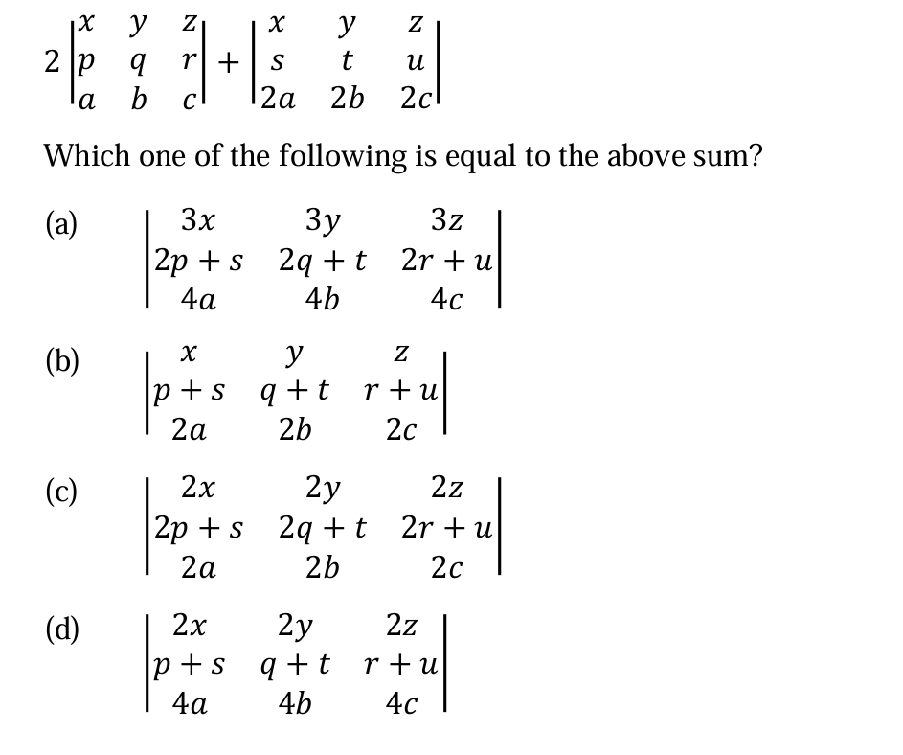

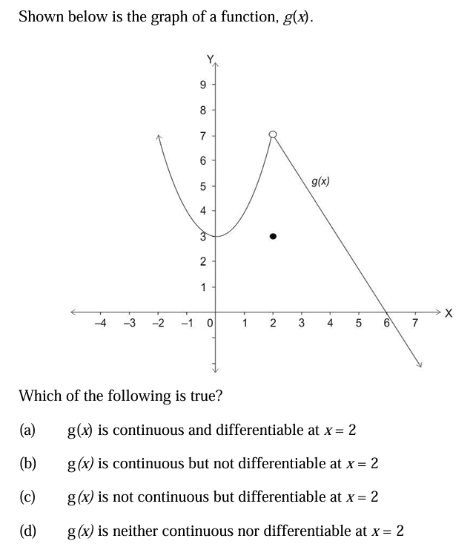

**h.)**