電通二乙微處理器實驗 實驗結報

實驗名稱 | 走馬燈
組別 | 自己 | 組員 | 吳東燁

- 實驗目的
LinkIt 7697 D1 – D8 分別接到 LED，實作跑馬燈展示。
- 實驗步驟
CHECK POINT 1 LED
向左及向右執行花色展示
CHECK POINT 2 LED
自訂花色展示 所有LED亮滅兩次 -> 左移八次 -> 所有LED亮滅兩次 -> 右移八次
CHECK POINT 3
開關 OFF -> LED 向左及向右執行花色展示 開關 ON -> 執行自定花色展示
- 程式碼
CHECK POINT 1
const byte NUM = 8;
const byte led[] = {15, 14, 13, 12, 11, 10, 9, 8};
const int delaytime = 300;
int i;
void setup() {
for (i = 0; i < NUM; i++)
{
pinMode(led[i], OUTPUT);
}
}
void loop() {

for (i = 8; i >= 0; i--)
{
digitalWrite(led[i], HIGH);
delay(delaytime);
digitalWrite(led[i], LOW);
}
delay(delaytime);

for (i = 0; i <= NUM; i++)
{
digitalWrite(led[i], HIGH);
delay(delaytime);
digitalWrite(led[i], LOW);
}
}
CHECK POINT 2
const byte NUM = 8;
const byte led[] = {15, 14, 13, 12, 11, 10, 9, 8};
int i, j = 0;
void setup() {
for (i = 0; i < NUM; i++)
{
pinMode(led[i], OUTPUT);
}
}
void loop() {
for (j = 0; j < 2; j++) {
for (i = 0; i <= NUM; i++)
{
digitalWrite(led[i], HIGH);
}
delay(500);
for (i = 0; i <= NUM; i++ )
{
digitalWrite(led[i], LOW);
}
delay(500);
}
for (j = 0; j < 8; j++) {
for (i = 8; i >= 0; i--)
{
digitalWrite(led[i], HIGH);
delay(100);
digitalWrite(led[i], LOW);
}
}
for (j = 0; j < 2; j++) {
for (i = 0; i <= NUM; i++)
{
digitalWrite(led[i], HIGH);
}
delay(500);
for (i = 0; i <= NUM; i++ )
{
digitalWrite(led[i], LOW);
}
delay(500);
}
for (j = 0; j < 8; j++) {
for (i = 0; i <= NUM; i++)
{
digitalWrite(led[i], HIGH);
delay(100);
digitalWrite(led[i], LOW);
}
}
delay(3000);
}
CHECK POINT 3
const byte NUM = 8;
const byte led[] = {15, 14, 13, 12, 11, 10, 9, 8};
const byte SW = 6;
int i, j = 0;
void setup() {
for (i = 0; i < NUM; i++)
{
pinMode(led[i], OUTPUT);
}
pinMode(SW, INPUT);
}
void loop() {
if (digitalRead(6)) {
for (j = 0; j < 2; j++) {
for (i = 0; i <= NUM; i++)
{
digitalWrite(led[i], HIGH);
}
delay(500);
for (i = 0; i <= NUM; i++ )
{
digitalWrite(led[i], LOW);
}
delay(500);
}
for (j = 0; j < 8; j++) {
for (i = 8; i >= 0; i--)
{
digitalWrite(led[i], HIGH);
delay(100);
digitalWrite(led[i], LOW);
}
}
for (j = 0; j < 2; j++) {
for (i = 0; i <= NUM; i++)
{
digitalWrite(led[i], HIGH);
}
delay(500);
for (i = 0; i <= NUM; i++ )
{
digitalWrite(led[i], LOW);
}
delay(500);
}
for (j = 0; j < 8; j++) {
for (i = 0; i <= NUM; i++)
{
digitalWrite(led[i], HIGH);
delay(100);
digitalWrite(led[i], LOW);
}
}
delay(3000);
}
else {
for (i = 8; i >= 0; i--)
{
digitalWrite(led[i], HIGH);
delay(100);
digitalWrite(led[i], LOW);
}
delay(500);

for (i = 0; i <= NUM; i++)
{
digitalWrite(led[i], HIGH);
delay(100);
digitalWrite(led[i], LOW);
}
}
}
- 實驗結果及分析
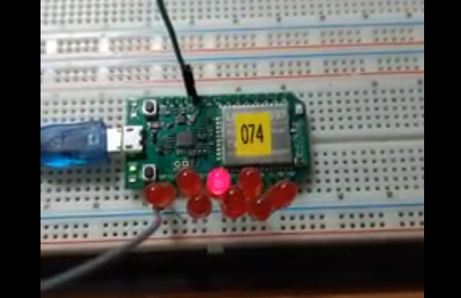
- 心得討論
這次實驗，我學到很多東西，包括程式碼上的編排以及想法，其實沒有我當下想的那麼難，都是稍微換個方向就能想的到的，讓我對Arduino又更加地了解了。

- 電路圖
