**電通二乙微處理器實驗 實驗結報**

|  |  |  |  |
| --- | --- | --- | --- |
| **實驗名稱** | **4X4鍵盤** | | |
| **組別** |  | **組員** | **吳東燁** |

1. **實驗目的**

**了解4X4鍵盤的工作原理**

1. **實驗步驟**

**1.4X4鍵盤如何連線?**

**2.如何使用Arduino keyboard libary**

**3.如何讀取鍵盤的顯示數值**

**4.如何讓七段顯示器顯示鍵盤的輸入值**

1. **程式碼**

**1.**

**#include <Keypad.h>**

**const byte rows = 4; /*行*/**

**const byte cols = 4; /*列*/**

**char keys[rows][cols] = {**

**{'F', 'E', 'D', 'C'},**

**{'B', '3', '6', '9'},**

**{'A', '2', '5', '8'},**

**{'0', '1', '4', '7'}**

**};**

**byte rowPins[rows] = {11, 10, 9 , 8 };**

**byte colPins[cols] = {15, 14, 13, 12};**

**Keypad keypad = Keypad(makeKeymap(keys), rowPins, colPins, rows, cols); /*建立Keypad*/**

**void setup() {**

**Serial.begin(9600);**

**};**

**void loop() {**

**char key =keypad.getKey();**

**if(key!=NO_KEY){**

**Serial.println(key);**

**}**

**};**

**2.**

**#include <Keypad.h>**

**#include "SevSeg.h"**

**SevSeg sevseg;**

**const byte rows = 4; /*行*/**

**const byte cols = 4; /*列*/**

**char keys[rows][cols] = {**

**{'F', 'E', 'D', 'C'},**

**{'B', '3', '6', '9'},**

**{'A', '2', '5', '8'},**

**{'0', '1', '4', '7'}**

**};**

**byte rowPins[rows] = {11, 10, 9 , 8 };**

**byte colPins[cols] = {15, 14, 13, 12};**

**Keypad keypad = Keypad(makeKeymap(keys), rowPins, colPins, rows, cols); /*建立Keypad*/**

**void setup() {**

**Serial.begin(9600);**

**byte numDigits = 1;**

**byte digitPins[] = {2};**

**byte segmentPins[] = { 17, 16, 3, 4, 5, 6, 7} ;**

**sevseg.begin(COMMON_CATHODE, numDigits, digitPins, segmentPins);**

**};**

**void loop() {**

**char key = keypad.getKey();**

**if (key != NO_KEY) {**

**Serial.println(key);**

**if ( key >= '0' && key <= '9') {**

**sevseg.setNumber(key - '0', 1);**

**}**

**}**

**sevseg.refreshDisplay();**

**};**

1. **實驗結果及分析**

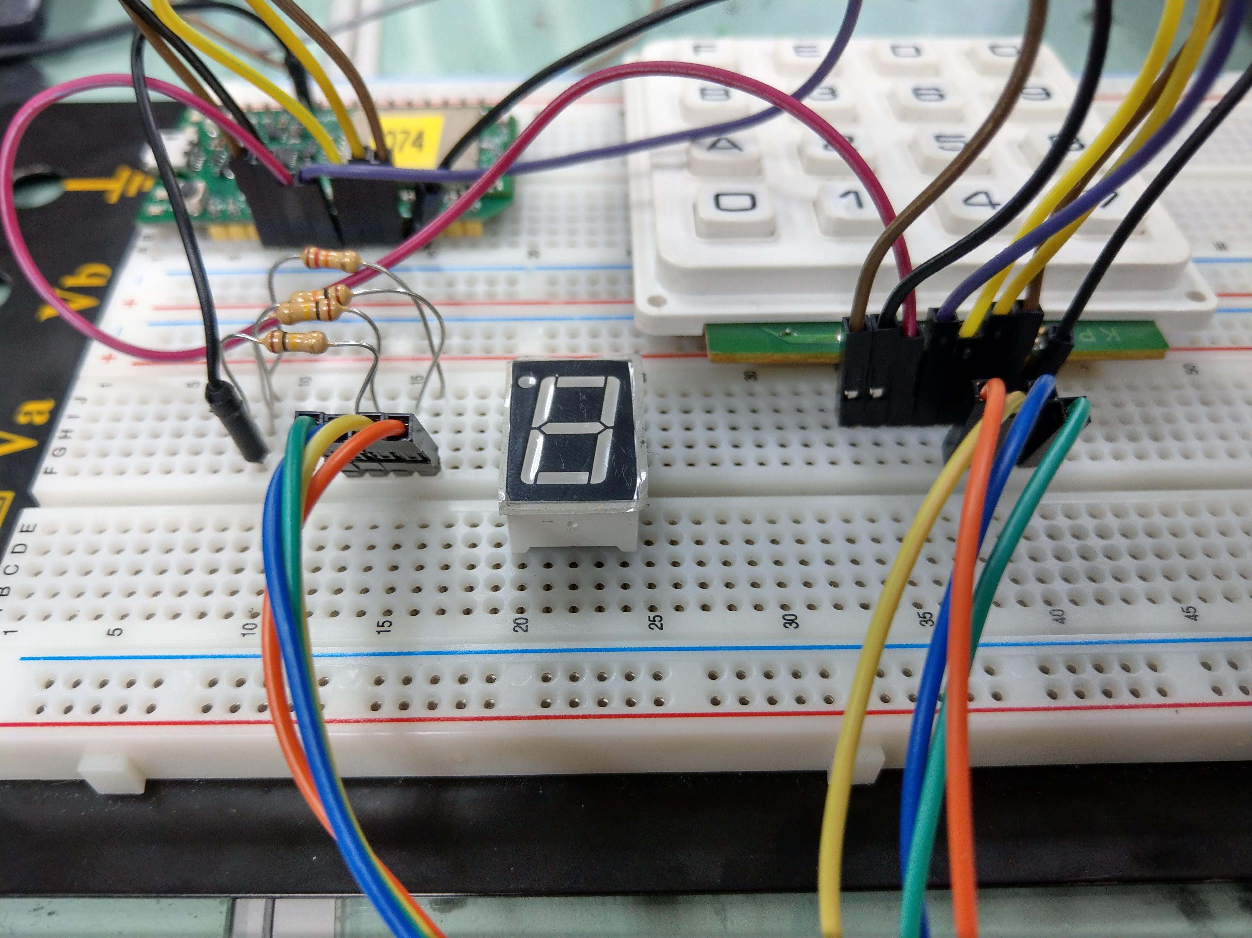

1. **心得討論**

**這次的實驗跟上周的大同小異，只不過換上了鍵盤以及七段顯示器，且接線上更多，但經過上次的實驗，這次就沒顯得那麼困難。**