**電通二乙微處理器實驗 實驗結報**

|  |  |  |  |
| --- | --- | --- | --- |
| **實驗名稱** | **Lab 06 – 音樂教室** | | |
| **組別** |  | **組員** | **吳東燁** |

1. **實驗目的**

**\*如何使 Arduino 發出特定旋律的聲音?**

1. **Arduino 接喇叭如何接線?**
2. **如何使用 tone library?**

**3.如何演奏一段音樂?**

**4.如何使用 4x4 鍵盤演奏音樂?**

**5.如何發報摩斯電碼?**

1. **實驗步驟**

**Arduino 演奏一段特定的音樂, 旋律不得是小蜜蜂**

**使用 4x4 鍵盤演奏音樂**

**發報摩斯電碼**

1. **程式碼**

|  |
| --- |
| **1.** |
| **/*月牙灣*/**  **#define NOTE_D-1 -1**  **#define NOTE_D0 262**  **#define NOTE_D1 294**  **#define NOTE_D2 330**  **#define NOTE_D3 350**  **#define NOTE_D4 393**  **#define NOTE_D5 441**  **#define NOTE_D6 495**  **#define NOTE_D7 556**  **#define NOTE_DH0 523**  **#define NOTE_DH1 589**  **#define NOTE_DH2 661**  **#define NOTE_DH3 700**  **#define NOTE_DH4 786**  **#define NOTE_DH5 882**  **#define NOTE_DH6 990**  **#define NOTE_DH7 1010**  **#define NOTE_DL0 1047**  **#define NOTE_DL1 1245**  **#define NOTE_DL2 1319**  **#define NOTE_DL3 1397**  **#define NOTE_DL4 1568**  **#define NOTE_DL5 1760**  **#define NOTE_DL6 1976**  **#define NOTE_DL7 2224**  **#define WHOLE 1**  **#define HALF 0.5**  **#define QUARTER 0.25**  **#define EIGHTH 0.25**  **#define SIXTEENTH 0.625**  **int tune[] = {**  **NOTE_D6, NOTE_D - 1, NOTE_D6, NOTE_D7, NOTE_DH1, NOTE_DH2, NOTE_DH3, NOTE_DH2, NOTE_DH1, NOTE_D - 1,**  **NOTE_DH1, NOTE_DH4, NOTE_DH4, NOTE_DH3, NOTE_DH2, NOTE_DH6, NOTE_DH6, NOTE_DH5, NOTE_D - 1,**  **NOTE_D5, NOTE_DH2, NOTE_DH3, NOTE_DH5, NOTE_DH3, NOTE_D - 1,**  **NOTE_DH2, NOTE_DH3, NOTE_DH5, NOTE_DH6, NOTE_DH5, NOTE_D - 1**  **};**  **float duration[] = {**  **1 + 1 , 0.5, 1, 1 , 1 , 1 , 1 + 0.5 , 1 + 0.5 , 1 + 0.5 , 1 + 0.5,**  **1 , 1 , 1 + 0.5, 1 + 0.5, 1 + 0.5, 1 + 0.5, 1 + 0.5, 1 + 1,**  **1 , 1, 1 , 1, 1 + 0.5, 1.5,**  **1, 1, 1, 2, 1.75, 1.5**  **};**  **int length;**  **int tonePin = 8;**  **void setup()**  **{**  **pinMode(tonePin, OUTPUT);**  **length = sizeof(tune) / sizeof(tune[0]);**  **}**  **void loop()**  **{**  **for (int x = 0; x < length; x++)**  **{**  **tone(tonePin, tune[x]);**  **delay(400 * duration[x]);**  **noTone(tonePin);**  **}**  **delay(5000);**  **}** |

|  |
| --- |
| **2.** |
| **#include <Keypad.h>**  **const int x = 5;**  **const byte ROWS = 4;**  **const byte COLS = 4;**  **char keys[ROWS][COLS] = {**  **{'F', 'B', 'A', '0'},**  **{'E', '3', '2', '1'},**  **{'D', '6', '5', '4'},**  **{'C', '9', '8', '7'}**  **};**  **byte rowPins[ROWS] = {15, 14, 13, 12};**  **byte colPins[COLS] = {11, 10, 9, 8};**  **Keypad keypad = Keypad(makeKeymap(keys), rowPins, colPins, ROWS, COLS);**  **void setup() {**  **Serial.begin(9600);**  **}**  **void loop() {**  **char key = keypad.getKey();**  **if (key != NO_KEY) {**  **if (key == '1')**  **tone(x, 523,500);**  **if (key == '4')**  **tone(x, 587,500);**  **if (key == '7')**  **tone(x, 659,500);**  **if (key == '2')**  **tone(x, 698,500);**  **if (key == '5')**  **tone(x, 784,500);**  **if (key == '8')**  **tone(x, 880,500);**  **if (key == '3')**  **tone(x, 988,500);**  **if (key == '6')**  **tone(x, 1047,500);**  **if (key == '9')**  **tone(x, 1175,500);**  **}**  **}** |

|  |
| --- |
| **3.** |
| **#define Do 440**  **const byte audio11 = 5;**  **int dotLen = 150;**  **int dashLen = 700;**  **char incomingByte = 0;**  **void setup() {**  **Serial.begin(9600);**  **}**  **void loop() {**  **if (Serial.available() > 0) {**  **// 讀取進來的 byte**  **incomingByte = Serial.read();**  **// 印出收到的資料**  **Serial.println(incomingByte);**  **GetChar(incomingByte);**  **delay(800);**  **}**  **}**  **void MorseDot() {**  **tone(audio11, Do, dotLen); // start playing a tone**  **delay(500); // hold in this position**  **}**  **void MorseDash() {**  **tone(audio11, Do, dashLen); // start playing a tone**  **delay(800); // hold in this position**  **}**  **void GetChar(char tmpChar) {**  **switch (tmpChar) {**  **case 'A':**  **MorseDot();**  **MorseDash();**  **break;**  **case 'B':**  **MorseDash();**  **MorseDot();**  **MorseDot();**  **MorseDot();**  **break;**  **case 'C':**  **MorseDash();**  **MorseDot();**  **MorseDash();**  **MorseDot();**  **break;**  **case 'D':**  **MorseDash();**  **MorseDash();**  **MorseDot();**  **break;**  **case 'E':**  **MorseDot();**  **break;**  **case 'F':**  **MorseDot();**  **MorseDot();**  **MorseDash();**  **MorseDot();**  **break;**  **case 'G':**  **MorseDash();**  **MorseDash();**  **MorseDot();**  **break;**  **case 'H':**  **MorseDot();**  **MorseDot();**  **MorseDot();**  **MorseDot();**  **break;**  **case 'I':**  **MorseDot();**  **MorseDot();**  **break;**  **case 'J':**  **MorseDot();**  **MorseDash();**  **MorseDash();**  **MorseDash();**  **break;**  **case 'K':**  **MorseDash();**  **MorseDot();**  **MorseDash();**  **break;**  **case 'L':**  **MorseDot();**  **MorseDash();**  **MorseDot();**  **MorseDot();**  **break;**  **case 'M':**  **MorseDash();**  **MorseDash();**  **break;**  **case 'N':**  **MorseDash();**  **MorseDot();**  **break;**  **case 'O':**  **MorseDash();**  **MorseDash();**  **MorseDash();**  **break;**  **case 'P':**  **MorseDot();**  **MorseDash();**  **MorseDash();**  **MorseDot();**  **break;**  **case 'Q':**  **MorseDash();**  **MorseDash();**  **MorseDot();**  **MorseDash();**  **break;**  **case 'R':**  **MorseDot();**  **MorseDash();**  **MorseDot();**  **break;**  **case 'S':**  **MorseDot();**  **MorseDot();**  **MorseDot();**  **break;**  **case 'T':**  **MorseDash();**  **break;**  **case 'U':**  **MorseDot();**  **MorseDot();**  **MorseDash();**  **break;**  **case 'V':**  **MorseDot();**  **MorseDot();**  **MorseDot();**  **MorseDash();**  **break;**  **case 'W':**  **MorseDot();**  **MorseDash();**  **MorseDash();**  **break;**  **case 'X':**  **MorseDash();**  **MorseDot();**  **MorseDot();**  **MorseDash();**  **break;**  **case 'Y':**  **MorseDash();**  **MorseDot();**  **MorseDash();**  **MorseDash();**  **break;**  **case 'Z':**  **MorseDash();**  **MorseDash();**  **MorseDot();**  **MorseDot();**  **break;**  **}**  **}** |

1. **實驗結果及分析**
2. **心得討論**

**做起來鰻不順手的，音樂的部分一直卡關**

1. **修正電路圖**

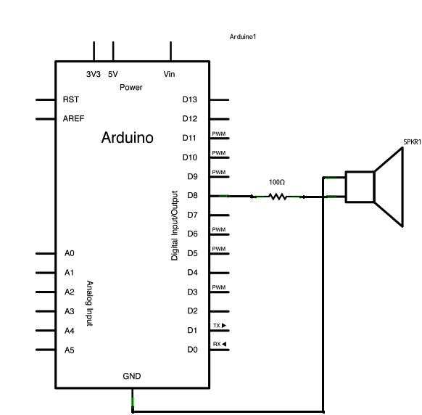**修正程式碼**