**電通二甲微處理器實驗 實驗結報**

|  |  |  |  |
| --- | --- | --- | --- |
| **實驗名稱** | Lab 10 –紅外線控制 | | |
| **組別** |  | **組員** | **吳東燁** |

1. **實驗目的**

認識紅外線並應用

1. **實驗步驟**

**使用紅外線遙控接收元件**

**收發紅外線**

1. **程式碼**

|  |
| --- |
| **Hw1**  **#include <IRremote.h>**  **const int irReceiverPin=2;**  **IRrecv irrecv(irReceiverPin);**  **decode_results results;**  **void setup() {**  **Serial.begin(9600);**  **irrecv.enableIRIn();**  **}**  **void loop() {**  **if(irrecv.decode(&results)){**  **Serial.print("irCode: ");**  **Serial.print(results.value, HEX);**  **Serial.print(", bits: ");**  **Serial.print(results.bits);**  **irrecv.resume();**  **}**  **}** |
| **Hw2**  **#include <IRremote.h>**  **const int irReceiverPin=2;**  **IRrecv irrecv(irReceiverPin);**  **decode_results results;**  **const int buttonPin=4;**  **int buttonState = 0;**  **IRsend irsend;**  **void setup() {**  **pinMode(buttonPin,INPUT);**  **}**  **void loop() {**  **buttonState = digitalRead(buttonPin);**  **if(buttonState == HIGH){**  **irsend.sendNEC(0x4FB48B7, 32);**  **}**  **if(irrecv.decode(&results)){**  **Serial.print("irCode: ");**  **Serial.print(results.value, HEX);**  **Serial.print(", bits: ");**  **Serial.print(results.bits);**  **irrecv.resume();**  **}**  **}** |

1. **實驗結果及分析**

**有接收到**

1. **心得討論**

**這次紅外線的元件要小心注意，因為收發元件一接錯，就會壞掉**

1. **修正電路圖**

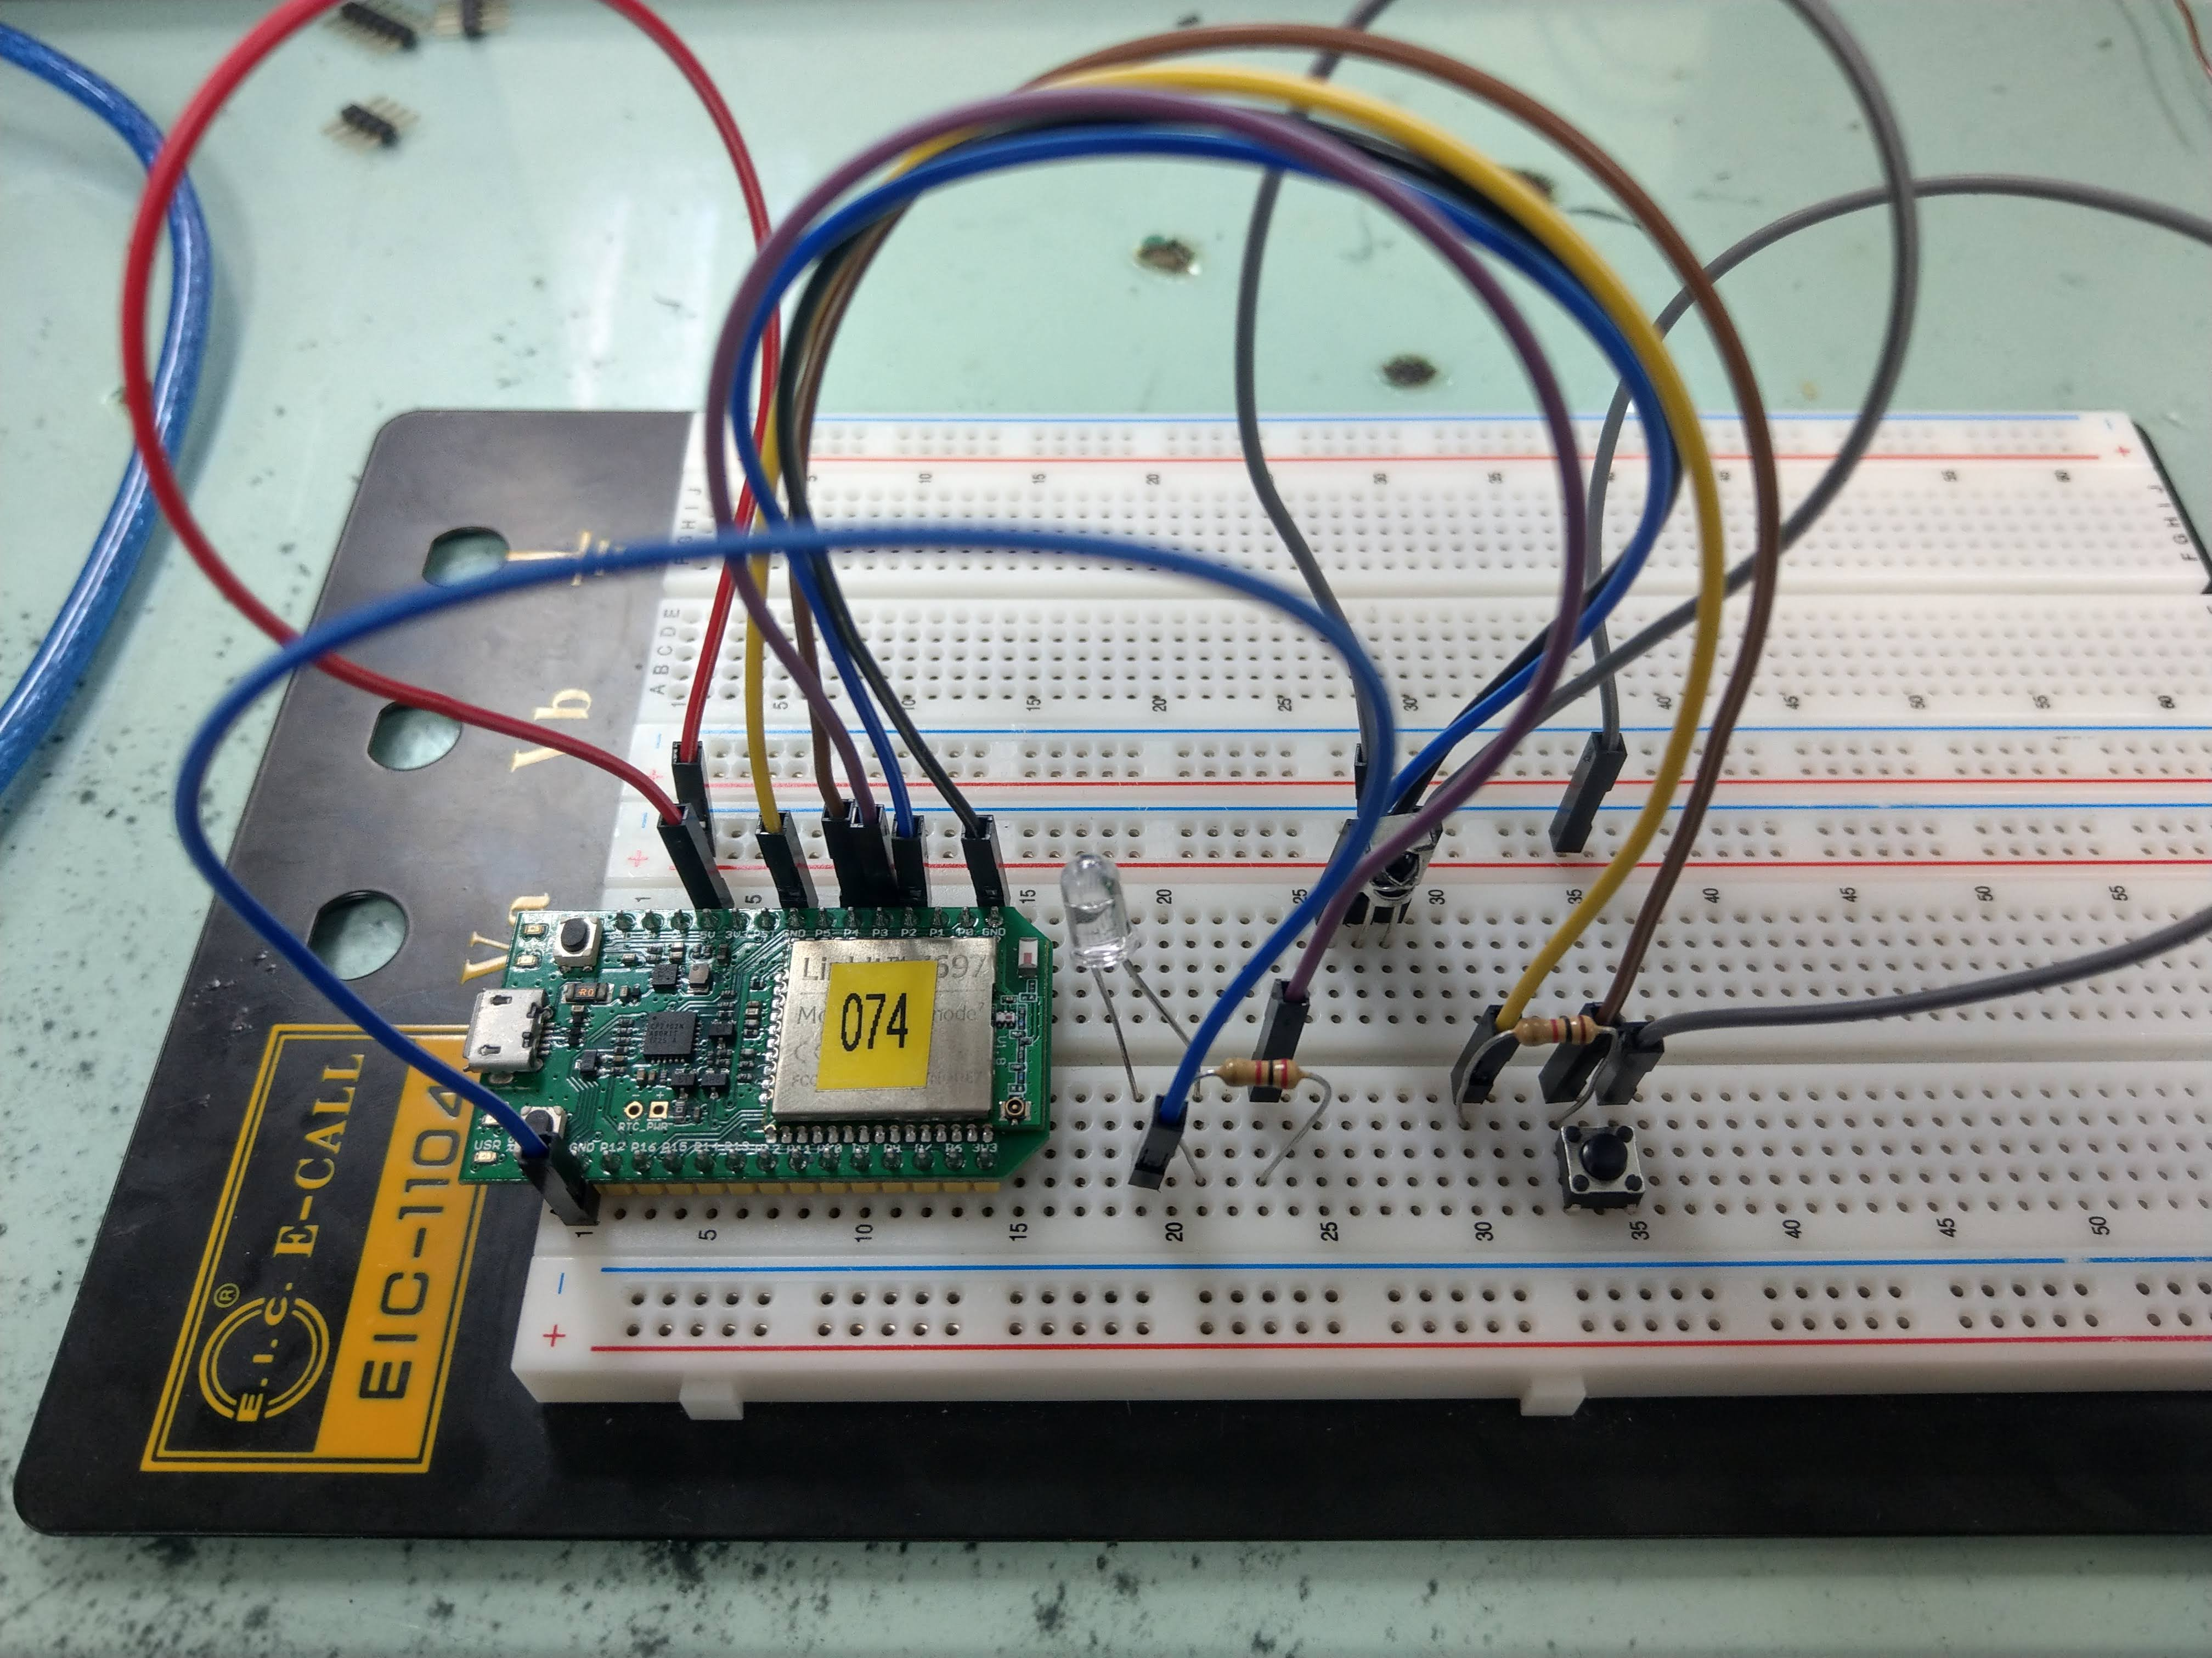

1. **修正程式碼**