**電通二甲微處理器實驗 實驗結報**

|  |  |  |  |
| --- | --- | --- | --- |
| **實驗名稱** | Lab 12 溫溼度感應器 | | |
| **組別** |  | **組員** | **吳東燁** |

1. **實驗目的**

**使用DHT-11來測量溫濕度**

1. **實驗步驟**

**讓DHT-11可以一直量測溫溼度**

**整合Timer與DHT-11測量溫濕度**

**使用Timer 每隔10秒將溫溼度上傳至MCS Cloud**

1. **程式碼**

|  |
| --- |
| **Hw1**  **#include "DHT.h"**  **#define DHTPIN 2**  **#define DHTTYPE DHT11**  **DHT dht(DHTPIN, DHTTYPE);**  **void setup() {**  **Serial.begin(9600);**  **Serial.println(F("DHTxx test!"));**  **dht.begin();**  **}**  **void loop() {**  **delay(2000);**  **float h = dht.readHumidity();**  **float t = dht.readTemperature();**  **float f = dht.readTemperature(true);**    **if (isnan(h) || isnan(t) || isnan(f)) {**  **Serial.println(F("Failed to read from DHT sensor!"));**  **return;**  **}**  **float hif = dht.computeHeatIndex(f, h);**  **float hic = dht.computeHeatIndex(t, h, false);**  **Serial.print(F("Humidity: "));**  **Serial.print(h);**  **Serial.print(F("% Temperature: "));**  **Serial.print(t);**  **Serial.print(F("°C "));**  **Serial.print(f);**  **Serial.print(F("°F Heat index: "));**  **Serial.print(hic);**  **Serial.print(F("°C "));**  **Serial.print(hif);**  **Serial.println(F("°F"));**  **}** |
| **Hw2**  **#include "Arduino.h"**  **#include "LTimer.h"**  **#include "DHT.h"**  **#define DHTPIN 2**  **#define DHTTYPE DHT11**  **DHT dht(DHTPIN, DHTTYPE);**  **float h;**  **float t;**  **float f;**  **void setup() {**  **LTimer timer0(LTIMER_0);**  **Serial.begin(9600);**  **Serial.println(F("DHTxx test!"));**  **dht.begin();**  **timer0.begin();**  **timer0.start(1000, LTIMER_REPEAT_MODE, _callback0, NULL);**  **}**  **void _callback0(void *usr_data)**  **{**  **if (isnan(h) || isnan(t) || isnan(f)){**  **Serial.println(F("Failed to read from DHT sensor!"));**  **return;**  **}**  **float hif = dht.computeHeatIndex(f, h);**  **float hic = dht.computeHeatIndex(t, h, false);**  **Serial.print(F("Humidity: "));**  **Serial.print(h);**  **Serial.print(F("% Temperature: "));**  **Serial.print(t);**  **Serial.print(F("°C "));**  **Serial.print(f);**  **Serial.print(F("°F Heat index: "));**  **Serial.print(hic);**  **Serial.print(F("°C "));**  **Serial.print(hif);**  **Serial.println(F("°F"));**  **}**  **void loop() {**  **h = dht.readHumidity();**  **t = dht.readTemperature();**  **f = dht.readTemperature(true);**  **}** |
| **Hw3**  **#include <LWiFi.h>**  **#include <WiFiClient.h>**  **#include "MCS.h"**  **#include "LTimer.h"**  **#include "DHT.h"**  **#define DHTPIN 2**  **#define DHTTYPE DHT11**  **#define _SSID "dong-ye home"**  **#define _KEY "0975621919"**  **float hic, hif;**  **int j = 0, flag = 0;;**  **float h, t, f;**  **LTimer timer0(LTIMER_0);**  **// Assign AP ssid / password here**  **DHT dht(DHTPIN, DHTTYPE);**  **MCSDevice mcs("DKGRDWrc", "Qel1T58oNcUH5KBu");**  **MCSDisplayFloat Temperature("Temperature");//溫度**  **MCSDisplayFloat Humidity("Humidity");//濕度**  **void setup() {**  **Serial.begin(9600);**  **Serial.println(F("DHTxx test!"));**  **dht.begin();**  **timer0.begin();**  **Temperature.set(t);**  **Humidity.set(h);**  **timer0.start(10000, LTIMER_REPEAT_MODE, aaaaa, NULL);**  **while (WL_CONNECTED != WiFi.status())**  **{**  **Serial.print("WiFi.begin(");**  **Serial.print(_SSID);**  **Serial.print(",");**  **Serial.print(_KEY);**  **Serial.println(")...");**  **WiFi.begin(_SSID, _KEY);**  **}**  **mcs.addChannel(Humidity);**  **mcs.addChannel(Temperature);**  **Serial.println("WiFi connected !!");**  **while (!mcs.connected())**  **{**  **Serial.println("MCS.connect()...");**  **mcs.connect();**  **}**  **Serial.println("MCS connected !!");**  **}**  **void aaaaa(void *usr_data)**  **{**  **Serial.print(F("Humidity: "));**  **Serial.print(h);**  **Serial.print(F("% Temperature: "));**  **Serial.println(t);**  **Serial.println("發送");**  **flag = 1;**  **}**  **void loop() {**  **Serial.print("process(");**  **Serial.print(millis());**  **Serial.println(")");**  **mcs.process(100);**  **h = dht.readHumidity();**  **t = dht.readTemperature();**  **if (flag)**  **{ Temperature.set(t);**  **Humidity.set(h);**  **flag = 0;**  **}**  **while (!mcs.connected())**  **{**  **Serial.println("re-connect to MCS...");**  **mcs.connect();**  **if (mcs.connected())**  **Serial.println("MCS connected !!");**  **}**  **}** |

1. **實驗結果及分析**

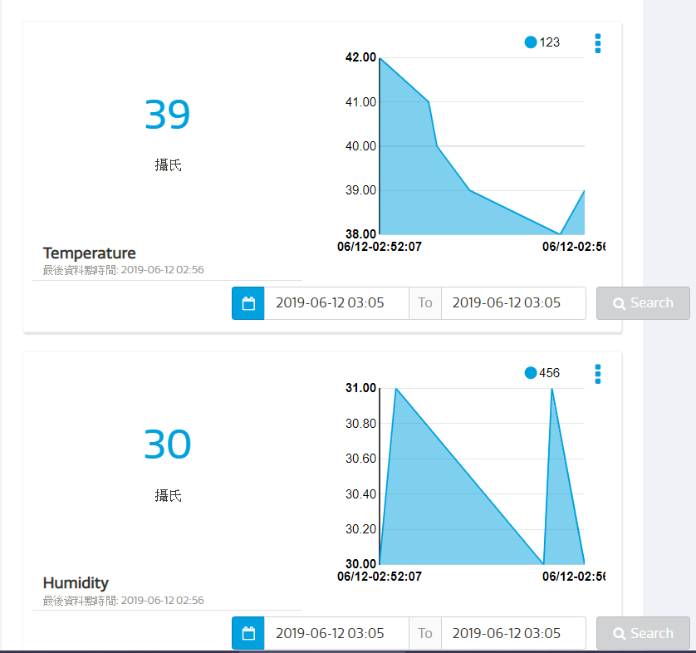

1. **心得討論**

**這次的實驗難度又更高了，畢竟是將我們才剛學過的東西，跟上禮拜所學的合在一起，都還是不太熟，所以只能多加練習，且下禮拜就要期末了，要好好努力。**

1. **修正電路圖**

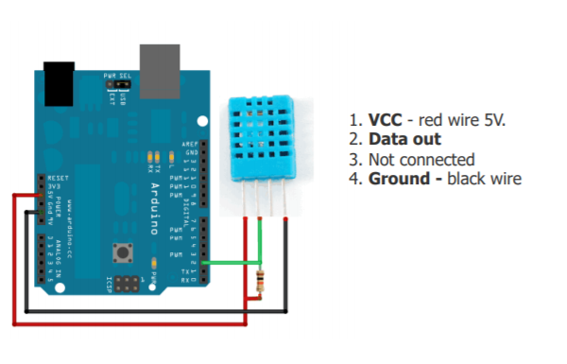

1. **修正程式碼**