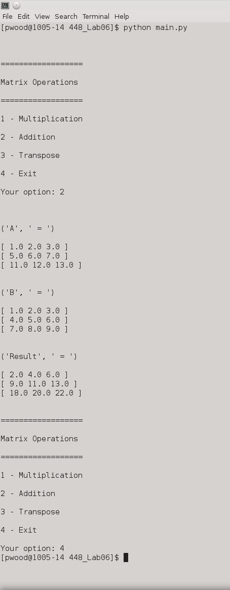
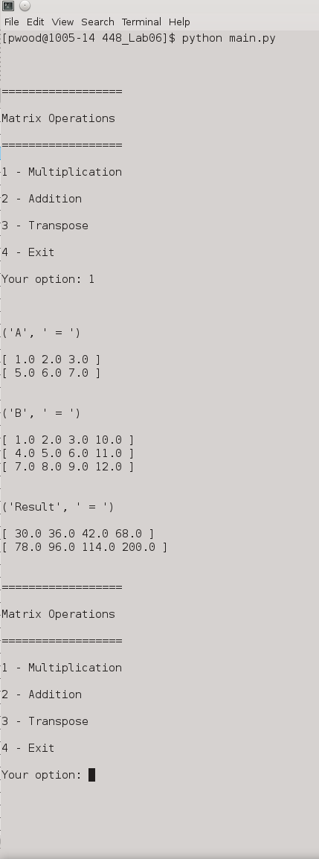
Addition example
Multiplication example
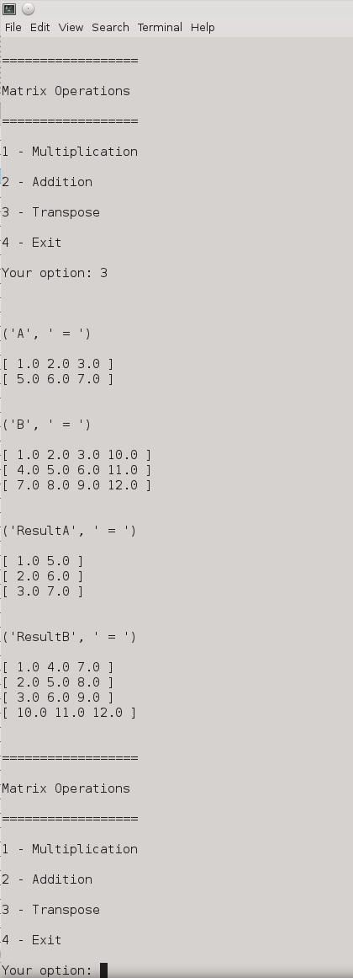
Transpose example

https://github.com/p3719/448_Lab06.git

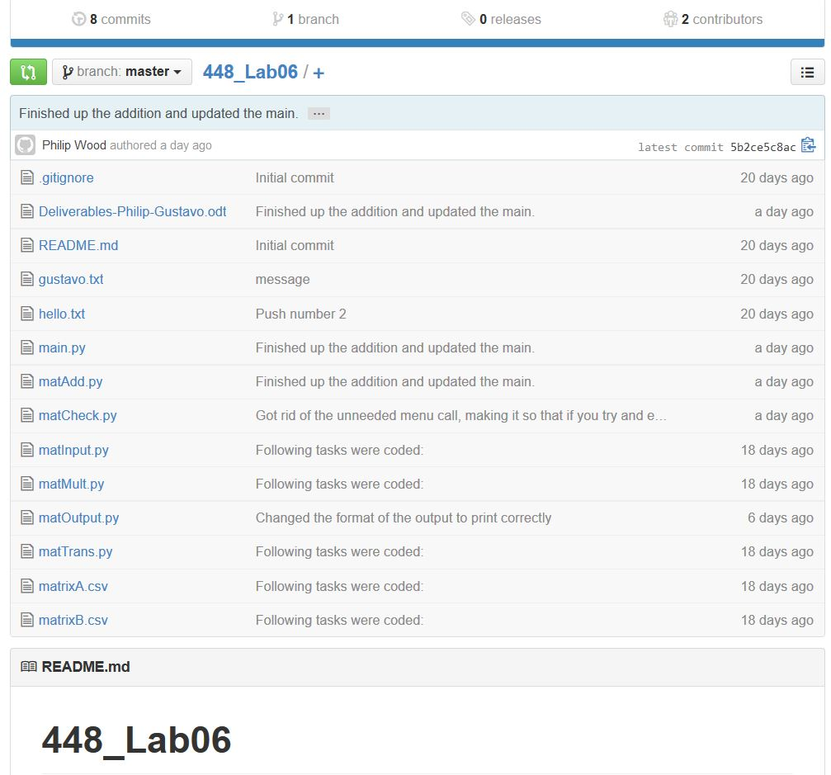

Main.py

import matInput
import matMult
import matTrans
import matOutput
import matCheck
import matAdd

def main():

# Get matrices
matrixA = matInput.getMatrixFromCSV('matrixA.csv')
if not matCheck.CheckMatrix(matrixA):
print("MatrixA is not a matrix!")
matrixB = matInput.getMatrixFromCSV('matrixB.csv')
if not matCheck.CheckMatrix(matrixA):
print("MatrixB is not a matrix!")

exit = False
while(not exit):
exit = menu(matrixA, matrixB)

def menu(matrixA = [], matrixB = []):
# Ask operation
print("\n\n")
print("==================\n")
print("Matrix Operations\n")
print("==================\n")
print("1 - Multiplication\n")
print("2 - Addition\n")
print("3 - Transpose\n")
print("4 - Exit\n")
operation = int(input('Your option: '))

# Get matrices
if not matrixA:
matrixA = matInput.getMatrixFromCSV('matrixA.csv')
if not matrixB:
matrixB = matInput.getMatrixFromCSV('matrixB.csv')

if operation != 4:
matOutput.showMatrix(matrixA, 'A')
matOutput.showMatrix(matrixB, 'B')

# Choose the operation
if operation == 1:
if matrixA and matrixB:
result = matMult.multiplication(matrixA, matrixB)
if not result:
print("\n\nMatrices cannot be multiplied.\n\n")
else:
matOutput.showMatrix(result, 'Result')
else:
print("\n\nMatrices were not found.\n\n")
elif operation == 2:
if matrixA and matrixB:
result = []
result = matAdd.addition(matrixA, matrixB)
if not result:
print("\n\nMatrices cannot be summed.\n\n")
else:
matOutput.showMatrix(result, 'Result')
else:
print("\n\nMatrices were not found.\n\n")
elif operation == 3:
if matrixA:
resultA = matTrans.transpose(matrixA)
matOutput.showMatrix(resultA, 'ResultA')
resultB = matTrans.transpose(matrixB)
matOutput.showMatrix(resultB, 'ResultB')

else:
print("\n\nMatrix was not found.\n\n")
elif operation == 4:
return True
else:
print("\n\nInvalid operation.\n\n")
return False

main()

matAdd.py

def addition(matrixA, matrixB):
matrixC = []
# If the matrixes can be added then they are
if CheckAdditionSize(matrixA, matrixB):
for rows in range(len(matrixA)):
matrixC.append([])
for cols in range(len(matrixA[0])):
matrixC[rows].append(matrixA[rows][cols] + matrixB[rows][cols])
return matrixC

def CheckAdditionSize(matrixA, matrixB):
# If the matrixes are of the same size return true otherwise false
if len(matrixA) == len(matrixB) and len(matrixA[0]) == len(matrixB[0]):
return True
return False

matCheck.py

def CheckMatrix(matrix):
for x in range(len(matrix)):
if x == 0:
cols = len(matrix[x])
else:
if len(matrix[x]) != cols:
return False
return True

matInput.py

def getMatrixFromCSV(fileName = 'matrixA.csv'):
file = open(fileName)

rowsSize = []
csvFormat = True
matrix = []
for line in file:
buffer = line.replace(" ", '').replace("\n", '')
if buffer:
buffer = list(buffer.split(','))
auxBuffer = []
for num in buffer:
auxBuffer.append(float(num))
buffer = auxBuffer
if not rowsSize:
rowsSize = len(buffer)
if rowsSize != len(buffer):
csvFormat = False
break
else:
matrix.append(buffer)
else:
return matrix

matMult.py

def multiplication(matrixA, matrixB):
matrixC = []
if checkMultiplicationSize(matrixA, matrixB):
for i in range(len(matrixA)):
matrixC.append([])
for j in range(len(matrixB[0])):
matrixC[i].append(0)

for row in range(len(matrixA)):
for column in range(len(matrixB[0])):
matrixC[row][column] = 0
for common in range(len(matrixB)):
matrixC[row][column] += matrixA[row][common] * matrixB[common][column]
return matrixC

def checkMultiplicationSize(matrixA, matrixB):
return len(matrixA[0]) == len(matrixB)

matOutput.py

import sys

def showMatrix(matrix, label = ''):
print("\n\n")
if label:
print(label, " = ")
for row in range(len(matrix)):
printf("\n[ ")
for column in range(len(matrix[0])):
printf(str(matrix[row][column]))
printf(" ")
printf("]")

def printf(message):
sys.stdout.write(message)

matTrans.py

def transpose(matrixA):
matrixB = []
numRows = len(matrixA)
numColumns = len(matrixA[0])
for row in range(numColumns):
matrixB.append([])
for column in range(numRows):
matrixB[row].append(0)
matrixB[row][column] = matrixA[column][row]
return matrixB

