# Files in folder – Before Code execution

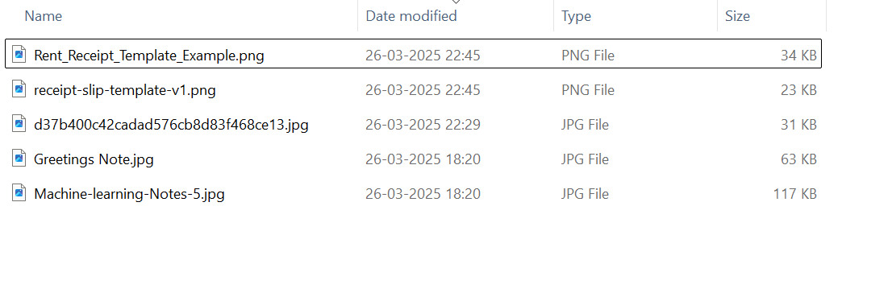

# Code execution – Terminal Output

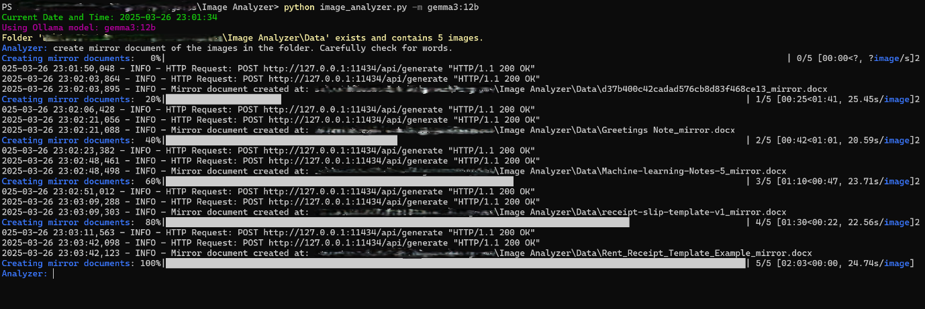

# Files in folder – After Code execution

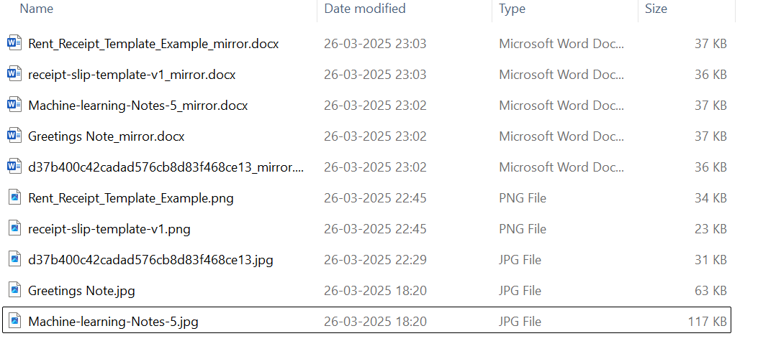

# Usual Queries to AI LLM

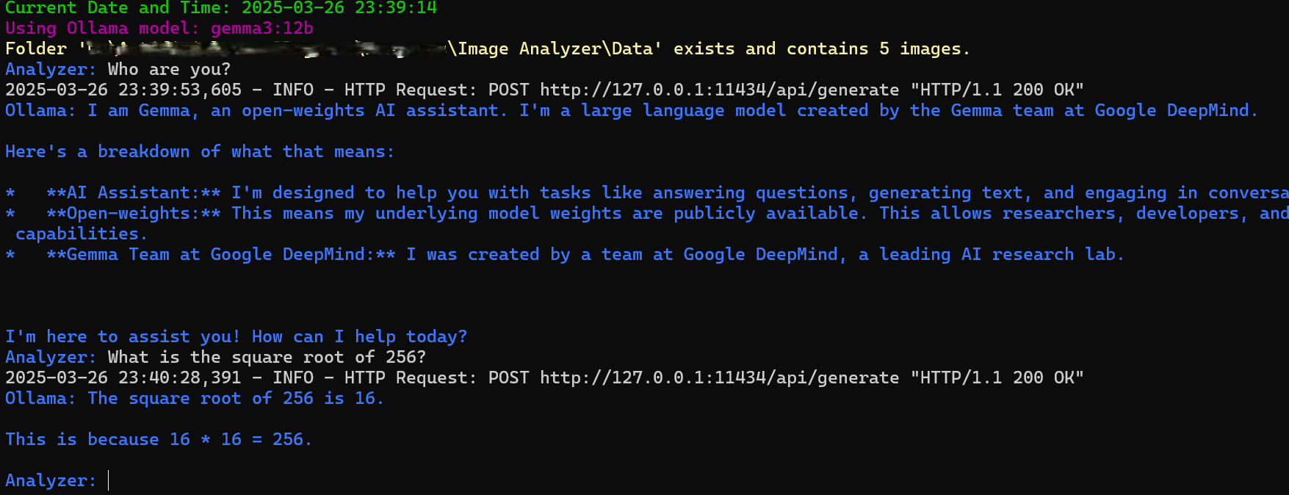

# Image to Document Creation

## Rent Receipt

### Image

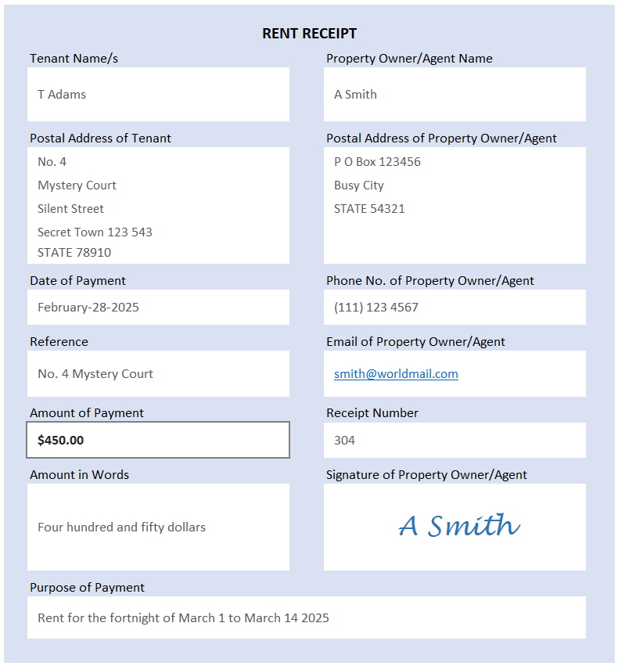

### Document

Tenant Name: T Adams  
Tenant Address: 4 Mystery Court  
Tenant Address: Silent Street  
Tenant Address: Secret Town 123 543  
Tenant Address: STATE 78910  
Date of Payment: February-28-2025  
Amount of Payment: $450.00  
Amount in Words: four hundred and fifty  
Purpose of Payment: Rent for the fortnight of March 1 to March 14 2025  
Property Owner/Agent Name: A Smith  
Property Owner/Agent Address: P O Box 123456  
Property Owner/Agent Address: Busy City  
Property Owner/Agent Address: STATE 78910  
Property Owner/Agent Phone Number: (111) 123 4567  
Property Owner/Agent Email: smith@worldmail.com  
Receipt Number: 304

## Rent Slip

### Image

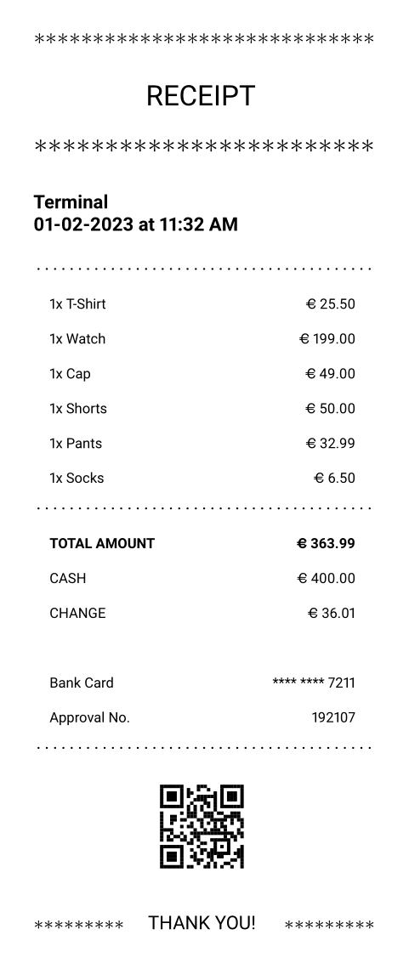

### Document

Terminal 199.00  
Date 01-02-2023  
Time 11:32 AM  
1x T-Shirt 25.50  
1x Watch 199.00  
1x Cap 49.00  
1x Pants 50.00  
1x Socks 6.50  
TOTAL 363.99  
CASH 400.00  
CHANGE 36.01  
Approval No. 192107

## Machine Learning Notes

### Image

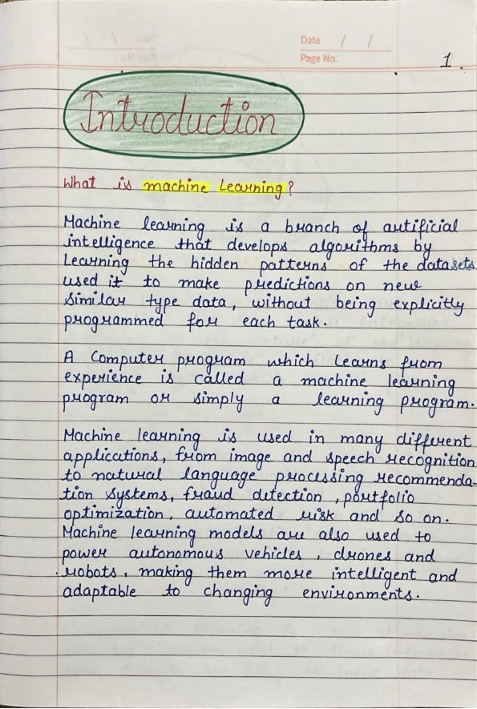

### Document

Here's a transcription of the handwritten note, aiming to preserve the original style and individual letter forms as accurately as possible:  
  
Introduction  
  
What is Machine Learning?  
  
Machine Learning is a branch of artificial intelligence that develops algorithms to learn the hidden patterns of the datasets. It is used to make predictions on new data without being explicitly programmed for each task.  
  
A program which learns from experience is called a machine learning program or simply a learning program.  
  
Machine Learning is used in many different applications, from image and speech recognition to natural language processing, recommendation systems, fraud detection, portfolio optimization, automated work and so on. Machine Learning models are also used to power autonomous vehicles, drones and robots, making them more intelligent and adaptable to changing environments.

## Greeting Note

### Image

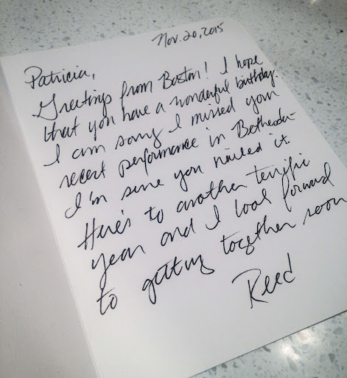

### Document

Here's a transcription of the handwritten note, attempting to preserve the original style and individual letter forms as accurately as possible:  
  
Nov. 20, 2015  
  
Patricia,  
Greetings from Boston! I hope you have a wonderful birthday.  
I'm sorry I missed you at the recent performance in Bethesda.  
It's pure, you nailed it!  
I look forward to getting together soon.  
  
Reed

## Credit Card Payment

Image

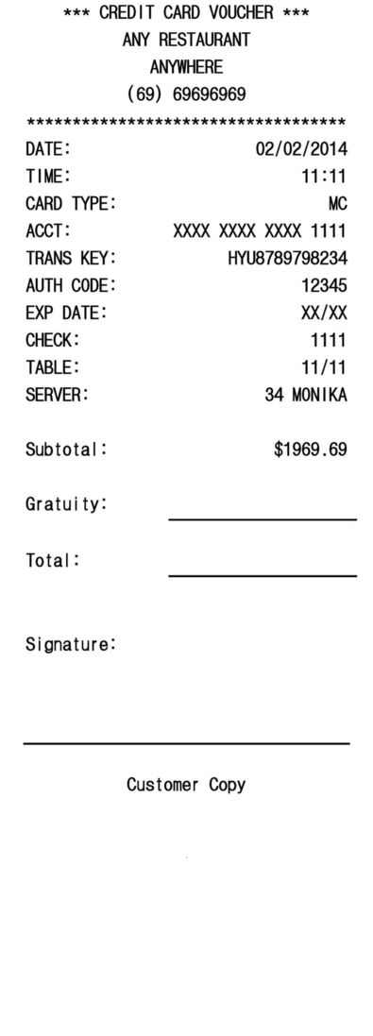

### Document

DATE: 02/02/2014  
TIME: 11:11  
CARD TYPE: MC  
ACCT: 1111  
TRANS KEY: HYU8789798234  
AUTH CODE: 12345  
SERVER: 34 MONIKA  
TABLE: 1111  
SUBTOTAL: 1969.69

**Note**

The image to document creation of AI depends on the efficiency and accuracy of the LLM model.