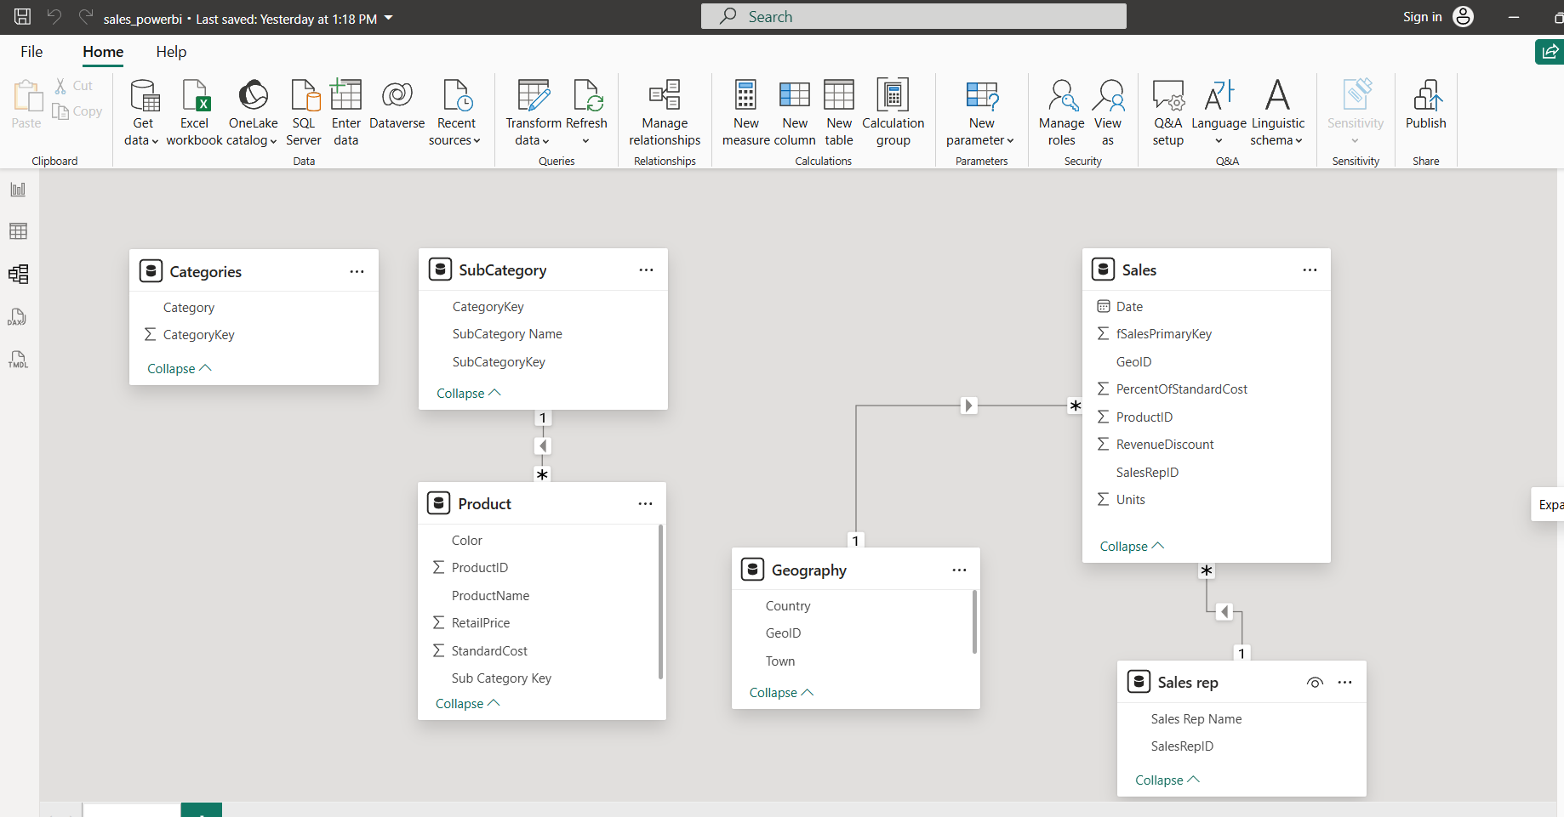

Open file where with transformed data yesterday
- Build relationship between table
Open Model View ,click on manage relationships under Home Tab, Click on Autodetect to detect relation between two table. Click close
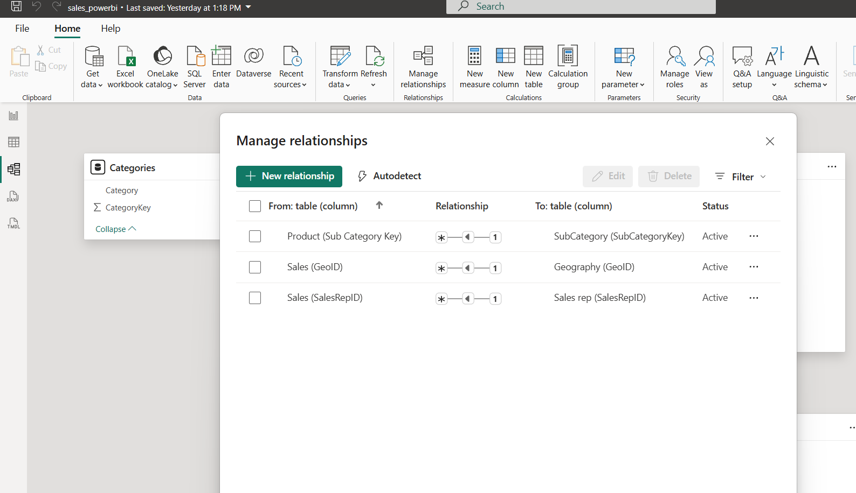
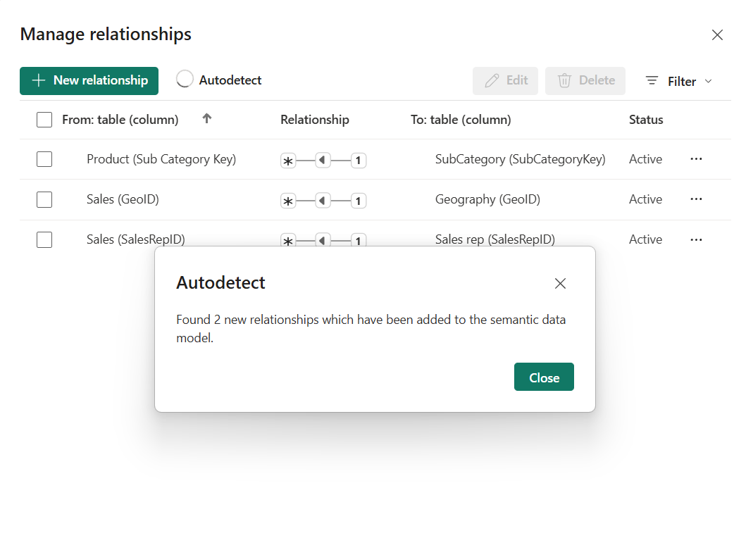
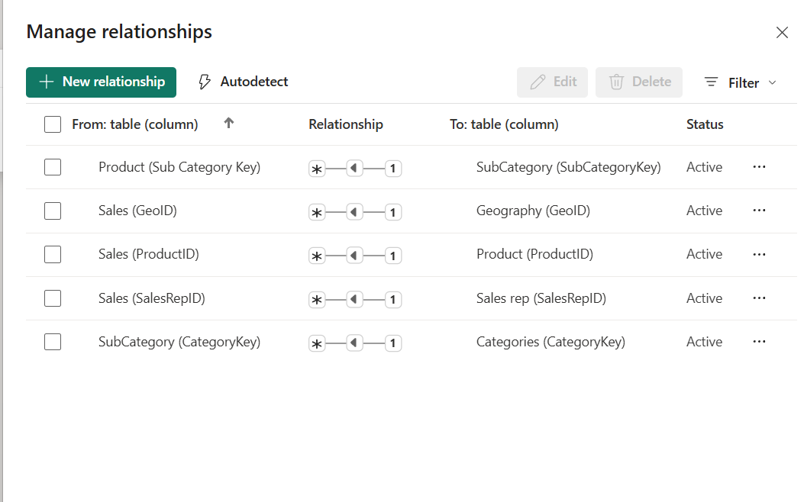
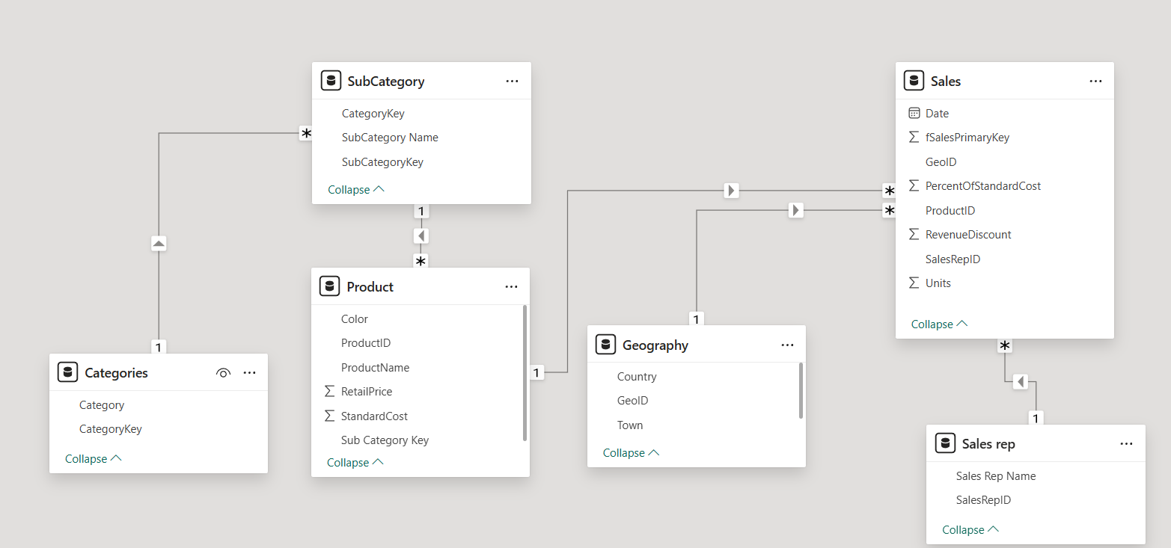

- Select on table view, New Table, Type “DateMaster = CALENDAR(FIRSTDATE('Sales'[Date]),LASTDATE(Sales[Date])) “ in formula bar and press “enter”.
Here we create new table datemaster to represent date related data from Sales table
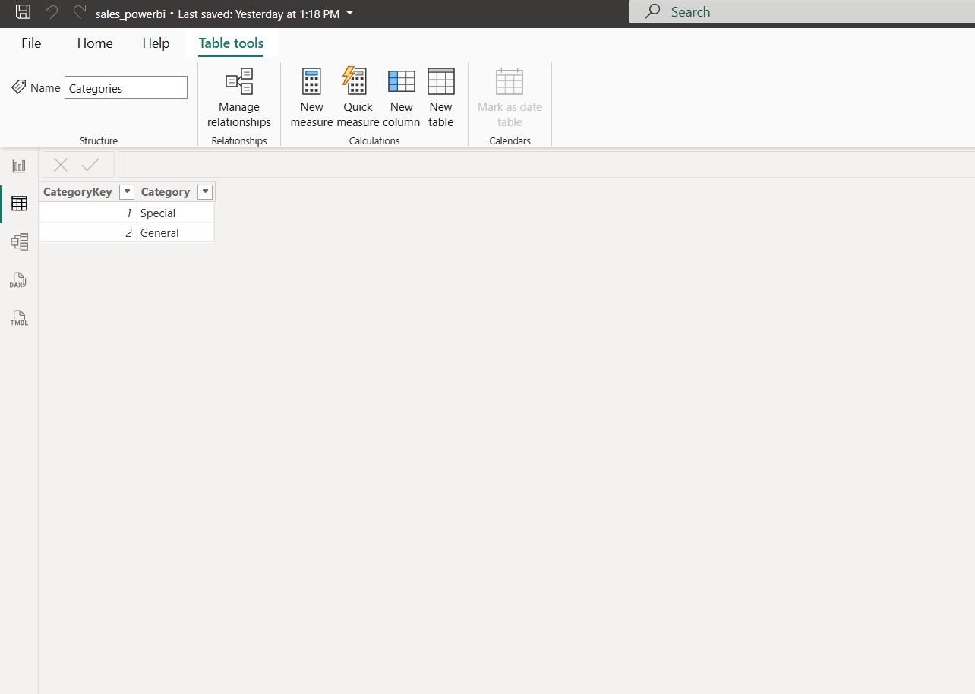
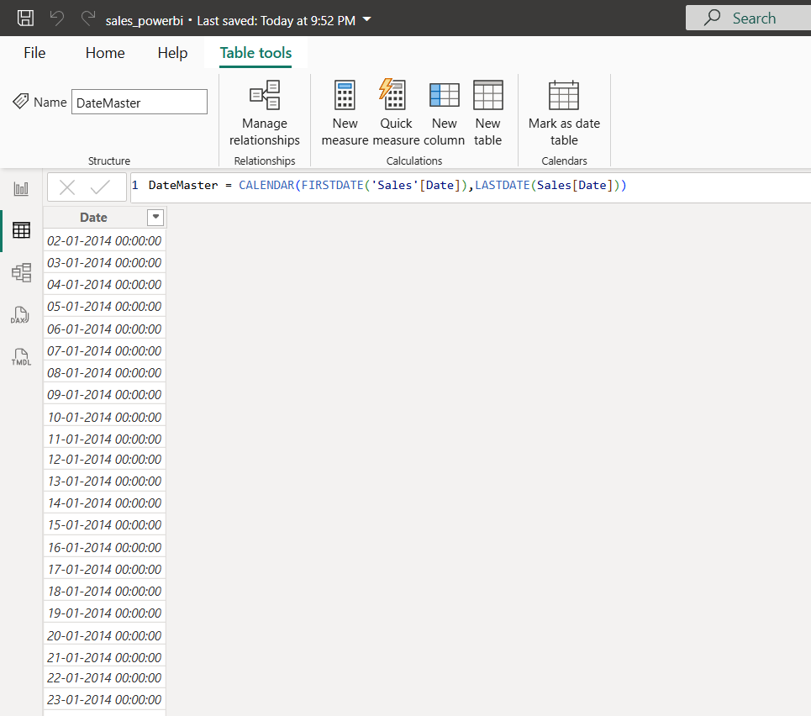
Click “new column”, under in Home tabformula: Year = YEAR(DateMaster[Date]),while adding new column make sure datemaster table is selected.
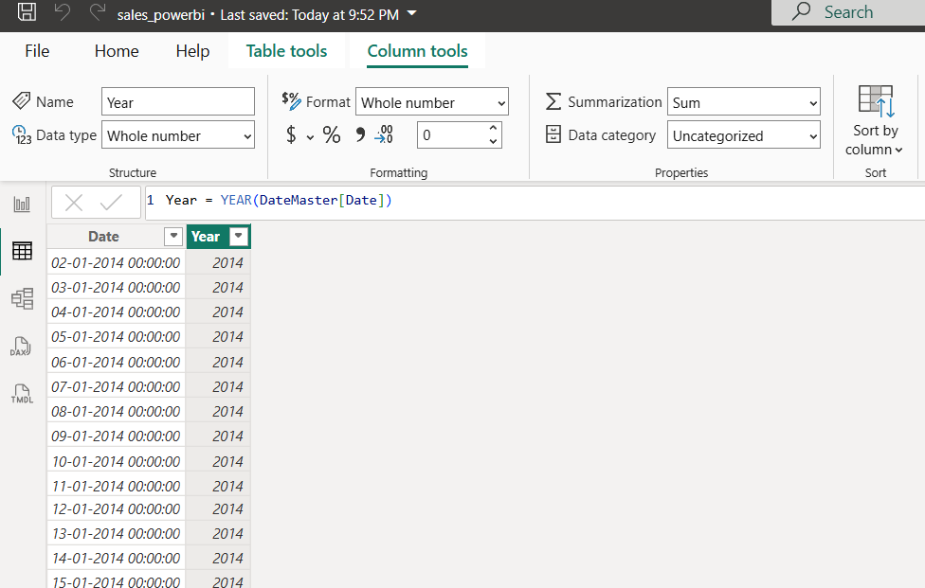
Click on new column, formula: QTR = QUARTER(DateMaster[Date])
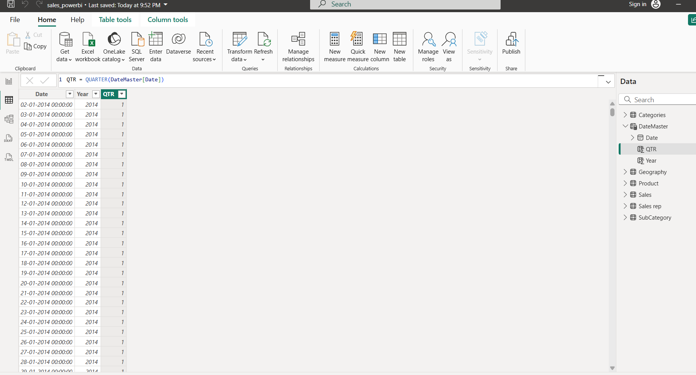
Click on new column, formula: Month = MONTH(DateMaster[Date])
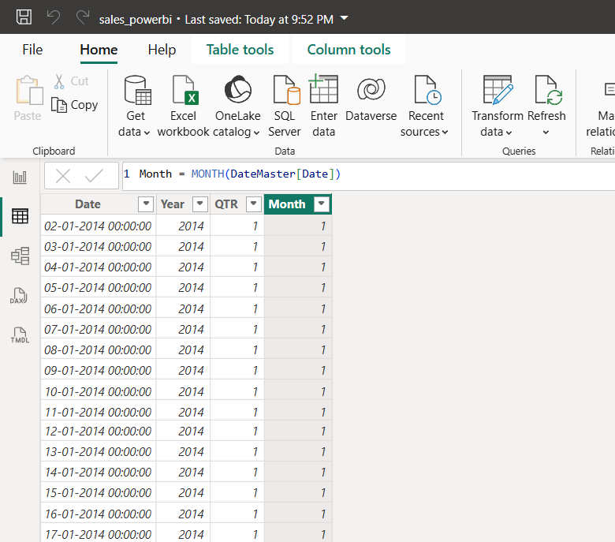

Click on new column, formula: MonthName = FORMAT(DateMaster[Date],"MMM")
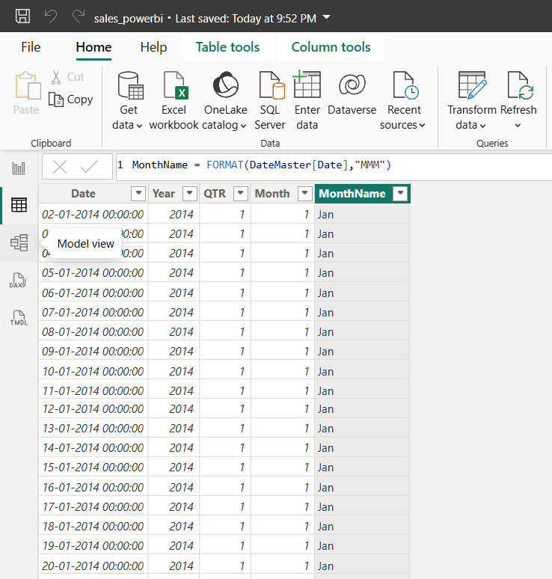
Click on new column, formula: Week = WEEKNUM(DateMaster[Date])
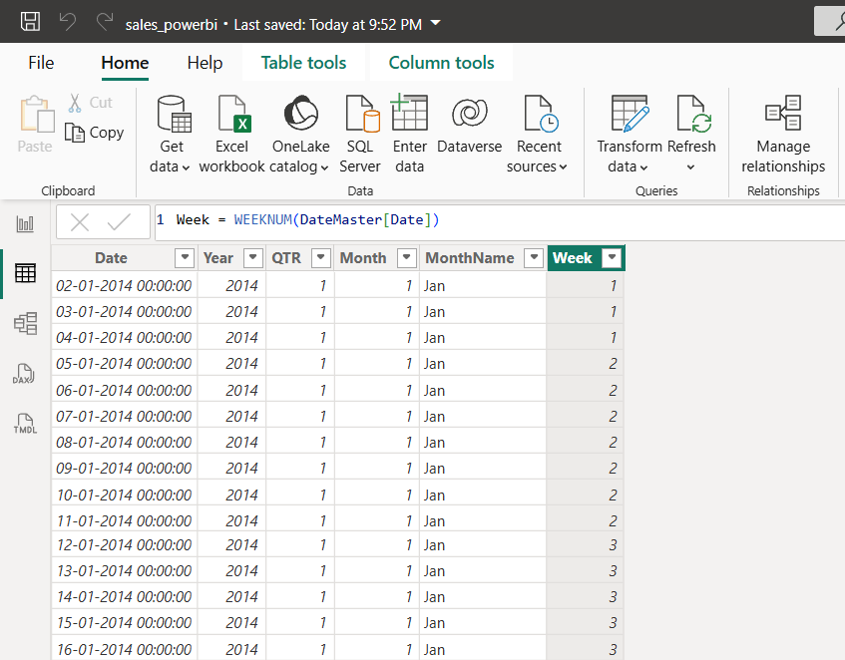
Click on new column, formula: WeekDays = WEEKDAY(DateMaster[Date])
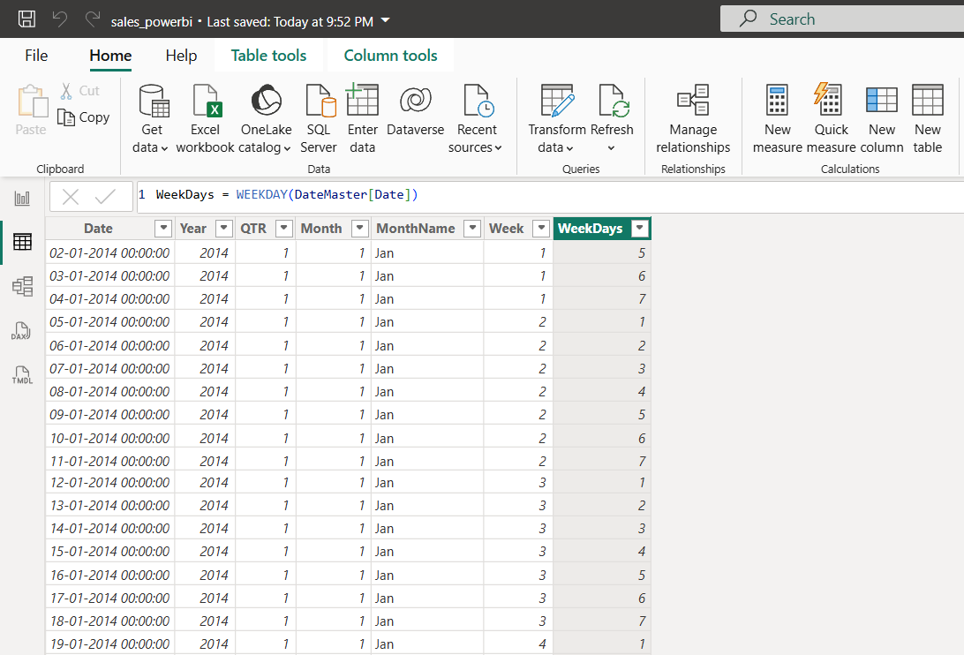
Click on new column, formula: WeekdayName = FORMAT(DateMaster[Date],"DDDD")
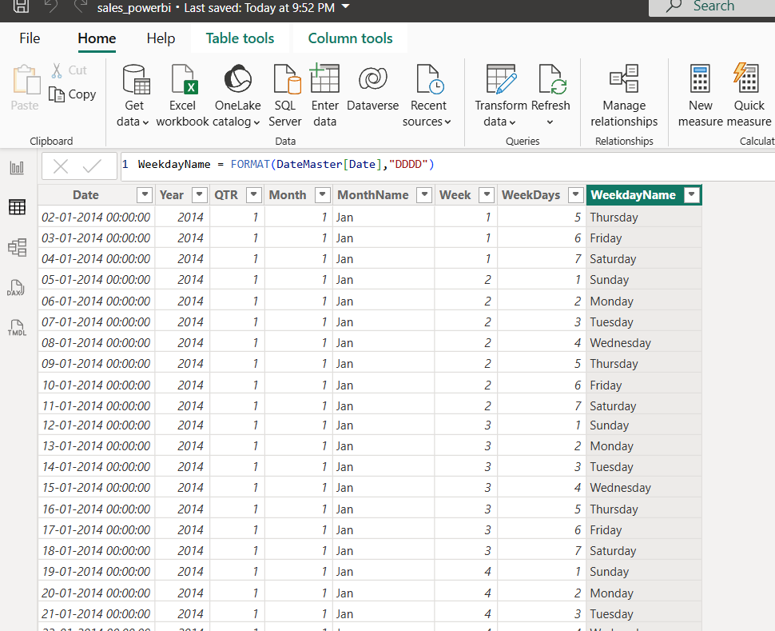
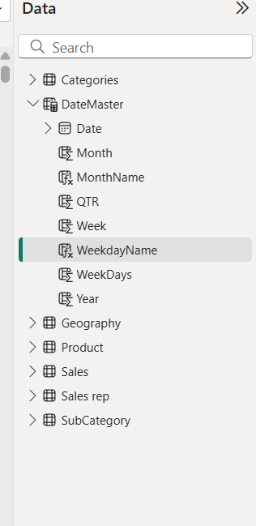
Columns after table is created.
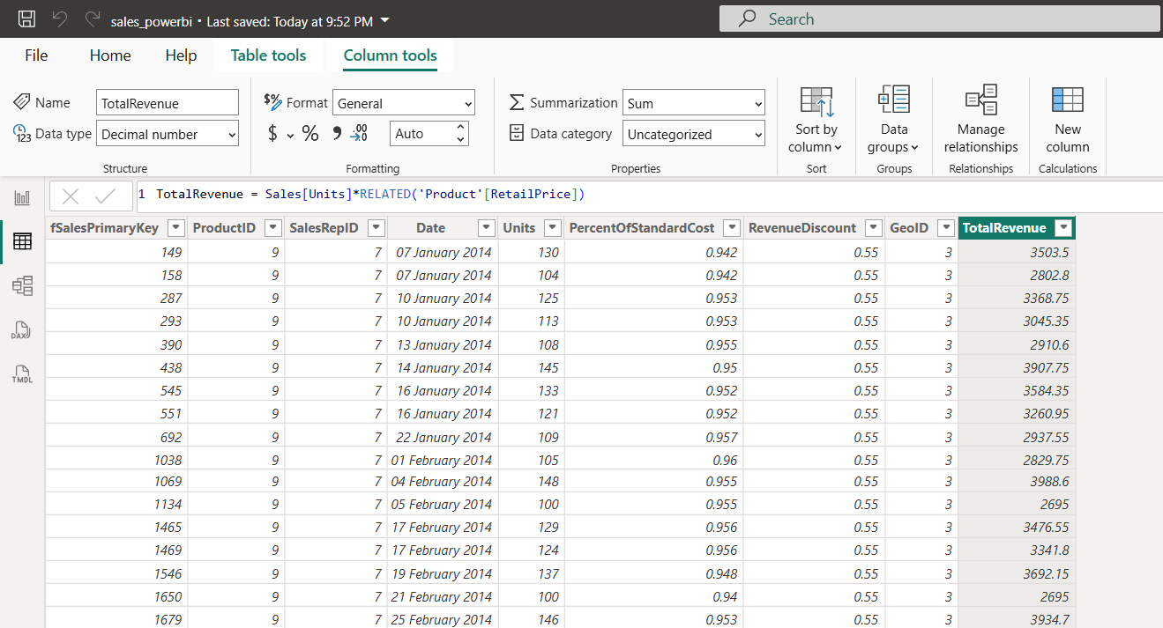
Select Sales table,
a. Click on New Column,
formula: TotalRevenue = Sales[Units]*RELATED('Product'[RetailPrice])
b. Click on New Column,
formula: TotalCost = Sales[Units]*RELATED('Product'[StandardCost])
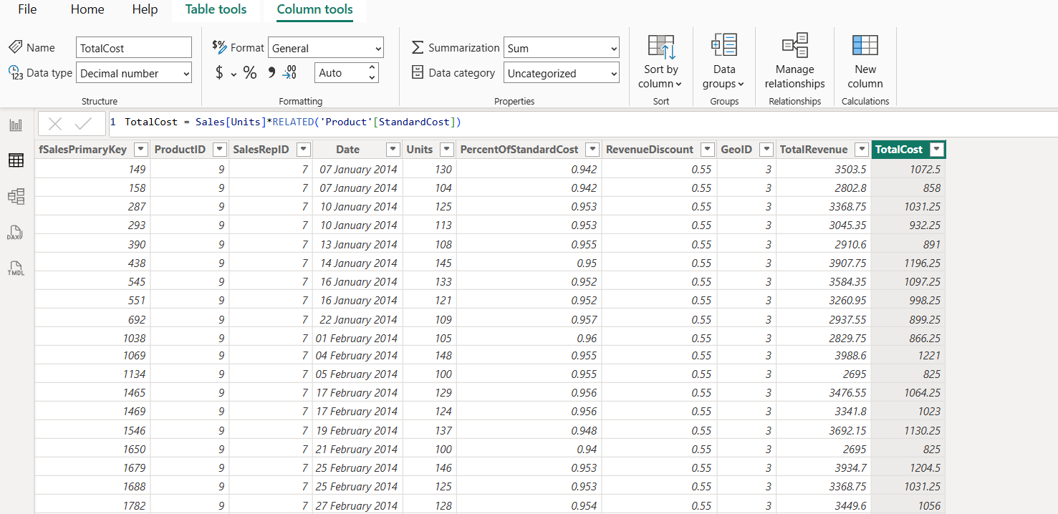
c.Click on New Column,
formula: GrossProfit = Sales[TotalRevenue]-Sales[TotalCost]
