# setup: domain for local foundry server

1. 1. **get foundry running**  
   self explanatory - ask discord for help if necessary

2. **fix your forwarding/firewall settings**   
this is needed even without a domain, make sure your players can connect to your ip:30000 when you have the app running (check whatismyipaddress.com or similar site) - ask discord or google for help if neccesary

**3. purchase a cheap domain**  
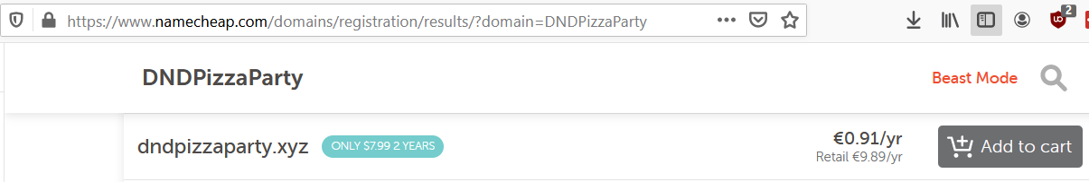

cheap urls can be had for under 1$ (just get the cheap deal for a year, nobody is going to snipe your url so you don’t need to lock it down, if it does get lost you can just get a different one)

note: you do not have to use “namecheap” there are a ton of sites where you can purchase a cheap domain  
  
**4. set up your dns settings**  
  
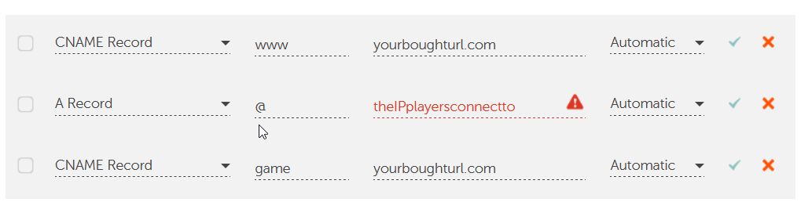

this will look a little different depending on the website where you bought the url, but you will need to set up at least the following two things:  
  
CNAME Record => here you put the url you just bought (is usually already set)  
A Record => here you put your ip (the one from whatismyipaddress.com or similar site)  
  
optional: if you plan to host more things in the future, it can be nice to add an additional cname record, this way players can connect to “game.yourboughturl.com” to join foundry, and for example “teamspeak.yourboughturl.com” to join teamspeak. but this is not needed

you can put anything here so for example “dnd.yourboughturl.com” “foundry.yourboughturl.com”

**5. set up nginx**

after you have done the above steps. players can already connect to your game by going to  
yourboughturl.com:30000  
but it is much nicer to hide the “30000” part too. or use the “game.yourboughturl.com” as mentioned earlier. for this you need a program like nginx.

[https://nginx.org/en/download.html  
  
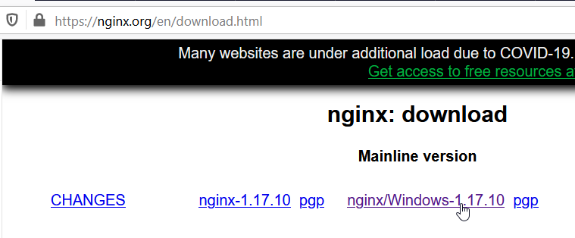](https://nginx.org/en/download.html)

download the latest mainline version, and unzip it somewhere. do not run the program yet, we need to make a small edit to the configuration file.

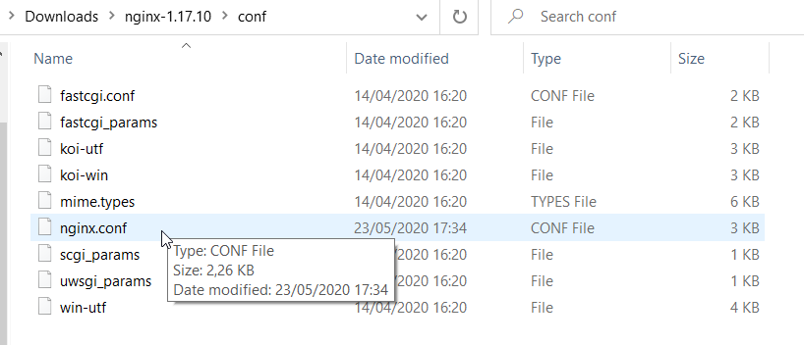

open the “nginx.conf” file located in the “conf” folder in your editor of choice (notepad etc)

scroll down to where it says “server{”  
  
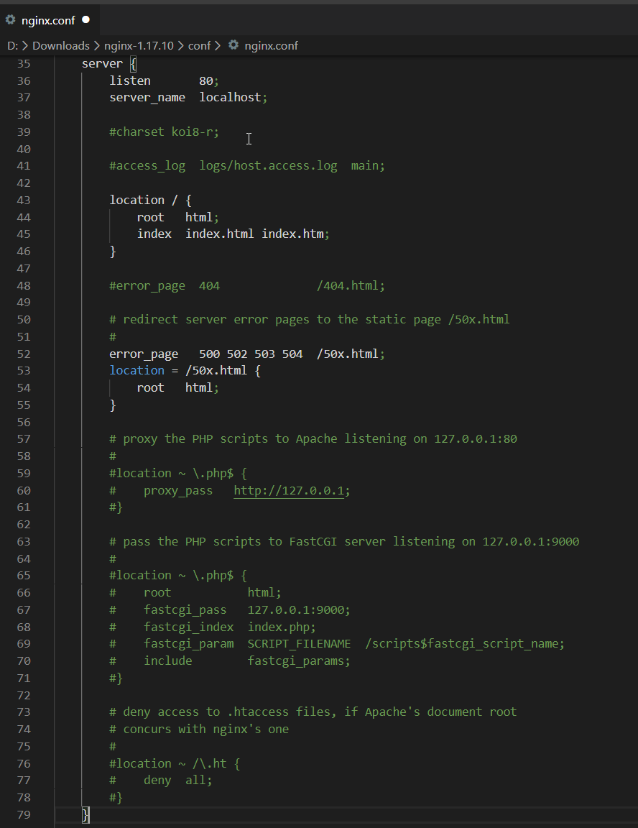

we are going to replace all of this with the server section provided by foundry on this web page:  
<https://foundryvtt.com/article/nginx/>so it looks like this:

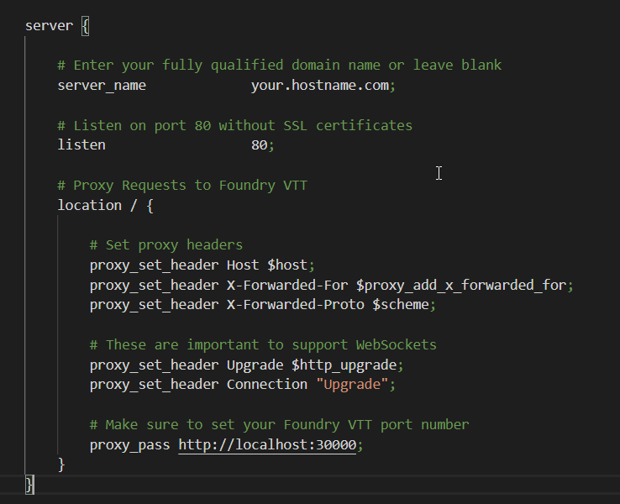  
  
**note: i only replaced the server section, you dont need to replace anything else**now all you need to do is update the server name to the domain you bought.

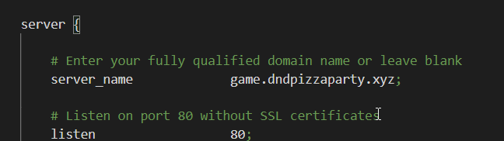

(if you did not add the “game” CNAME record, just put yourboughturl.com, withouth the game. in front of it.

now launch nginx, there you go:  
  
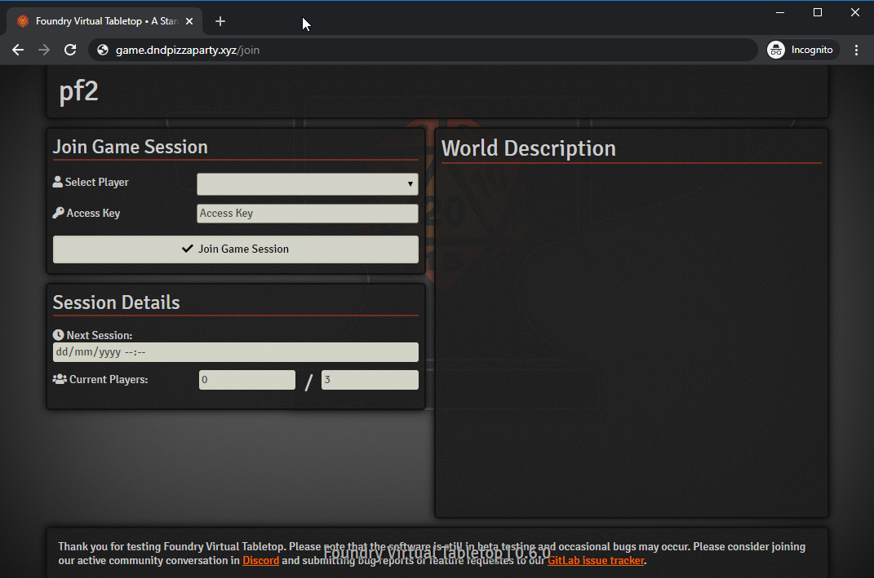

# Foundry VTT Modules which are ok

1. About Time

2. Actually Private Rolls

3. Sky's Alternate 5th Edition Dungeons & Dragons Sheet

4. Babele

5. Background Volume - Sliders for Scenes

6. Better Roll Tables

7. Better NPC Sheet 5e

8. Better Rolls for 5e

9. BubbleRolls

10. Bullseye - gives error

11. Calendar/Weather - gives message

12. Cautious Gamemaster's Pack

13. Chat Portrait

14. Combat Utility Belt

15. Combat Ready

16. Compendium Browser

17. Conditions for D&D 5e

18. Cursor Hider

19. darksheet 5e

20. styling for the darksheet 5 sheet - Remember! You MUST install the Signika font for this to work.

21. DugeonDraft Importer

22. Deselection

23. Dice Tray

24. Dice So Nice! - gives message

25. Dice Tooltip - D&D5e

26. Display Mode

27. D&D5e Dark Mode

28. DNDBeyond Character Sheet for 5E

29. Dynamic effects

30. Easy Target

31. Effectifier

32. 5e Encounter Builder

33. E-Z Roller - gives error

34. Roll of Fate

35. Favourite Item Tab

36. The Forge

37. Foundry Token Patroller

38. Pin

39. The Furnace

40. FX Master

41. GM Scene Background

42. GM Notes

43. Group Initiative

44. Group Roll Checks and Saves

45. Health Estimate

46. ImageDrop

47. Image Previewer

48. Item Delete Check

49. Item Containers

50. Jitsi WebRTC client

51. Kobold Press OGL Compendium

52. Layer Hotkeys - gives error

53. Less Fog

54. Let Me Roll That For You!

55. Loot Sheet NPC 5e

56. Maestro

57. Magic Items

58. Max Crit - gives error

59. Merge Walls

60. Mess - Moerills enhancing super-suit(e)

61. Metric System for D&D5e

62. Michael Ghelfi Audio Pack

63. M.I.N.M.A.P - Moerillis Indecision Negator, Decision Maker, And Planner

64. Minor Quality of Life Improvements

55. ModBox

56. Mount Up!

57. MyTab

58. No Token Animations

59. Obsidian Character Sheets - requires changing sheets

60. Pathfinder 1 - Dark-Style Addon

61. Permission Viewer

62. Pathfinder 2e Quick Rolls

63. Pin Cushion

64. Pings

65. Playlist Importer

66. Points of Interest Character Sheet

67. Pointer

68. Polyglot

69. PopOut! - gives message

70. Printable /stream

71. Query

72. RollTable Buttons

73. Route-Finder

74. Grid Scale Menu

75. Search Anywhere

76. Actor Sheet Macro

77. Sheet To Token

78. Sidebar Aesthetics - Changes to the Sidebar Aesthetics

79. Simple Dice Roller

80. Simple Name Generator

81. Skycons

82. Speaker stats

83. Special Dice Roller

84. 5e Spell School Icons

85. Squeaker

86. Stat Drawer

86. Theatre Inserts

87. Tiles Browser

88. Token Audio

89. Token Auras

90. GM Token-Drag Visibility

91. Token Health

92. Token Info Icons

93. Token Mold

94. Token Tooltip

95. Torch

96. Trigger Happy

97. Turn Marker

98. Tweak Playlist

99. Virtual Tabletop Assets - D&D Beyond Integration

100. Virtual Tabletop Assets - Iconizer

101. Virtual Tabletop Assets - Party overview

102. Virtual Tabletop Assets - Tokenizer

103. WebRTC Tweaks

104. WFRP - Tweaks

Please note :

1. I have not loaded in any of the translation files.

2. A few of the above modules were loaded and had

errors. They were updated, I reloaded them and their errors

appear to be gone. You may have some errors. If you do

- they you MUST uninstall the module and re-install it

again. Otherwise you may have something left over which

might still cause a problem.

# **Power Users of Foundry, post your best tricks here!**

Hanging out on the Foundry Discord has taught me a plethora of nifty tricks, uncommon knowledge and useful shortcuts that have made using Foundry even easier. Ive been able to freely reap the wisdom of people way smarter than me, and it has improved my experience - and that of my players - considerably! But why hoard all these secrets like a greedy, gluttonous dragon? In celebration of Foundrys official release, feel free to post the best tricks and personal advice that has revolutionized your game!

All content is welcome - whether it be nifty keyboard shortcuts to handle common tasks, scripted macros that make your life as a DM easier, interesting synergies from using multiple modules together - anything that has polymorphed you from a Foundry newb into a grizzled VTT battlemaster is on the table!

Let me kick this off with a few tricks of my own. Ill start with some of the basics, and end with the technical wizardry. All advice has been tested on Foundry 0.5.7 using the D&D 5e 0.9 game system.

**Handy Targeting Shortcut**

As a player, double-rightclick on a token you do not own to target it. This will create a visual indicator around the monster youve targeted, visible to players and GM.

**Quickly Measure Distance to Waypoint and Automatically Move Token**

With the Token tool enabled (its the people-shaped icon on the left sidebar), you can quickly measure out the distance between a token you own and any point on the map (the waypoint), and then execute the move. To do this:

Hold down the Control key

Leftclick on a Token you own, and while holding Leftclick down,

Drag the mouse cursor to your desired waypoint

This will bring up a line that displays the distance between that token and the waypoint. You can then hit Spacebar to make the token automatically move from its position to the waypoint.

Note: You can set multiple waypoints by leftclicking the mouse while dragging the cursor. Hitting Spacebar will then execute the move, with the token auto-moving to each waypoint in the order that you set them.

**Quickly Open Token Config for any Token**

As the GM, double-rightclick on any token in a Scene. This will open the Token Configuration menu directly, allowing you to change token properties such as Character, Image, Position, Vision and Resources.

**Modifying Initiative**

When you first launch combat, you can rightclick the d20 icon for each combatant to modify initiative (putting in your own values, for example), reroll initiative, or remove the combatant from combat. Note that even after initiative has been rolled, you can still right-click on the initiative number to modify, reroll, or remove the combatant.

Try right-clicking on other things inside of Foundry. Youll find many things have options that become available when rightclicked.

**Right-click to launch Combat Tracker in a separate window**

As GM youll often want to have both the Chat and Combat Tracker visible at the same time. To do this, right-click the Combat Tracker on the right Sidebar Tab (its the icon that looks like an upraised fist on the righthand side of Foundry) and itll pop out in a separate window.

Note: With the exception of Chat, you can rightclick any icon in the right Sidebar Tab to pop it out as a separate window. This includes Combat Tracker, Scenes, Actors, Items, Journals, Rollable Tables, Audio Playlists, Compendium Packs and Game Settings.

**Easy Copy and Paste Monsters**

Foundry allows you to select any Canvas element and copy + paste them. Canvas elements are anything that you manually place in your Scene, such as Tokens (players, characters, NPCs, monsters, etc), Tiles, Walls, Lights, Ambient Sounds, Measurement Templates, Drawn Elements, and Journals.

To copy a Canvas element, click on the element inside the Scene and hit Ctrl+C. To paste it, hit Ctrl+V. A second instance of that element will appear.

Lets say you need to create a crowd of 40 goblins. You could drag each goblin out, one at a time, from the Actors tab and place them in the Scene. But a much faster method would be to drag out one Goblin, copy & paste it, copy the two Goblins now in the scene & paste them, copy the four goblins now in your scene & paste them, and so on until you reach 40. Foundry lets you select multiple canvas elements (in our case, multiple goblins) and copy + paste them all.

You can use this trick to quickly duplicate repeated sections of walls, saving a lot of time. Other people on Discord have reported using this trick to quickly duplicate and place light sources that have been customized to fit their Scene. No more dragging out a light radius and setting Dim/Bright values for every single light!

**Measuring Network Load for Complicated Maps**

This one comes Atropos himself. If youve got a complicated Scene - think a HUGE map filled with countless walls, light sources, enemies and tons of other elements - and you want to find out how network intensive it is for your players to load, do the following:

Press F12,

Navigate to the Network panel,

Press F5, and

See how much stuff youre chucking at your players when loading the map.

The key reports will be at the bottom of the Network panel.

**Measuring Realtime Performance of Complicated Maps**

Lets go back to our large, complex map example. Measuring the network load is useful, but it doesnt give us any realtime stats on the performance of our Scene. To measure this, download Firefox Developers Edition. Launch Firefox Developers Edition, log into your Foundry game world and navigate to your complicated Scene. Hit F12, select the Performance tab, and hit Record.

Firefox will now start recording the realtime performance data of your scene. Move some tokens around in the Scene and notice the change in FPS. Youll likely see dips as you move the tokens through more complicated areas, such as unexplored areas with a LOT of walls, shadows and overlapping light sources. You can see exactly when the dips happened and the stack state at a given time. Lots of juicy info here for the web dev folks.

Note: To boost performance on older/slower computers, you can limit framerate in Foundry to a more manageable speed (I use 30 FPS), and disable Soft Shadows. Both of these options can be configured in Game Settings > Configure Settings.

**Using SymLinks**

Symlinks are an operating system feature that allows you to nest a folder from another location inside an existing folder. This effectively gives you a shortcut from one folder to another in a way that lets programs directly access the data. For example, putting a symlink to a folder containing all of your mapping assets inside your FVTT userdata folder allows Foundry to use those assets without copying the files over. Think of it as a super-powered shortcut.

*Some examples of how people on the Discord use symlinks:*

I use a cloud based storage to keep all my campaign stuff. I keep meticulous track of all my folders. So I create a symlink in the base directory of Foundry called for example 'art'. Then I symlink that to the general art directory in my cloud storage.

I use a symlink just as a bulk dump folder to my /mapassets/. But I've got a second symlink where I've kind of cheated by mapping my local harddrive on my PC as remote storage from my hosted server through SSHFS. This way, I can access tokens and music files from my home PC on my hosted virtual machine.

I keep things by source (so I know where to find certain styles), but then also symlink them by type (weapon, armor, etc)

Symlinks are definitely more of a power user feature, and one Im not too familiar with. I highly recommend reaching out to folks on Discord if youd like to learn more!

**The Final Word - Insane Things You Can Do in Foundrys Editor**

Foundry uses TinyMCE, a highly customizable and flexible rich text editor that you see whenever you edit a Journal, post to Chat, or touch anything in FVTT that formats rich text. One of the nifty features of TinyMCE is that it can accept HTML.

Let me repeat that.

You can pass HTML arguments inside Foundrys Rich Text Editor.

This opens up the door to some truly ridiculous things.

On a more practical note, being able to pass HTML arguments makes wild things feasible. Want music to play when your players open a Journal entry? Totally possible. Want animations to display in Chat? You got it. Want to embed a Youtube video in a Journal entry? Believe it or not, thats possible too.

The rich text editor inside Journals (and other places, such as chat) will take nearly any pasted HTML and do its best to maintain the formatting. You can literally copy a websites HTML code, throw it into the Rich Text Editor and itll do its darndest to render it correctly.

This is a game changer itself, but the true insanity comes when you realize that you can include iframes to host direct links to external websites. In Foundry, it is technically possible for you to create a journal entry that allows you to open an entirely separate webpage. Youll want to open up the Journal Editor and paste the following in as Source Code, changing https://foundryvtt.com/ to whatever site address you want:

<div style="overflow: hidden; position: relative; min-height: 100%;"><iframe style="border: 0; height: 100%; left: 0; position: absolute; top: 0; width: 100%;" src="https://foundryvtt.com" width="100%" height="100%" allowfullscreen="true;">

</iframe></div>

Now, before you get excited about creating Journal entries that open directly to your beautiful notes on GMBinder, realize that the cold water of Cross-Origin Resource Sharing is here to ruin your fun. Due to CORS, nearly all websites will block any connection you attempt to make inside of a Journal entry or Foundry Chat. However, if youre hosting your own websites on a server you own, and can configure the connectionthe sky is the limit.

Those who are much more web-savvy than me might be able to improve upon this, or come up with new methods that blow this one out of the water. Exploring these possibilities is one of the things Im excited to see developed further by the community. One of the most amazing things about Foundry is the passionate group of developers making incredible things possible within it. If you have js.node, javascript, or general web development experience and are looking to make an impact on the VTT gaming community, come join us on Discord! We have cookies.

On a similar note, if you spot any technical inconsistencies, errors, or just flat-out wrong statements, please let me know and I'll be happy to correct them in this article.

I owe a huge thank you to the following folks for their invaluable advice and wisdom, and their infinite patience holding my hand while I proceeded to throw anything and everything at Foundry: