# Introduction

*Alone and gasping for breath, the last surviving adventurer from a failed expedition wanders through a desolate ruin, hoping desperately to find succor in this long-forgotten corner of the world… turning a corner, their eyes fixate on a portal, tantalizingly beckoning them to safety. With a seemingly final, desperate gasp, they leap through, knowing that whatever lies beyond, it has to be better than this godforsaken place.*

*At the corner of a hidden underground market in the city of Waterdeep, a young mage and her companions look over their spoils, ready to head back to the Cage. They may not be the most welcome there, being simple ‘Primes’, but it doesn't matter: their coin is coin, and their treasure is treasure. Heading through the stable portal, they make their way to the Lady’s Ward, hoping to make the most of their adventure’s rewards.*

*A young adventurer from an unknown world wanders through a portal, leaving behind everything he ever knows… and when he arrives, he sees a mage carrying the spoils of adventure, and a battered warrior limping, holding their side… on the crowded street before him, he sees the wondrous city of Sigil, bustling and full of life and danger.*

Now that you are here, what will your story be? There is nowhere in the multiverse you can’t go, nothing you can’t find in this place. Will you be a lone adventurer, wandering from place to place to establish your own tale? Will you travel with a group of companions, writing your story in tandem? Will you join one of the many guilds, establishing a name for yourself and your guild in order to help it grow in power? Your path awaits you in Sigil, the City of Doors, and in the multitude of worlds that lie beyond the Cage…

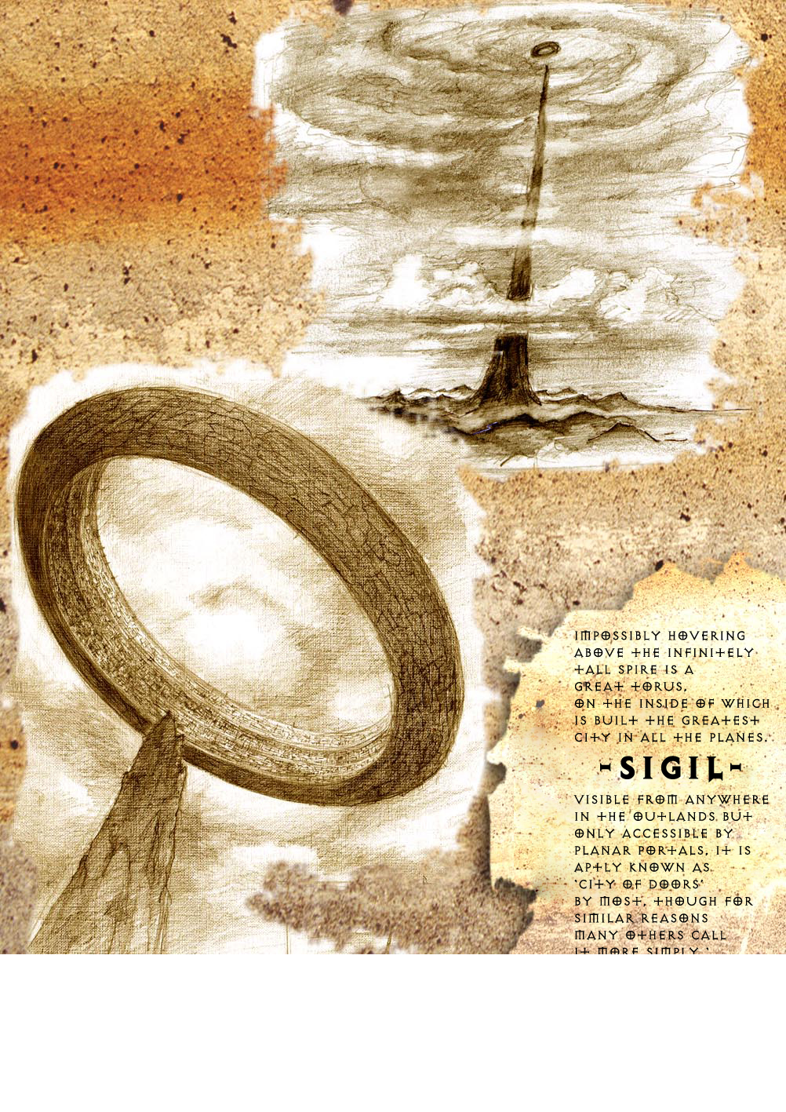

## Sigil, the City of Doors

**Sigil** is an impossible place; a city located in the inner surface of a massive hollow torus. The torus itself floats atop the Infinite Spire in a plane known as the Outlands which stretches out infinitely below. Known as the crossroads of the multiverse, there are few places in the world that do not link to Sigil - if it exists, a portal likely links to the **City of Doors** from somewhere else. Impossibly crowded, upon first entering this city the first thing a new adventurer will see is building stacked upon building and, seemingly, person stacked upon person. To the inhabitants of the city, it is known as the Cage as there is no sky - just light and darkness made manifest by the whims of the city's mysterious ruler, the Lady of Pain.

The city is divided into six different Wards:

• The Lady’s Ward is the home to Sigil’s powerful elite.

• The Lower Ward is Sigil’s beating industrial heart, churning out the tools and supplies that make city life possible.

• The Market Ward is where things are sold, bartered and traded.

• The Guildhall Ward is where services are provided.

• The Clerk’s Ward is the bureaucratic center of the city, where things are documented in triplicate.

• The Hive Ward is home to the utterly destitute, its inhabitants basically trapped in the city because they cannot afford to get out of this place.

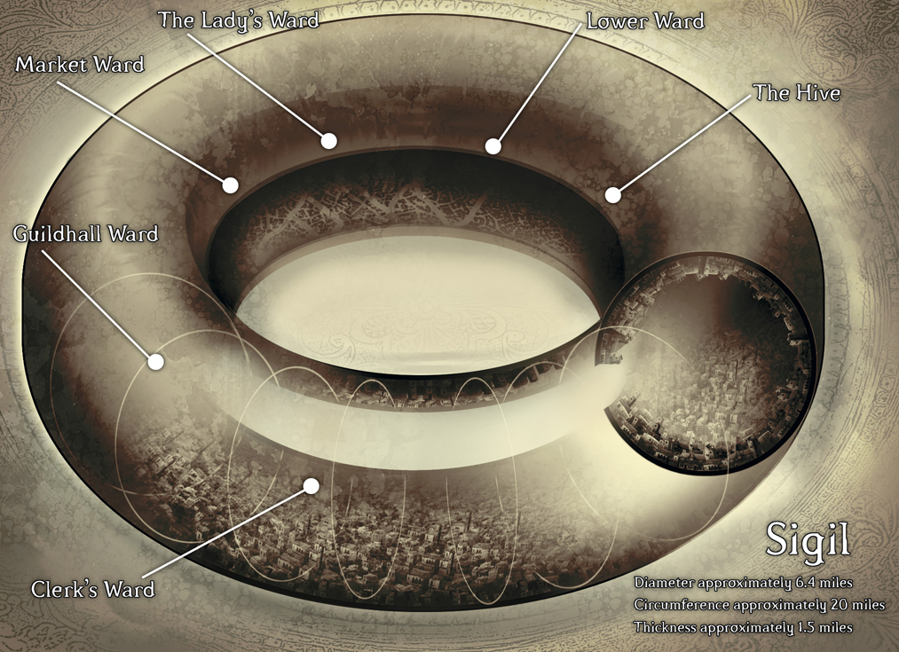

Adventurers are but one part of Sigil’s vast populace, but adventuring is a popular trade in the City of Doors, and those who ply their fortunes in the city find it to be a prosperous if unwelcoming and sometimes dangerous home. Everything can be found within Sigil - everything. Because of this, vast numbers of adventurers make their way to Sigil, whether by choice or by accident, and while many are able to make their way out into the multiverse via inter-planar portals, Sigil remains a useful and common hub once they have located the means to access it.

In the this version of Sigil, powerful guilds of adventurers with common interests and ideals dominate the Sigil adventuring scene, teaching their members specialized techniques in exchange for guild dues and banding together to ensure that their goals are met. Many of these guilds have headquarters in worlds across the multiverse, ensuring that their power and influence is felt beyond the walls of the Cage. Within Sigil itself, many are powerful enough to challenge the existing power structures for dominance, though all are wary to avoid provoking the wrath of the Lady of Pain, Sigil's inscrutable ruler.

These adventurers' guilds took the place of the former Factions of Sigil following the devastating Faction War which destroyed much of the structure that held back the formation of outside groups within the Cage's walls. Now, petitioners from across the multiverse request aid from these organizations, their members, as well as freelance agents. These people know that skilled hands can be hired here, so long as the coin is exchanged and contracts are drawn. In some cases, the guilds themselves take on tasks and hire other adventurers at their own behest, seeking opportunities to further their own agendas through the expenditure of coin and resources.

## Expanding Your Lore

Because Sigil links to every possible place in the multiverse, you are not limited in the places you create and use for your one-shots or characters on D&D Friends. We allow both official settings and homebrew settings, including your own original content for use in expanding the official server lore. We intentionally keep the server lore simple to allow for as much flexibility as possible. You can invent cities, nations, regions, continents, and even demi-planes, and all the people, history, culture, and lesser gods of these places. Your lore can be well-known within Sigil and the Material Plane, or an undiscovered secret enshrouded in mystery.

If you would like to introduce your character after you've made them, you can post an image of them along with a short introduction in adventurer-intros for everyone to see. Step-by-step instructions for how to create your character can be found in how-to-play.

If you have lore that you would like to make widely known to the server, you can write it in lore-building so everyone can read it.

Alternatively, you can make your own pages on our official D&D Friends Wiki:

https://dndfriends.fandom.com/wiki/D%26D_Friends_Wiki.

You can collaborate with other members to create your lore, either directly or by building off of a previous post in lore-building or on our Wiki, and you can post maps, concept art, Google Docs or other similar files, and even music to further cement your lore.