Powerzio Penetration Test Report

Security Assessment Findings and research

Author: Leo Smith
Creation date: 03/20/2021

Index

Assessment Overview

Starting on Friday 16th of March 2021 Leo Smith, Alexandre Chetafi, Baudouin Vanhoffelen and Guillaume djaider fornari engaged on a Penetration Test on a network. All testing performed was done with the following methodology:
- Discovery
- Scanning
- Footprinting
- Exploitation
- Reporting

Allong this report the team has provided screenshots and important files used during the assessment.

Assessment Components

External Penetration Test

An external penetration test emulates an attacker that would attempt to gain access to a network, system or information.

Severity Ratings
The following table defines levels of severity and corresponding CVSS score range that are used throughout the document to assess vulnerability and risk impact.
Severity | CVSS V3 Score Range | Definition
Critical | 9.0-10.0 | Exploitation is straightforward and usually results in system-level compromise. It is advised to form a plan of action and patch immediately.
High | 7.0-8.9 | Exploitation is more difficult but could cause elevated privileges and potentially a loss of data or downtime. It is advised to form a plan of action and patch as soon as possible.
Moderate | 4.0-6.9 | Vulnerabilities exist but are not exploitable or require extra steps such as social engineering. It is advised to form a plan of action and patch after high-priority issues have been resolved.
Low | 0.1-3.9 | Vulnerabilities are non-exploitable but would reduce an organization’s attack surface. It is advised to form a plan of action and patch during the next maintenance window.
Informational | N/A | No vulnerability exists. Additional information is provided regarding items noticed during testing, strong controls, and additional documentation.

Overview of the network and scope
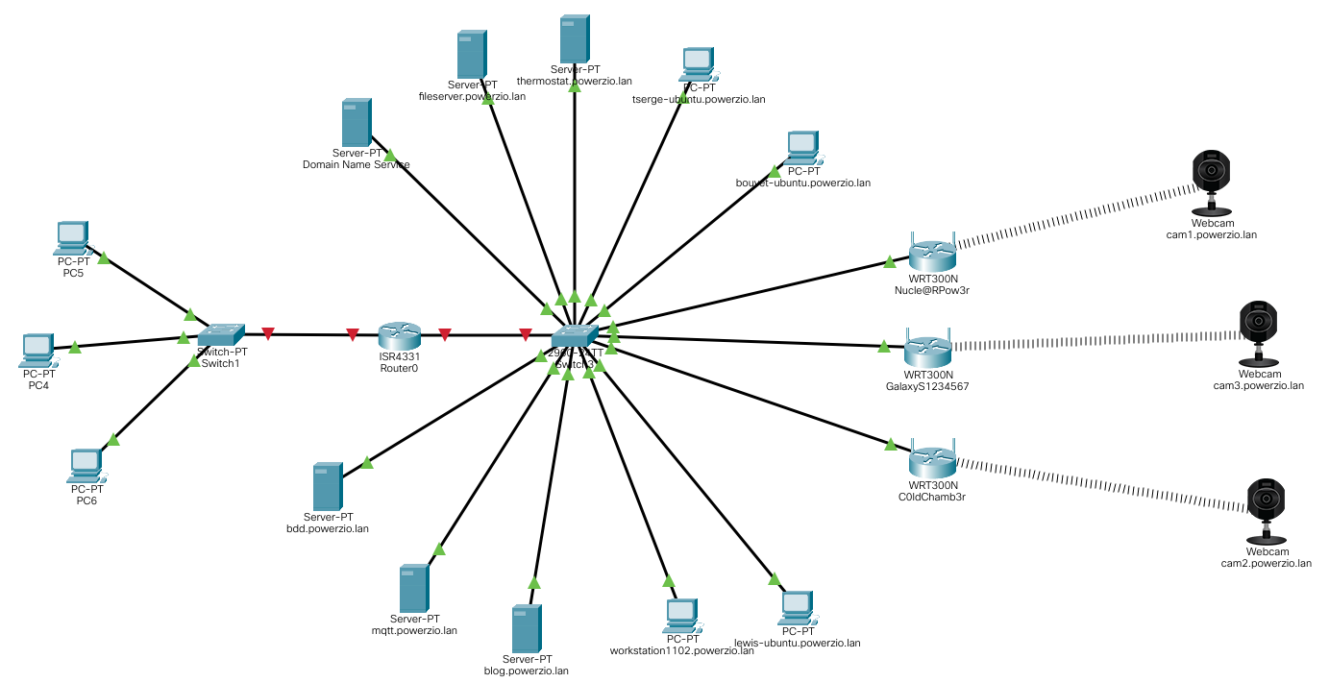
The network Is devided in 3 sub-network, A publicly available are a private sub-network and a secure sub-network. The private and secure sub-networks use the same IP address range that was provided to us as scope at the beginning of the engagement.

Scope of Engagement: 10.10.11.0/24

Domain Name Service

Executive Summary
The team evaluated the external security posture through a Domain Name Server Penetration Test on Friday 16th of March. By leveraging an attack the team was able to extract the different domain names from the IP address list provided throught the initial scan of the network. With the information gathered on this target the team was able to compromise other services.

Attack Summary
The following table describes how the team extracted information from the Domain Name Server.
Step | Action | Recommendation
1 | Scan the network to fin all of the potential machines available | Isolate sensitive machines from the internal network
2 | Do a reverse DNS lookup on each ip address found on the network and retrieve the different host names | Remove sensitive IP addresses from the Main Domain Name Server.

The following Information gives more context to the found vulnerability.
Vulnerability Exploited: Reverse DNS lookup
Vulnerability Explanation: Querying technique of the Domain Name System to determine the domain name associated with an IP address
Severity: Informational

Detailed explanation of the Attack

Scan the network range to find the different Ip addresses with the following unix command:

fping -g -a 10.10.11.0/24 2> /dev/null

You can now do a reverse DNS lookup with the following command

dig @10.10.11.1 -x <Found Ip address>

In the following screenshot is the desired output:

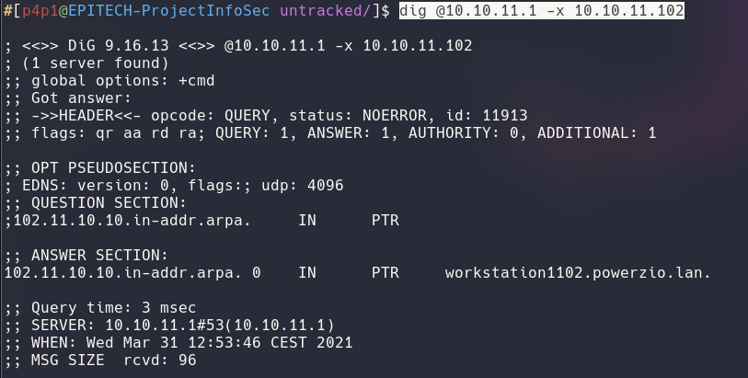

Remediation
Setting up a firewall in front of the network and only allowing known hosts to request the Domain Name Server.

workstation1102

Executive Summary
The team evaluated the external security posture through a File Transfer Protocol Server Penetration Test on Friday 16th of March. By leveraging an attack the team was able to gain administrative access to the remove server.

Attack Summary
The following table describes how the team exploited the File Transfer Protocol Server.
Step | Action | Recommendation
1 | Scan the machine for it’s open ports | Implement a firewall to provent detection from external sources
2 | Scan the port 21 or FTP for it’s vulnerabilities with a public tool | Implement a Cross Site Request Forgery token on the registeration page.
3 | Use a publicly available exploit to execute arbitrary code on the server | Update to the latest version of vsftpd

The following Information gives more context to the found vulnerabilities.

Vulnerability Exploited: CVE-2011-2523
Vulnerability Explanation: vsftpd 2.3.4 downloaded between 20110630 and 20110703 contains a backdoor which opens a shell on port 6200/tcp.
Severity: Critical

Detailed explanation of the Attack

Scan the ip address of the workstation1102 machine with the ftp-vsftpd-backdoor script. The resulted should look like the following screenshot:
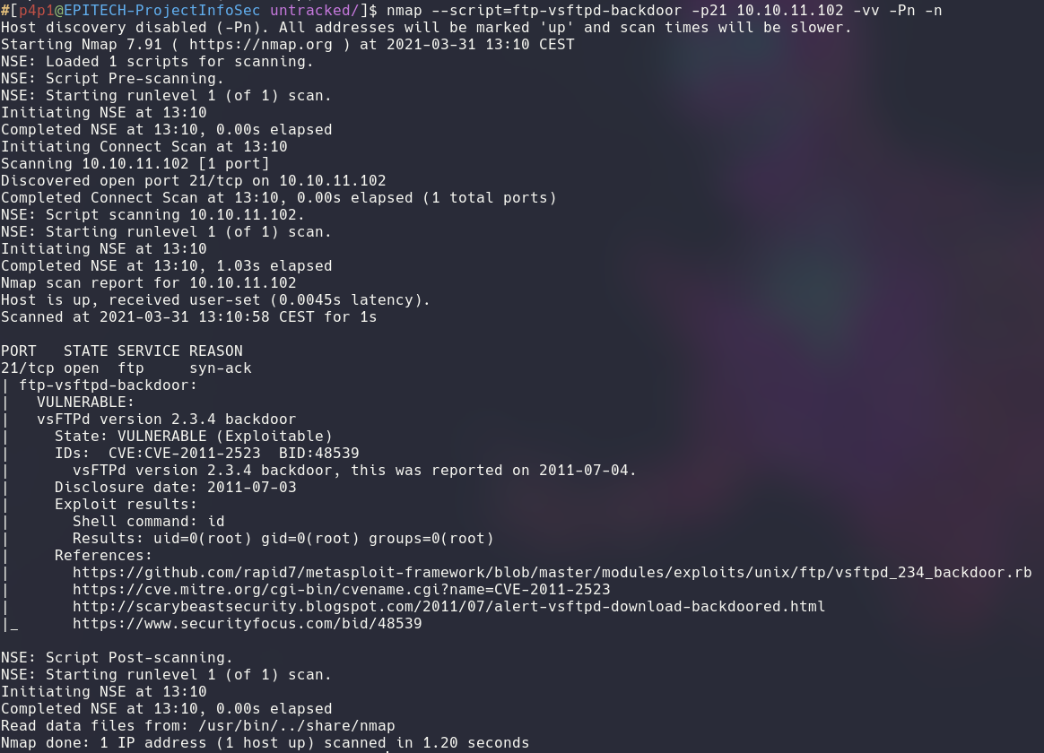
The following script will allow you to exploit the machine: https://github.com/Hellsender01/vsftpd_2.3.4_Exploit. After running the exploit you should have the following output:
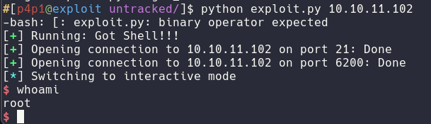

You should now be root on the workstation1102 machine. With this account you are now able to dump the username and password hashes and control the different services on the machine.

Cleanup
On the script exists the backdoor closes automaticaly.

Remediation
To correct this issue you should update to the latest version of vsftpd to not be affected by this vulnerability and block the port 6200 on your internal firewall.

File Sever

Executive Summary
The team evaluated the external security posture through a File Server Penetration Test on Friday 16th of March. By leveraging an misconfiguration the team was able to gain access to sensitive company documents.

Attack Summary
The following table describes how the team extracted sensitive documents from the file server.
Step | Action | Recommendation
1 | Scan the machine to find it’s open ports | Setup a firewall to block network scans
2 | Log in with Anonymous account | Remove guest and Anonymous accounts from the server

The following Information gives more context to the found vulnerabilities.
Vulnerability Exploited: Anonymous Loggin
Vulnerability Explanation: The default user anynomous can be used by anyone.
Severity: Moderate

Detailed explanation of the Attack

Scan the machine with nmap and the smb-security-mode script

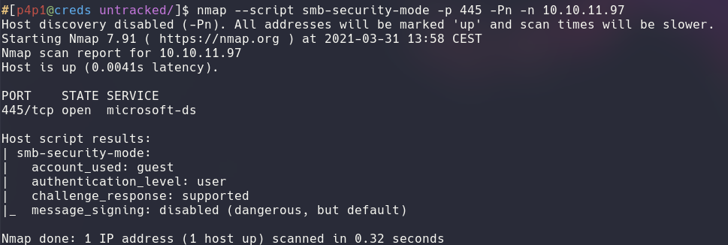
We can see in the nmap output that the account_used is guest, so this machine is vulnerable to Anonymous loggin exploit. Using this we can use enum4linux to extract the different shares and users from the machine.
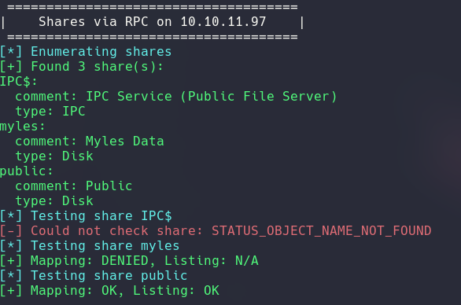

In the previous screenshot we can view the different shares available. To extract data from those share we can loggin with smbclient. The following screen shot show the different files inside of the public shares:

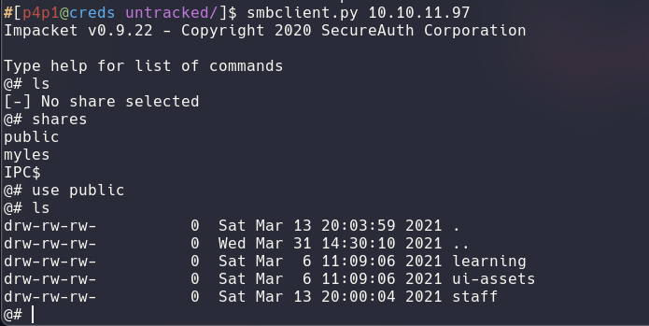

Please note that the smbclient script used in the previous example is part of the impacket suite. From this share it possible to retrieve staff information inside of the staff folder.

Remediation
Remove anonymous loggin from the file server and store the staff information inside of a private share.

Surveillance Cameras

Executive Summary
The team evaluated the external security posture through a Surveillance Camera pivoted Penetration Test on Friday 16th of March. By leveraging a Previous exploit the team was able to circomvent the network configuration and gain access to the security cameras and then with a public exploit was able to extract the credentials of each camera through the same exploit.

Attack Summary
The following table describes how the team pivoted through the network and compromised the surveillance cameras
Step | Action | Recommendation
1 | Create a dynamic proxy on a previously exploited machine (workstation1102). | See the workstation1102 section.
2 | Using this proxy scan the internal network. | Configure the cameras to not respond to a ICMP echo request.
3 | Resolve the newly found Ip addresses and identify the cam1-3 domain names | See the Domain Name Service section.
4 | Scan the different cameras and identify the port on wich the webserver is running
5 | Execute the netwave IP camera memory leak script. | Use a different kind of camera

The following Information gives more context to the found vulnerabilities.

Vulnerability Exploited: EDB-ID 41236

Vulnerability Explanation: Memory leak allows you to extract username and password for the weblogin.
Severity: High

Detailed explanation of the Attack

Reproduce the step of the workstation1102 exploit and install ssh key on the machine to gain an initial foothold on the network. Then use the ssh connection to create a dynamic proxy with the following command:
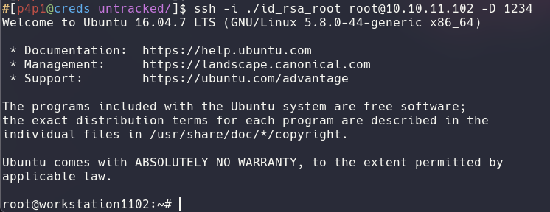
Using this proxy you can scan the different machine with proxychains using nmap, for example you can use the following command:

proxychains nmap -sC -sV -p 80 10.10.11.88

From here you can use the following exploit to leak the different credentials of the machine:
https://www.exploit-db.com/exploits/41236

The output should look like the following:

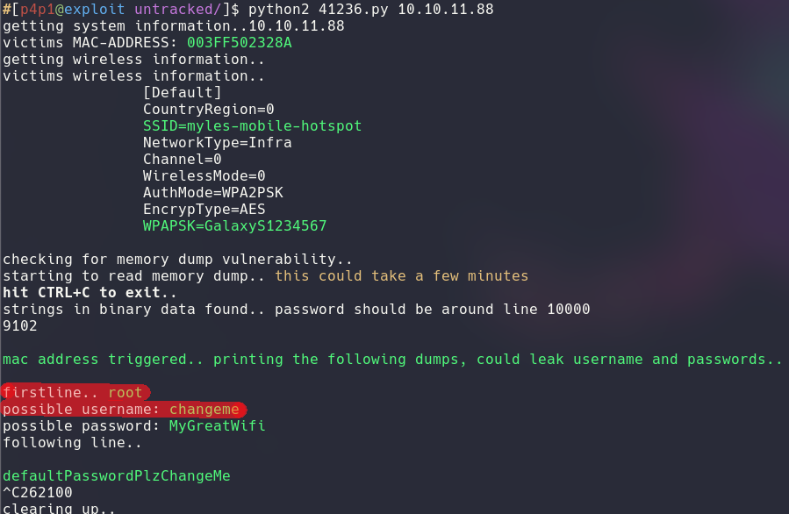

Highlited in red are the credentials with the username first and password second. This process can be repeated for each camera.

Remediation
Use a different kind of security camera

