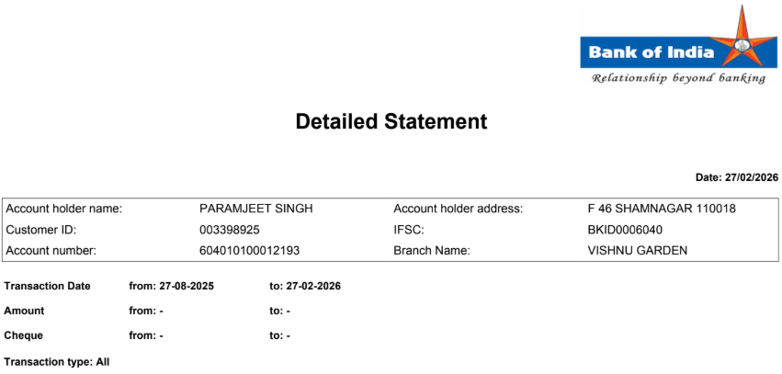
Sr No | Date | Remarks | Debit | Credit | Balance
1 | 02-09-2025 | UPI/390823378745/DR/PAYTM  /HDFC/utilitypa/Sent u | 750.00 |  | 4,108.00
2 | 25-09-2025 | UPI/691211111257/DR/LOVELY/UTIB/mab.037  21/Sent u | 500.00 |  | ₹ 3,608.42
3 | 15-10-2025 | UPI/261593197628/CR/AMANDE/UBIN/999012  960/Paymen |  | 2500.00 | ₹ 6,108.42
4 | 22-10-2025 | UPI/391168007478/CR/GAGAND/KKBK/999919  948/Sent f | 1000.00 |  | ₹ 5,108.42
5 | 18-11-2025 | UPI/532230828050/DR/NISHA  /SBIN/880033544/Sent u | 5000.00 |  | ₹ 108.42
6 | 26-11-2025 | UPI/720615306294/CR/AMANDE/UBIN/999012  960/Paymen |  | 10000.00 | ₹ 10,108.42
7 | 28-11-2025 | UPI/392969602444/DR/Mr  SAN/IDIB/981085494/Sent f | 3000.00 |  | ₹ 7,108.42
8 | 08-12-2025 | UPI/296361573491/DR/BSES R/YESB/paytm-  ptm/Sent u | 2080.00 |  | ₹ 5,028.42
9 | 12-12-2025 | UPI/695469038386/DR/AMAN  P/KKBK/817833261/Sent f | 640.00 |  | ₹ 4,388.42
10 | 03-01-2026 | UPI/696729846149/DR/Aman  S/AIRP/928985721/Sent f | 300.00 |  | ₹ 4,088.42
11 | 12-01-2026 | UPI/601213401151/DR/SMILE  /ICIC/smileindi/Sent u | 500.00 |  | ₹ 3,588.42
12 | 07-02-2026 | UPI/396865169727/DR/Yashvi/UTIB/gpay-  1124/Sent u | 2800.00 |  | ₹ 788.42
13 | 20-02-2026 | UPI/269159520795/CR/AMANDE/UBIN/999012  960/Paymen |  | 1500.00 | ₹ 2288.42
