Create your own Shodan scanner for your terminal

Attack 1: Get your IP

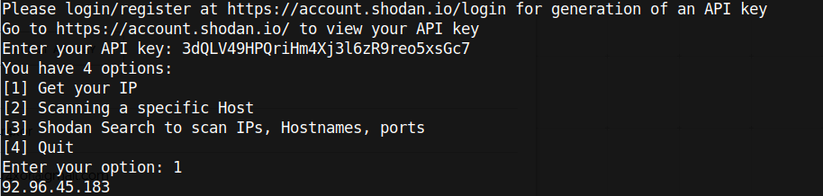
Code:

if option == 1:
ip = api.tools.myip()
print(ip)

Attack 2: Scanning a specific host

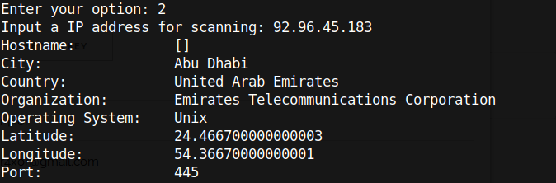
Code:

elif option == 2:
host_ip = input("Input a IP address for scanning: ")
scan = api.host(host_ip, history=True)
print("Hostname: ", " "*9, scan['hostnames'])
print("City: ", " "*13, scan["city"])
print("Country: ", " "*10, scan["country_name"])
print("Organization: ", " "*5, scan["org"])
print("Operating System: ", " "*1, scan["os"])
print("Latitude: ", " "*9, scan["latitude"])
print("Longitude: "," "*8, scan["longitude"])
print("Port: ", " "*13, scan["data"][0]["port"])

Attack 3: Shodan Search to scan IP, Hostnames, ports

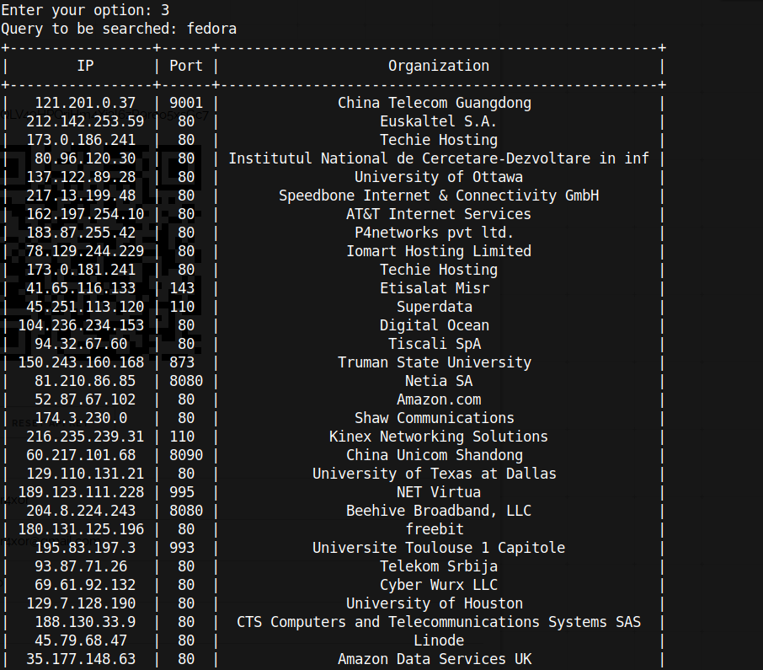
This image is not complete, but you get the idea :)

Code:

elif option ==3:
search = input("Query to be searched: ")
scan = api.search(search)
x = PrettyTable()
x.field_names = ["IP", "Port", "Organization"]
for i in scan['matches']:
a = i['ip_str']
b = i['port']
c = i['org']
x.add_row([a,b,c])
print(x)

