What Makes a Language Model's Representations Useful?
Assignment 1: Language Models and Learned Text Representations

Experimental focus
Comparison question. On this corpus and under a fixed training budget, how do (1) the sequence-model family and (2) the source of the input embeddings affect next-token prediction, and does the better language model also provide better frozen features for text classification?
The required experiments address this question in sequence. Part I compares an n-gram model, RNN, LSTM, and causal Transformer with the same corpus, tokenizer, and common test targets. Part II holds the LSTM language-model setup fixed and varies only its input embeddings: jointly learned random vectors, frozen Skip-gram vectors learned from the training corpus, or frozen public GloVe vectors. Part III takes the Part I LSTM and Transformer, freezes each encoder, converts labeled AG News articles to fixed-length vectors, and compares the same classifier and test procedure. This design uses the required comparisons without adding architectures or a large hyperparameter search.
The data flow is: WikiText training text → one training-only SentencePiece tokenizer → next-token model training and shared language-model evaluation (Part I) → fixed input-table comparison within the LSTM (Part II); the Part I LSTM and Transformer checkpoints separately encode labeled AG News articles → masked mean pooling → logistic-regression classification (Part III). Appendix A collects supplementary formulas, Appendix B shows Part I continuations, Appendix C shows Part II continuations, and Appendix D records reproducibility details.

Abstract
The comparison asks whether architecture and embedding choices improve next-token prediction, and whether that advantage carries over to classification. On 272,267 shared WikiText-2 targets, the causal Transformer had the lowest Part I cross-entropy (5.686 nats; perplexity 294.60); the LSTM had the fastest neural end-to-end inference (20,747 tokens/s). In the controlled LSTM embedding comparison, frozen corpus-trained Skip-gram gave the lowest perplexity (303.88), followed by frozen public GloVe (332.43) and jointly learned random embeddings (350.01). For AG News, a classifier trained on frozen, mean-pooled Transformer states scored 69.17% accuracy and 69.06% macro-F1, versus 61.18% and 61.05% for the LSTM states. The two-model downstream ranking agrees with Part I, but this single experiment supports an observed association, not a general rule that lower language-model perplexity causes better classification. The sampled continuations also show that improved next-token scores did not ensure coherent free-running text.

1. Shared data and experimental protocol

1.1 Language-model corpus and tokenization
The language-model corpus is the wikitext-2-raw-v1 configuration of WikiText-2 [1, 2]. SentencePiece BPE was trained using the training split only, with a chosen vocabulary of 30,000 pieces, NFKC case-fold normalization, and byte fallback [3]. The same saved tokenizer was used across splits, models, and generation. <pad>, <unk>, and <eos> have IDs 0, 1, and 2. A line-ending <eos> is added after each nonempty source line.
The 3,000,000-token setting is a maximum, not the amount processed. The encoded training split has 2,224,073 subword IDs, or 2,224,072 next-token targets in a full sequential epoch. Validation contributes 239,174 targets with the first subword ID used as context; the common test evaluation uses 272,267 targets, starting at position 2 for the trigram to have 2 preceding tokens. The BPE vocabulary size counts subword pieces rather than whole words. Byte fallback yielded a measured <unk> rate of 0% on train, validation, and test.

1.2 Models and training
All Part I neural models use randomly initialized, trainable 100-dimensional input embeddings, context length 32 subword tokens, batch size 32, Adam with learning rate 0.001, gradient clipping at 1.0, and seed 42. The RNN and LSTM each have one recurrent layer with 128 hidden units. The causal Transformer projects 100-dimensional token embeddings to 128 dimensions and uses learned position embeddings, two attention blocks, four attention heads, and a 512-unit feed-forward layer. Its causal mask prevents attention to future tokens. Padding targets are excluded from loss. The trigram uses additive smoothing with α = 0.1 and interpolation weights 0.1, 0.3, and 0.6 for unigram, bigram, and trigram probabilities.
The neural training budget was at most 25 epochs with early stopping patience 5; the best validation-loss checkpoint was retained. Runs used an Apple M2 Mac (Mac14,2) with 16 GB memory, macOS 26.6.2, PyTorch 2.14.1, and the MPS backend. The RNN, LSTM, and Transformer stopped after 10, 12, and 12 epochs, respectively. Training time below is the sum of synchronized training-epoch times and excludes startup, validation, and checkpoint writing.

1.3 Evaluation and timing
All Part I models were evaluated on the same 272,267 test targets. Neural-model cross-entropy averages the negative log probability of each next subword; perplexity is its exponential. Timing used batch size 128, one warm-up batch, and the median of three passes on MPS. “Forward” throughput uses prebuilt device tensors and measures model forward computation. “End-to-end” throughput also includes context-window construction, tensor creation/device transfer, and loss computation. Model size is the serialized checkpoint size. These timings describe this machine and implementation; they are not hardware-independent rankings.
2. Part I: which model family predicts best?

2.1 Test quality, cost, and throughput
Model | Test CE (nats) ↓ | Rolling Test PPL ↓ | Chunk-matched PPL | Parameters / stored entries | Artifact size | Train time | Forward tok/s | End-to-end tok/s
Interpolated trigram | 7.196 | 1,334.35 | NA | 2,236,087 stored entries | 26.78 MB | 1.44 s | 694,020 | 710,838
RNN | 5.887 | 360.42 | 371.521 | 6,899,440 | 27.60 MB | 2,173.77 s | 30,234 | 17,570
LSTM | 5.858 | 350.01 | 362.724 | 6,987,760 | 27.95 MB | 2,413.23 s | 21,209 | 20,747
Causal  Transformer | 5.686 | 294.60 | 319.232 | 7,312,240 | 29.26 MB | 2,462.59 s | 12,285 | 13,164
Answer to the architecture comparison: the Transformer predicts best on the shared test targets. Its perplexity is about 15.8% lower than the LSTM’s, while its parameter count is about 4.6% higher and its training time is similar. Its measured end-to-end throughput is lower than the LSTM’s. The LSTM therefore offers the best neural speed-quality balance in this timing workload. The trigram is substantially worse in predictive quality, but its inference is much faster and its training cost is tiny. The table compares serialized artifact sizes; a parameterized neural checkpoint and a counted n-gram table have different storage structures.

2.2 Learning behavior and context
Model | Best validation loss  (epoch) | Final train loss | Final validation loss | Epochs run
RNN | 5.893 (5) | 4.795 | 5.954 | 10
LSTM | 5.857 (7) | 4.749 | 5.924 | 12
Causal Transformer | 5.731 (7) | 4.544 | 5.774 | 12
Each model’s training loss continued to fall after its best validation checkpoint, while validation loss rose.
From best epoch to final recorded epoch, training loss fell by 0.436 (RNN), 0.380 (LSTM), and 0.298 (Transformer), while validation loss rose by 0.061, 0.067, and 0.043, respectively. This is evidence of overfitting after epochs 5–7 under this training setup. Early stopping retained the best validation checkpoint rather than the later, worse-validation epoch. The Transformer has the lowest validation and test losses, but the curves show that its training fit also continued to improve after validation peaked. Figure 1 shows the saved curves.
The context ablation supports a benefit from longer context in all three neural models. Rolling and chunk-matched perplexities use the same test set and exactly the same 272,267 target positions (all stream positions from index 2 onward); only the available preceding context changes. Rolling supplies up to the previous 32 test tokens. Chunk-matched resets history at the same 32-token chunk boundaries used during training. The chunk-matched perplexities are 371.52 (RNN), 362.72 (LSTM), and 319.23 (Transformer), compared with rolling values of 360.42, 350.01, and 294.60. Removing cross-chunk history raises PPL by 3.1%, 3.6%, and 8.4%, respectively. This shows the Transformer benefits most from the rolling context policy in these results; it still leads under both policies. Restricting rolling context to two tokens raises PPL further to 430.70, 423.23, and 419.49. The findings are consistent with the Transformer using broader context more effectively here, but they do not isolate architecture from training dynamics or parameterization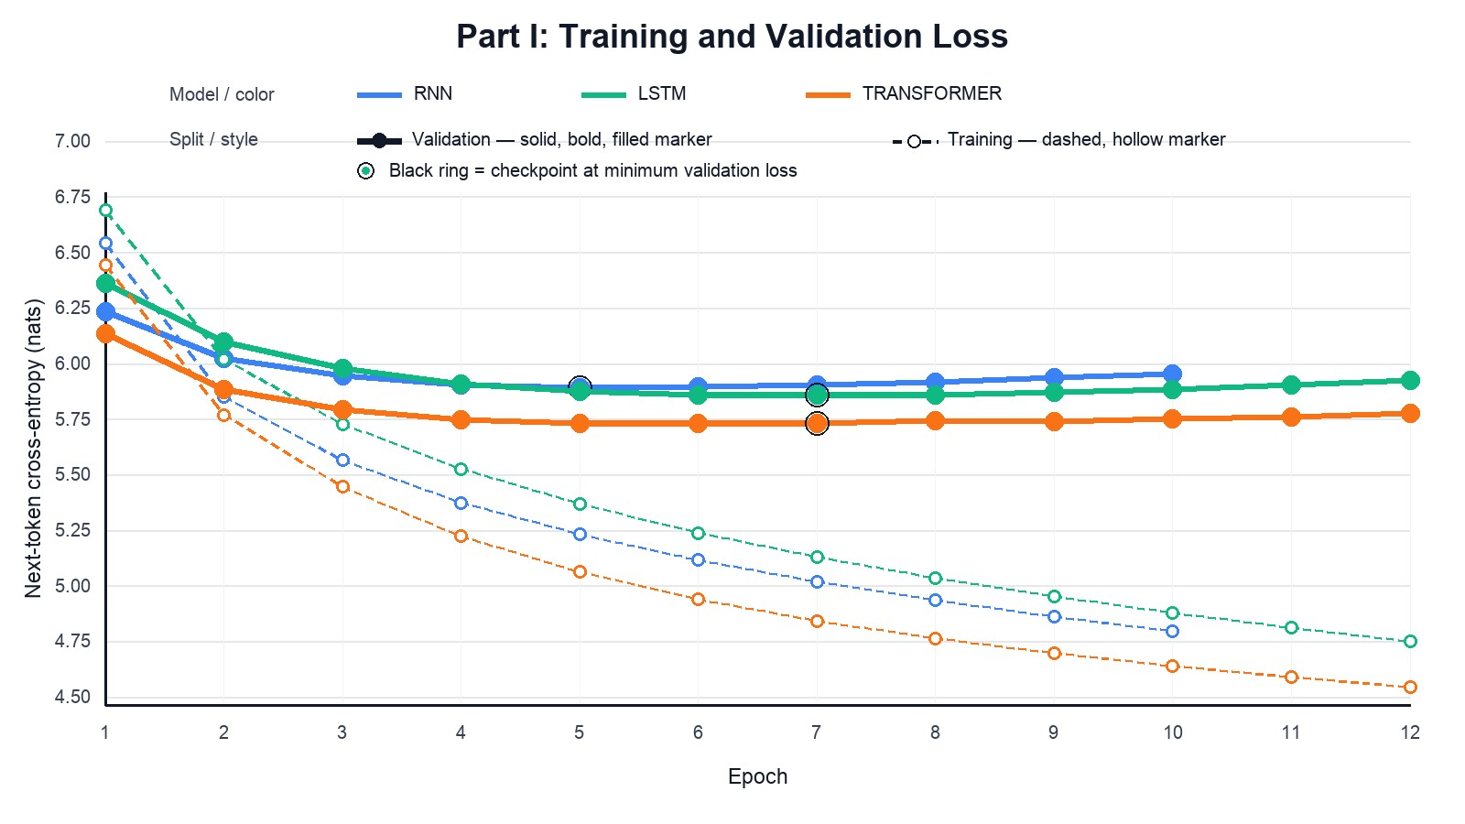
Figure 1: Part I neural training and validation curves

2.3 Possible architectural explanations
Part I primarily compares model families. A plausible reason for the Transformer’s lower test loss is that
causal self-attention can directly combine information from any earlier position in its 32-token window.
The RNN and LSTM instead carry history through a recurrent state, and the trigram conditions on only
the previous two tokens. This gives the Transformer a different way to use context, which may help
explain its advantage. The context ablation is supporting evidence: with only two preceding tokens, the
Transformer–LSTM perplexity gap narrows from 55.41 to 3.74. These results do not prove that attention
alone caused the gain: the Transformer also has 4.6% more parameters than the LSTM and trained
slightly longer [9].
The LSTM’s modest lead over the vanilla RNN (PPL 350.01 versus 360.42) may reflect its gates, which
let it retain or update information over the sequence [10]. The models have similar parameter counts, but this is a single-seed comparison and does not establish that gating alone produced the gain. The
trigram’s much higher perplexity is plausible given its two-token history and sparse counts over a
30,000-piece subword vocabulary, even with smoothing. However, it shows its cost advantage by the very low training time and high measured throughput.

2.4 Generated continuations
Generation used the same prompts, maximum of 30 new subword tokens, temperature 0.8, top-k 40, and seed 42; <eos> stopped the continuation early. The examples in Appendix B show why the lowest perplexity should not be equated with fluent open-ended text. For “The scientist studied,” the RNN creates a longer sequence with some local syntax but drifts into unrelated clauses; the Transformer produces repeated quotation patterns and a semantically disconnected sequence. The LSTM and trigram stop early, but their short endings are not evidence of stronger coherence. For “The government announced,” models often continue with a grammatically possible phrase that does not fit the prompt. Overall, the models learn local regularities, yet the samples remain weak in semantic continuity and topic control. The WikiText source also contains article fragments and markup artifacts, which appear in some outputs.
3. Part II: do fixed embeddings help the same LSTM?
The LSTM was selected to keep the language-model architecture fixed while varying only input embedding initialization. The random condition is the Part I LSTM: its 100-dimensional embedding table is learned jointly with the language model. For Skip-gram, vectors were trained on the same training corpus for five epochs with a window of five; the resulting table was then fixed while the LSTM language model was trained. For GloVe, the public glove-wiki-gigaword-100 table was aligned to the project vocabulary and likewise fixed. The remaining LSTM architecture, data, context, batch size, optimizer, seed, and early-stopping setup were held constant. Coverage is type coverage among the 29,997 non-special vocabulary pieces. Missing vectors used seeded random initialization; <unk> used the mean matched lexical vector when available, and <pad> was zero.
What “external GloVe data” means here: GloVe is the embedding table used as the LSTM input; this code does not train a second language model on Wikipedia or Gigaword. However, these pretrained vectors were created before this experiment using Wikipedia 2014 and Gigaword 5 (about 6 billion tokens; 400,000 word types). We load the public vectors, look up matching SentencePiece pieces, initialize missing pieces with the documented fallback, and freeze the resulting full input table during LSTM training [8]. Thus the comparison imports information learned from a much larger external text collection. Since WikiText-2 is also Wikipedia-derived, the source corpora may overlap in domain or content; article-level overlap was not audited, so this is a limitation on how cleanly the GloVe comparison isolates embedding method. The 42.33 seconds recorded here is the local vector-load/alignment preparation time; it is not the cost of the original GloVe pretraining.

Embedding Comparison
Input embedding | Source type coverage | Rolling test CE ↓ | Rolling PPL ↓ | Chunk-matched PPL ↓ | LM train time | Embedding  preparation time
Random, learned  jointly | — | 5.858 | 350.01 | 362.72 | 2,413.23 s | —
Skip-gram, fixed | 93.80% | 5.717 | 303.88 | 324.71 | 3,473.09 s | 48.01 s training
Public GloVe  100d, fixed | 81.81% | 5.806 | 332.43 | 354.58 | 2,843.79 s | 42.33 s loading
Both fixed tables outperform the jointly learned random-embedding condition on the common test targets, with Skip-gram best. Skip-gram improves rolling perplexity by 46.13 points (13.2%) relative to random initialization; GloVe improves by 17.58 points (5.0%). The ordering is the same under chunk-matched evaluation. The full measured project-side cost is about 3,521 seconds for Skip-gram vector training plus LM training, and 2,886 seconds for GloVe loading/alignment plus LM training. The GloVe total does not include its original public pretraining cost.
Overall Skip gram generally performs better likely due to it being trained on the corpus and thus it may fit this tokenization and domain better. However, these results use one seed and one frozen-table setup; they do not show what fine-tuned pretrained embeddings would achieve.
Validation loss reached its minimum at epoch 12 for Skip-gram and epoch 10 for GloVe, then rose while training loss continued to improve. Early stopping ended the runs at epochs 17 and 15, respectively. The selected checkpoints use the minimum validation loss, rather than the last epoch.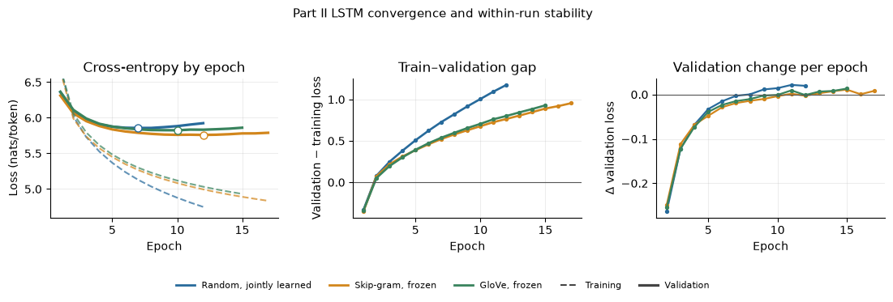
Figure 2: Part II convergence and within-run stability for the three LSTM embedding conditions
In the above figure, we compare epoch losses, train–validation gaps, and epoch-to-epoch validation changes. Best validation loss occurs at epoch 7 for random (5.857), epoch 12 for Skip-gram (5.759), and epoch 10 for GloVe (5.825); patience-based stopping ends them at epochs 12, 17, and 15. After each minimum, training loss continues to decline and validation loss rises modestly. The gap grows from
0.728/0.764/0.706 at each best checkpoint to 1.175/0.955/0.929 at the final epoch. Curves show no
abrupt loss spikes, though validation loss fluctuates near its minimum. This describes within-run
convergence; with one seed per condition, it cannot measure run-to-run stability.
Representative Generated Text:
The matched samples in Appendix C show mixed generation behavior. For “The government
announced,” the random condition begins “that the ‘big boy’...” before drifting; Skip-gram gives the
longer but repetitive “the first nations for the british government...”; GloVe stops after the awkward “that
the ‘never ever in’.” These examples do not establish a fluency ranking, but illustrate why lower test
perplexity does not guarantee coherent free-running text.
4. Part III: does language-model ranking carry over to classification?
The downstream task uses the four-class AG News dataset [6, 7]. From the 120,000-example training split, 20,000 examples were selected with seed 42; evaluation used the full 7,600-example test split. Articles were encoded with the project SentencePiece tokenizer and truncated to 128 tokens. Each language model was frozen and run over an article; the valid contextual token states were averaged, excluding padding, to form a fixed-length 128-dimensional article representation. A StandardScaler followed by multinomial logistic regression (C = 1, maximum 300 iterations) was fit for each representation. The classifier family, train/test split, and evaluation procedure were the same for LSTM and Transformer.
Frozen encoder representation | Accuracy ↑ | Macro-F1 ↑ | Test errors
LSTM mean contextual states | 61.18% | 61.05% | 2,950
Transformer mean contextual states | 69.17% | 69.06% | 2,343
The Transformer improves accuracy by 7.99 percentage points and macro-F1 by 8.01 points, with 607 fewer errors. It also performs better in each class’s F1: World 0.698 vs 0.617; Sports 0.804 vs 0.702; Business 0.601 vs 0.561; Sci/Tech 0.659 vs 0.562. Sports is the strongest class for both, while Business is the weakest for both.
Representative mistakes, in Appendix E, expose the topic overlap. Both models label “Ky. Company Wins Grant to Study Peptides” (gold Sci/Tech) as World, despite the scientific subject, perhaps because the short title and location cue dominate the representation. Both also confuse a British copyright-education article with World. For “Fears for T N pension after talks,” the LSTM predicts Sports and the Transformer predicts World, although the gold label is Business. These are examples, not a full error taxonomy.
Answer to the transfer comparison: for the two encoders tested, the ranking agrees with Part I: the Transformer has both lower language-model perplexity and better AG News classification. This agreement is suggestive, not proof that lower perplexity generally produces better classification. The downstream experiment uses only 20,000 training examples and one mean-pooling choice. It does not compare final-state pooling with mean pooling, other pooling rules, or multiple random seeds; any broader claim about pooling or representation quality should be limited accordingly.

5. Overall answer and limitations
Taken together, the experiments favor the Transformer when predictive quality and frozen-feature classification are the priorities, and the LSTM when neural inference throughput matters. The trigram is far cheaper to train and run but much less accurate. Within the LSTM comparison, both frozen embedding sources beat joint random initialization, with corpus-trained Skip-gram strongest. The evidence therefore suggests that both architecture and input-vector source matter in this setup; it does not establish that one choice will dominate with different data, vocabularies, compute budgets, or seeds.
The Part I and Part II generation samples are provided in Appendices B and C. Across the Part II examples, Skip-gram often produces longer continuations with locally plausible phrases but also joins unrelated clauses; GloVe sometimes produces a coherent topical phrase that does not follow the prompt, and the random-trained model also drifts or repeats. No condition is consistently coherent across these three prompts. These examples are qualitative and do not establish a generation-quality ranking. The Part III implementation evaluates one pooling method (mean valid contextual states), rather than directly comparing multiple pooling methods. Results use one seed; Part III has no validation-based model or classifier selection; and the 20,000-example training subset is smaller than the full AG News training split. The exact recorded timings depend on MPS, batch construction, and this machine. These limits should guide the strength of the conclusions.

References
- Merity, S., Xiong, C., Bradbury, J., and Socher, R. (2016). “Pointer Sentinel Mixture Models.”Proceedings of ICLR. arXiv:1609.07843.
- Salesforce AI Research. WikiText dataset card, configuration wikitext-2-raw-v1. Hugging Face Datasets.
- Kudo, T., and Richardson, J. (2018). “SentencePiece: A Simple and Language IndependentSubword Tokenizer and Detokenizer for Neural Text Processing.” arXiv:1808.06226.
- Mikolov, T., Chen, K., Corrado, G., and Dean, J. (2013). “Efficient Estimation of WordRepresentations in Vector Space.” arXiv:1301.3781.
- Pennington, J., Socher, R., and Manning, C. (2014). “GloVe: Global Vectors for Word
Representation.” Proceedings of EMNLP, 1532–1543. ACL Anthology. Public vectors: Stanford GloVe project.
- Zhang, X., Zhao, J., and LeCun, Y. (2015). “Character-level Convolutional Networks for TextClassification.” Advances in Neural Information Processing Systems 28, 649–657. NeurIPS proceedings.
- Hugging Face Datasets. AG News dataset, repository fancyzhx/ag_news. Dataset card.
- Gensim-data. Pretrained `glove-wiki-gigaword-100` model metadata. Model catalog. The catalog identifies Wikipedia 2014 + Gigaword 5 (6B tokens) as the source corpus.
AI assistance statement. OpenAI Codex assisted with implementation, debugging, and organizing this report.

Appendix A. Supplementary formulas

A.1 Next-token cross-entropy and perplexity
For N evaluated target subwords $y_{i} ,$with preceding context $c_{i}$, the average cross-entropy is
$$\text{CE}=-\frac{1}{N}\sum_{i=1}^{N}{\log{p}}\left(y_{i}∣c_{i}\right),$$
$$\text{PPL}=\exp\left(\text{CE}\right).$$
Padding targets are omitted from both the sum and N. The logarithm is natural, so CE is reported in nats.

A.2 Interpolated trigram
The smoothed trigram estimate combines probabilities at three history lengths:
where each component uses additive smoothing with alpha = 0.1. The interpolation makes shorter histories available when a longer context is sparse.

A.3 Mean pooling for a downstream article
If an article has L non-padding contextual states $h_{1},…,h_{L} ,$ its fixed-length feature vector is
$$\overline{h}=\frac{1}{L}\sum_{j=1}^{L}{h_{j}}∈R^{128}$$
This vector is passed to the same standardized multinomial logistic-regression classifier for each frozen encoder.

A.4 Skip-gram training objective (conceptual)
Skip-gram learns a center-token vector that predicts nearby context tokens. A common negative-sampling objective for a center w, observed context c, and sampled noise words $n_{k}$ is
$$\log{σ}\left(v_{c}^{⊤}v_{w}\right)+\sum_{k=1}^{K}{\log{σ}}\left(-v_{n_{k}}^{⊤}v_{w}\right).$$
where sigma is the logistic sigmoid. The Skip-gram vectors are pretrained on the training corpus, copied into the LSTM embedding table, and kept fixed during the language-model fitting step.

Appendix B. Part I generated continuations
All examples use maximum 30 new subword tokens, temperature 0.8, top-k 40, and seed 42. Samples terminate at <eos> when it is generated; otherwise generation stops at the 30-token limit.

Prompt: “The scientist studied”
- Interpolated trigram: “, when he is a in a similar to "” (stopped at <eos> after 10 pieces)
- RNN: “in order to become a new year with the club, though they were not in the same year. in the series, the church of scientology's”
- LSTM: “in england and.” (stopped at <eos> after 4 pieces)
- Causal Transformer: “the languedoc as " a " a lion " and a.v. " the part of the city ", and the city's third army,”

Prompt: “The government announced”
- Interpolated trigram: “the song, the new zealand for the the end of the new, which was.” (stopped at <eos> after 17 pieces)
- RNN: “the area.” (stopped at <eos> after 3 pieces)
- LSTM: “the team of the game's final, but he could be a better to be a " perfect boy [ in love " and the songs of the”
- Causal Transformer: “, " the most important parties that he was not to make the " big ".” (stopped at
<eos> after 17 pieces)

Prompt: “In the history of”
- Interpolated trigram: “, the episode of the second @-@ to, 's ".” (stopped at <eos> after 13 pieces)
- RNN: “the song ".” (stopped at <eos> after 4 pieces)
- LSTM: “the time of the season.” (stopped at <eos> after 6 pieces)
- Causal Transformer: “the new kingdom.” (stopped at <eos> after 4 pieces)

Appendix C. Part II generated continuations
The same three prompts, maximum of 30 new subword tokens, temperature 0.8, top-k 40, and seed 42 were used for all conditions. The public GloVe table is fixed in its LSTM; the other two settings are the Part I jointly learned random table and the frozen training-corpus Skip-gram table. <eos> stops decoding when sampled.

Prompt: “The scientist studied”
- Random, jointly learned: “at the age of the country .” (stopped at <eos> after 8 pieces)
- Skip-gram, frozen: “that ‘some people of scientology were told in the early 1819 to this’, ‘a lot of being’ too successful for the song, ‘as”
- GloVe, frozen: “that the gods were the principal member of the government . this is only to be the first word to be the oldest deity of the roman of the kings”

Prompt: “The government announced”
- Random, jointly learned: “that the ‘big boy’ is a part of all time of the season, and has been known as their ownisation — the first person .” (stopped at <eos> after 29 pieces)
- Skip-gram, frozen: “that the first nations for the british government in the federal government, and the first time since they had been scheduled to purchase funds, and that the ship”
- GloVe, frozen: “that the ‘never ever in’ .” (stopped at <eos> after 8 pieces)

Prompt: “In the history of”
- Random, jointly learned: “the film . these were recorded, and that he does not believe her with a limited edition of the song as a song .” (stopped at <eos> after 25 pieces)
- Skip-gram, frozen: “the city . while the university of st. louis. smith had previously called a way that ‘the first leg of the’ was chosen to his right”
- GloVe, frozen: “the north of kent, who was in the same way in october 1913 .” (stopped at <eos> after 15 pieces)
The samples illustrate why perplexity alone is not a free-generation quality measure: the Skip-gram continuation can remain syntactically plausible while drifting in topic, and all three conditions show mismatched or stitched-together content in at least some prompts.

Appendix D. Reproducibility record
The primary saved evidence used for this draft is results/revised_common_evaluation.json,
results/revised_generation.json, results/part2_skipgram.json, results/part2_glove.json, results/part2_generation.json, runs/revised/*/history.csv, runs/part2_revised/{skipgram,glove}/lstm/history.csv, the embedding metadata under
runs/embeddings/, and runs/downstream_revised/results.json plus its error CSVs. Part I,
Part II, and Part III outputs reflect the saved runs as of 16 October 2026. No new model training or downstream evaluation was run to prepare this draft; the Part II generated continuations were newly sampled from saved checkpoints.

Appendix E: Prediction error example for both Transformer and LSTM
Text: Ky. Company Wins Grant to Study Peptides (AP) AP - A company founded by a chemistry researcher at the University of Louisville won a grant to develop a method of producing better peptides, which are short chains of amino acids, the building blocks of proteins.
Gold standard: Sci/Tech
Prediction: World
(more can be found in runs/downstream_revised)

