Assignment B | Binary Search Tree and Treasure Hunter

TA: Wayne ([yuntcsie@gmail.com](mailto:yuntcsie@gmail.comw)) Deadline: Nov. 20th (Thursday) 11:59pm

Demo Steps

1. Use a **Makefile** to compile your program. (Make sure that you can compile and run your program successfully. Otherwise, you will not get the scores of HWB.)

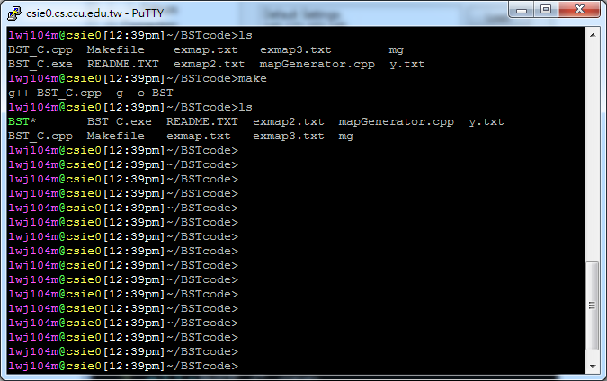

1. You must provide a user interface to let a user choose either **Search Tree** or **Treasure Hunter**.

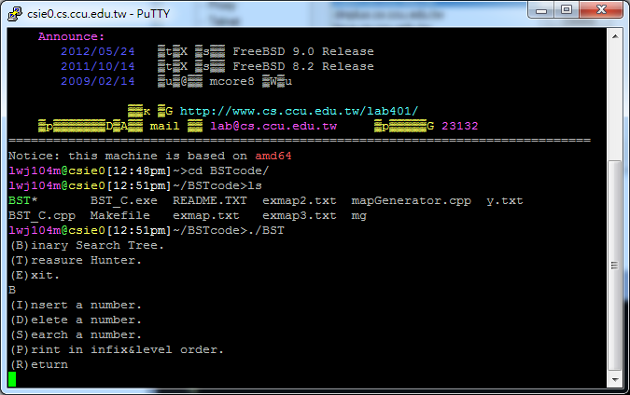

**Choose one**

1. For the **Binary Search Tree**, let a user choose to insert, delete, and search a number. Print the binary search tree in infix order and level order.



**Let a user choose one**

1. For example, sequentially insert the numbers (7, 4, 2, 12, 8, 10, 6, 15, 1, 3, 14). Then delete the numbers (7, 2) sequentially. The print result is as follow:

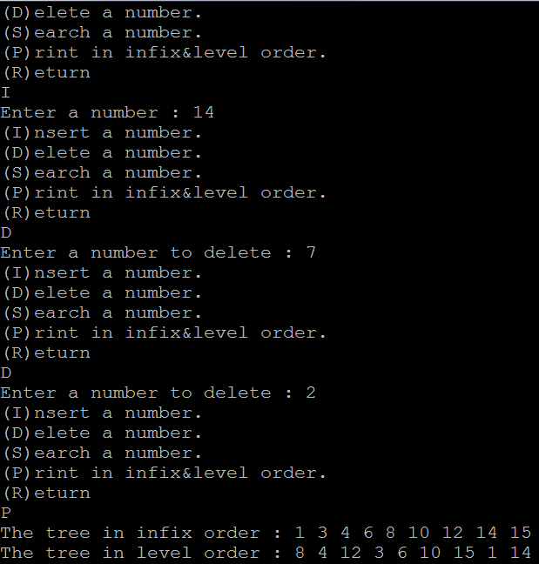

**Print result**

**Delete 2**

**Delete 7**

**Insert 14**

1. For the Treasure Hunter
2. let a user read a map file (during the demo, we will use different map files)
3. let a user input a key location
4. let a user input a treasure location
5. let a user input a trap number x from 0 to 9 ( If number out of range, please restart input a trap number)
6. print the result

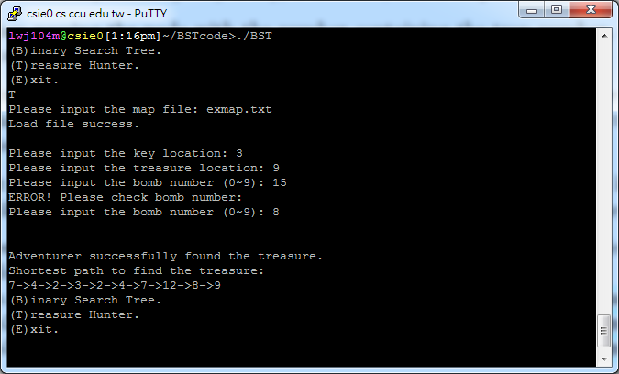

Number out of range, restart it