EE 596 HOMEWORK 2 REPORT
COLOR CLUSTERING AND SKIN FINDING
Name:

1. Introduction
Briefly explain the method, especially any parts that you designed.
2. Skin Finding Results
You need to try at least 2 classifiers including Naïve Bayes and Random Forest and report skin-labeled image and intersection/union measure for each of the 7 required image (face1, face4, face5, face8, face10, face23, face28) . For each image, this measure is defined as the number of true positives TP (the intersection of the pixels your program called skin with the skin mask) divided by the union of the two: the sum of the true positives, false positives and false negatives (TP+FP+FN). You only need to display skin-labeled image produced by Naïve Bayes, but you should report the measure for all classifiers you’ve tried. Please follow the format below and give for both (r,g) space and (R,G,B) space:

- Name: face28
Original Image NB Skin-Labeled Image (r,g) NB Skin (RGB)
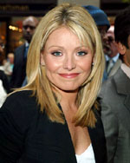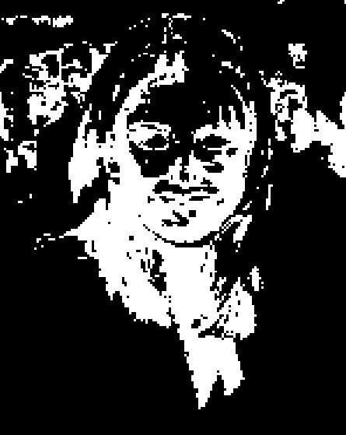
Naïve Bayes Jaccard (r,g) Naïve Bayes Jaccard (RGB)
Random Forest Jaccard (r,g) Random Forest Jaccard (RGB)

Name: face1
Original Image NB Skin-Labeled Image (r,g) NB Skin (RGB)

Naïve Bayes Jaccard (r,g) Naïve Bayes Jaccard (RGB)
Random Forest Jaccard (r,g) Random Forest Jaccard (RGB)

(3) Name: face4
Original Image NB Skin-Labeled Image (r,g) NB Skin (RGB)

Naïve Bayes Jaccard (r,g) Naïve Bayes Jaccard (RGB)
Random Forest Jaccard (r,g) Random Forest Jaccard (RGB)

(4) Name: face5
Original Image NB Skin-Labeled Image (r,g) NB Skin (RGB)

Naïve Bayes Jaccard (r,g) Naïve Bayes Jaccard (RGB)
Random Forest Jaccard (r,g) Random Forest Jaccard (RGB)
(5) Name: face8
Original Image NB Skin-Labeled Image (r,g) NB Skin (RGB)

Naïve Bayes Jaccard (r,g) Naïve Bayes Jaccard (RGB)
Random Forest Jaccard (r,g) Random Forest Jaccard (RGB)
(6) Name: face10
Original Image NB Skin-Labeled Image (r,g) NB Skin (RGB)

Naïve Bayes Jaccard (r,g) Naïve Bayes Jaccard (RGB)
Random Forest Jaccard (r,g) Random Forest Jaccard (RGB)

(7) Name: face23
Original Image NB Skin-Labeled Image (r,g) NB Skin (RGB)

Naïve Bayes Jaccard (r,g) Naïve Bayes Jaccard (RGB)
Random Forest Jaccard (r,g) Random Forest Jaccard (RGB)

3. Discussion on Results and Limitations

