MinSeg Linear Dynamical Model and Feedback Control

EE547 (PMP) Final Project

Winter 2015

Paul Adams

Chris Schulenberg

# Introduction

The objectives of the final project were to develop a linear state-space model of the MinSeg Test Platform (shown Figure 1), use the model to derive a stabilizing feedback controller, and to deploy the feedback controller to the MinSeg using measured or estimated state feedback as required. The purpose of stabilizing the MinSeg system is to enable it to sustainably achieve balance in an upright position as shown in Figure 1.

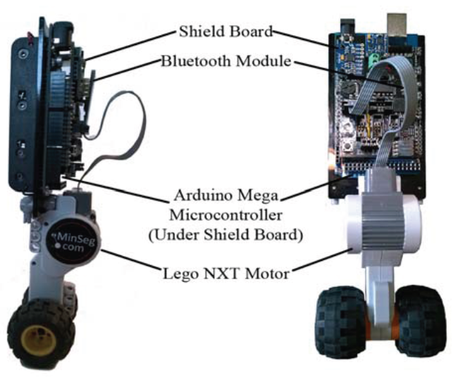

Figure MinSeg Test Platform

This report is organized into an overview of the linear dynamical MinSeg model and physical characteristics, an evaluation of the MinSeg’s inherent stability, controllability, and observability properties, discussion of the observer and controller design, and results and conclusions from the implementation and deployment to the MinSeg test platform.

# Linear Dynamical Model

The MinSeg test platform was modeled as a pendulum and motorized wheel as shown in Figure 2. Applying voltage the motor produces torque at the wheel center, which produces a combination of torque on the pendulum and rotation of the wheel. Rotation of the wheel translates the entire assembly in the *x* direction. The angle between the MinSeg pendulum and the *y* axis is defined as *α*. Steady state balance is defined as equilibrium about *α ≈ 0* with no constraints on position along *x*. Therefore model was linearized about the equilibrium point *α = 0*.



Figure Mathematical Model of MinSeg around Zero Equilibrium Point

The equations of motion were given as follows:

Where the relationship between torque, input voltage, and state variables were given as:

From these equations of motion, the following state-space matrices A and B were derived:

The physical parameters of the MinSeg system were measured and/or defined as follows:

|  |  |  |
| --- | --- | --- |
| Parameter | Value | Description and Units |
| g | 9.81 | Acceleration due to gravity (m/s^2) |
| k_t | 0.323 | Torque constant (Nm/a) |
| k_b | 0.495 | Back-EMF constant (Vs/rad) |
| R | 5.26 | DC motor resistance (ohms) |
| L | 0.11 | Length of pendulum (m) |
| m_p | 117.0 | Mass of pendulum (kg) |
| m_w | 0.028 | Mass of wheel (kg) |
| r_w | 0.016 | Radius of wheel (m) |
| I_p | 1.42 | Inertia of pendulum (kg-m^2) |
| I_w | 3.58e-6 | Inertia of wheel (kg-m^2) |

These physical parameters led to the derivation of the following linearized state-space system and transfer function:







# Stability

The stability of the MinSeg linear model was evaluated by determining the poles of the open loop system. Because not all eigenvalues are negative and the system poles are not all in the open left hand plane of the pole-zero map, the unaugmented system is not asymptotically stable.







# Controllability and Observability

The controllability and observability of the MinSeg linear model were evaluated by determining the rank of the system controllability and observability matrices, respectively. The Controllability Matrix was determined to be of rank 4:



Because the rank of the controllability matrix is equal to the number of columns of the A matrix, the system is controllable.

The Observability Matrix was determined to be of rank 4:



Because the rank of the observability matrix is equal to the number of columns of the A matrix, the system is observable.

For computational efficiency and direct readability of certain system characteristics, the linearized MinSeg state-space model was transformed to Controllable and Observable Canonical Forms (CCF and OCF, respectively.









# Observer Design and Performance

Although on the actual MinSeg platform all required states can be measured or calculated directly from measured values, a state observer was developed to demonstrate system stability with state feedback. An observer would enable state feedback on a platform where the states could not be measured due to inaccessibility, cost, equipment, etc.

The design decision was made to place the observer poles to provide 6 times bandwidth of the dynamics inherent to the MinSeg linear model. This resulted in the following observer gain *L*:



To demonstrate the performance of the observer, a Simulink model was developed to compare the MinSeg linear model state time history to the observer state time history for a step input.



Figure : Open Loop MinSeg Model with Observer



Figure : Observer Tracking Performance

# Proportional Feedback Control Design and Performance

For the proportional feedback controller gain *K*, the design decision was made to place the poles of the closed loop system to provide the controller with 6 times the bandwidth of the dynamics inherent to the MinSeg linear mode. This resulted in the following proportional feedback gain *K*:



The stability of the system with proportional feedback control was determined by evaluating the characteristic polynomial and poles of the closed loop system, *ACL = A – B*K.*  Because the eigenvalues are all negative and the system poles are in the open left hand plane of the pole-zero map, the closed loop system is asymptotically stable.







Figure : Poles of Proportional Feedback Controller

In order to demonstrate the performance of the proportional feedback controller, a Simulink model was developed to show stabilization of a step input.



Figure : Closed Loop MinSeg Model



Figure : Closed Loop Feedback Controller Performance

Finally, the state observer and proportional feedback were integrated into a single Simulink model to demonstrate the performance of the integrated design.



Figure : Closed Loop MinSeg Model with Observer



Figure : Step-input Response of Closed-loop System with Proportional Feedback Controller



Figure : State Estimator



Figure : State Estimator Error

# MinSeg Robot Implementation

# Results

# Conclusions