MinSeg Linear Dynamical Model and Feedback Control

EE547 (PMP) Final Project

Winter 2015

Paul Adams

Chris Schulenberg

# Introduction

The objectives of the final project were to develop a linear state-space model of the MinSeg Test Platform (shown Figure 1), to use the model to derive a stabilizing feedback controller, and to deploy the feedback controller to the MinSeg using measured or estimated state feedback as required. The purpose of stabilizing the MinSeg system is to enable it to sustainably achieve balance in an upright position as shown in Figure 1.

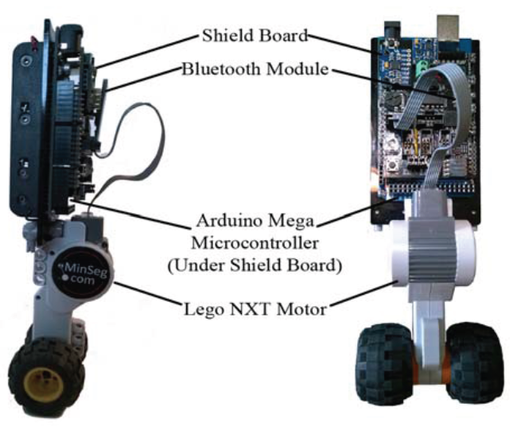

Figure MinSeg Test Platform

This report is organized into an overview of the linear dynamical MinSeg model and physical characteristics, an evaluation of the MinSeg’s inherent stability, controllability, and observability properties, discussion of the observer and controller design, and results and conclusions from the implementation and deployment to the MinSeg test platform.

# Linear Dynamical Model

The MinSeg test platform was modeled as a pendulum and motorized wheel as shown in Figure 2. Applying voltage the motor produces torque at the wheel center, which produces a combination of torque on the pendulum and rotation of the wheel. Rotation of the wheel translates the entire assembly in the *x* direction. The angle between the MinSeg pendulum and the *y* axis is defined as *α*. Steady state balance is defined as equilibrium about *α ≈ 0* with no constraints on position along *x*. Therefore model was linearized about the equilibrium point *α = 0*.



Figure Mathematical Model of MinSeg around Zero Equilibrium Point

The equations of motion were given as follows:

$$\left[\begin{matrix}-(I_{p}+m_{p}L^{2} & m_{p}\cos{α} \\ m_{p}Lr_{w}^{2}\cos{α} & -\left(I_{cm,w}+m_{w}r_{w}^{2}+m_{p}r_{w}^{2}\right)\end{matrix}\right]\left[\begin{matrix}\ddot{α} \\ \ddot{x}\end{matrix}\right]=\left[\begin{matrix}T_{m}-m_{p}Lg\sin{α} \\ T_{m}r_{w}+m_{p}Lr_{w}^{2}{\dot{α}}^{2}\cos{α}\end{matrix}\right]$$

Where the relationship between torque, input voltage, and state variables were given as:

$$T_{m}=\frac{k_{t}}{R}V+\frac{k_{t}k_{b}}{Rr_{w}}\dot{x}+\frac{k_{t}k_{b}}{R}\dot{∝}$$

From these equations of motion, the following state-space matrices A and B were derived:

$$A= \left[\begin{matrix}0 & 1 & 0 & 0 \\ \frac{gLm_{p}\left(i_{cmw}+\left(m_{p}+m_{w}\right)r_{w}^{2}\right)}{i_{cmw}\left(i_{p}+L^{2}m_{p}\right)+\left(L^{2}m_{p}m_{w}+i_{p}\left(m_{p}+m_{w}\right)\right)r_{w}^{2}} & -\frac{k_{b}k_{t}\left(i_{cmw}+r_{w}\left(m_{w}r_{w}+m_{p}\left(L+r_{w}\right)\right)\right)}{R\left(i_{cmw}\left(i_{p}+L^{2}m_{p}\right)+\left(L^{2}m_{p}m_{w}+i_{p}\left(m_{p}+m_{w}\right)\right)r_{w}^{2}\right)} & 0 & -\frac{k_{b}k_{t}\left(i_{cmw}+r_{w}\left(m_{w}r_{w}+m_{p}\left(L+r_{w}\right)\right)\right)}{R\left(i_{cmw}\left(i_{p}+L^{2}m_{p}\right)+\left(L^{2}m_{p}m_{w}+i_{p}\left(m_{p}+m_{w}\right)\right)r_{w}^{2}\right)} \\ 0 & 0 & 0 & 1 \\ \frac{gL^{2}m_{p}^{2}r_{w}^{2}}{i_{cmw}\left(i_{p}+L^{2}m_{p}\right)+\left(L^{2}m_{p}m_{w}+i_{p}\left(m_{p}+m_{w}\right)\right)r_{w}^{2}} & -\frac{k_{b}k_{t}r_{w}\left(i_{p}+Lm_{p}\left(L+r_{w}\right)\right)}{R\left(i_{cmw}\left(i_{p}+L^{2}m_{p}\right)+\left(L^{2}m_{p}m_{w}+i_{p}\left(m_{p}+m_{w}\right)\right)r_{w}^{2}\right)} & 0 & -\frac{k_{b}k_{t}\left(i_{p}+Lm_{p}\left(L+r_{w}\right)\right)}{R\left(i_{cmw}\left(i_{p}+L^{2}m_{p}\right)+\left(L^{2}m_{p}m_{w}+i_{p}\left(m_{p}+m_{w}\right)\right)r_{w}^{2}\right)}\end{matrix}\right]$$

$$B=\left[\begin{matrix}0 \\ -\frac{k_{t}\left(i_{cmw}+r_{w}\left(m_{w}r_{w}+m_{p}\left(L+r_{w}\right)\right)\right)}{R\left(i_{cmw}\left(i_{p}+L^{2}m_{p}\right)+\left(L^{2}m_{p}m_{w}+i_{p}\left(m_{p}+m_{w}\right)\right)r_{w}^{2}\right)} \\ 0 \\ \frac{k_{t}r_{w}\left(i_{p}+Lm_{p}\left(L+r_{w}\right)\right)}{R\left(i_{cmw}\left(i_{p}+L^{2}m_{p}\right)+\left(L^{2}m_{p}m_{w}+i_{p}\left(m_{p}+m_{w}\right)\right)r_{w}^{2}\right)}\end{matrix}\right]$$

The physical parameters of the MinSeg system were measured and/or defined as follows:

These physical parameters led to the derivation of the following linearized state-space system and transfer function:

# Stability

The stability of the MinSeg linear model was evaluated by eigenvalues of the open loop system.

# Controllability and Observability

The controllability and observability of the MinSeg linear model were evaluated by determining the rank of the system controllability and observability matrices, respectively.

# Observer Design and Performance

Although all required states can be measured on the MinSeg platform, a state observer was developed to model system stability with state feedback. An observer would enable state feedback on a platform where the states could not be measured due to inaccessibility, cost, equipment, etc.

The design decision was made to place the observer poles such that they provided 6 times bandwidth of the dynamics inherent to the MinSeg linear model. This resulted in the following observer gain *L*:

To demonstrate the performance of the observer, a Simulink model was developed to compare the MinSeg linear model state time history to the observer state time history for a step input.

# Proportional Feedback Control Design and Performance

For the proportional feedback controller gain *K*, the design decision was made to place the poles of the closed loop system to provide the controller with 6 times the bandwidth of the dynamics inherent to the MinSeg linear mode. This resulted in the following proportional feedback gain *K*:

The stability of the system with proportional feedback control was determined by evaluating the characteristic polynomial and poles of the closed loop system, *ACL = A – B*K.*

In order to demonstrate the performance of the proportional feedback controller, a Simulink model was developed to show stabilization of a step input.

Finally, the state observer and proportional feedback were integrated into a single Simulink model to demonstrate the performance of the integrated design.

# MinSeg Robot Implementation

### Hardware and Software Environment

The MinSeg Kit consists of an Arduino Mega 2560 system-on-a-chip with a MinSeg shield in addition to a DC motor embedded in a Lego wheel assembly. The MinSeg shield provides various sensors for interacting with the physical world. Most important for the purposes of balancing a MinSeg, are the Gyro/Accelerometer/Magnetometer chip and the DC motor encoder. The Gyro enables measurement of angular position and rate about the *x* axis, while, the encoder enables deriving displacement from wheel rotation. C drivers were provided to interface the sensors with the Arduino chip. An Arduino Support Package for Simulink was also made available to enable building models in Simulink with SFunction drivers, compiling models to C and deploying to the Arduino for real-time embedded operation. Simulink was also used in conjunction with Matlab to simulate and validate the State-Space model derived in class.

### Software Revision Control

The decision was made to utilize GitHub coupled with git software configuration management to transfer code between team members and to manage revisions locally. This also turned out to be an expedient method for managing/transferring other documentation.

### Development

Physical parameters of the MinSeg, including masses of the wheel and pendulum, as well as wheel radius and length from wheel to reference point, were measured by borrowing a gram scale, in class, from another team, and using a ruler.

The modeling of the MinSeg system in Matlab/Simulink followed the steps of the Project document as outlined in the above sections. While this structure communicated the underlying theory of Linear Control Systems, the connection to the MinSeg system remained only theoretical.

Initially an effort was made to build a Simulink model from scratch based on the derived State-Space representation. However, with time constraints, it was much more expedient to resort to the provided Simulink template. This model contained appropriate conversion factors for raw sensor data, a robust Gyro calibration module, and an implementation of a proportional feedback loop with an integrator element.

Additionally, by inserting only three batteries as counterbalance and operating the MinSeg in tethered mode (powered and connected to Simulink by USB) a less unstable configuration was achieved for initial development.

# Results

The MinSeg balanced quite well for our team. Versions for tethered and untethered operation were both developed and successfully deployed to the Arduino. The tethered mode seemed to result in a more stable MinSeg, however there was insufficient time to experiment with different *K* matrices. The proportional gain matrix that worked for our team was one provided in the Simulink template. We were unable to derive a *K* based on State-Space representation of the system that enabled balancing the MinSeg.

# Conclusions

The MinSeg is designed to be balanced, with a center of mass roughly half the length of the full assembly. Additionally, the Arduino provides a rich abstraction layer onto which sensors and actuators can be interfaced with minimal effort. The MinSeg Kit provides an excellent environment for implementing Linear Control theory on practical physical systems.

The team concluded that the key factor in achieving a balancing MinSeg, is an appropriate gain matrix, *K*. This assumes lower level details are given due diligence – measuring physical parameters, converting raw sensor IO, proficient operation of software environment.

Further work of interest would be, given a MinSeg which is known to balance with some proportional gain matrix, *K*, log state variables over time and use this offline feedback to optimize *K* for a given MinSeg.