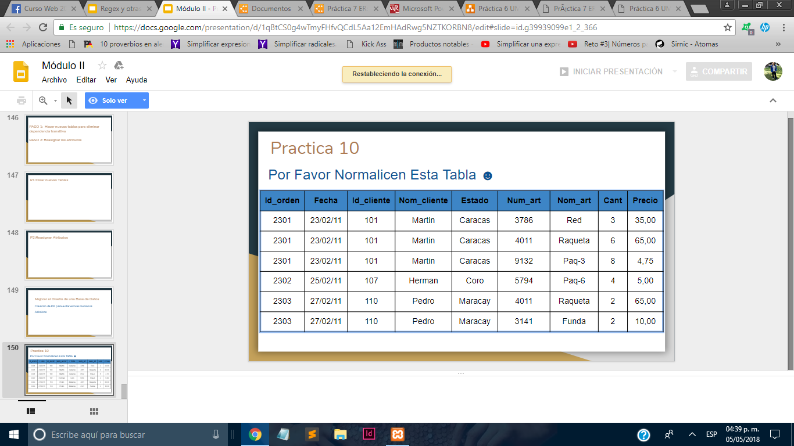

1 FORMA NORMAL

Campos repetidos: Id_orden,Fecha,id_cliente,Nom_cliente,Estado,

-> Identificar Pk

Id_orden🡪Id_cliente

|  |  |  |  |
| --- | --- | --- | --- |
| Id_cliente | Fecha | Nom_cliente | Estado |
| 101 | 23/02/11 | Martin | Caracas |
| 107 | 25/02/11 | Herman | Coro |
| 110 | 27/02/11 | Pedro | Maracay |

|  |  |  |  |  |  |
| --- | --- | --- | --- | --- | --- |
| Id_orden | Id_cliente | Num_art | Nom_art | Cant | Precio |
| 2301 | 101 | 3786 | Red | 3 | 35,00 |
| 2301 | 101 | 4011 | Raqueta | 6 | 65,00 |
| 2301 | 101 | 9132 | Paq-3 | 8 | 4,75 |
| 2302 | 107 | 5794 | Paq-6 | 4 | 5,00 |
| 2303 | 110 | 4011 | Raqueta | 2 | 65,00 |
| 2303 | 110 | 3141 | Funda | 2 | 10,00 |

2 FORMA NORMAL

|  |  |  |  |  |
| --- | --- | --- | --- | --- |
| Num_art | Id_orden | Nom_art | Cant | Precio |
| 3786 | 2301 | Red | 3 | 35,00 |
| 4011 | 2301 | Raqueta | 6 | 65,00 |
| 9132 | 2301 | Paq-3 | 8 | 4,75 |
| 5794 | 2302 | Paq-6 | 4 | 5,00 |
| 4011 | 2303 | Raqueta | 2 | 65,00 |
| 3141 | 2303 | Funda | 2 | 10,00 |

-

|  |  |  |  |
| --- | --- | --- | --- |
| Num_art | Nom_art | Cant | Precio |
| 3786 | Red | 3 | 35,00 |
| 4011 | Raqueta | 6 | 65,00 |
| 9132 | Paq-3 | 8 | 4,75 |
| 5794 | Paq-6 | 4 | 5,00 |
| 4011 | Raqueta | 2 | 65,00 |
| 3141 | Funda | 2 | 10,00 |

3 FORMA NORMAL(Aquí puse todo el proceso)

|  |  |  |  |
| --- | --- | --- | --- |
| Id_cliente | Fecha | Nom_cliente | Estado |
| 101 | 23/02/11 | Martin | Caracas |
| 107 | 25/02/11 | Herman | Coro |
| 110 | 27/02/11 | Pedro | Maracay |

-

|  |  |  |  |  |  |
| --- | --- | --- | --- | --- | --- |
| Id_orden | Id_cliente | Num_art | Nom_art | Cant | Precio |
| 2301 | 101 | 3786 | Red | 3 | 35,00 |
| 2301 | 101 | 4011 | Raqueta | 6 | 65,00 |
| 2301 | 101 | 9132 | Paq-3 | 8 | 4,75 |
| 2302 | 107 | 5794 | Paq-6 | 4 | 5,00 |
| 2303 | 110 | 4011 | Raqueta | 2 | 65,00 |
| 2303 | 110 | 3141 | Funda | 2 | 10,00 |

-

|  |  |  |  |  |
| --- | --- | --- | --- | --- |
| Id_orden | Num_art | Nom_art | Cantidad | Precio |
| 2301 | 3786 | Red | 3 | 35,00 |
| 2301 | 4011 | Raqueta | 6 | 65,00 |
| 2301 | 9132 | Paq-3 | 8 | 4,75 |
| 2302 | 5794 | Paq-6 | 4 | 5,00 |
| 2303 | 4011 | Raqueta | 2 | 65,00 |
| 2303 | 3141 | Funda | 2 | 10,00 |

-

|  |  |  |  |
| --- | --- | --- | --- |
| Num_art | Nom_art | Cant | Precio |
| 3786 | Red | 3 | 35,00 |
| 4011 | Raqueta | 6 | 65,00 |
| 9132 | Paq-3 | 8 | 4,75 |
| 5794 | Paq-6 | 4 | 5,00 |
| 4011 | Raqueta | 2 | 65,00 |
| 3141 | Funda | 2 | 10,00 |

-

|  |  |
| --- | --- |
| Num_art | Nom_art |
| 3786 | Red |
| 4011 | Raqueta |
| 9132 | Paq-3 |
| 5794 | Paq-6 |
| 4011 | Raqueta |
| 3141 | Funda |

-

|  |  |
| --- | --- |
| Num_art | Nom_art |
| 3786 | Red |
| 4011 | Raqueta |
| 9132 | Paq-3 |
| 5794 | Paq-6 |
| 3141 | Funda |