# To become familiar with how files are added to and removed from HDFS and how to view files in HDFS

**The hdfs dfs command to view the usage of hdfs**

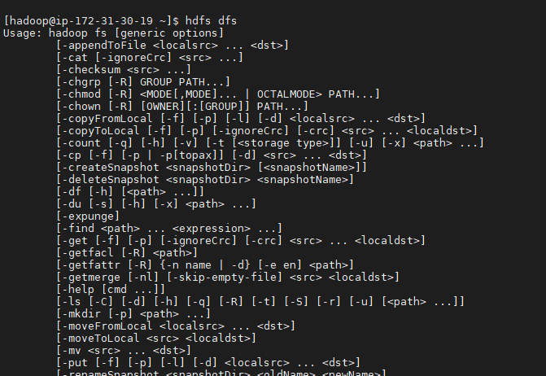

**Run the -ls command to view the contents of the user’s root directory in HDFS, which is /user/root**

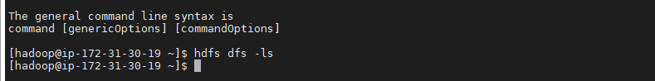

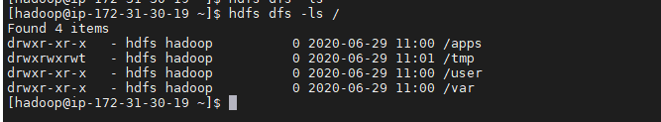

**Create a directory named test in HDFS:**

dfs_fs1] ![C:\Users\admin\Pictures\Screenshots\Screenshot (266).png

c. Verify that the folder was created successfully:

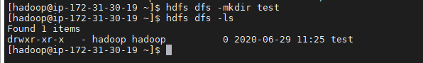

**Create a couple of subdirectories for test:**

C:\Users\admin\Pictures\Screenshots\Screenshot (285).png

**To recursively view the contents of a folder, use -ls -R:**

C:\Users\admin\Pictures\Screenshots\Screenshot (268).png

**Delete a Directory means delete the test2 folder (and recursively, its subcontents) using the -rm -R

command:**

C:\Users\admin\Pictures\Screenshots\Screenshot (269).png

**Upload a File to HDFS:**

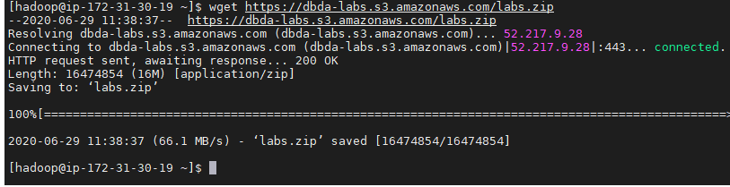

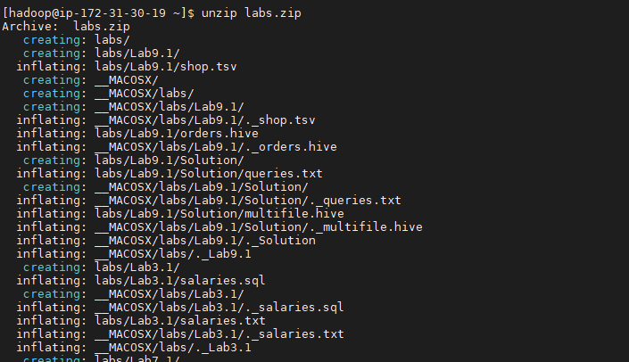

a.Now let’s put a file into the test folder. Change directories to  /root/devph/labs/Lab2.1:

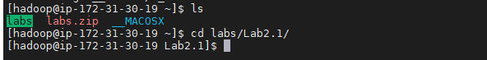

b. Notice this folder contains a file named data.txt:

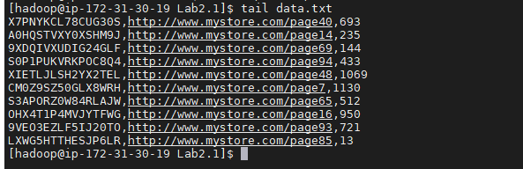

c. Run the following -put command to copy data.txt into the test folder in HDFS:

C:\Users\admin\Pictures\Screenshots\Screenshot (282).png

d. Verify that the file is in HDFS by listing the contents of test:

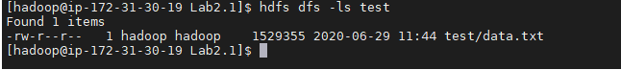

**5 ) Copy a File in HDFS :**

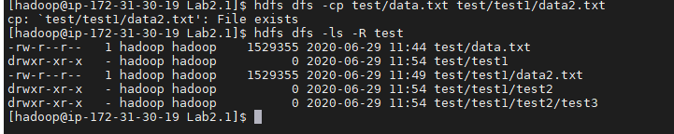

*Now delete the data2.txt file using the -rm command: *

C:\Users\admin\Pictures\Screenshots\Screenshot (287).png

**View the Contents of a File in HDFS:**

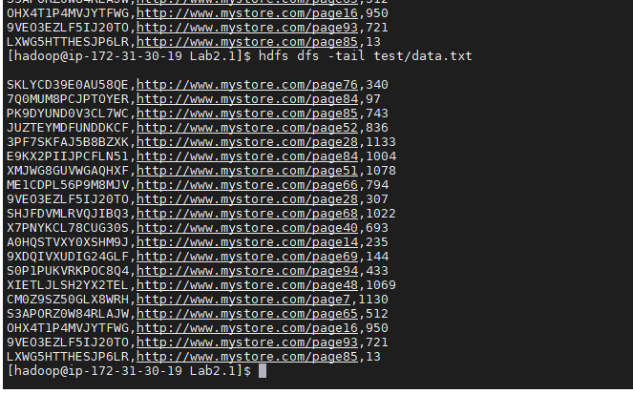

**tail command to view the end of a file:**



**Getting a File from HDFS:**

C:\Users\admin\Pictures\Screenshots\Screenshot (290).png

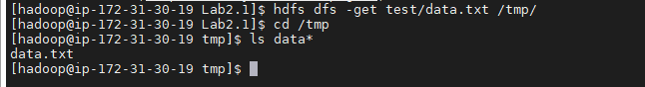

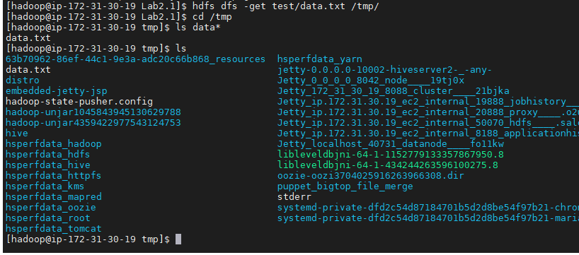

** The getmerge Command:**

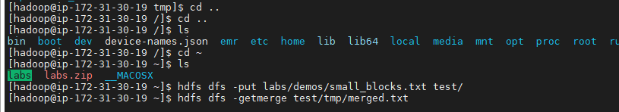

** Specify the Block Size and Replication Factor :**

a. Put /root/devph/labs/Lab2.1/data.txt into /user/root in HDFS, giving it a  blocksize of 1,048,576 bytes.

C:\Users\admin\Pictures\Screenshots\Screenshot (300).png

b. Run the following fsck command on data.txt:

