uAPI Developer Guide
Development Environment: Microsoft Visual Studio 2008
C/C++ Language:
- include the “AxUfiAPI.h”
- add “AxUfiAPIx32.lib” to the project “Properties” as follow:
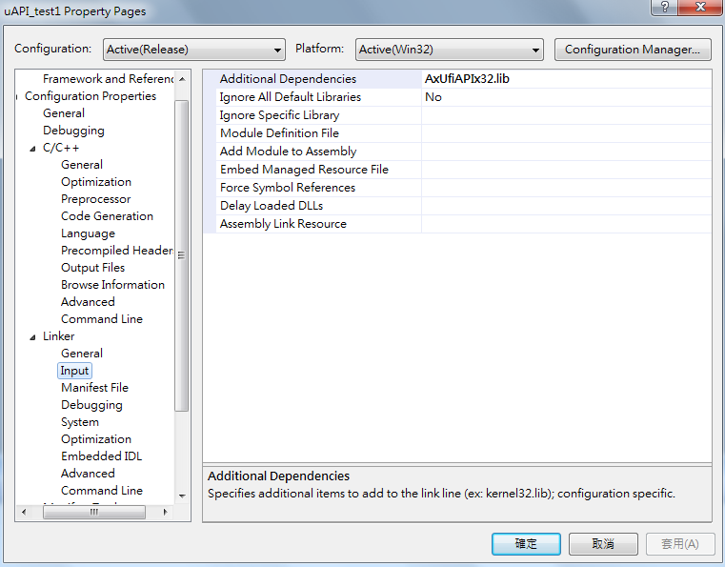
- copy the file “AxUfiAPIx32.dll” file to “Debug” or “Release” directory
- if the AxWIO IO/Memory Driver is not install, please copy “AxWIO32.sys”, “AxWIO32.cat” and “AxWIO32.dll” to the “Debug” or “Release”directory

C# Language:
- copy the file “AxUfiAPIx32.dll” file to “Debug” or “Release” directory
- if the AxWIO IO/Memory Driver is not install, please copy “AxWIO32.sys”, “AxWIO32.cat” and “AxWIO32.dll” to the “Debug” or “Release”directory
- in the .cs file, using namespace, System.Runtime.InteropServices.
- then importing the functions in “AxUfiAPIx32.dll” like below.
