

ASSIGNMENT

By-NEETIKA PALIWAL

ASET |TAAZAA| 22/03/21

# **CONSTRUCTORS IN C#**

Constructors are used to create objects and to initialize it. There are six types of constructors in c#.

* DEFAULT Constructor
* PARAMETERIZED Constructor
* STATIC Constructor
* PRIVATE Constructor
* COPY Constructor

## DEFAULT Constructor

The default constructor is the one that is automatically created. It does not accept any parameters and is perhaps a parameter less constructor.

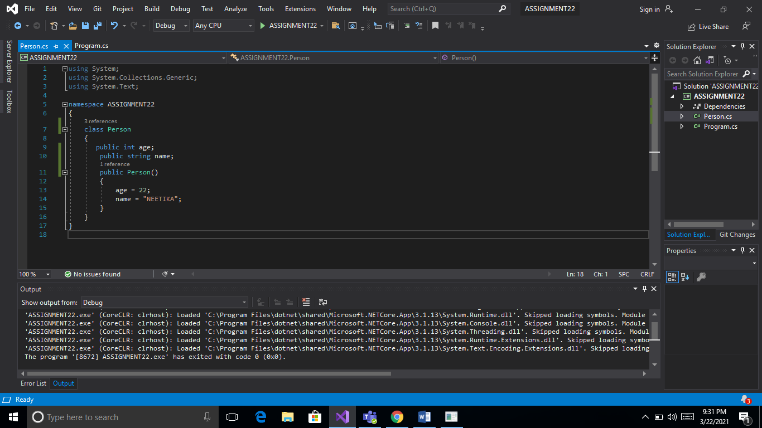

As you can see in the above code we created a default constructor with no parameters .When the object is created the constructor “Person p1=new Person” is called and the name and age of person are printed using “Console.WriteLine (p1.age)” and “Console.WriteLine (p1.name)”

## PARAMETERIZED Constructor

There is always a default constructor when we create an object , but when we create a constructor then that default constructor is gone and we can pass parameters to the new constructor such type of constructor is called parameterized constructor. If we want to create a parameter less constructor then we need to explicitly create one.

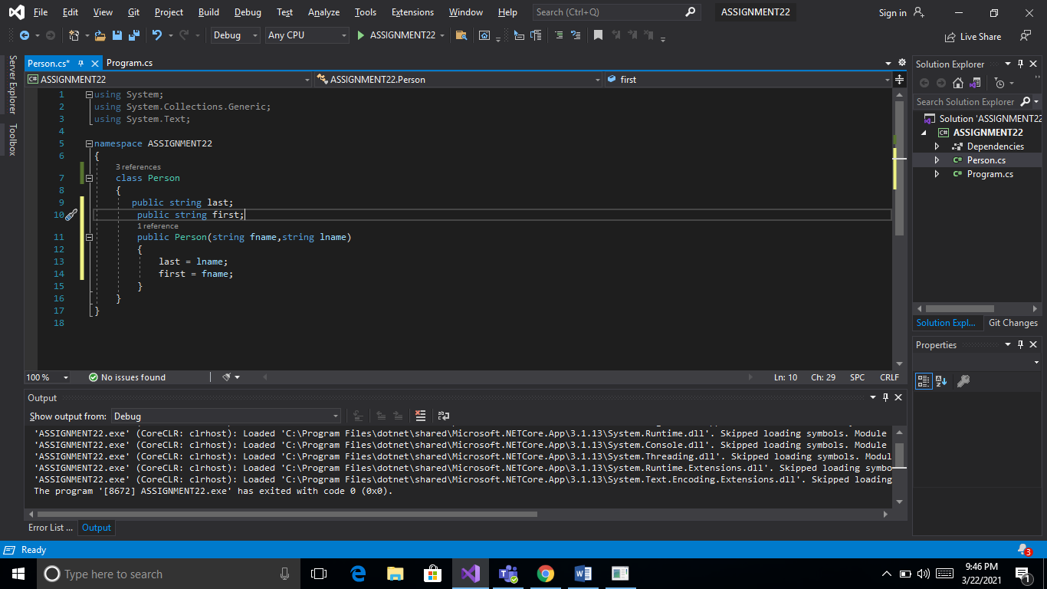

As you can see in the above code we passed parameters to it i.e. fname and lname (firstname & lastname) and we need to pass the values to it Person p1=new Person (“neetika”,”paliwal”);

## STATIC Constructor

The constructor which get called even before the first object is created is called a static constructor. A static constructor does not have non-static fields or parameters so we can say that it is a parameterless constructor. A class can have one static constructor and does not have a return type.

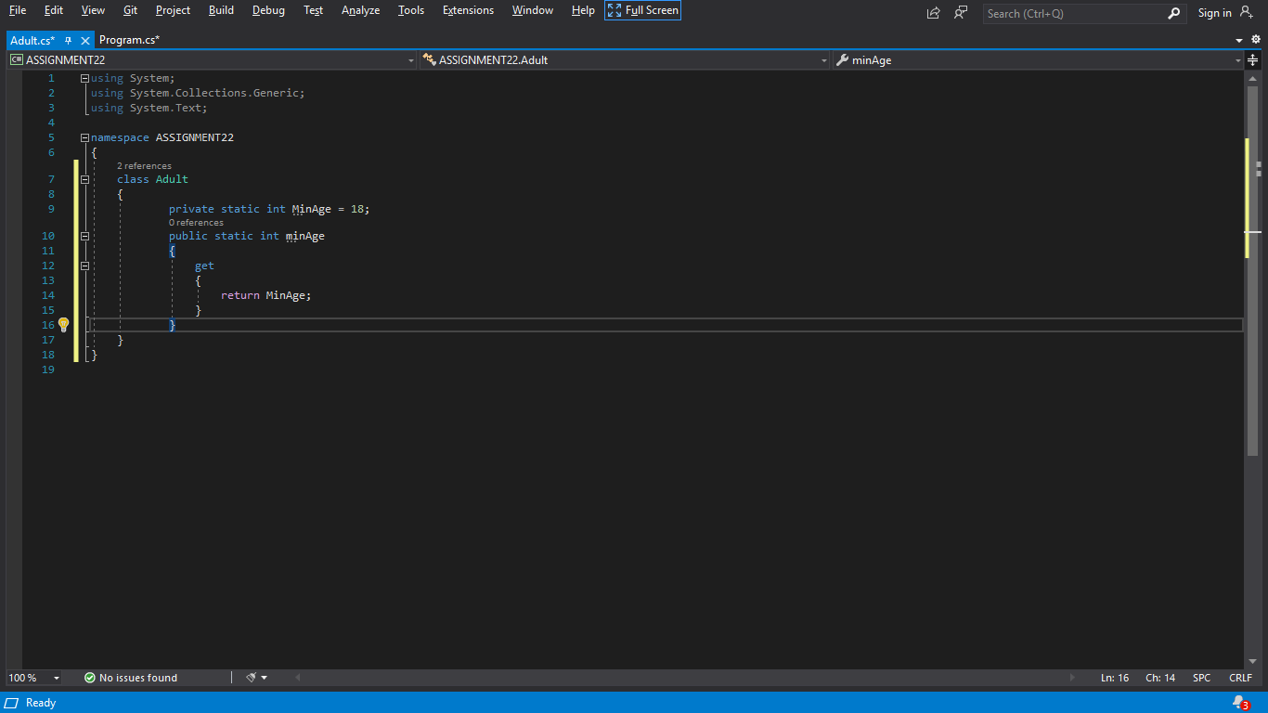

## PRIVATE Constructor

The constructor which cannot be derived from other classes are called private constructor. In this we can neither create the objects of the class nor can it inherited.

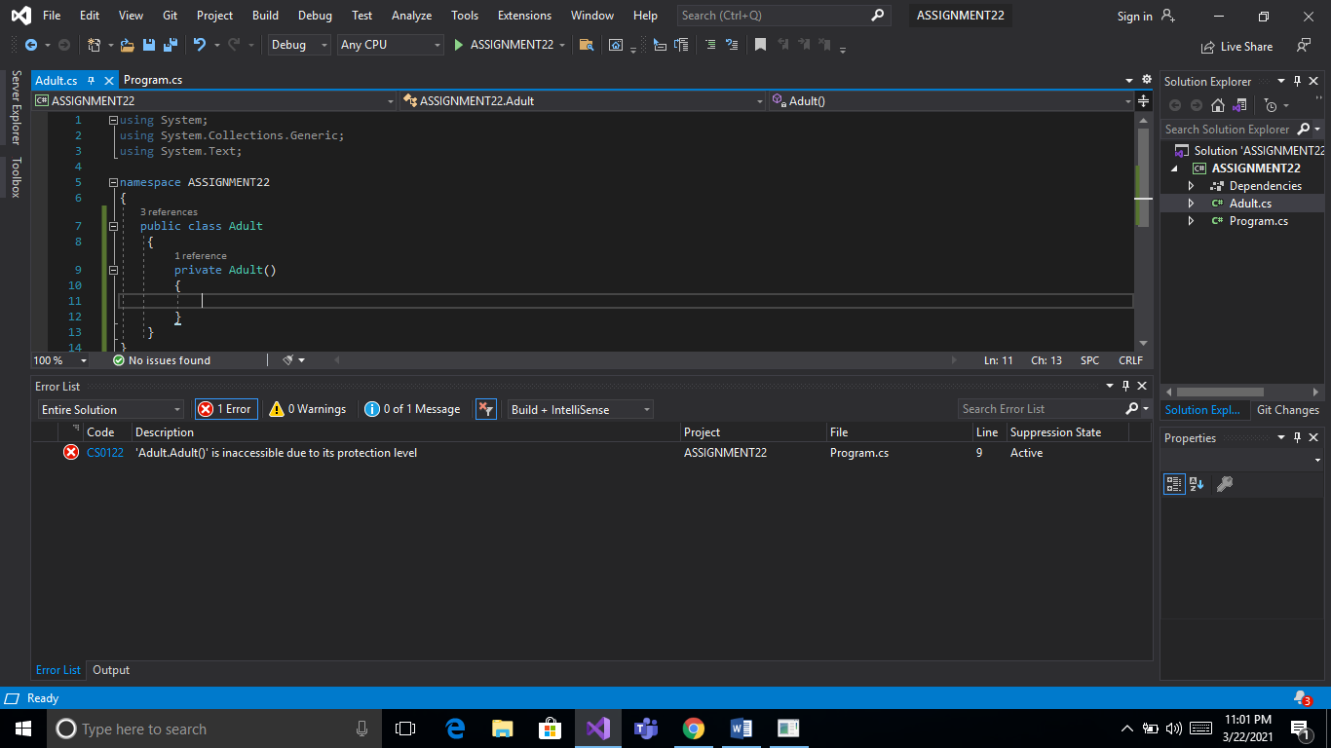

As you can see in the above code it is giving us error and saying that the class adult is not accessible due to its protect level. This is because we made it private.

## COPY Constructor

The constructor which creates objects by copying the values of one variable from an object to another object variable is called a copy constructor. It is a parameterized constructor.

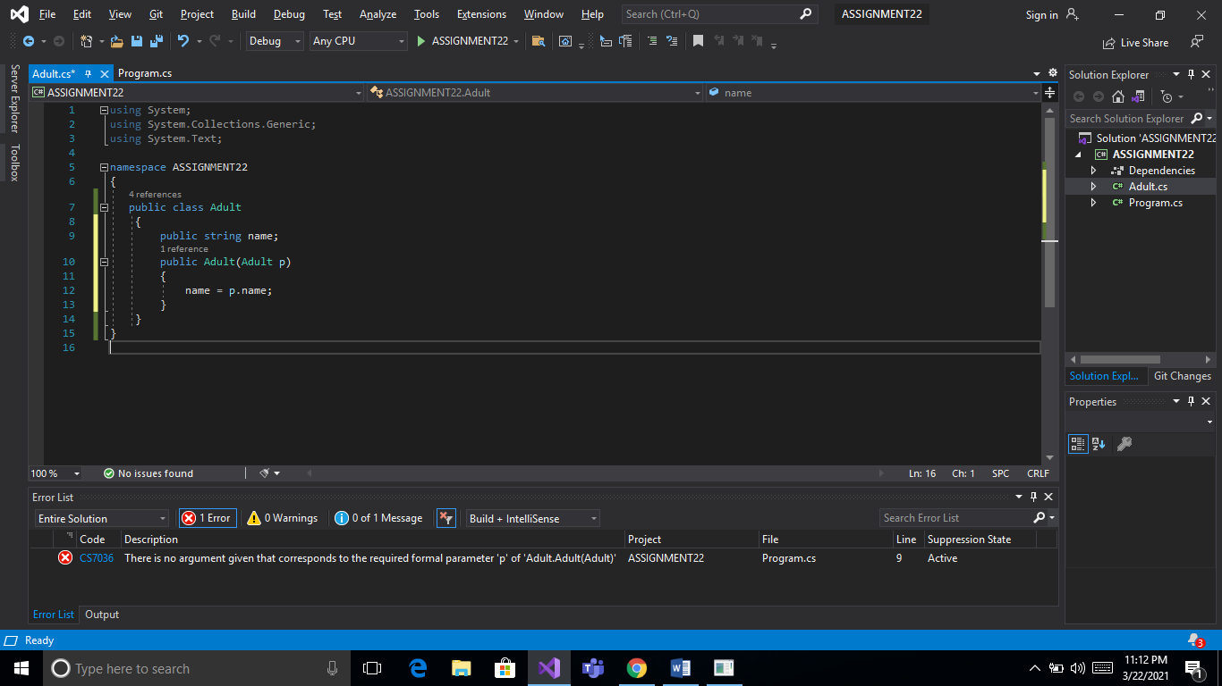

As you may see in the above code we are making a public class Adult and copying the value of variable from one object to another.

# **KEYWORDS IN C#**

There are four keywords in C#

* VIRTUAL
* OVERRIDE
* NEW
* SEALED

## vIRTUAL KEYWORD

This keyword is used to make sure that the child class method can be overrided. We use the virtual keyword in the parent class to override the child class.

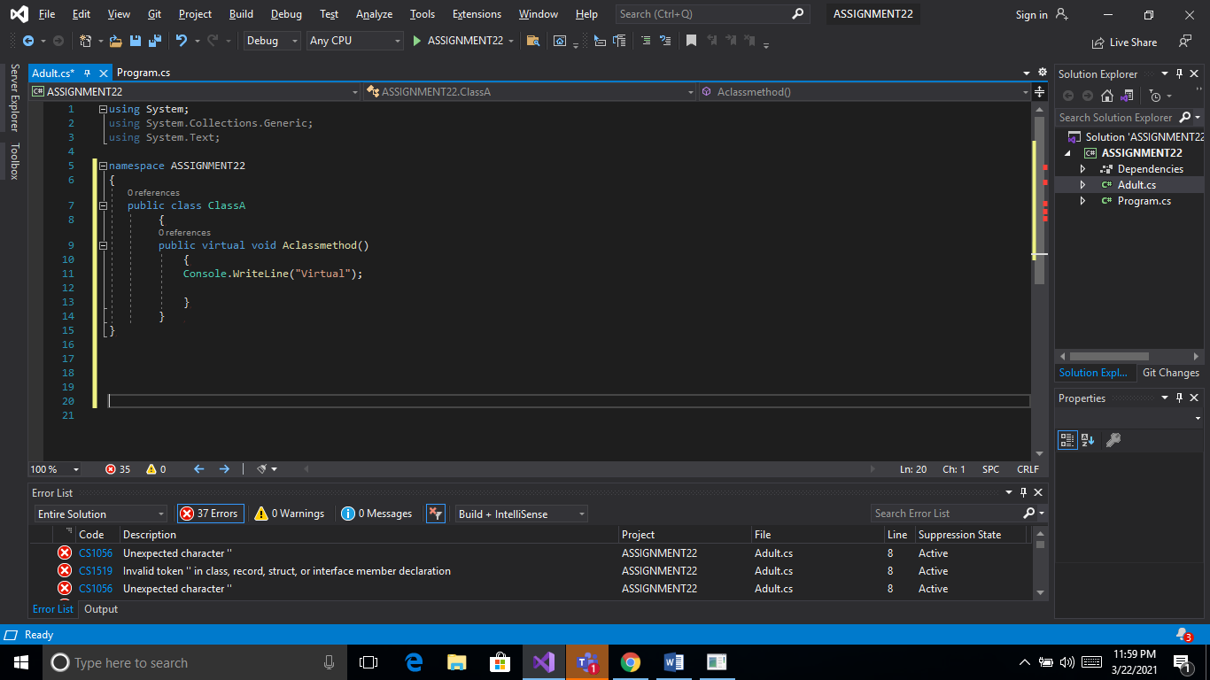

## Override keyword

When we want the child class to override a given function in the base class then we use the override keyword in child class and virtual keyword in the parent class.

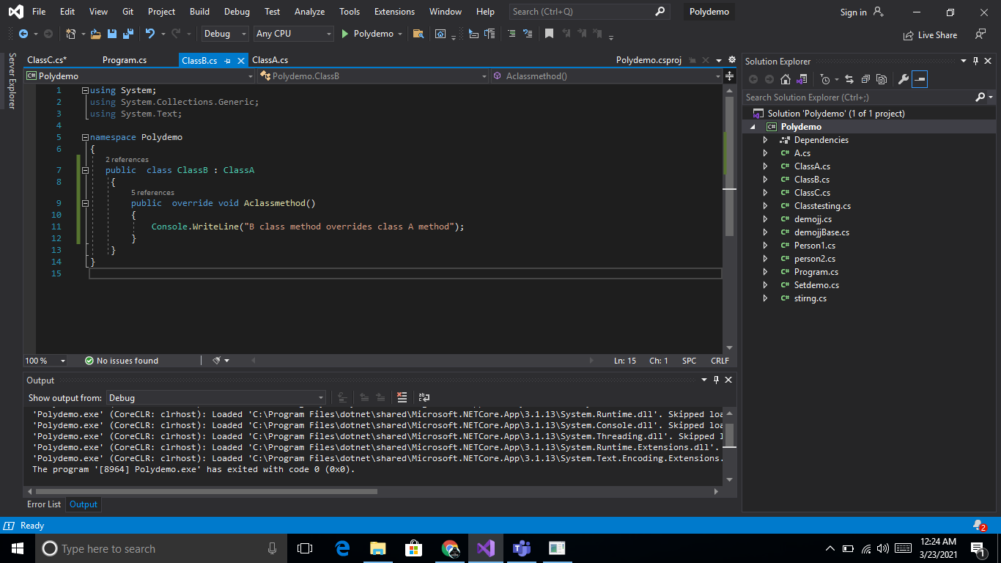

## new keyword

The new keyword is used when we want to hide the properties of the base class to the child class but it remains there in hierarchy.

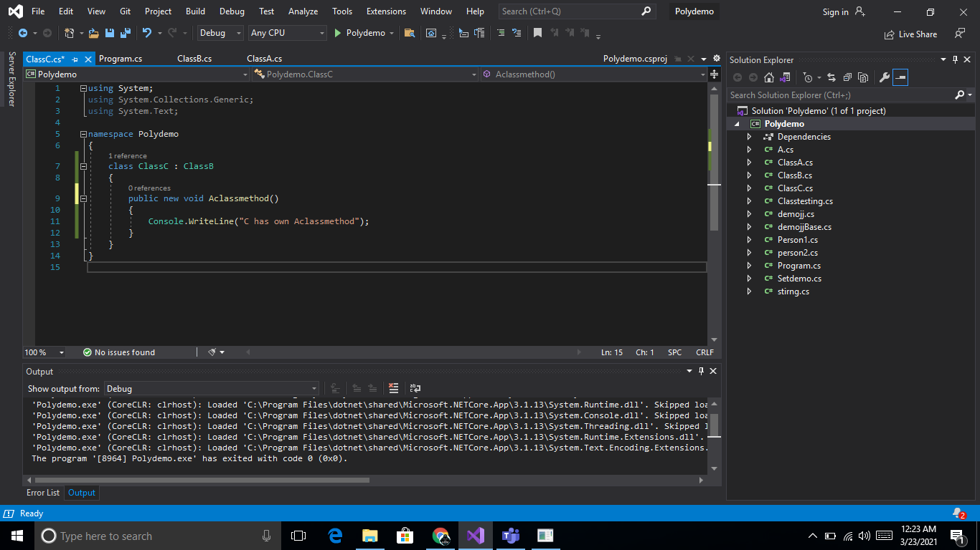

## sealed keyword

This keyword is used to avoid inheritance from the class and is used to avoid the child class method to be override.

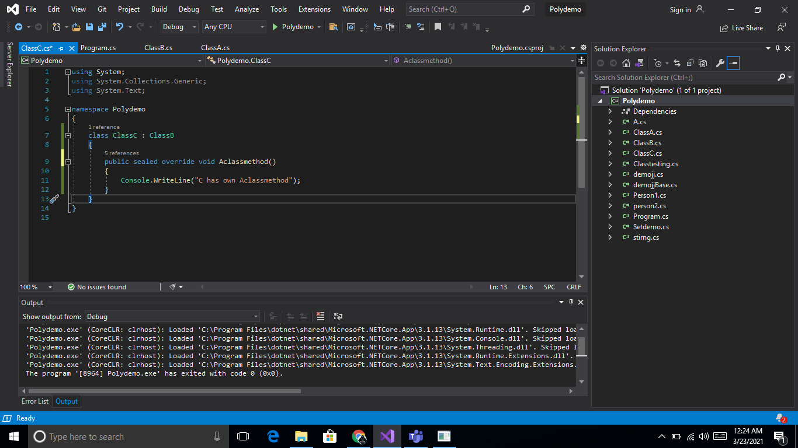

# **PROPERTIES IN C#**

In properties we use the get and set methods. Get is used to read the value and is called getter and set is used to assign a value and is called setter. If we want to make a method read-only then for that we need to remove the set method.

There are three properties initializer in C#:-

## AUTOMATIC PROPERTY INITIALIZER

Public string name

{

get; set;

}

## INLINE PROPERTY INITIALIZER

Public string name

{

get => name;

set => name = value;

}

## OBJECT PROPERTY INITIALIZER

Person p3= new Person

{

Age=3;

Name=”Neetika”;

}