Notes Recap
Playwright Timeouts — Recap Notes

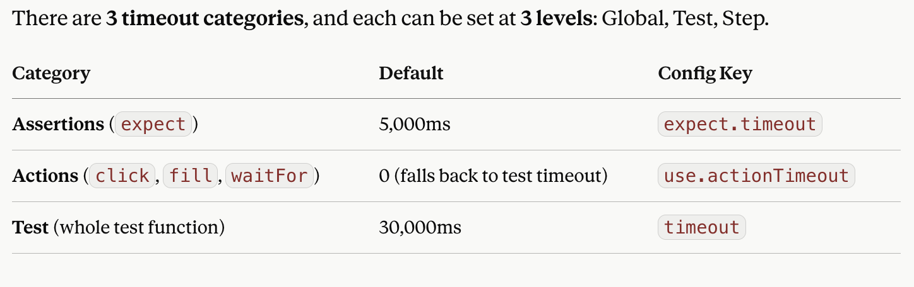
1️⃣ ASSERTION Timeout (expect)
Example used: expect(page.getByText('Success!')).toBeVisible();
LevelHow to SetCode
Global
(applies to all tests)playwright.config.ts
export default defineConfig({
expect: { timeout: 10000 }
});
Test
(applies to all assertions in one test only)expect.configure() inside the test
const slowExpect = expect.configure({ timeout: 10000 });
await slowExpect(locator).toBeVisible();
Step
(applies to just this one line)Pass timeout directly
await expect(page.getByText('Success!'))
.toBeVisible({ timeout: 10000 });
📌 Default = 5s. Unrelated to test timeout — it's a separate clock.
2️⃣ ACTION Timeout (click, fill, waitFor, etc.)
Example used: await page.getByText('Get Started').click();
LevelHow to SetCode
Global
(applies to all actions across suite)playwright.config.ts
export default defineConfig({
use: { actionTimeout: 10000 }
});
Test
(applies to all actions in one test)
page.setDefaultTimeout()
page.setDefaultTimeout(10000);
await page.getByText('Get Started').click();
Step
(applies to just this one line)Pass timeout directly
await page.getByText('Get Started') .click({ timeout: 10000 });
📌 Default = 0 (no built-in limit — inherits whatever's left of the test's 30s).
📌 page.setDefaultTimeout() affects actions only, NOT assertions.

3️⃣ TEST Timeout (entire test function)
Example used: A test with multiple steps: goto → click → fill → click → assert.
LevelHow to SetCode
Global
(applies to every test in suite)playwright.config.ts
export default defineConfig({
timeout: 60000
});
Test
(applies to just one test)test.setTimeout() inside the test
test('checkout flow', async ({ page }) => {
test.setTimeout(60000);
// ...
});
Step❌ Not applicable — test timeout has no per-line override; it's the ceiling for the whole test
📌 Default = 30s. This is one single cumulative clock — it does NOT reset between steps.
📌 Bonus shortcut: test.slow() triples the default (30s → 90s) without typing a number.
🔑 Golden Rule to Remember
An explicit timeout (step or config) only shortens or lengthens that specific operation's own wait. It can never push execution beyond the overall Test Timeout. If the Test Timeout hits first, everything stops — regardless of what any action/assertion timeout was set to.
Quick memory hook for students:
- Assertions → "Is it there?" → 5s default
- Actions → "Do it now" → 0 default (borrows from test clock)
- Test → "How long can the whole thing run?" → 30s default, the ultimate ceiling

