ScreenShot Of Website Used
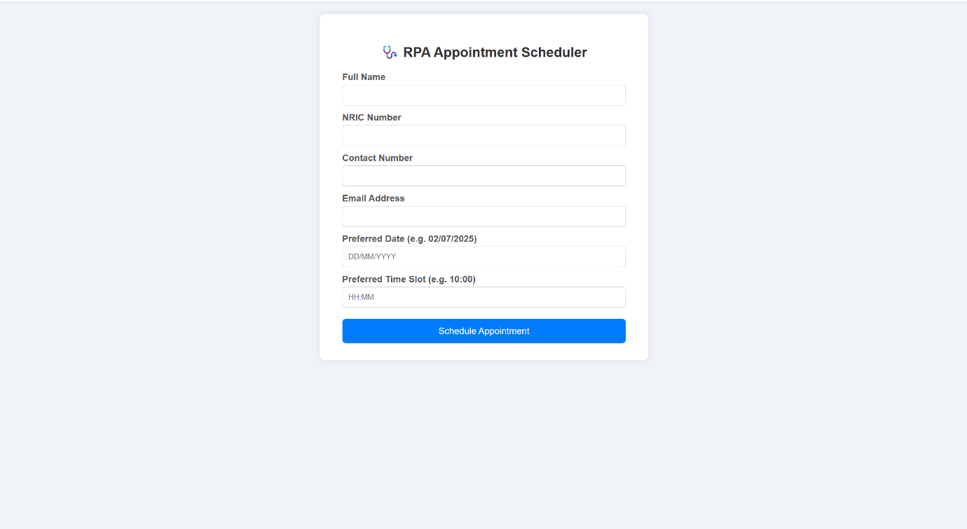
ScreenShot Of Form that Patient Fills up
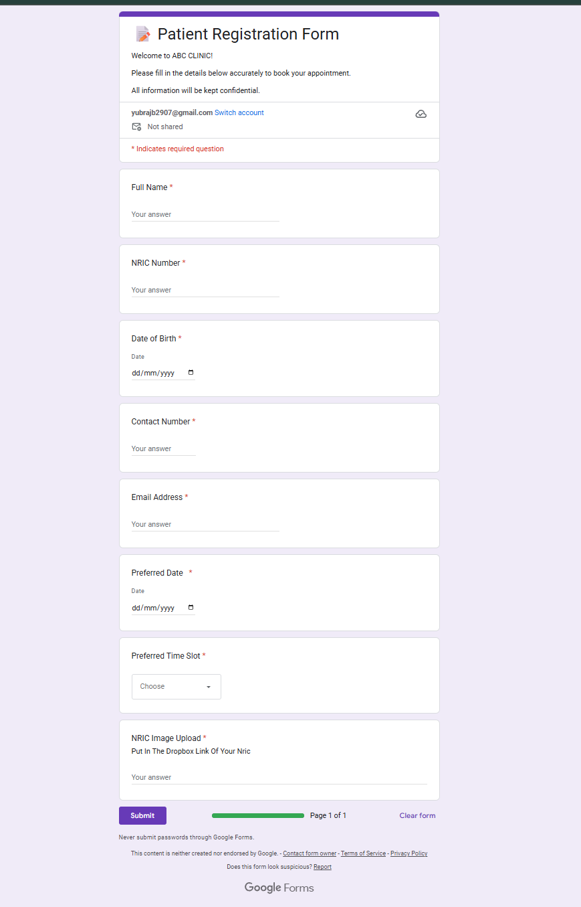
Link to form : https://forms.gle/Gf47fHyYy7Hs8gbj6

ScreenShot Of Google Sheet
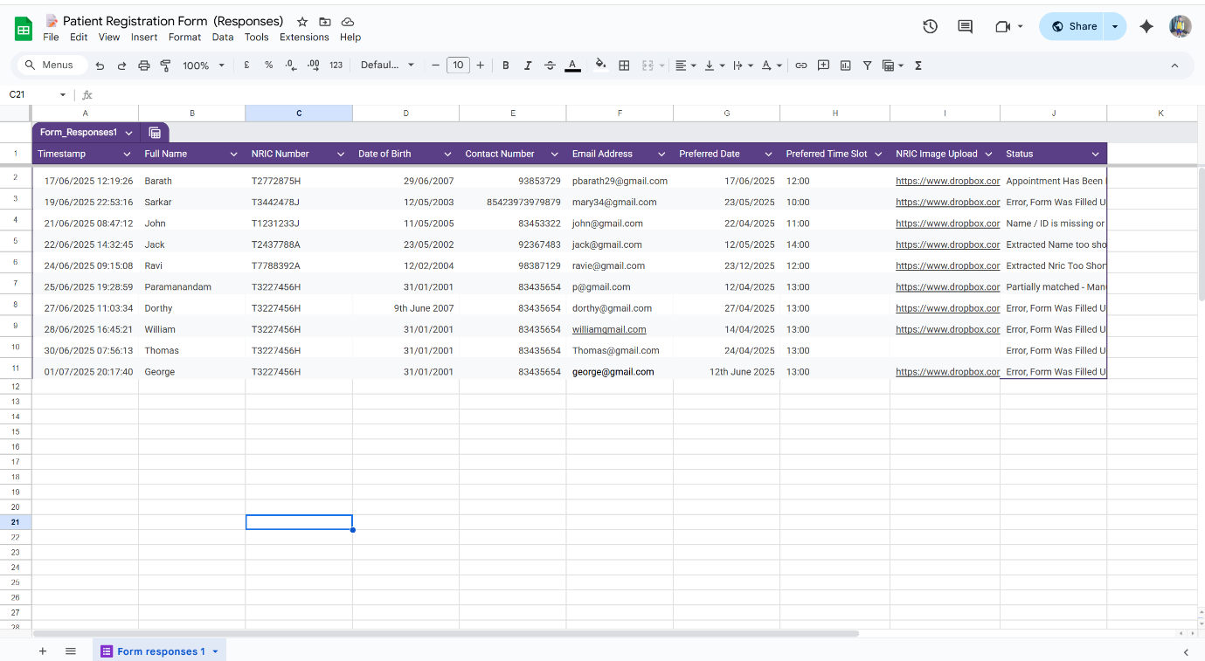
Link to Google Sheet : https://docs.google.com/spreadsheets/d/1Jg0_GVGcQh3foRMVAnOpEZo73-OoSIUZ0bj6MlilIaM/edit?usp=sharing

ScreenShot Of Email Sent To Patient
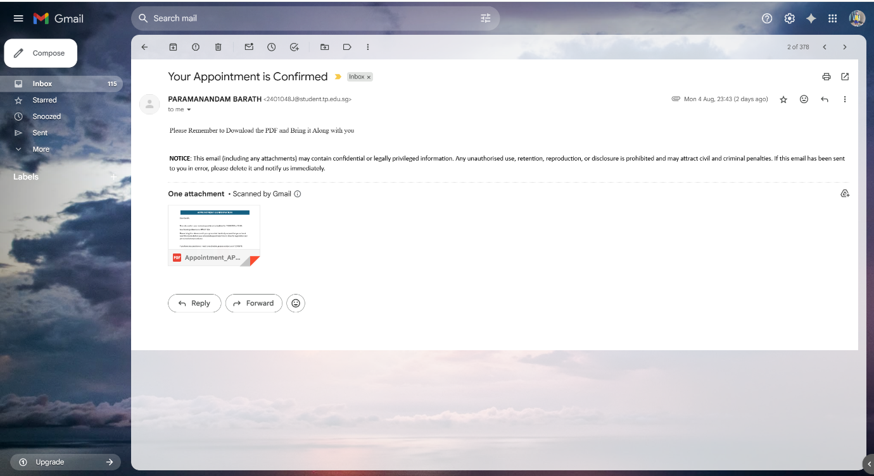
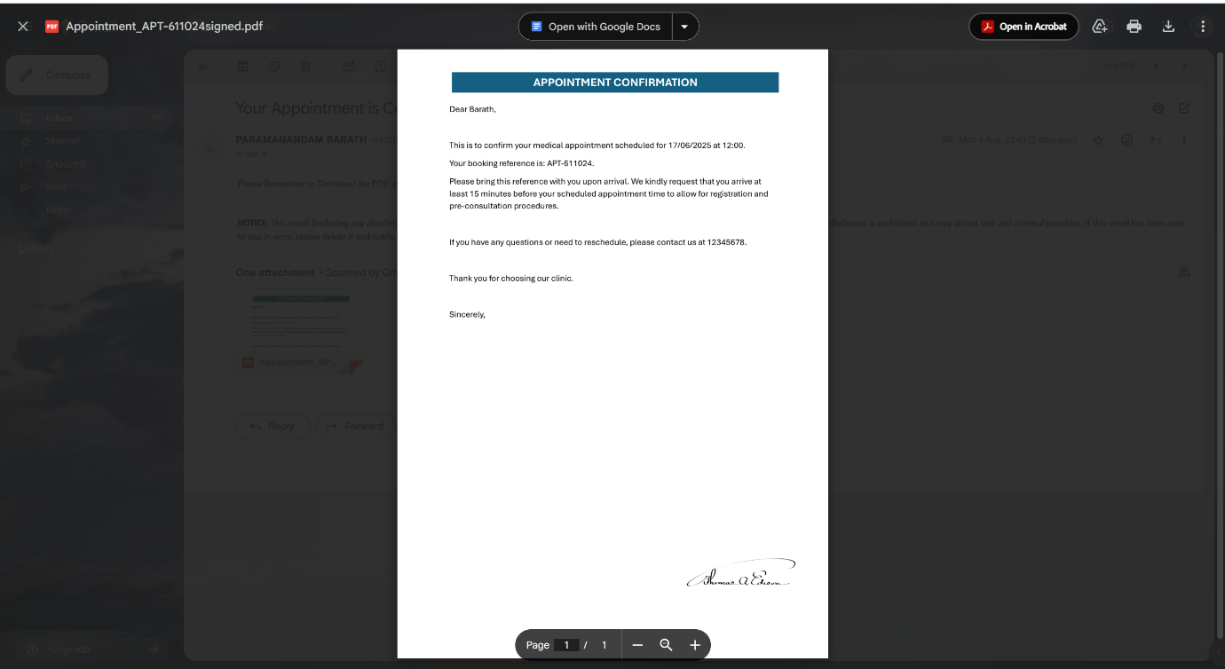

ScreenShot OF summary Sent to Clinic / Admin
