Course Notes: Introduction to Robots and Robotics

What is a Robot?
- Origin: The term comes from the Czech word 'robota', meaning "forced" or "slave laborer."
- First Appearance: Coined by Czech playwright Karel Capek in his 1921 play Rossum’s Universal Robot (R.U.R.). He described robots as looking similar to humans.

Formal Definitions:
- Oxford English Dictionary: An automatic machine capable of carrying out a complex series of actions, especially one programmable by a computer.
- ISO: An automatically controlled, reprogrammable, multifunctional manipulator, programmable in 3 or more axes (fixed or mobile) for use in industrial automation.
- RIA (Robot Institute of America): A reprogrammable, multi-functional manipulator designed to move materials, parts, or tools through variable programmed motions for a variety of tasks.
Key Distinction: While both CNC machines and robots are reprogrammable, robots possess a much higher level of re-programmability. A CNC machine is not a robot.

What is Robotics?
- Definition: The multidisciplinary science dealing with the design, development, and application of robots.
- Origin: Coined by Isaac Asimov in his 1942 story Runaround.
- Disciplines Involved: Physics, mathematics, mechanical engineering, electrical/electronics engineering, and computer science.

The "3 Hs" Goal
Robotics fundamentally attempts to copy three human traits:
- Hand: The mechanical hand (manipulator).
- Head: Human intelligence.
- Heart: Human emotion (the future goal is to make robots intelligent and emotional).

Motivation: Why Study Robotics?
To survive in today's dynamic and competitive market, businesses must fulfill three conflicting requirements:
1. Produce goods at a low cost
2. Maintain high productivity
3. Ensure improved product quality
The only way to achieve all three simultaneously is through automation.
Production Type | Characteristics | Automation Method
Piece | Several designs, small numbers | No automation possible
Batch | Few designs, few in number | Flexible automation (Robotics)
Mass | One design, large numbers | Fixed / hard automation
Because robotics is a form of flexible automation, it is heavily used in batch manufacturing. Beyond manufacturing, robots are increasingly used in space exploration, medicine, sea-bed mining, agriculture, and firefighting.

Brief History of Robotics
- 1950 - Development of NC Machines: The numerical controlled (NC) machine was developed, paving the way for programmable machinery.
- 1954 - First Manipulator Patent: George Devol (known as the 'Father of the Robot') filed the first patent for a manipulator.
- 1956 - Unimation Founded: Joseph Engelberger started the first robotics company, named Unimation.
- 1962 - Unimate in Production: General Motors began using the 'Unimate' manipulator for die-casting applications.
- 1967 - First 4-Legged Robot: General Electric Operation built and demonstrated a functional 4-legged vehicle.
- 1969 - SAM and Shakey: NASA built 'SAM', while the Stanford Research Institute (SRI) manufactured 'Shakey'—the world's first intelligent mobile robot.
- 1970 - Stanford Arm & Space Robotics: Victor Scheinman demonstrated the Stanford Arm. In the same year, the USSR sent Lunokhod 1 to the moon, and Odetics built ODEX 1.
- 1973 - The Tomorrow Tool (T^3): Richard Hohn of Cincinnati Milacron Corporation manufactured the T^3 robot.
- 1975 - First Hopping Machine: Raibart (Carnegie Mellon University) built a dynamically stable 1-legged hopping machine, earning him the title 'Father of multi-legged robots.'
- 1978 - PUMA Developed: Unimation introduced PUMA (Programmable Universal Machine for Assembly), a 6-degree-of-freedom manipulator still common in industries today.
- 1979-1980 - Robotics in India: The formal study of robotics began in India.
- 1983 - Odetics 6-Legged Device: Odetics introduced a unique experimental six-legged robotic device.
- 1986 - Adaptive Suspension Vehicle (ASV): The ASV was developed by Ohio State University.
- 1997 - Mars Mission: NASA sent intelligent robots to Mars, though the mission ultimately failed due to specification mismatches.
- 2000 - Asimo Robot: Honda developed the famous humanoid robot, Asimo.
- 2004 - Spirit & Opportunity: NASA successfully explored the surface of Mars with the Spirit and Opportunity rovers.
- 2012 - Curiosity Rover: NASA's intelligent autonomous robot, Curiosity, successfully landed on Mars.
- 2015 - Sophia the Robot: Hanson Robotics (Hong Kong) built Sophia, a sophisticated, intelligent, and slightly emotional humanoid robot.

Robotic System Components
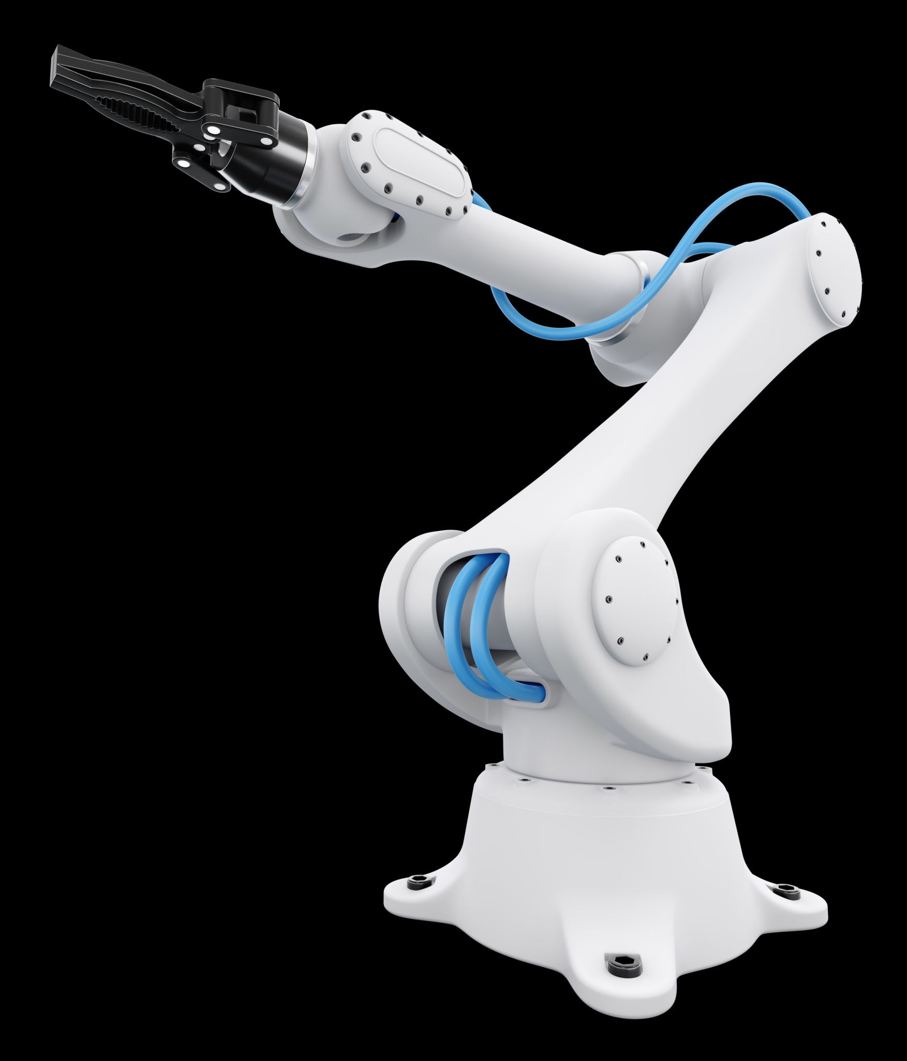
A typical robotic system is made up of several core structural elements:
- Manipulator: The mechanical arm itself. A 'serial manipulator' has a fixed base.
- Drive Unit: Powers the manipulator.
- Controller: Acts as the 'director' that instructs the drive unit.
- Links: The rigid sections of the manipulator used to transmit mechanical power.
- Joints: The connecting points between two separate links that allow for motion.

Types of Robotic Joints
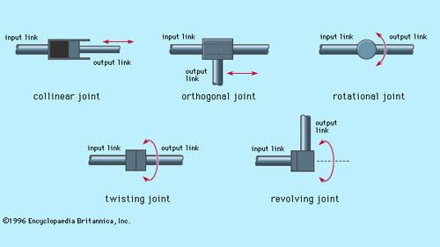
Robotic joints fall into two primary categories based on the type of motion they allow between the input link and the output link.

1. Linear Joints (Translational movement)
- Prismatic Joint: Operates like inserting a key into a block, allowing one part to slide strictly in a linear direction.
- Sliding Joint: Similar to a pin inserted into a block, locking movement to a single sliding path.

2. Rotary Joints (Rotational movement)
- Twisting Joint (T): The axis of the output link coincides with the axis of rotation. (Think of the motion used when turning a screwdriver).
- Revolute Joint (R): The axis of the output link and the axis of rotation are exactly 90 degrees apart. (Think of how a standard door hinge operates).

