Course Notes: Kinematic Diagrams & Degrees of Freedom

1. Joint Symbols & Kinematic Diagrams
To represent a complicated robotic system simply, we use standardized symbols for joints and links to create a Kinematic Diagram. This diagram serves as the starting point for kinematic analysis, dynamics, control, and programming intelligence.

Standard Joint Symbols:
- Revolute Joint: R
- Prismatic Joint: P
- Cylindrical Joint: C
- Spherical Joint: S'
- Hooke (Universal) Joint: U
- Twisting Joint: T
How to Draw a Kinematic Diagram:
1. Start from the fixed base.
2. Add the appropriate symbol for the first joint.
3. Connect rigid links between subsequent joints.
4. End at the end-effector (gripper).

2. Degrees of Freedom (DoF) / Mobility
Definition: The minimum number of independent parameters, variables, or coordinates needed to completely describe a robotic system.

Basic Principles:
- Point in 2D Space: Has 2 DoF (x, y coordinates).
- Point in 3D Space: Has 3 DoF (x, y, z coordinates).
- Rigid Body in 3D Space: Has 6 DoF total (3 for position: x, y, z; and 3 for orientation: rotation about X, Y, Z axes).

3. Types of Manipulators Based on DoF
- Ideal Manipulator: Has exactly the required degrees of freedom for its environment. (e.g., 6 DoF for a 3D spatial manipulator like the PUMA robot, or 3 DoF for a 2D planar manipulator).
- Redundant Manipulator: Has MORE degrees of freedom than required (e.g., >6 in 3D, or >3 in 2D). Used for specific purposes like reaching difficult, constrained spaces (e.g., performing a welding task in a tight geometry).
- Under-Actuated Manipulator: Has FEWER degrees of freedom than an ideal manipulator (e.g., <6 in 3D). Used when high precision orientation is not required, such as simple pick-and-place tasks. (Example: 'Minimover' 5 DoF robot).

4. Grubler's Criterion (Calculating Mobility)
Grubler's Criterion mathematically determines the mobility (M) of a system. Note: For manipulators with DoF > 6, the term 'Mobility level' is preferred over 'Degrees of Freedom'.

Variables:
- n = number of rigid moving links
- m = number of joints
- Ci = connectivity (DoF) of the i-th joint

Formulas:
- Spatial (3D) Manipulator: 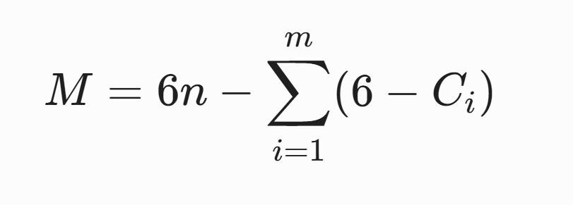
- Planar (2D) Manipulator: 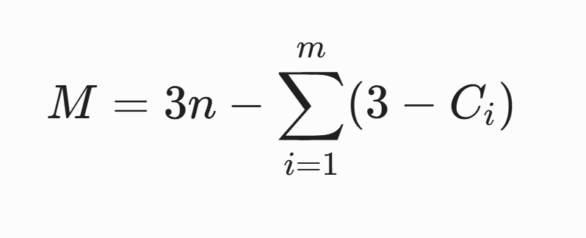

Application Examples:
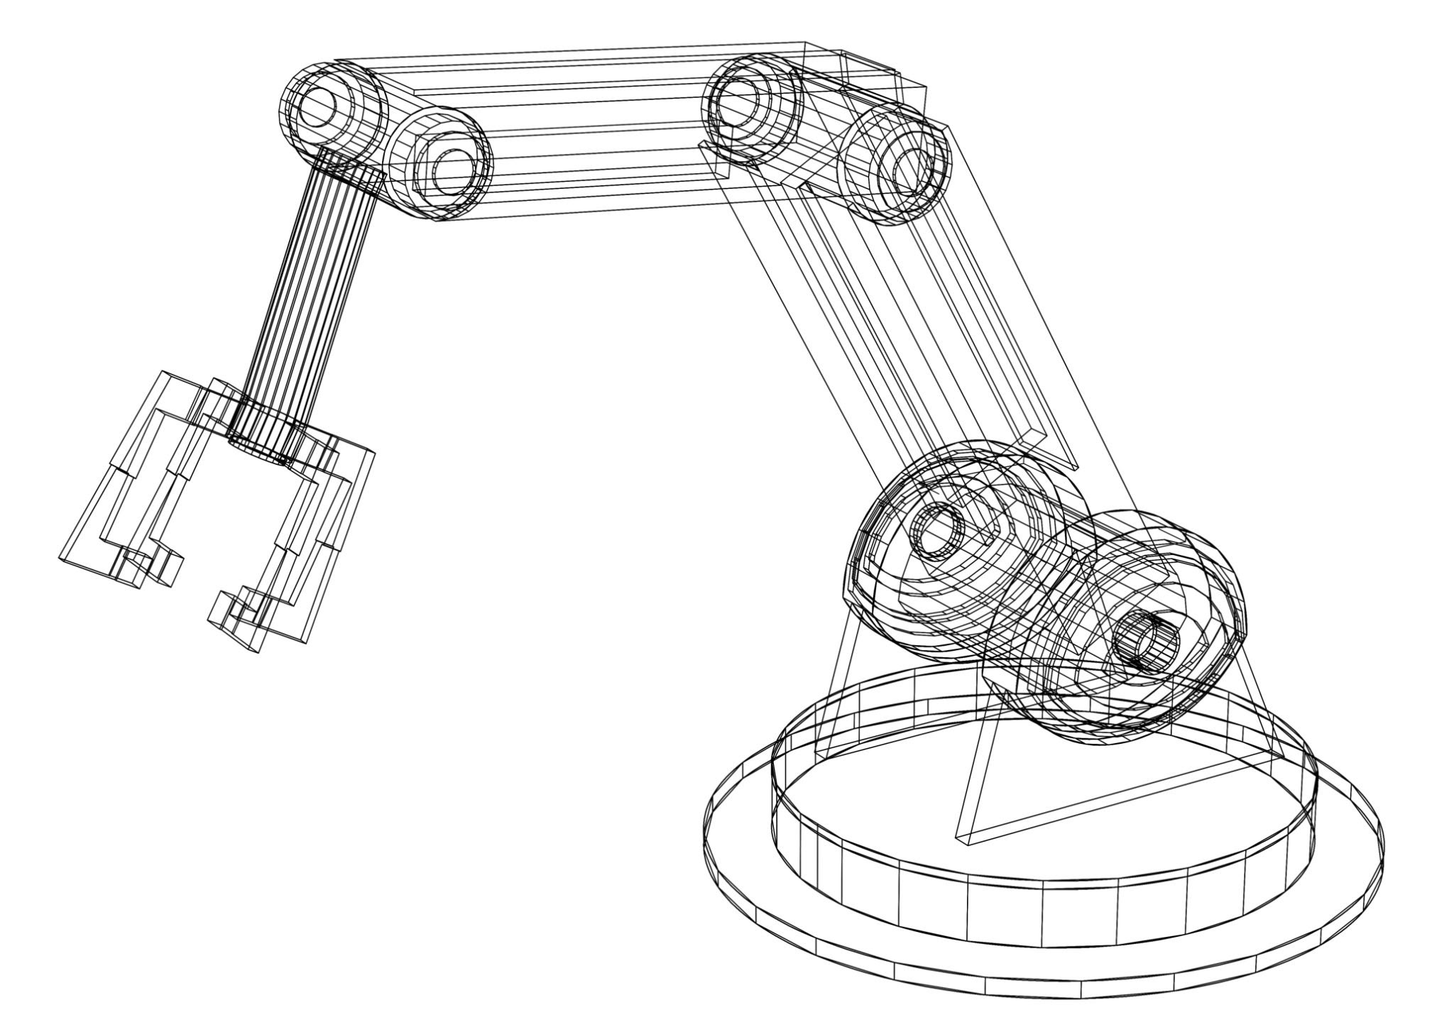
- Planar Serial Manipulator: 4 moving links (n=4), 4 joints (m=4), each joint has 1 DoF (Ci=1).
Calculation: M = 3(4) - [4 × (3-1)] = 12 - 8 = 4.
Result: A redundant planar serial manipulator. (Note: For serial manipulators, M is always the sum of all Ci values).
- Planar Parallel Manipulator: 7 moving links (n=7), 9 joints (m=9), each joint has 1 DoF (Ci=1).
Calculation: M = 3(7) - [9 × (3-1)] = 21 - 18 = 3.
Result: An ideal planar parallel manipulator.

