Course Notes: Specialized End-Effectors & Robot Teaching

1. Specialized Grippers
- Magnetic Grippers: Used exclusively for magnetic materials (like steel, but not stainless steel). Can utilize permanent magnets or electromagnets. They can grip various sizes quickly. Drawback: Subject to residual magnetism.
- Permanent Magnet Un-gripping: Requires a mechanical stripping device (like a steel pin inserted through the magnet) to weaken the magnetic lines of force so the object drops.
- Electromagnet Un-gripping: Achieved simply by reversing the polarity.
- Adhesive Grippers: Suitable only for very light objects. Operates similarly to a frog catching an insect using a sticky substance.
- Universal Grippers: Highly sophisticated, robust, and flexible (mimicking the human hand) to grip objects of multiple shapes and sizes.

Passive Grippers (RCC for Assembly)
Passive grippers lack sensors and are heavily used in precision assembly, such as inserting tiny resistors into Printed Circuit Boards (PCBs). This presents a classic robotics problem: the 'Peg-in-Hole' insertion.
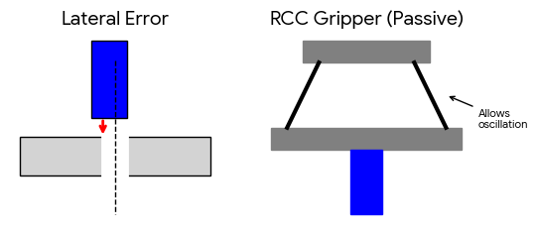
Figure 1: Lateral Error in peg insertion and the RCC solution.
- Lateral Error: The peg is slightly misaligned with the hole and collides with the surface.
- Angular Error: Occurs if chamfering is added to fix lateral error, causing the peg to tilt and jam.
- The Solution - RCC (Remote Center Compliance): A passive gripper structure using flexible links that allows the peg to naturally oscillate and guide itself into the hole through trial and error. (Requires hole chamfering of less than 45 degrees and only works vertically).

2. Robot Teaching Methods
Teaching provides the necessary instructions (e.g., coordinate points) for a robot to complete a task. There are two primary categories:

A. Online Teaching
Uses the physical robot itself to record instructions.
- Manual Teaching (Point-to-Point): Used to record discrete coordinate points (theta values).
- Control Handle/Joystick: Physically steering the robot arm to a point and storing the joint angles via optical encoders.
- Push Buttons: Using the controller panel to jog the robot in Cartesian or joint space.
- Teach-Pendant: A remote control device used to manually drive the robot to desired points and save them.
- Lead-Through Teaching (Continuous Path): Used for tasks where the tool must stay in continuous contact with the job (e.g., cutting a complex profile).
- Because moving a heavy, geared industrial robot manually is difficult, a 'Robot Simulator' (a lightweight, kinematically identical dummy arm with optical encoders but no motors/brakes) is used. The operator manually traces the profile with the dummy arm, and the encoders record thousands of continuous points to feed to the main robot.

B. Offline Teaching
Does not use the physical robot during programming. Instead, it relies on writing code using specialized programming languages.
- VAL (Variable/Versatile Assembly Language): A language specific to the PUMA series robots (Programmable Universal Machine for Assembly), utilizing BASIC-like commands.

VAL Application: Pick and Place
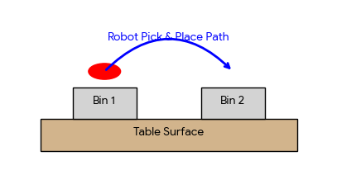
Figure 2: Layout for a classic Pick and Place task.
To program a pick-and-place task in VAL:
- 1. Define coordinate systems: The robot base has one, and the table/bins have another.
- 2. Store coordinates: Program the exact 3D position and orientation (6 pieces of information) of Bin 1, Bin 2, and the object.
- 3. Execute movement commands: e.g., MOVE to HOME, MOVE to Bin 1, Grip, MOVE to Bin 2, Release, MOVE to HOME.

