Course Notes: VAL Programming, Robot Specifications & Economic Analysis

1. VAL Programming (Pick and Place Task)
VAL (Variable/Versatile Assembly Language) is used to program robots like the PUMA. Below is a standard Pick and Place sequence, assuming the exact position and orientation of the object ('PART') and the target bins ('BIN' / 'BIN 2') have been predefined.

Pick and Place Sequence:

- APPRO PART, 100 : Approach the 'PART', stopping 100mm above it (Z-direction).
- MOVES PART : Move in a Straight line directly to the PART.
- CLOSEI : Close the gripper to grasp the object, followed by a short delay ('I').
- DEPARTS 200 : Depart in a Straight line by 200mm (Z-direction).
- APPROS BIN, 300 : Approach in a Straight line to a point 300mm above the target 'BIN'.
- MOVE BIN : Move directly to the target BIN.
- OPENI : Open the gripper to release the object, followed by a short delay ('I').
- DEPART 100 : Depart upwards by 100mm (Z-direction).

Other Essential VAL Commands:
- SPEED 40: Sets the robot's movement speed to 40% of its maximum rated motor speed.
- EXECUTE / ABORT: Run or stop the current program.
- EDIT [filename]: Opens a saved program for modification.
- STORE / LOAD [filename]: Saves or loads a program to/from memory.
- LISTF / DELETE: Lists all files in the directory or deletes a specific file/line.
Important Note: Teaching and programming only provide instructions; they do not inherently make a robot intelligent.

2. Preparing Robot Specifications
When purchasing a robot, a comprehensive specification sheet must be defined based on the application:
Specification Category | Details to Define
Control Type | Servo-controlled (accurate, closed-loop) vs. Non-servo controlled.
Drive System | Mechanical, Hydraulic, Pneumatic, Electro-hydraulic, etc.
Coordinate System | Cartesian, Cylindrical, Spherical, or Revolute.
Programming Method | Online (Manual, Lead-through) or Offline (VAL, etc.).
Performance Metrics | Accuracy, Repeatability, and Resolution.
Payload Capacity | Maximum load the end-effector can carry (dictates required motor torque).
Physical Specs | Weight of the manipulator (affects foundation planning), Workspace volume.
Kinematics | Range and maximum speed of the arms and wrist.
Sensors | Required sensors to grant the robot intelligence/feedback for the task.

3. Economic Analysis of Robots
Before purchasing an expensive industrial robot (e.g., a 6-DoF arm costing ~25 Lakhs), a manufacturing unit must perform an economic analysis to determine if taking a bank loan is a sound decision.

Variables & Formulas:
- F = Capital Investment (Purchasing + Installation costs)
- B = Savings (Material and labor cost reductions)
- C = Operating / Maintenance Cost
- D = Depreciation (Falling asset value used for tax deductions. Assumed constant here).
- A = Net Savings (A = B - C - D)
- G = Tax paid on net savings
- I = Modified Net Saving (Remaining income after tax G is paid)
- Payback Period (E): The minimum time (years) required to recoup the initial investment.
Formula: E = F / (B - C - G)
- Rate of Return on Investment (H): Formula: H = (I / F) * 100

Robot Life Definitions:
- Technical Life: The period the robot can produce goods within tolerance limits.
- Economic Life: The period the robot produces goods within the profit zone.
- Techno-Economic Life: The intersection (the lesser) of the Technical and Economic life.

Final Decision Criteria:
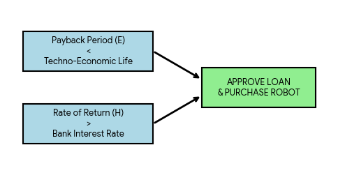
Figure 2: The economic conditions required to approve a robot purchase.

