Course Notes: Economic Analysis Case Study

1. Problem Statement & Given Parameters
A manufacturing unit is evaluating whether to take a bank loan to purchase a robot. We must perform an economic analysis using the following given parameters:
Parameter | Value
Cost of Robot (including accessories) | Rs. 12 Lakhs (1,200,000)
Installation Cost | Rs. 3 Lakhs (300,000)
Maintenance & Operating Cost | Rs. 20 / hour
Labor Savings | Rs. 100 / hour
Material Savings | Rs. 15 / hour
Operating Shifts | 24 hours/day (Three 8-hour shifts)
Effective Work Days | 200 days / year
Tax Rate | 30%
Techno-Economic Life | 6 years
Estimated Bank Interest Rate | ~10%

2. Step-by-Step Calculations
- Step 1: Capital Investment (F) & Running Hours
- F = Cost of Robot + Installation Cost = 12 Lakhs + 3 Lakhs = Rs. 15 Lakhs (1,500,000)
- Total Running Hours/Year = 24 hours/day * 200 days = 4,800 hours/year
- Step 2: Annual Savings (B) & Operating Costs (C)
- B (Total Savings) = (Labor Savings + Material Savings) * Running Hours
- B = (Rs. 100 + Rs. 15) * 4,800 = 115 * 4,800 = Rs. 552,000
- C (Operating Cost) = Rs. 20 * 4,800 = Rs. 96,000
- Step 3: Depreciation (D) & Net Savings
- Depreciation applies ONLY to the asset cost (excluding installation).
- D = Rs. 12 Lakhs / 6 years = Rs. 2 Lakhs (200,000) per year
- Net Savings (before tax) = B - C - D
- Net Savings = 552,000 - 96,000 - 200,000 = Rs. 256,000
- Step 4: Taxes (G) & Modified Net Savings (I)
- G (Tax) = 30% of Net Savings = 0.30 * 256,000 = Rs. 76,800
- I (Modified Net Savings) = Net Savings - Tax = 256,000 - 76,800 = Rs. 179,200

3. Final Analysis & Decision
A. Payback Period (E):
E = F / (B - C - G)
E = 1,500,000 / (552,000 - 96,000 - 76,800) = 1,500,000 / 379,200
E = 3.9 years
B. Rate of Return on Investment (H):
H = (I / F) * 100
H = (179,200 / 1,500,000) * 100
H = 11.95%
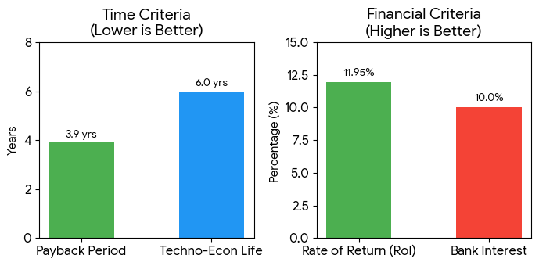
Figure 1: Visual comparison of calculated metrics against required thresholds.

Conclusion:
Since the Payback Period (3.9 years) is less than the Techno-Economic Life (6 years), and the Rate of Return (11.95%) is greater than the Bank Interest Rate (~10%), the economic conditions are favorable. The manufacturing unit should proceed with purchasing the robot via a bank loan.

