Course Notes: Jacobians & Robot Singularity

1. Defining Robot Singularity
A singularity is a specific mechanical configuration or pose where a robot loses one or more Degrees of Freedom (DoF). In this state, certain joints become 'locked' or effectively useless, restricting the end-effector from moving in specific directions regardless of how hard the motors turn.

2. The Mathematical Jacobian
To detect singularities mathematically, we use the Jacobian. In calculus, a Jacobian is a multi-dimensional form of a derivative. It represents a matrix of all first-order partial derivatives of a vector-valued function.

The Kinematic Jacobian Equation:
In robotics, the Jacobian matrix relates Joint Velocities (how fast the motors spin) to Cartesian Velocities (how fast the end-effector moves in X, Y, Z space).
V = J(θ) * θ'
- Where V is Cartesian velocity, θ' is joint velocity, and J(θ) is the Jacobian matrix.

Checking for Singularity:
To find joint velocities from a known Cartesian velocity, we must take the inverse of the Jacobian:
θ' = J⁻¹(θ) * V
Crucially, a matrix is only invertible if its determinant is non-zero. If the determinant of the Jacobian equals exactly 0, the matrix becomes singular, meaning the math breaks down and the robot has entered a physical singularity.
- Singularity Condition: Det( J(θ) ) = 0

3. Case Study: Singularity of a 2-DoF Planar Arm
Let's analyze a 2-DoF robotic arm with links L1 and L2 and joint angles θ1 and θ2 to find its singular positions.

Step 1: Forward Kinematics Equations
- Px = L1*cos(θ1) + L2*cos(θ1 + θ2)
- Py = L1*sin(θ1) + L2*sin(θ1 + θ2)

Step 2: Deriving the Jacobian
We calculate the partial derivatives of Px and Py with respect to θ1 and θ2 to build the 2x2 Jacobian matrix:
- J11 (∂Px/∂θ1) = -L1*sin(θ1) - L2*sin(θ1 + θ2)
- J12 (∂Px/∂θ2) = -L2*sin(θ1 + θ2)
- J21 (∂Py/∂θ1) = L1*cos(θ1) + L2*cos(θ1 + θ2)
- J22 (∂Py/∂θ2) = L2*cos(θ1 + θ2)

Step 3: Calculating the Determinant
The determinant of a 2x2 matrix [A B; C D] is (A*D - B*C). Multiplying and canceling terms using trigonometric identities simplifies the determinant to:
Det(J) = L1 * L2 * sin(θ2)

Step 4: Finding the Singularities
We set the determinant to 0:
L1 * L2 * sin(θ2) = 0
Since link lengths L1 and L2 cannot be zero, the only way this equation equals zero is if sin(θ2) = 0. Therefore, the singular angles are:
θ2 = 0° AND θ2 = 180°

4. Physical Interpretation
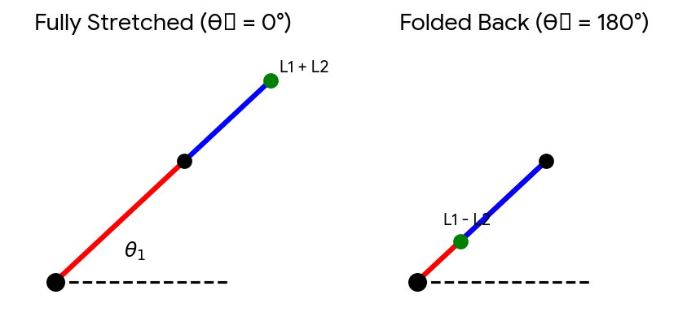
Figure 1: The two singular physical configurations of a 2-DoF arm.
- 1. Fully Stretched (θ2 = 0°): The arm is reaching as far as possible. The two links form a single rigid straight line. Joint 2 can no longer contribute to moving the end-effector inward/outward radially. The robot behaves as a 1-DoF arm with length (L1 + L2).
- 2. Folded Back (θ2 = 180°): Link 2 folds completely backward over Link 1. Again, the robot behaves as a 1-DoF arm, this time with an effective length of (L1 - L2).

