Project One: ABCollege Course Portal

¯¯¯¯¯¯¯¯¯¯¯¯¯¯¯¯¯¯¯¯¯¯¯¯¯¯¯¯¯¯¯¯¯¯¯¯¯¯¯
This project was developed for ABCollege to give school administrators a web interface for managing the courses they offered. They have provided the back end server and database.

Database
There are two tables that was used, one for user verification and the other contains details about the courses offered.

Server
The server provided us with different routes in order to access the database. For more details on the routes please see ABCollge Student Portal

Technologies used for Back End:
- Node JS – It is an open source run time for JavaScript that runs on a V8 engine. This allows the program to communicate with back-end.
- Node Packages:
-Express
- Express -sessions
- jest
- nodemon
-router
-super test
-fs for logs
- Express JS – Is a framework for JavaScript mainly to develop web or mobile applications.
- Jest – It is an open source Framework maintained by Facebook to test JavaScript.
- PostgreSQL – Open source relational database. It is considered as the most advanced database system.
- JavaScript/TypeScript – Java script as a front end more interactive while JavaScript as a backend enables the program to communicate with the server. TypeScript is a super set of JavaScript.

¯¯¯¯¯¯¯¯¯¯¯¯¯¯¯¯¯¯¯¯¯¯¯¯¯¯¯¯¯¯¯¯¯¯¯¯¯¯¯ABCollege Course Portal

Upon visiting the site, you will be presented by a log-in page, only authorized users are allowed to access the courses portal
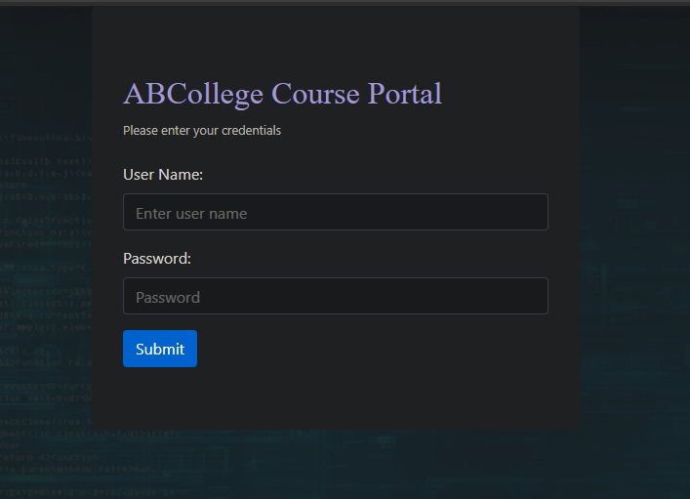

After login you will be redirected to the welcome page

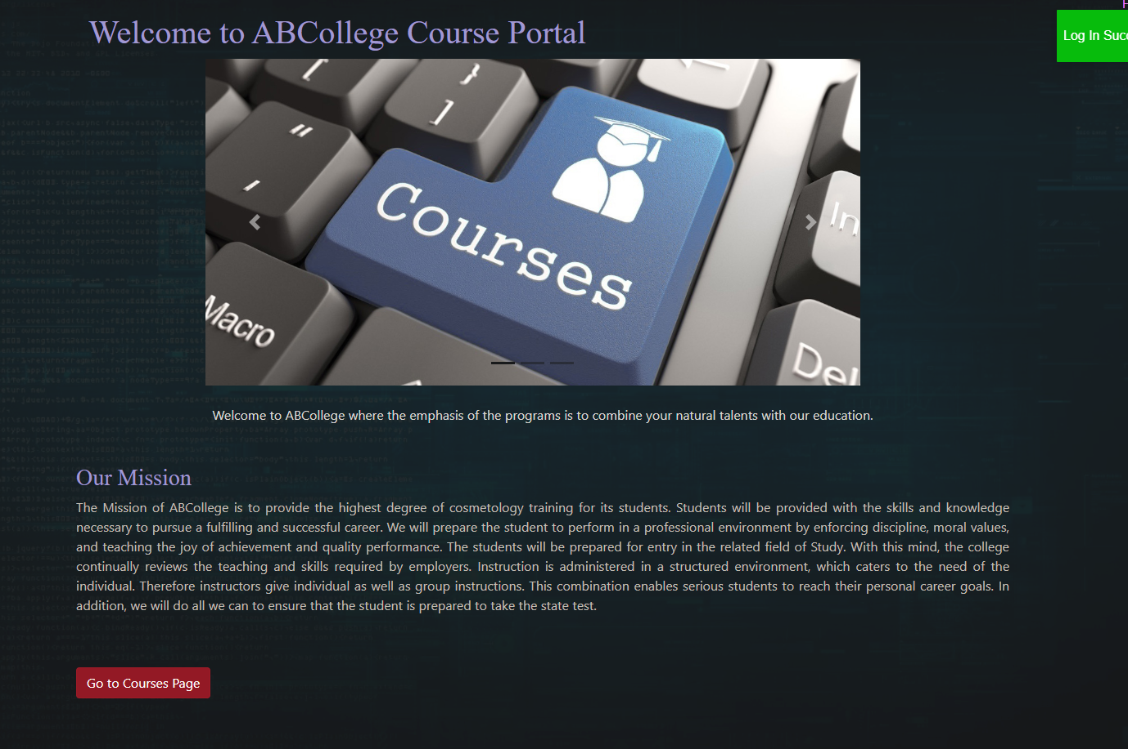
next, click on the “Go to Course Page” button to manage the course list. Alternatively, you can click in the courses link on the upper right of the page. Both will redirect you to the Courses Page

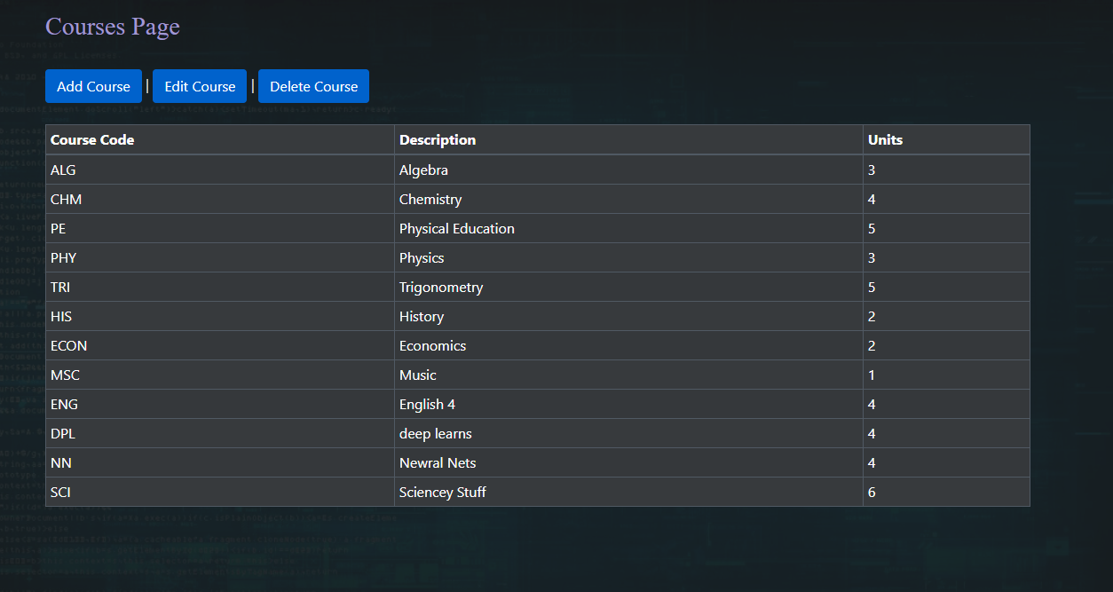
In the Courses page, you can view the list of courses offered and their respective course code, description, and number of units.

To add a new course click on the “Add Course” button. The user will be presented with a form
to fill in:

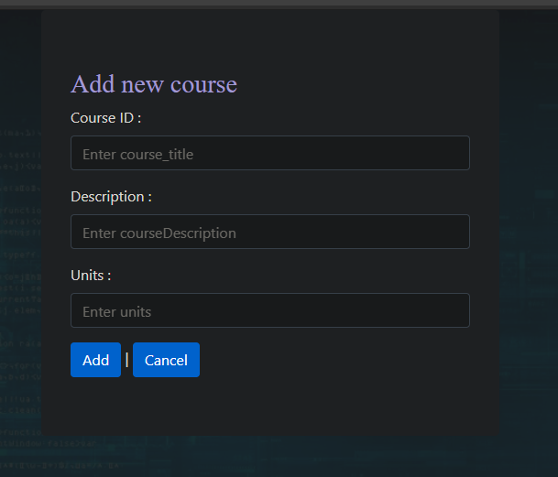
To edit an existing course, click on the edit course button. You can only edit the Description and Units fields as the Course Code is the unique identifier. The course list is shown below so the user has reference on the course codes.

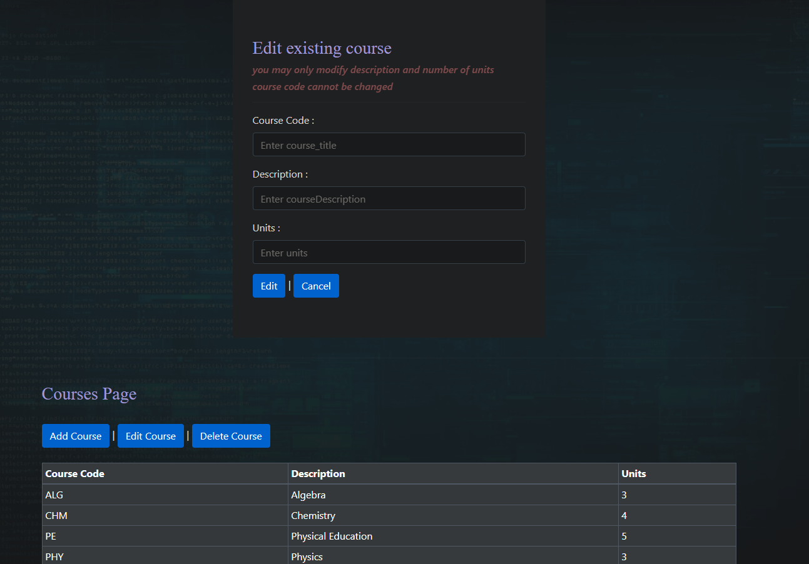

To delete a course, click on the “Delete Course” button. Enter the Course ID and it will be deleted from the Course List.

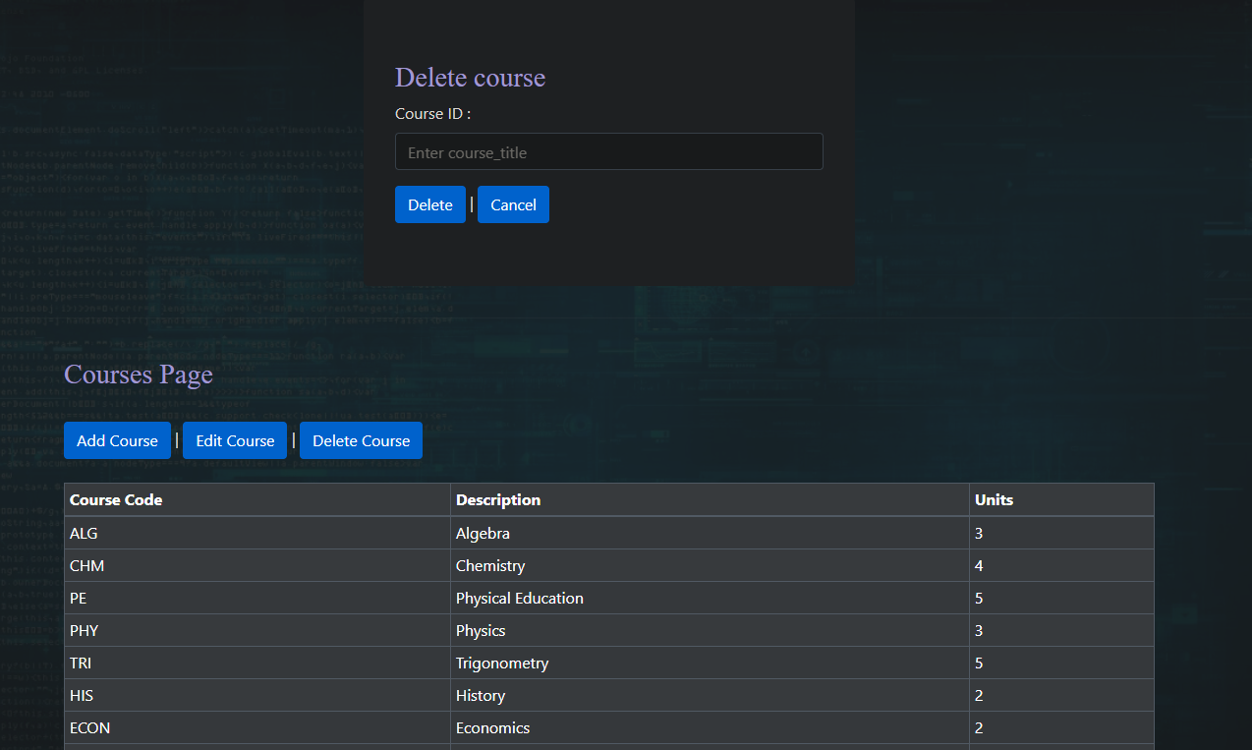

Technologies used for Front End:
- JavaScript-React
- Jest
- Enzyme
- Bootstrap

