

**A new way of learning English**

*iLearn, you learn, we learn.*

**Authors :                         Fioravanti Anthony**

**Sieradzki Florian**

**TELECOM Nancy 2nd year**



**Promotion : 2013-2016**

**Introduction**

English is everywhere nowadays, in our musics, in our game even in our common language. That is all true in information technogies world. In this dynamic, the iLearn team decided to offer a smart way to improve Shakespeare language.

The team consists of two Telecom Nancy's student. Telecom Nancy is an engineering school specialized in computer science.

In this document, we present you a new light and portable application that deals with English.

Summary

**Introduction** 2

User documentation 4

Home page 4

TOEIC 5

Step to apply 6

Order the resume 8

Documentation technique 9

Design 9

MVC : Modèle Vue Contrôleur 9

Exercices 10

Conclusion 11

# User documentation

Here is a little documentation to discover the software’s functionalities

## Home page

The home page is the simplest of the application. We can call it the portal, this is where you choose the exercise you want to do. This is the first view when you logged-in.

As you can see, there are three different exercises offered in the first iLearn version

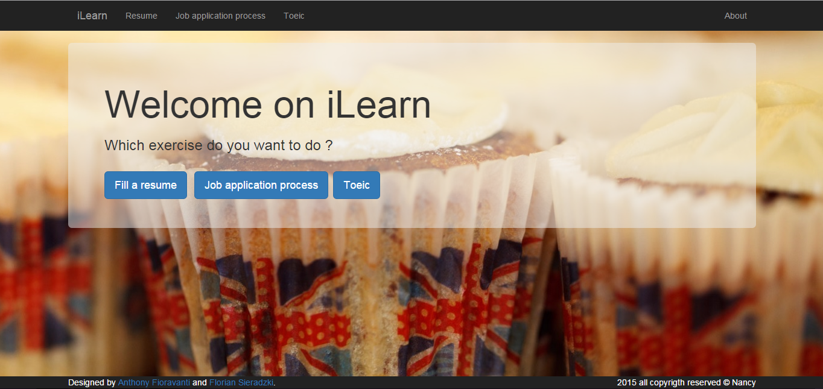

## TOEIC

The toeic section provides a simple and efficient way to improve the reading section of the English test. The application shows a question and proposes you four possibles anwsers.

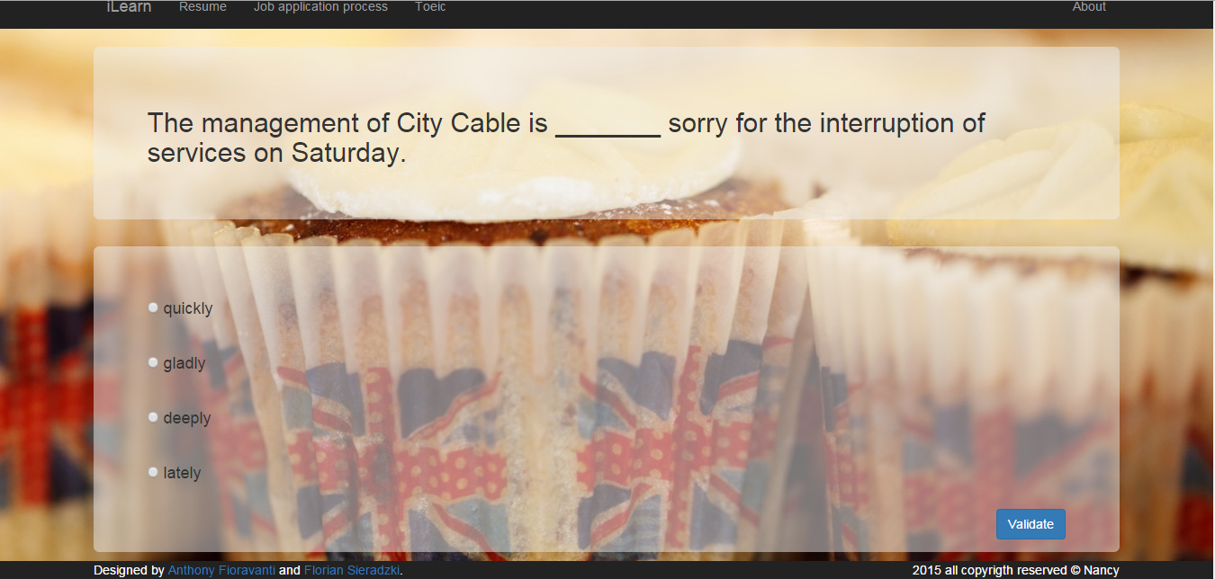

Once you have validated your choice, a popup window informs you about the result. After that you can retry or see the associated rule if you mistook.

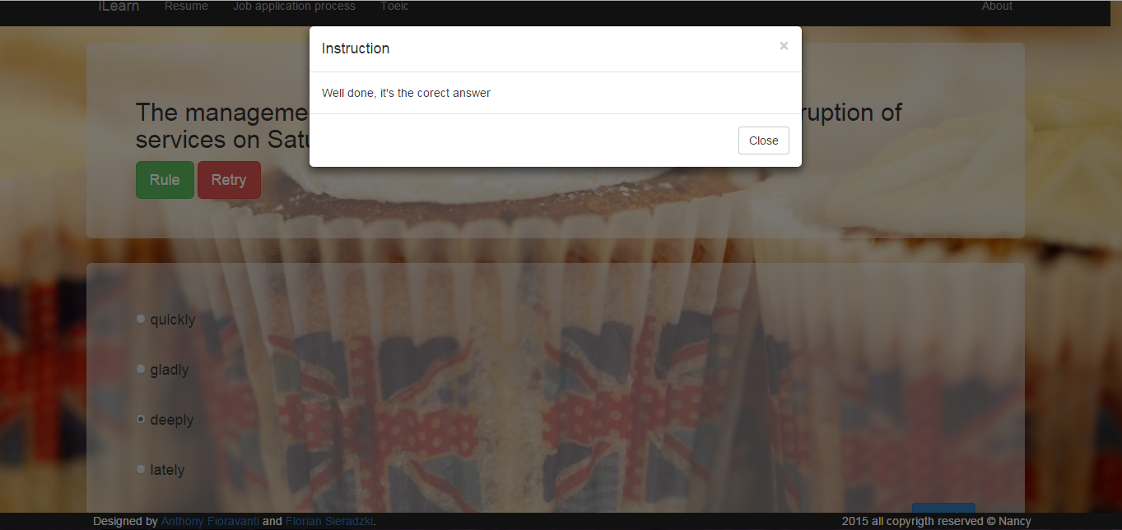

## Step to apply

In this exercise, the user must reorder the different steps to apply for a job.

You will find at the top right-hand-corner the instructions button if you want to have more information about the exercise.

You have to reorder the step, by a drag and drop process thanks to the computer mouse or your finger in case of mobile application version.

If the step is in the correct position, the background becomes green.

The user can click on the "What?" button and further information appear in another windows.

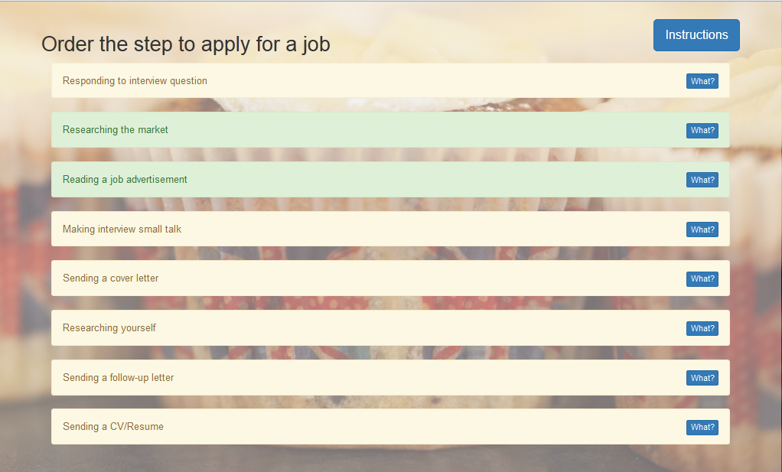

## Order the resume

In this exercise, the user must reorder the different parts of a resume.

Once again you can find at the top right-hand-corner the instructions button if you want to have more information about the exercise.

The aim of this exercise is the same than the prior one

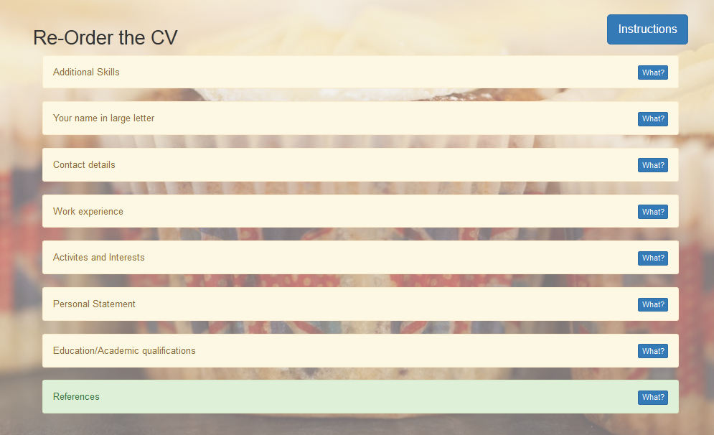

# Documentation technique

## Design

Pour la partie design, nous avons utilisé le framework Bootstrap. Le framework Twitter bootstrap est un ensemble d'outil proposant divers fonctionnalités permettant la mise en place rapide d'effets visuels et d'ajout de composant comme par exemple les boutons et les bars de navigation.

## MVC : Modèle Vue Contrôleur

Le patron de conception MVC a été utilisé pour le développement de cette application.

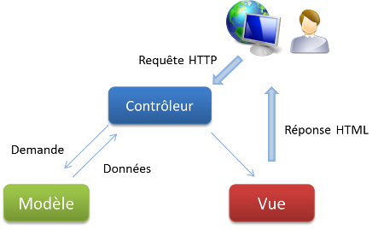

C’est un modèle de conception permettant une plus grand flexibilité et maintenabilité du code et de l’application en général. Un suivi par une autre équipe de développement est ainsi plus aisé

Un modèle accède aux données. Un contrôleur traite les données et les envoie à une vue qui va les afficher sur le navigateur de l’utilisateur.

## Exercices

Pour  la mise en œuvre et le choix  des exercices, nous avons décidé d'utiliser des exercices vus en cours pour essayer d'intégrer certaines notions, comme la structuration d'un CV ou les différentes étapes lors de la recherche d'un emploi. Nous avons voulu avoir des exercices qui soient simple et rapide à comprendre pour les utilisateurs.

# Conclusion

This application reachs its goal : to improve his english skills in a clever template. As we said, that's a new way to understand english professionnal cultur. If you are able to make a good resume, you will be better prepared to apply for the position you want. If you have good command of professionnal vocabulary, you'll be ahead in the application process. Here is the first version of the webApp.

It could be upgraded, for example, adding more exercises, listening and writing tests. A second version will implement these functionalities and we decided to add sessions management (students and teachers accounts) and automatic correction with email delivering.

To put it in a nutshell, it was a good project and we decided to improve it on our free time. It will be a demo webApp of our skills when application process will come.

**Sources**

|  |  |
| --- | --- |
| **Author** | **Source** |
| AngularJS framework Documentation | https://angularjs.org/ |
| NodeJS | https://nodejs.org/ |
| Bootstrap | http://getbootstrap.com/ |
| GitHub | https://github.com/ |
| WebStorm | https://www.jetbrains.com/webstorm/ |
| SourceTree | https://www.sourcetreeapp.com/ |