**Project Documentation**

**Title of website:** Planets in the Universe

**Theme of website:** To give information about eight planets in the solar system.

**Introduction:**

I made the website on the planets because I have great interest in the universe. I want to explore the astronomical objects. I like to study about the planets, and want to share the knowledge about the planets as much as I can.

There are a lot of sources on the Internet to get each and every information about the planets. But I tried to provide this information in the simplest way through my website.

**Website Organization:**

There are three pages in the website.

First page gives some basic knowledge about planets and solar system with the help of some paragraphs, image of planets revolving around the sun, video delivers some information about solar system and there is a trick to remember the names of the planets in order. The users can also find their weight on the different planets with weight calculator and they can learn about the main fact about the respective planet with the help of a game.

Second page is about interesting information for every planet with its images (the images are dynamic in nature whose width and height increase when the user will hover the mouse pointer over it and when the user will take mouse pointer away from the image, the image takes its original width and height). At last, there is a table comparing some facts of every planet.

Finally, the third page has some questions with answers to enhance knowledge about the planets. It also has a form for feedback.

**Website Layout Documentation:**

For First page:

1. Float

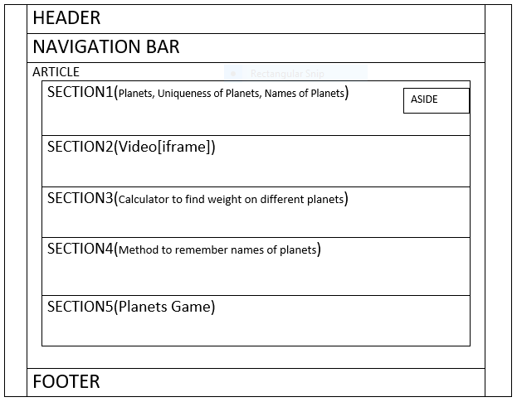

For second page:

1. Flexbox

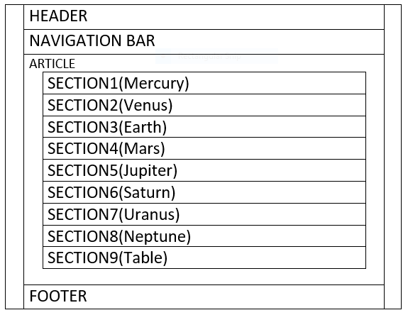

For third page:

b.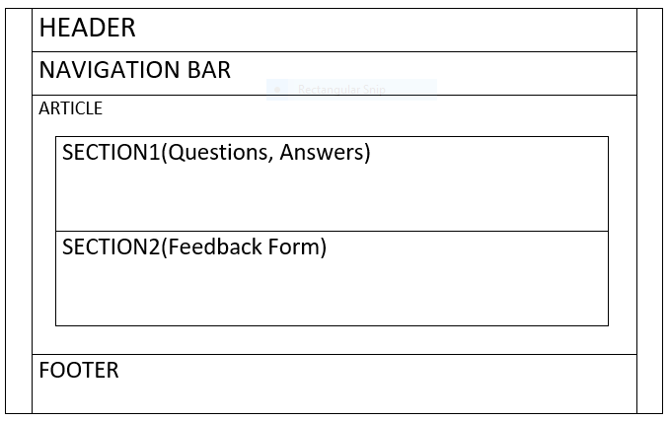

**Highlight part:**

My website has a weight calculator for different planets in the first page. I feel, this is very interesting part of my website. However, there are a lot of sources to find the weight on different planets. But it is my first approach to make a website, so I am expecting that it is an attractive part of my website. I also want to put focus on the planets game in the first page because it took me a plenty of time to find images to set the background color change-able.

**Content declaration:**

For text content, I used the following websites:

* Planets: https://en.wikipedia.org/wiki/International_Astronomical_Union
* Uniqueness of planets: <https://www.universetoday.com/38118/how-was-the-solar-system-formed/>
* Mercury: <https://en.wikipedia.org/wiki/Mercury_(planet)>
* Venus: https://en.wikipedia.org/wiki/Venus
* Earth: <https://en.wikipedia.org/wiki/Earth>
* Mars: <https://en.wikipedia.org/wiki/Mars>
* Jupiter: <https://en.wikipedia.org/wiki/Jupiter>
* Saturn: <https://en.wikipedia.org/wiki/Saturn>
* Uranus: <https://en.wikipedia.org/wiki/Uranus>
* Neptune: <https://en.wikipedia.org/wiki/Neptune>

For images and media content, I used the following websites:

For images:

* Solar_System: <https://pixabay.com/photos/solar-system-sun-mercury-venus-439046/>
* Mercury:https://cdn.pixabay.com/photo/2015/06/26/18/48/mercury-822825__340.png
* Venus: https://pixabay.com/photos/venus-surface-hot-heat-planet-11022/
* Earth: <https://pixabay.com/photos/earth-blue-planet-globe-planet-11015/>
* Mars: <https://pixabay.com/photos/mars-red-planet-planet-starry-sky-11012/>
* Jupiter: https://pixabay.com/vectors/jupiter-planet-solar-system-153563/
* Saturn: https://pixabay.com/photos/saturn-planet-saturn-s-rings-5255043/
* Uranus: https://pixabay.com/illustrations/uranus-planet-space-celestial-body-5559037/
* Neptune: https://cdn.pixabay.com/photo/2012/11/28/09/17/neptune-67537__340.jpg
* Messenger: https://www.universetoday.com/wp-content/uploads/2014/09/2007-0228messenger.jpg
* Mariner_10: https://media.wired.com/photos/59331905a4b3d04a471894bc/master/w_2560%2Cc_limit/Mariner_10.jpeg

For game:

* Mercury1: https://i.pinimg.com/originals/d0/86/52/d08652aeab047160c6a2f2c56ace12fc.png
* Venus1: https://cdn.pixabay.com/photo/2012/04/10/17/39/venus-26620_960_720.
* Earth1:https://cdn.pixabay.com/photo/2016/06/14/20/38/planet-earth-1457453_960_720.png
* Mars1: https://upload.wikimedia.org/wikipedia/commons/2/27/Mars_transparent.png
* Jupiter: https://pixabay.com/vectors/jupiter-planet-solar-system-153563/
* Saturn1: <https://pixabay.com/illustrations/saturn-saturn-s-rings-planet-4314403/>
* Uranus1: <https://pixabay.com/vectors/uranus-solar-system-planet-153572/>
* Neptune1: <https://pixabay.com/vectors/neptune-solar-system-planet-153571/>

For media files:

iframe(video): <https://youtu.be/libKVRa01L8>

**References:**

I used some material from w3schools.com