**Library Database Management Project Table Normalization Documentation**

The Library Database Management Project included tables in 2nd Normalization form. There were no repeating fields in every row of the table. Hence the tables were already in 1st Normalization form. And the columns in the tables were entirely dependent of the primary key. Library_ID_Number was the primary key for Library table and the related fields in the Library table like Library_Name, Director_Name, Contact_Number, Address, City, State, ZipCode, Timings were directly dependent on the Library_ID_Number and identified by this primary key. Other tables in the database like Book, eBook, Journal, eJournal, DVD, CD etc were also in 2nd Normalization form.

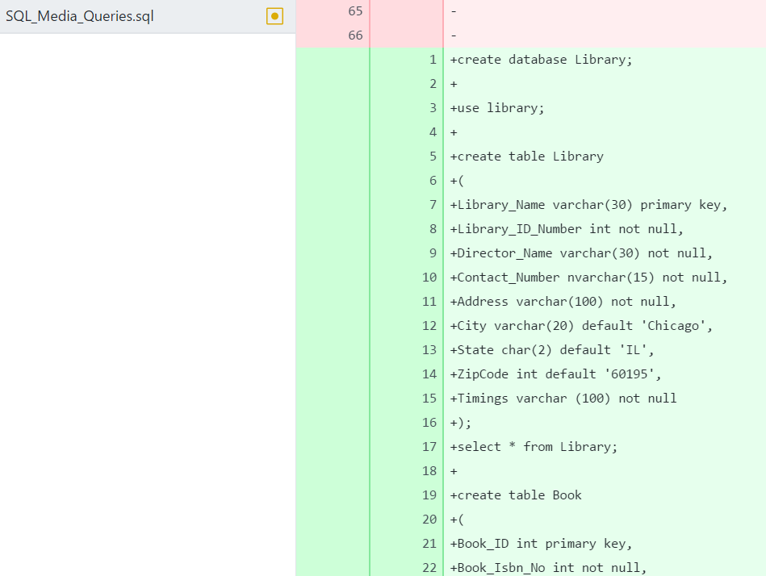

Figure Library Table

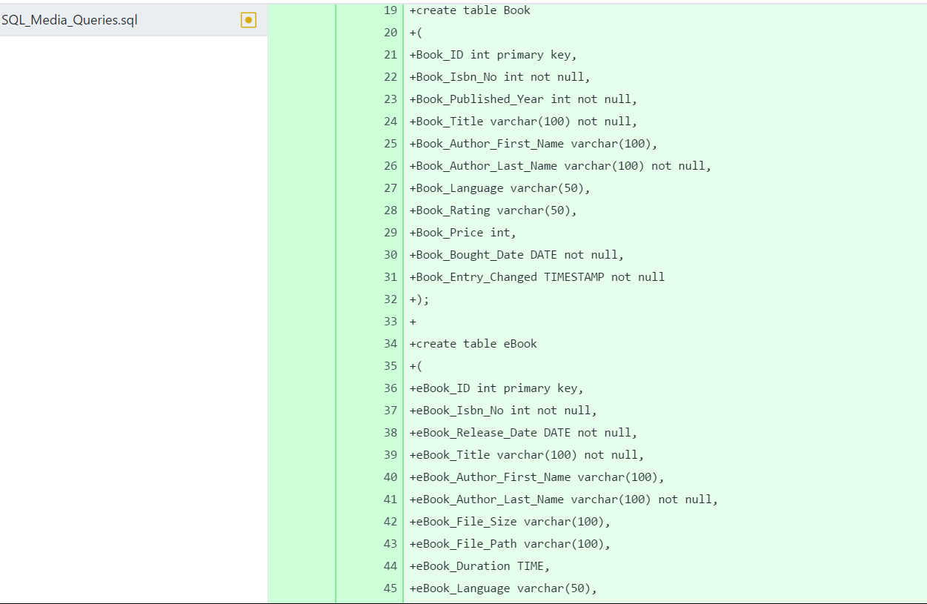

Figure Book & eBook Table

Even though in 2nd Normalization form, some tables had redundancies in repeating columns of data, for example in Book table, Book_ID was unique per physical copy of the book, but columns like Book_ISBN_No, Book_Published_Year, Book_Title, Book_Author_First_Name, Book_Author_Last_Name etc. columns were unique to the book and were repeated for every copy of the book. This case was similar to eBook, Journal, eJournal, DVD, CD tables. To update them to 3rd Normalization form, every column had to depend entirely on the primary key. For this the transitive dependency had to be created by creating an associate table structure. This was done, by separating columns pertaining to Book details from other columns unique to every copy of the Book. Creating Book as an associate table, containing Book_Media_ID, Book_ISBN_No and Book_Bought_Date as unique to every copy of the book, and Book_Details as the table with columns regarding a book eg. Book_Details_ISBN_No , Book_Details_Title, Book_Details_Author_First_Name, Book_Details_Author_Last_Name updated the tables to 3rd Normalization form.

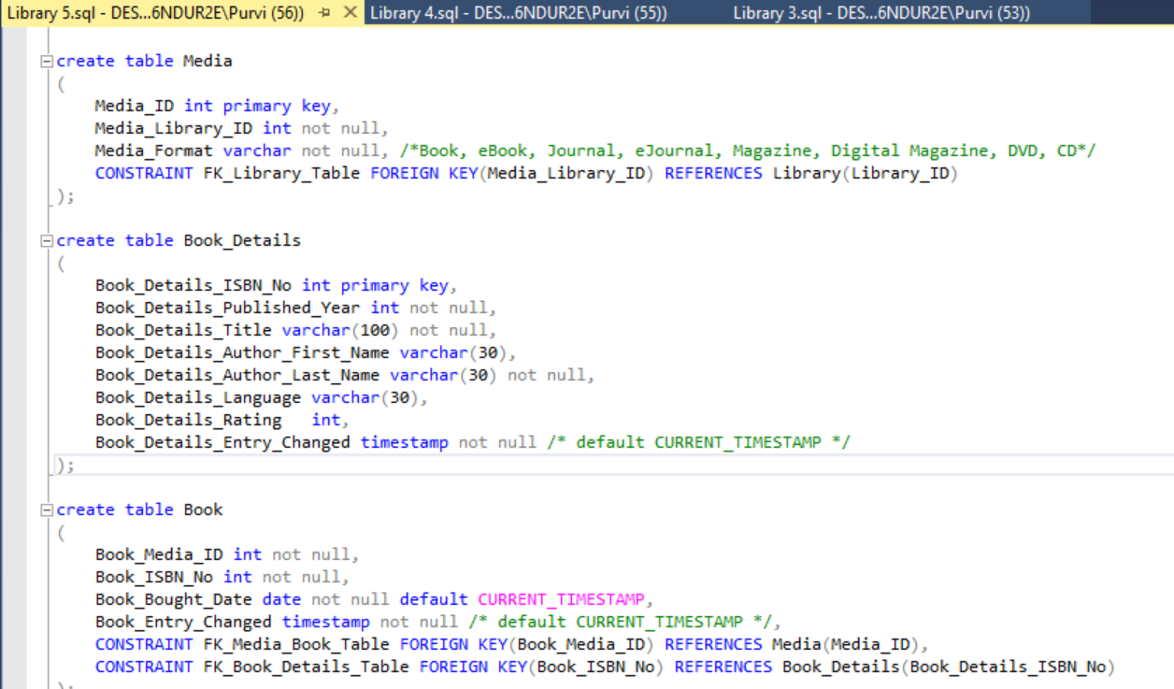

Figure Media and Book Table in 3rd Normalization Form

Over a period of weeks, the tables were updated to add more tables related to the Library Database and some fields and their formats were changed. For more history regarding the update to the Library Database Management table refer to the Git project: <https://github.com/pKpallavi/Library_SQL_Project_2017>.