Circulation Statistics for 2016-2017

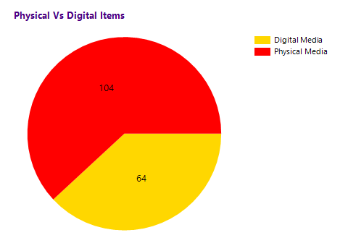
Total Library Members enrolled = 20

Total Items bought in 2016-2017 = 12

Total Items checked out in 2016-2017 = 3

