**Jenkins - Github – Maven**

1. Login into Jenkins with Jenkins username and password.

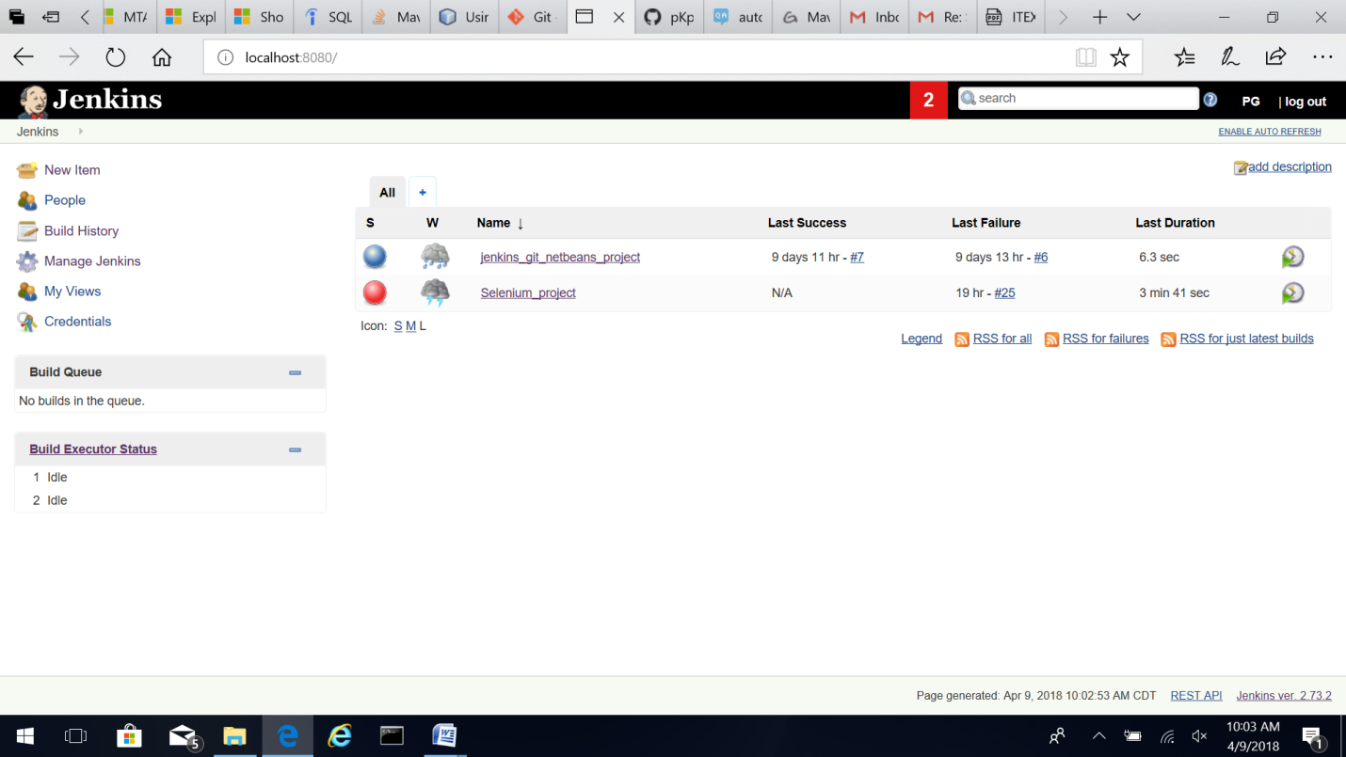

1. Click on New Item.

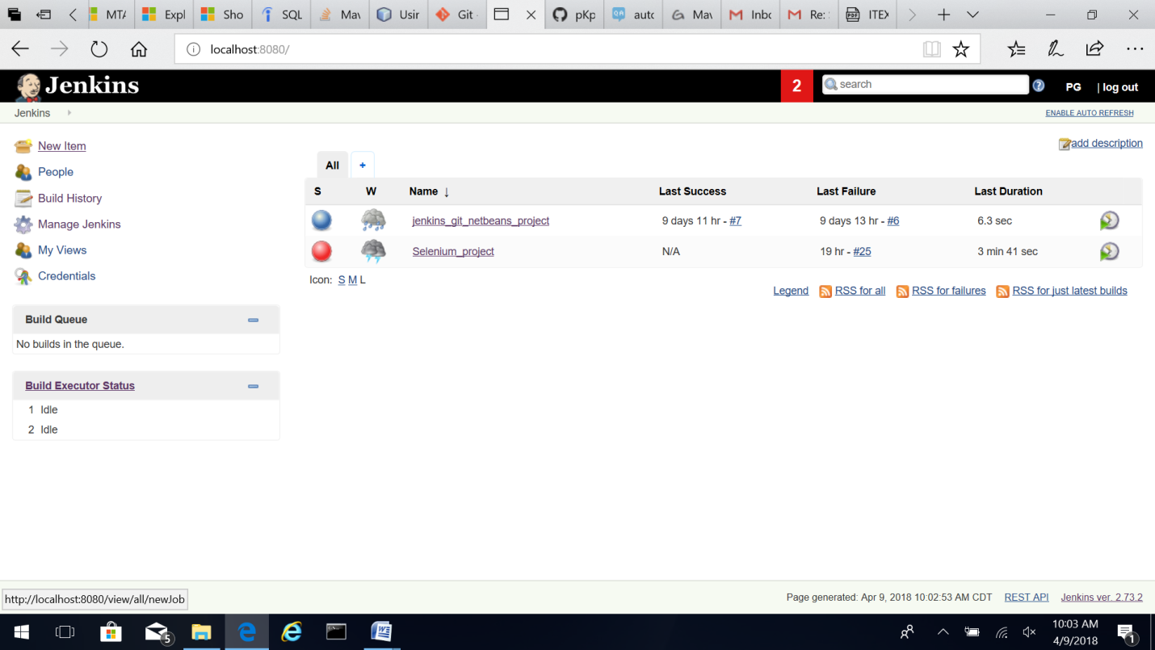

1. Enter project name and select “Freestyle Project”. Click OK.

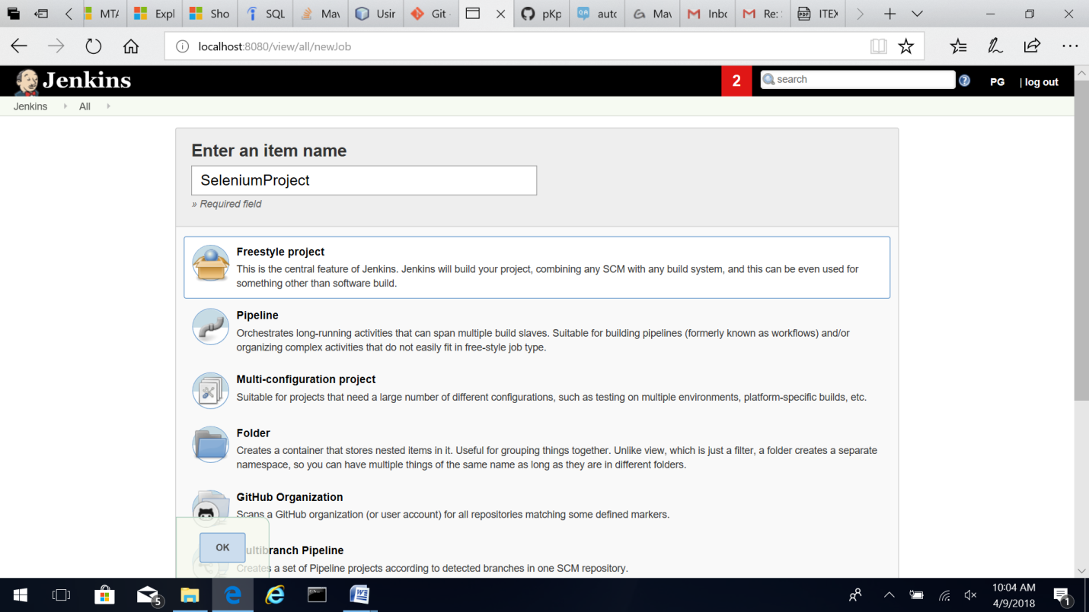

1. In SeleniumProject select “Configure” option.

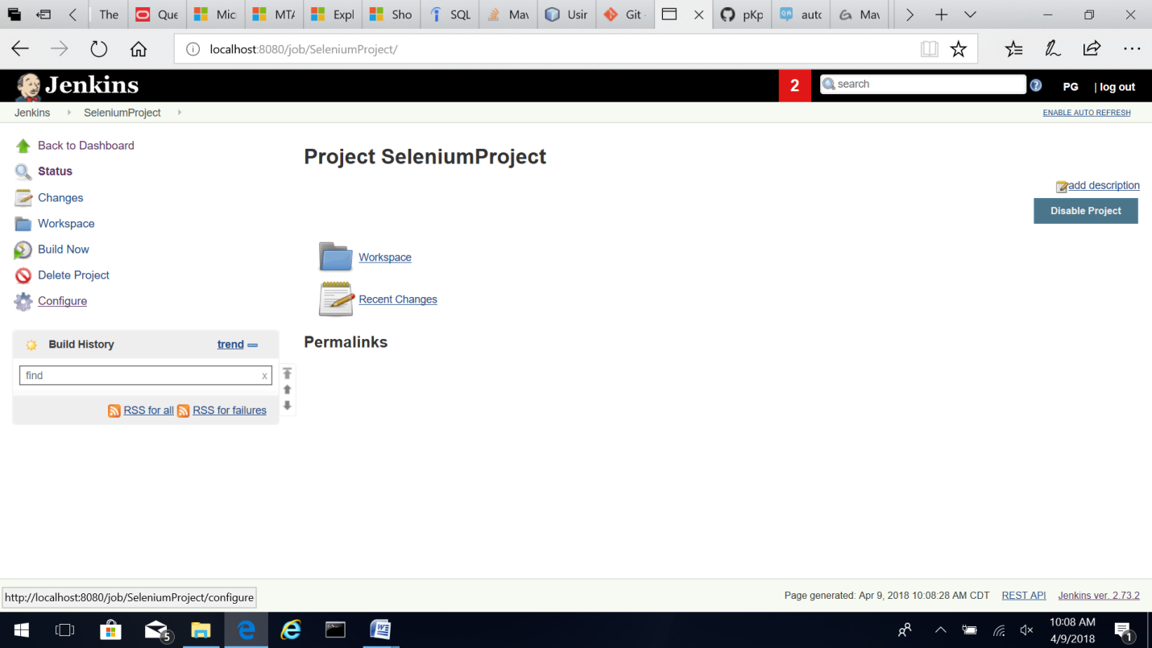

1. In General options of the project, click Advanced options. 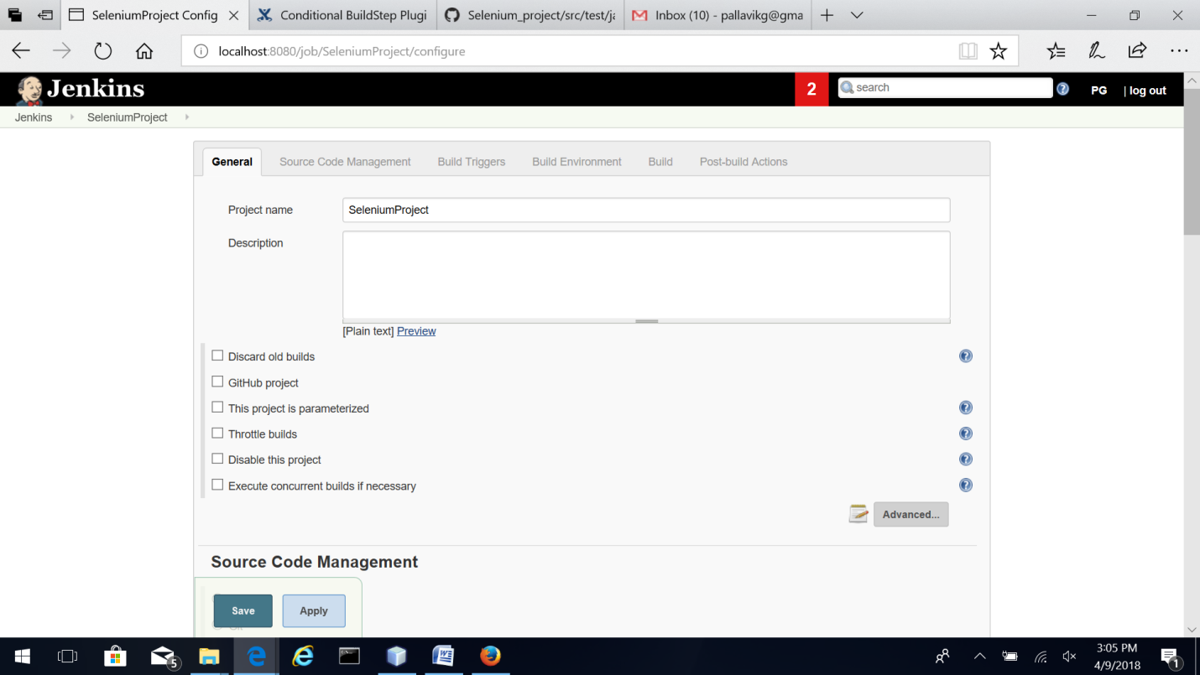
2. Click on Custom workspace. Create a sub-folder in the NetBeansProjects folder to check out the code from GitHub and use this same folder as Jenkins workspace.
3. 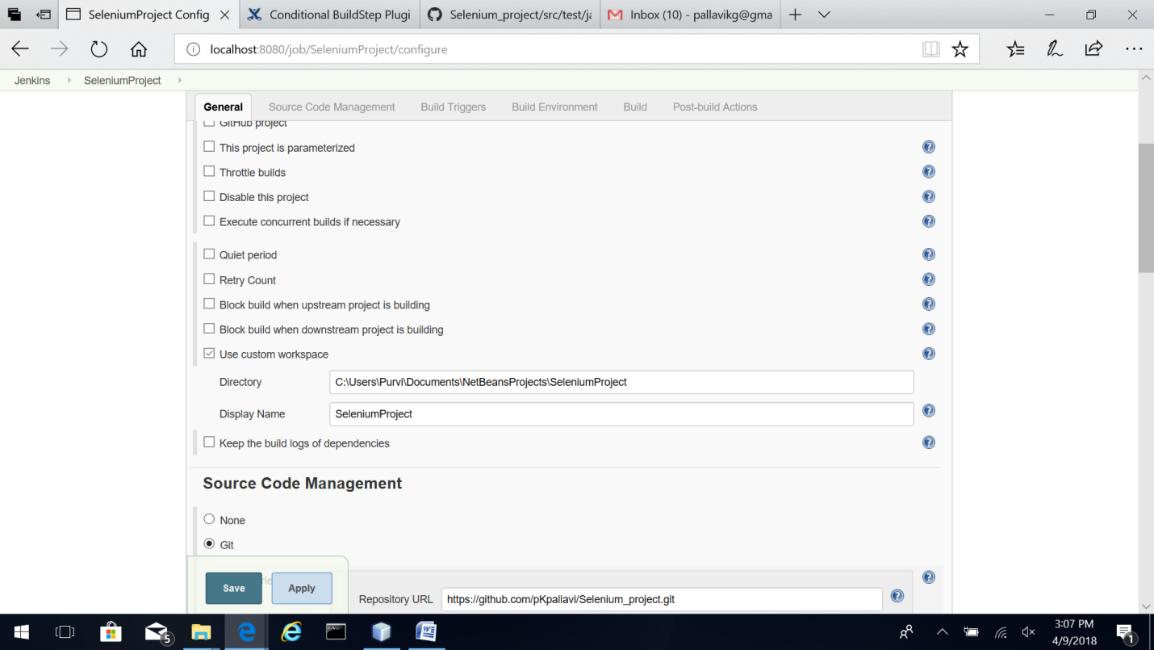
4. Copy the Git Repository URL of the project. This can be found in GitHub project. 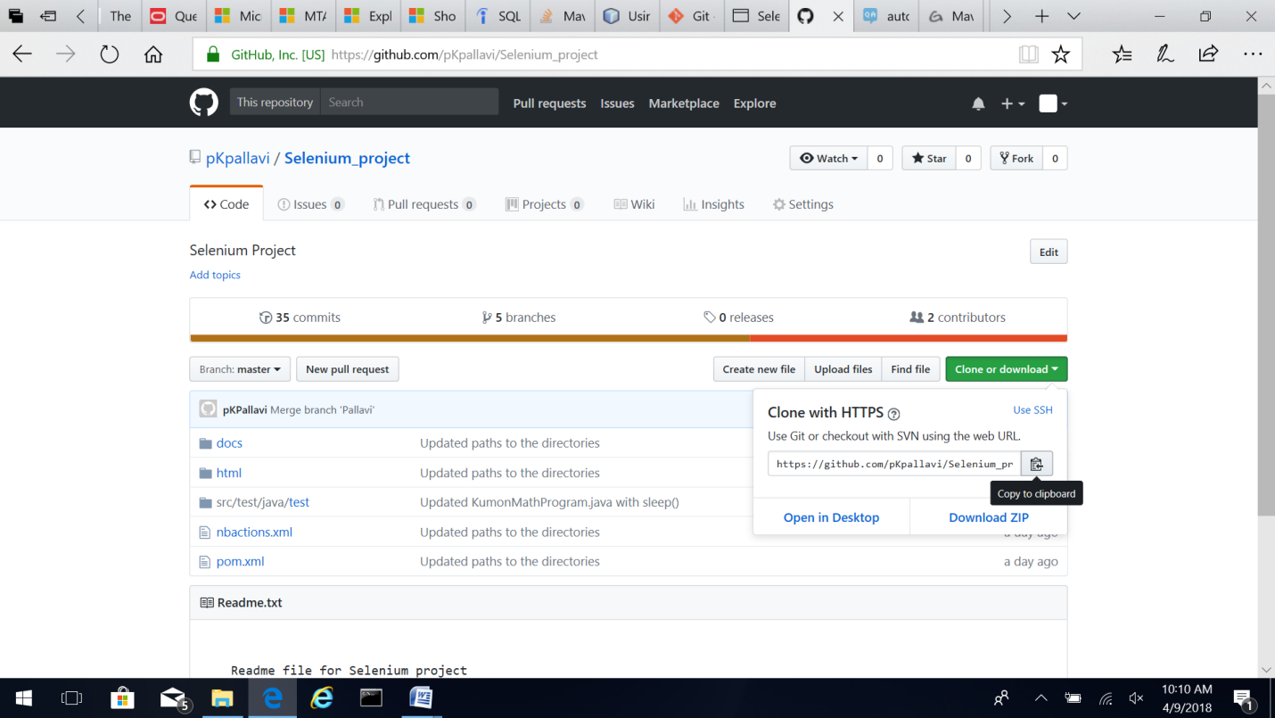
5. Add the repository URL in “Source Code Management” Git option.

<https://github.com/pKpallavi/Selenium_project.git>.

Write the branch to be built. If you are testing your code through Jenkins you can use the specific branch. In “Additional Behaviours” option select “Check out to a sub-directory”. Use the same sub-folder in the NetBeansProjects folder to check out the code from GitHub.

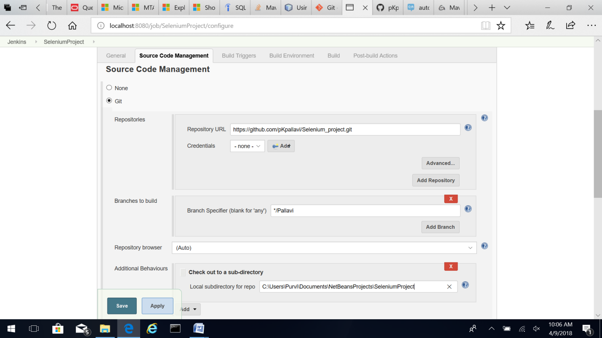

1. Select “Delete workspace before build starts” option.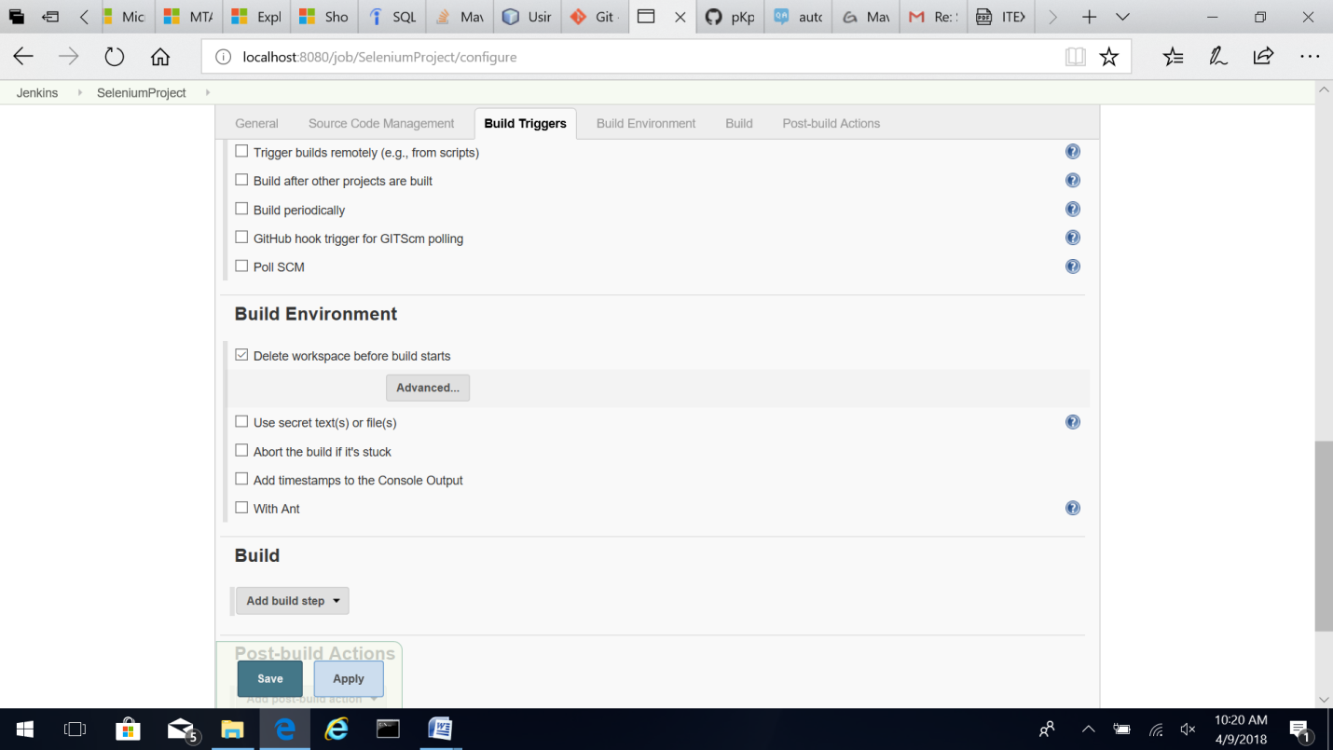
2. In Build option select “Invoke top-level Maven targets”.

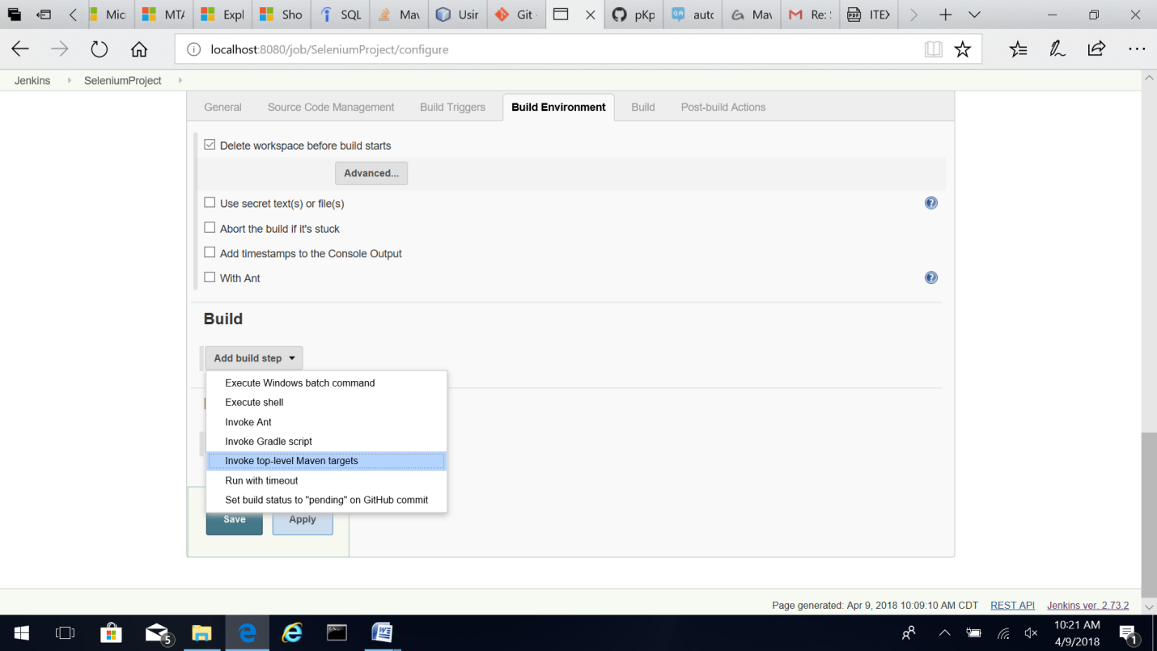

1. Add the following options in Build settings. Specify the full path to pom.xml.

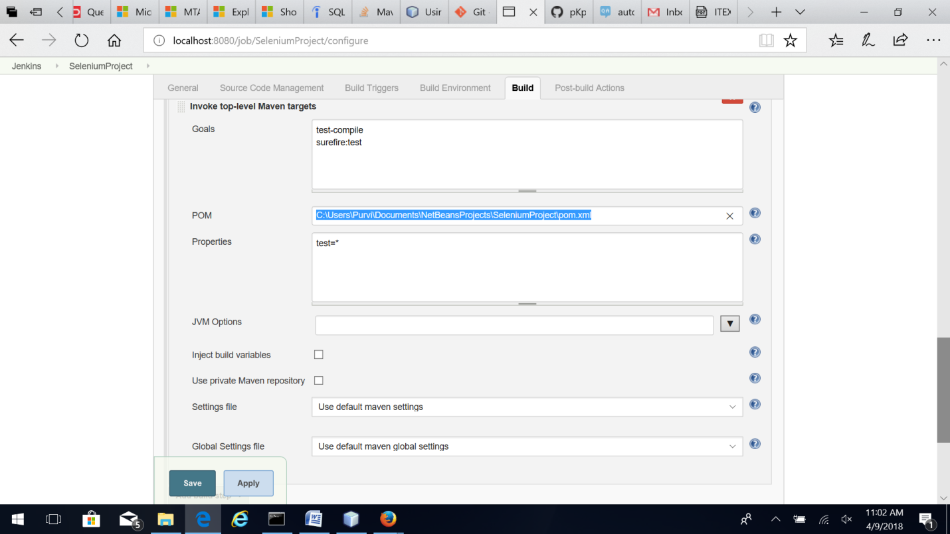

1. In Post-build actions select “Publish TestNG Results”. 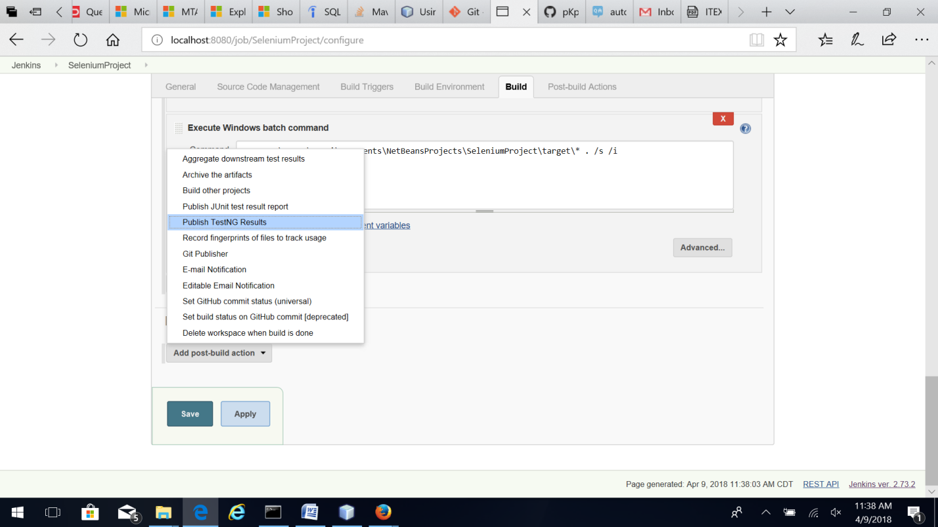
2. Give the path to the TestNG test report as target/surefire-reports/testng-results.xml. 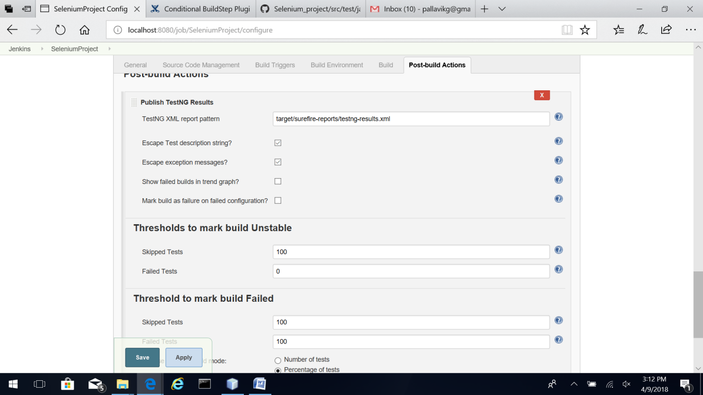
3. Build the project. View the TestNG results on the project dashboard.