# The Installation and Configuration of the Couchdb

## Opening port for external web server access

Couchdb is one kind of NoSQL database systems (DBS) for distributed system as well as abilities of this database are aligned with project’s requirements because of global twittering analysis and distribution-based architecture. Based on this conceptual idea, couchdb can be implemented in this project and installed in a virtual machine by the command line tool. Also, the couchdb can be accessed by HTTP so that the bind_address is required to modify to 0.0.0.0 for client access. The diagram 1.1 illustrates the installation of the couchdb.

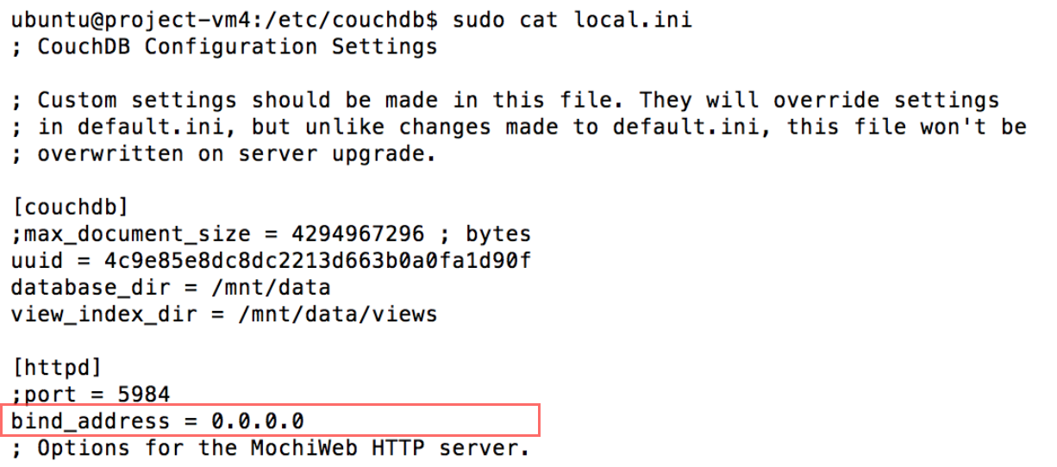

Diagram 1.1: Changing bind_address for client access.

## Accessing to the Couchdb

Executing “curl –X Get <http://yourdatabaseip:5984/_all_dbs>” to the command line and <http://115.146.95.53:5984/_utils/> to the webpage, as a Futon webpage, are useful approaches, verifying whether the couchdb is working or not. The diagram 1.2 and 1.3 depict the process of installing and verifying couchdb.



Diagram 1.2: A command script to check all of DBS in the couchdb

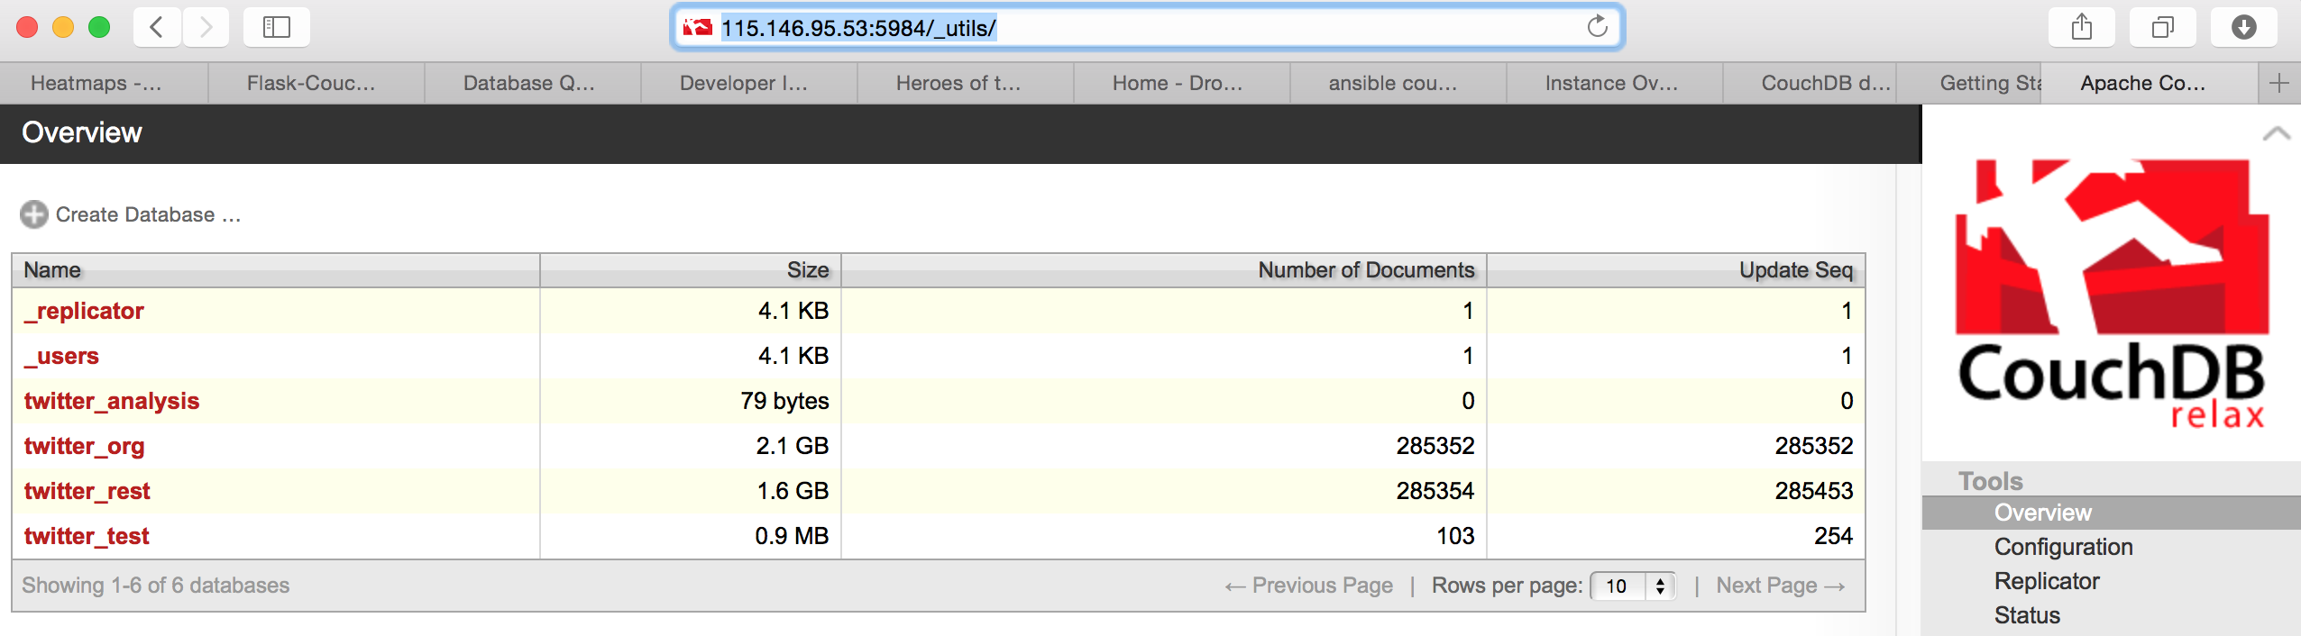

Diagram 1.3: Futon webpage for verifying all of DbS in the couchdb

## The attachment of volumes

The system also attaches a volume to the DBS because it may be increased incrementally due to inserting the tweet data on a daily basis for purposes of data and sentiment analysis. The diagram 1.4 shows a volume has been attached in couchdb partition.

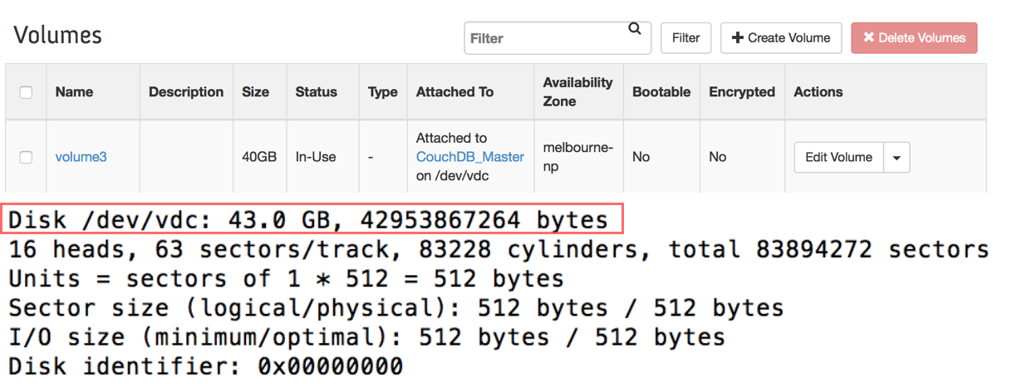

Diagram 1.4: The volume for the DBS partition

## Configurations of the replication

## Replication is essential for data backup as well as avoids accidental disaster. This disaster recovery in Couchdb can be implemented by web configuration as a continuous mode so that this recovery is executed constantly. The diagram 1.5 depicts the status of this recovery.





Diagram 1.5: the status of the replication