*Scenario Analysis 6: Timeline for Chicago Bulls*

Chicago Bulls is an American professional basketball team based in Chicago. The NBA playoffs is currently going on in America and should expect a large number of tweets regarding their home basketball team by the people of Chicago.

Unfortunately it was hard to distinguish the tweets from generic ones regarding pit bull dogs, red bull drinks etc. Hence we collected and analyzed the tweets regarding Chicago Bulls.

This time line traces the changes in sentiment over time. We had only around 300-400 tweets to do a sentiment analysis and this sample may not be true for the collective whole.

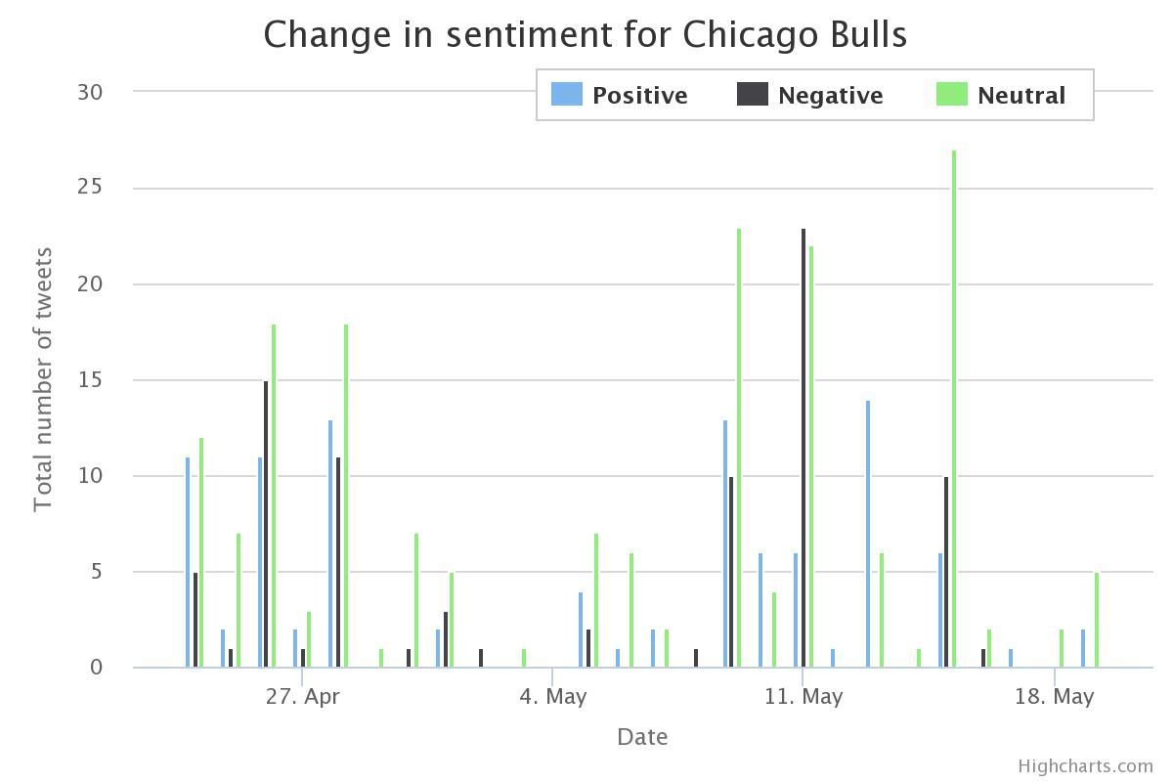

We can compare this against the game schedule of Chicago Bulls and how they fared.

Schedule of Chicago Bulls Semifinals:

|  |  |  |
| --- | --- | --- |
| **Date** | **Opposing Team** | **Win/Lost** |
| April 23rd | Milwaukee Bucks | Win |
| April 25th | Milwaukee Bucks | Lost |
| April 27th | Milwaukee Bucks | Lost |
| Apr 30th | Milwaukee Bucks | Win |

Schedule for Chicago Bulls Quarter Finals:

|  |  |  |
| --- | --- | --- |
| **Date** | **Opposing Team** | **Win/Loss** |
| May 4th | Cleveland Cavaliers | Win |
| May 6th | Cleveland Cavaliers | Lost |
| May 8th | Cleveland Cavaliers | Win |
| May 10th | Cleveland Cavaliers | Lost |
| May 12th | Cleveland Cavaliers | Lost |
| May 14th | Cleveland Cavaliers | Lost |

Most of the tweets were neutral, however we can see a spike in the negative tweets. This could be attributed to losses faced by the Chicago bulls. The number of positive tweets peaks during April 23rd which is when Bulls won against Milwaukee Bucks, but gets more negative on April 26th as they lose.

We again see a spike in negative tweets after Bulls lost against Cleveland Cavaliers on May 10th. But it does seem they became neutral about their team as Chicago Bulls close this season with a loss on May 14th.

NeCTAR Research Cloud

NeCTAR is based on the OpenStack™ is an open-source Infrastructure-as-a-Service (IaaS) platform. OpenStack was founded by joint efforts from Rackspace and NASA in 2010.

OpenStack is open of the fastest growing open source communities in the world with more than 18,000 individual contributors and 430 participating companies. The IT industry shows the widest uptake, and adoption is increasing in Academic/Research, Telecommunications, Finance, Media, and more. OpenStack is being widely adopted across many global regions, with an increasing number of OpenStack deployments moving from test/staging environments into production

One of main advantages of OpenStack is availability of a centralized dashboard through which we can manage the computing, storage and networking resources. The project mainly used python BOTO interface for the image creation and volume provisioning. Another advantage is the ability to utilize open source technologies, this allowed us to software which might has been unavailable to us in a closed proprietary platform like Azure.

The Dashboard allows for easy setup and creation of security groups and access to the application. However it is a bit complex for first time users unless they have encountered similar systems before. OpenStack also offers multiple other services such as Orchestration, Block Storage etc. which we have not made use of in our application.

The major issues we did face with Nectar was its stability. We had instances of down time as well as networking errors while trying to provision new instances and volumes. This could be attributed to the fact that Nectar is used by a large number of research groups from across Australia and availability of resources per zone. This was compounded by the reboot required due to Venom, we could not access the master node containing the main CouchDB instance and the volume attached was missing for a few hours.

We had implemented another backup database as a failsafe, which helped to diminish any panic we felt during this issue.