**NEWSPAPER AGENCY**

**APPLICATION DEVELOPMENT – II**

**SOFTWARE DESIGN SPECIFICATION**

**Submitted in partial fulfillment for the award of the degree**

**Of**

**Master of Technology**

**In**

**Information Technology**

**By**

**SANKET SURESH PETHKAR**

**REG NO: 14MIN2879**

**School of Information Technology and Engineering**

**September, 2017**



|  |  |
| --- | --- |
| Newspaper Agency | Version: 1.0 |
| Software Design Document | Date: 2017-09-02 |
| SDD- Newspaper Agency | |

Revision History :

|  |  |  |  |
| --- | --- | --- | --- |
| Date | Version | Description | Author |
| 07/17 | <1.0> | Initial Version of Document | Sanket Suresh Pethkar |
|  |  |  |  |
|  |  |  |  |
|  |  |  |  |

Document Approval:

The following Software Design Document has been accepted and approved by the following:

|  |  |  |  |
| --- | --- | --- | --- |
| Signature | Printed Name | Title | Date |
|  | Sanket Suresh Pethkar | Newspaper Agency | 2nd September 2017 |
|  | Evaluator Name |  |  |
|  |  |  |  |

**Table of Contents**

|  |  |  |
| --- | --- | --- |
| **Sr. No** | **Topic** | **Page No.** |
| 1 | Introduction | 4 |
| 1.1 | Purpose | 4 |
| 1.2 | Scope | 5 |
| 1.3 | Project Overview | 6 |
| 2 | System Overview | 6 |
| 3 | System Architecture | 8 |
| 3.1 | Architectural Design | 8 |
| 3.2 | Decomposition Description | 10 |
| 4 | Data Design | 19 |
| 4.1 | Data Description | 21 |
| 4.2 | Data Dictionary | 22 |
| 5 | Component Design | 24 |
| 6 | Human Interface Design | 26 |
| 6.1 | Overview of user Interface | 26 |
| 6.2 | Screen Images | 26 |

1. **INTRODUCTION**

The modern industrial world is very much advanced in technology and competition in the world is intense. The user of a computer is provided with the HARDWARE and SOFTWARE, the two source of the computer. Much of the software will be programs which facilities the fast automatic management of the computer system resource.

“The Newspaper agency System” is one can go into almost required solution regarding the newspaper agency. This software package provides guidance for all the newspaper shop purpose, as a perfect guide, the current demand for such software became needful. This project will provide for computerization of a small agency whose main goal is to keep the detail information about the customer, supplier, newspaper and billing process and wants to change from paper based work to computerized system.

* 1. **PURPOSE**
* **“The Newspaper agency System”** is one can go into almost required solution regarding the Newspaper shop.
* Software we can easily track all the customer detail, supplier detail, newspaper detail, stock detail, bill detail and also we can able generate report.
* The main goal of the software is build a good management tool.
* The newspaper agency system will make storing of the customer records, stock records, sales detail, employee information, expense detail and order details in the database it will generate bills and print the bills.
  1. **Scope**
* This software is used to maintain day to day activities for the newspaper agencies, like maintain customer details, requirement details, which paper needed for particular day, product master with day to day rate, daily requirement and stock entry, line and supplier details, transaction, creation of bills for single customer to all customer, payment collection, reports.
* It is totally self-contained and works efficiently.
* It provides simple database rather than complex ones for high requirements and it provides good and easy graphical user interface to both new as well as experienced user of the computer.
  1. **Definitions, Acronyms, and Abbreviations**

NPA: Newspaper Agency.

POC: Point Of Contact.

* 1. **References**

Links

* <http://www.google.com>
* <http://stackoverflow.com/>
* <https://en.wikipedia.org/wiki/Swing_(Java)>
* <http://www.javatpoint.com/java-swing>
* <http://www.tutorialspoint.com/sql/>

Books

* Java 2: The Complete Reference.
* Java Black book
* Learning MySQL.
* MySQL for beginners.

* 1. **Overview**

The modern industrial world is very much advanced in technology and competition in the world is intense. If we want healthy growth of business, one must keep business techniques up-to-date. Today computer is the mandatory part of every business in the world. That is why computer is used for major task like storing records, complex calculations, worldwide communication etc. since it is not possible to complete all these tasks by human itself in efficient way.

The Newspaper agency business is closely related to management of things like customer, stock, supplier, newspaper, and so on. So, if we select manpower to perform management of all these things, following problems may arise:

1. Paper based transaction has become old nowadays because it is time consuming and less secured/reliable.
2. The process of storing all these records also raises the issue of security and space.

Computerization solves all these problems and provides reliability and correctness in the process of management.

Performing operation with the help of computer will save the manual work of agent and so the billing work becomes easy no need for manual calculation. Security of data is maintained. We can retrieve or manage records instantly because of user friendly environment of computer.

The process which is carried out currently has certain drawbacks:-

* All work is carried on manually, hence increases the manpower.
* Also, the manual entries, increases the probability of human errors.
* There are lots of ways, through which the system might crack.
* Also there are separate formats required for different types of customers.

So we developed this Newspaper Agency.

* This project is to manage all the newspapers, their suppliers, customers, distributors, etc.
* It makes easy to generate and maintain bills, payments and auditing.

The prime goals of proposed system are:-

* To provide security of the software with the help of password facility.
* To provide User Friendly interface that will make various operations easier to perform.
* To provide automatic bill generation.
* To provide automatic stock inward outward.
* To provide automatic stock update after the selling process.
* To provide data validation.
* To provide facility of storing record of Employees, record of sold items, record of pending order, record of completed order, and record of expense.
* To provide facility of instant report generation.

**2. GENERAL Description**

**2.1 PRODUCT PERSPECTIVE:**

* Newspaper Agency acts as single stop portal for managing the product details, customer details and supplier details.
* It facilitates the user to add, delete and modify the customer, product and supplier details.
* It facilitates the user to generate the customer and product report.

**2.2 PRODUCT FUNCTION:**

* Access to Newspaper Agency is provided with username login and credentials.
* Username can be decided by the user.
* Change password facility is provided to maintain security constraints.
* The User will be able to insert customer requirements in the system.

**2.3 USER CHARACTERISTICS:**

* Login : It is the login session for
* Register: It is used to register new user.
* Change Password: A user can change the current password.
* Product Master: This is used to add, delete, modify and view product details.
* Supplier Master: This is used to add, delete, modify and view supplier details.
* Customer Master: This is used to add, delete, modify and view customer details.
* Customer requirements: It is used to add, delete and modify the customer requirements.
* Customer report: It helps to create customer report.
* Product report: It helps to create product report.
* Daily customer update: It is used to save the details of products taken by customer on daily basis.
* Daily stock update: It is used to save the status of stock on daily basis.
* Customer bill: It is used to generate the customer bill.

**2.4 GENERAL CONSTRAINTS:**

* There are no specific environmental constraints in Newspaper Agency.

**2.5 ASSUMPTIONS AND DEPENDENCIES:**

* As the Newspaper Agency is developed in Java it is platform in dependent.
* It does not require any external device.
* The application usage Knowledge transfer needs to be done to the user

**3. SYSTEM ARCHITECTURE**

**3.1 ARCHITECTURAL DESIGN**

**Entity-relationship model**

**The entity-relationship model or entity-relationship diagram (ERD) is a data model or diagram for high-level descriptions of conceptual data model, and it provides a graphical notation for representing such data models in the form of entity-relationship diagrams.**

**Such models are typically use in the first stage of information-system design; they are used, for example, to describe information needs and/or the type of information that is to be stored in the database during the requirement analysis.**

**The data modelling technique, however, can be using to describe any ontology (i.e. an overview and classifications of used terms and their relationships) for a certain universe of discourse (i.e. area of interest).**

**E R Diagram.**

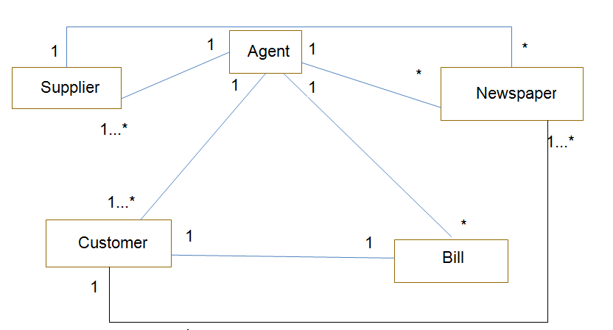

Use Case Diagram

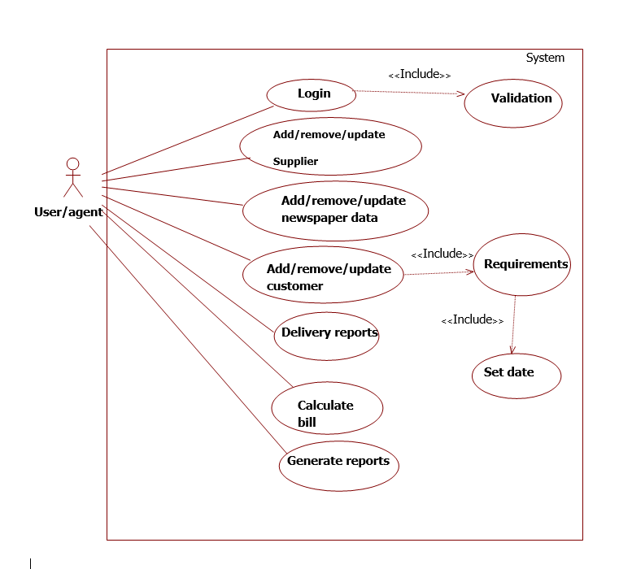

The above use case can be explained as follows:

NEWSPAPER AGENCY:

* It contains all details about the product in which we can add, delete, modify and search product detail.
* It can add, modify and delete the supplier details.
* It can add, modify and delete the customer details.
* Customer requirements will be added in the system and date would be set for the requirements of the product.
* The delivery reports of the newspaper will be updated daily.

**3.4 Classes / Objects**

CLASS DIAGRAM:

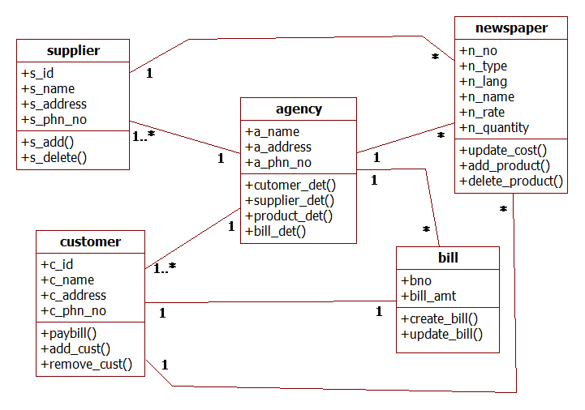

OBJECT DIAGRAM:

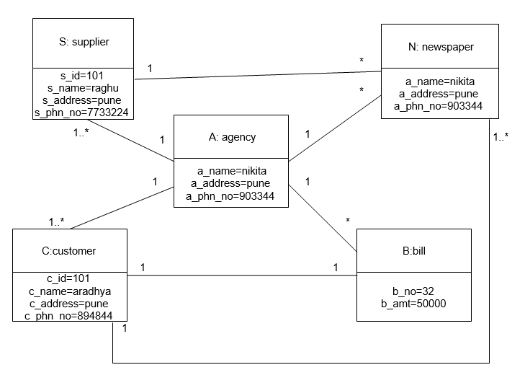

**3.4.1 Class/Objects:**

* Agency: This class has the detail of Newspaper agency.
* Supplier: This class stores the detail of supplier along with its unique id.
* Customer: This class holds the details of customers and is linked to the bill class.
* Newspaper: This class holds the data of newspaper products supplied by the various suppliers.
* Bill: This class holds the billing details of the customer who buy the newspaper.

**3.4.1.1 Attributes:**

* Agency: The attributes of this class are a_name(Agency Name), a_address(Address of agency), a_ph_no(Agency Phone number)
* Supplier: The attributes of this class are s_id (Supplier ID) and s_name (Supplier name), s_address(Address of supplier), s_ph_no(Supplier Phone number)
* Customer: The attributes of this class are c_id (Customer ID) and c_name (Customer name), c_address(Address of Customer), c_ph_no(Customer Phone number)
* Newspaper: The attributes of this class are n_id, n_name, rate.
* Bill: The attributes of this class are bill_no, bill_amount.

Sequence diagram

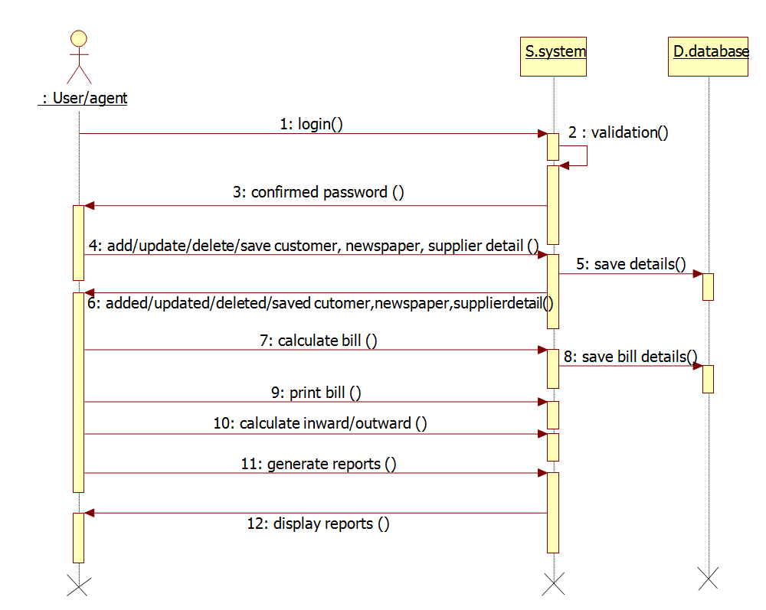

**Component diagram**

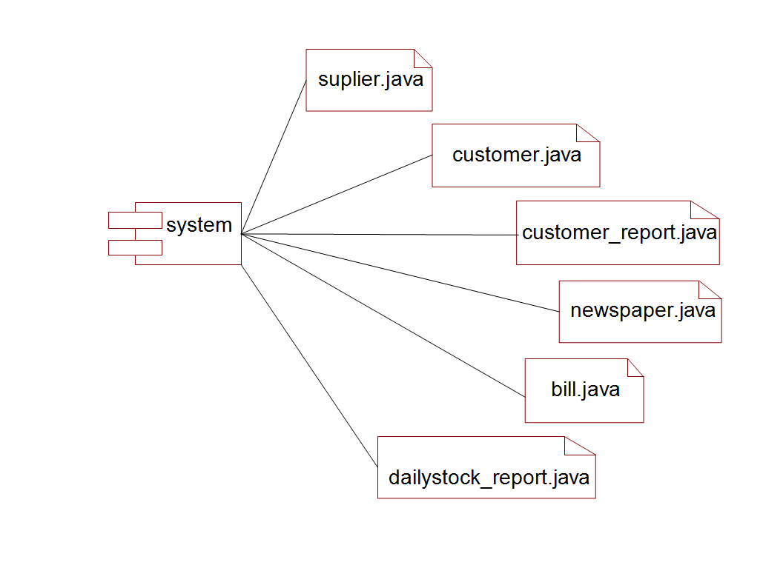

**Collaboration diagram**

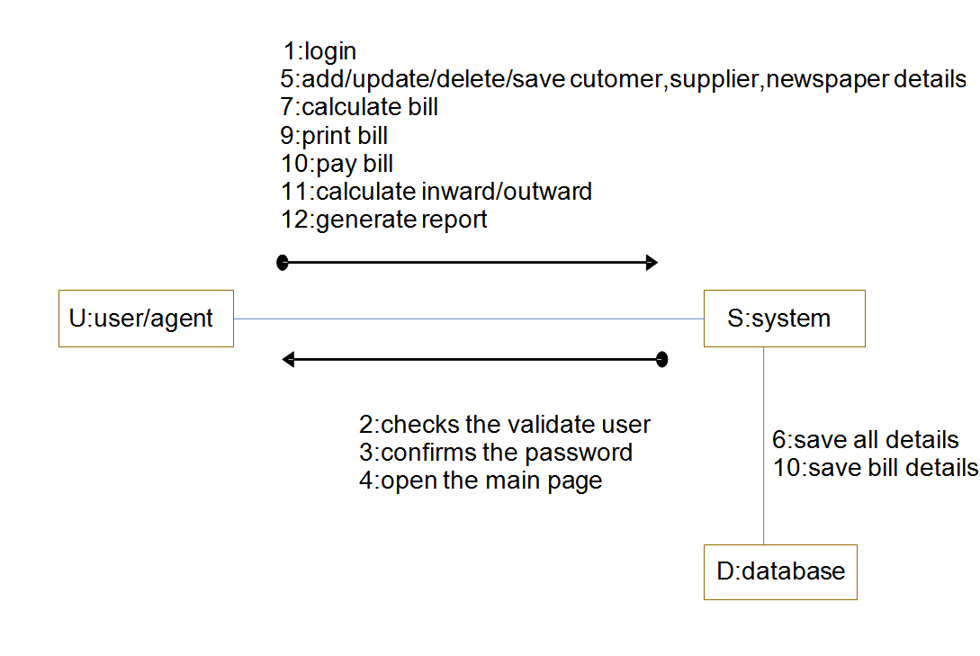

**Activity diagram**

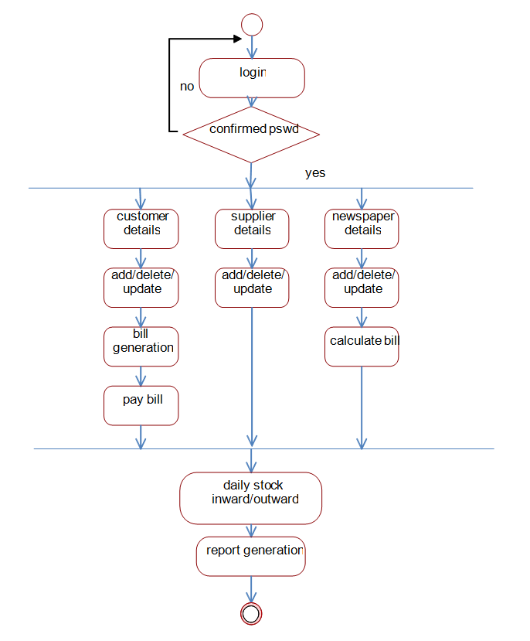

**State chart Diagram**

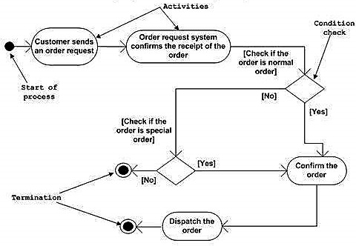

**Data Description**

**NPA**

**NPA**

**NPA**

**SQL CLIENT DATABASE**

Keyboard or mouse

Keyboard or mouse

Keyboard or mouse

**Data Dictionary**

LIST OF TABLES WITH ATTRIBUTES

1. npa.supplier:

|  |  |  |
| --- | --- | --- |
| Fields | Data Type | Description |
| Supplier ID | Int | This auto generated unique id |
| Name | String |  |
| Address | String |  |
| Phone No. | Int |  |

2. npa.productType:

|  |  |  |
| --- | --- | --- |
| Fields | Data Type | Description |
| Product Type ID | Int | This auto generated unique id |
| Name | String |  |

3. npa.language:

|  |  |  |
| --- | --- | --- |
| Fields | Data Type | Description |
| Language ID | Int | This auto generated unique id |
| Language | String |  |

4. npa.productInfo:

|  |  |  |
| --- | --- | --- |
| Fields | Data Type | Description |
| Product ID | Int | This auto generated unique id |
| Product Type | Int | Foreign Key of Product Type |
| Language | Int | Foreign key of Language |
| Name | String |  |
| Supplier ID | Int | Foreign Key of Supplier |

5. npa.productRate:

|  |  |  |
| --- | --- | --- |
| Fields | Data Type | Description |
| Product ID | Int | Foreign key of Product Master |
| Effective Date | Date |  |
| Rate | Float |  |

6. npa.customer:

|  |  |  |
| --- | --- | --- |
| Fields | Data Type | Description |
| Customer ID | Int | This auto generated unique id |
| Name | String |  |
| Address | String |  |

7. npa.week:

|  |  |  |
| --- | --- | --- |
| Fields | Data Type | Description |
| Week ID | Int | This auto generated unique id |
| Name | String |  |

8. npa.custRequirements:

|  |  |  |
| --- | --- | --- |
| Fields | Data Type | Description |
| ID | Int | This auto generated unique id |
| Customer ID | Int |  |
| Product ID | Int |  |
| No of Copies | Int |  |
| Start Date | Date |  |
| Close Date | Date |  |

9. npa.custMaster:

|  |  |  |
| --- | --- | --- |
| Fields | Data Type | Description |
| Master ID | Int | This auto generated unique id |
| Customer ID | Int | Foreign key of customer |
| Product ID | Int | Foreign key of product |
| Received Date | Date |  |

10. npa.stockInfo:

|  |  |  |
| --- | --- | --- |
| Fields | Data Type | Description |
| ID | Int | This auto generated unique id |
| Supplier ID | Int | Foreign key of supplier |
| Product ID | Int | Foreign key of product |
| Date | Date |  |
| Quantity | Int |  |
| Return | Int |  |

**Human Interface Design**

**Screen Images**

Login:

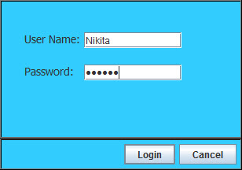

Home Screen :

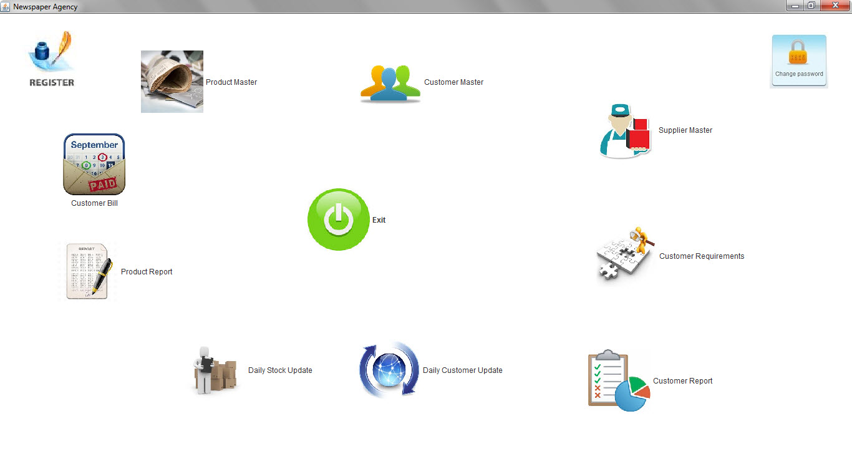

Product Master:

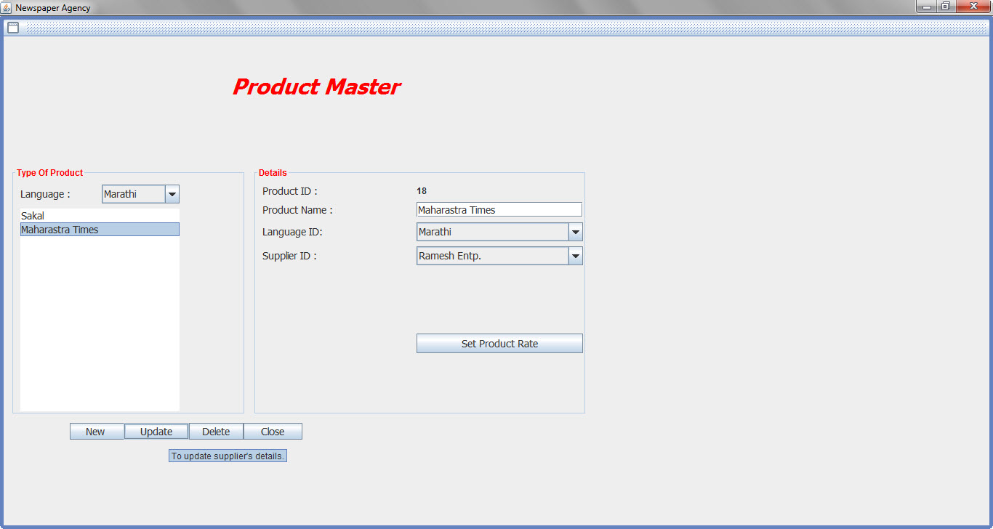

Set Product Rate:

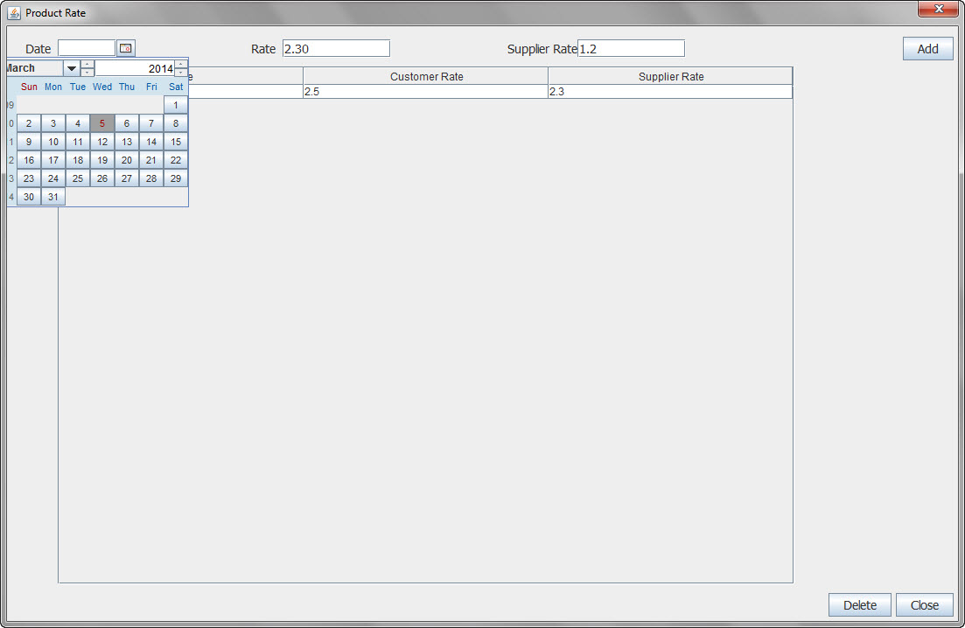

Customer Master :

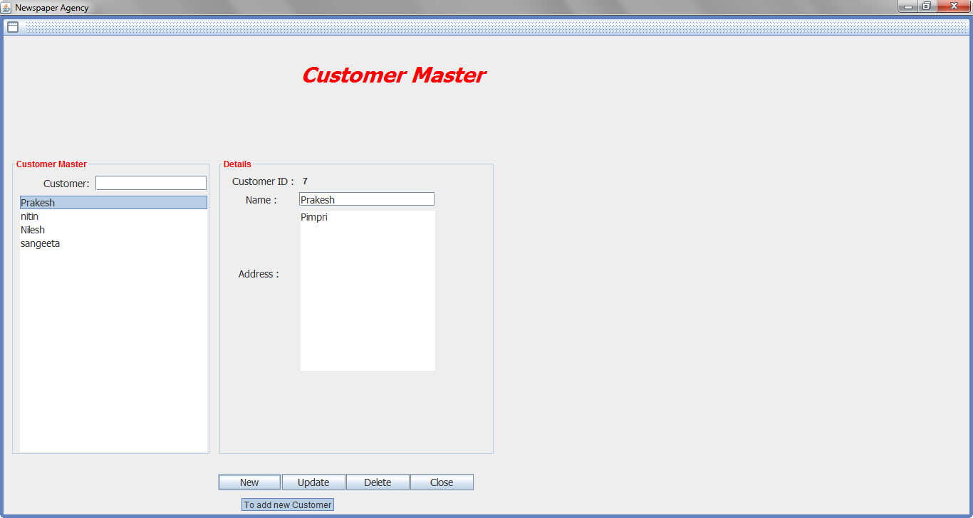

Supplier Master :

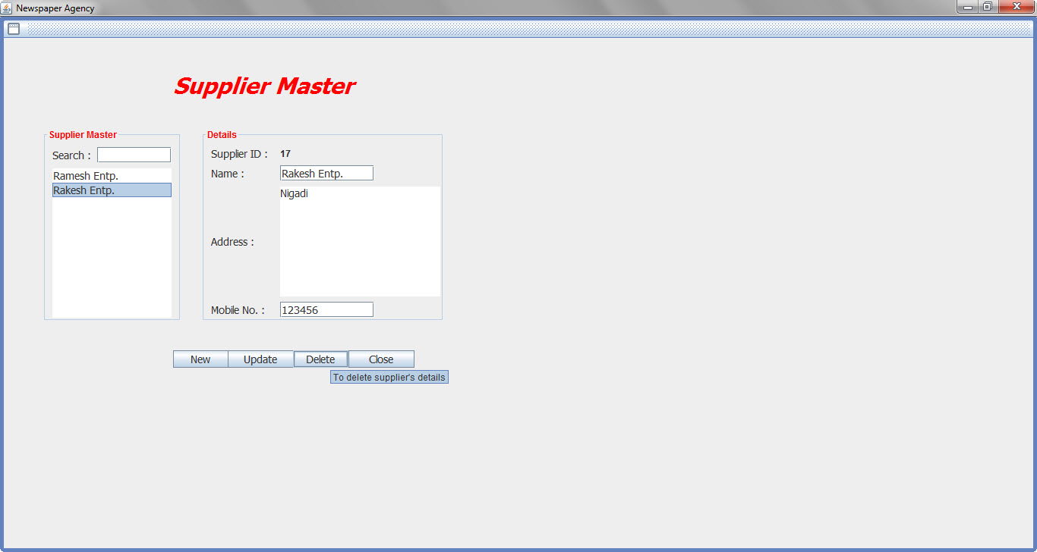

Customer Requirements :

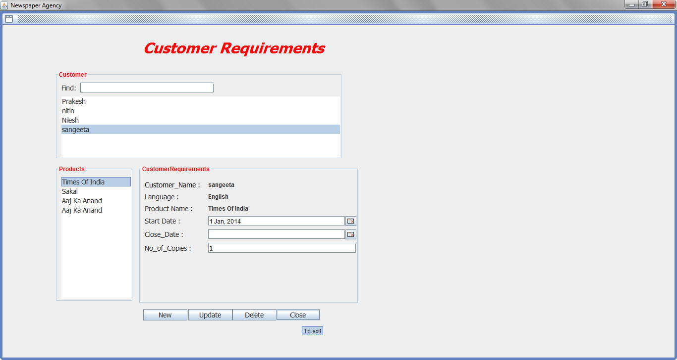

Customer Report:

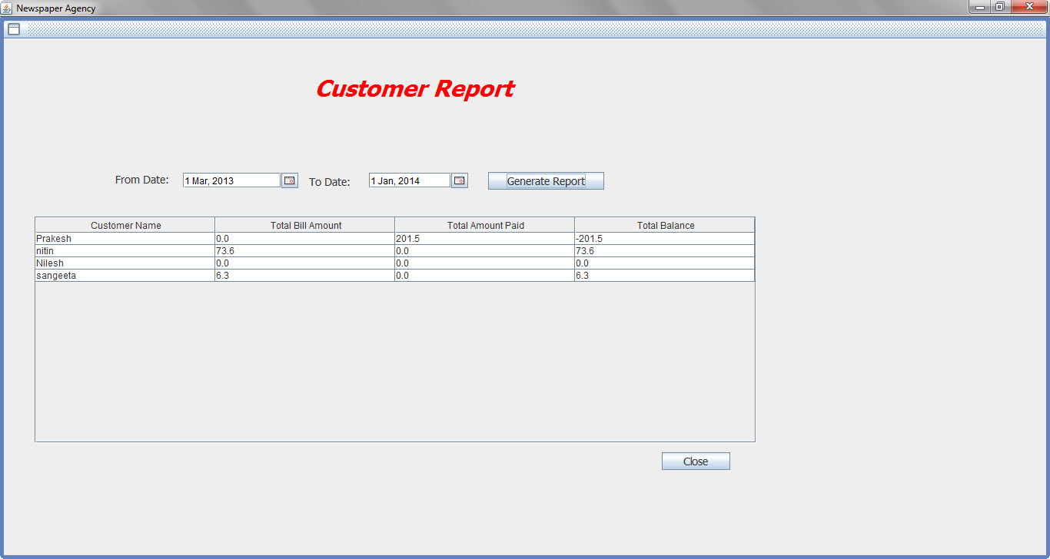

Daily Customer Update:

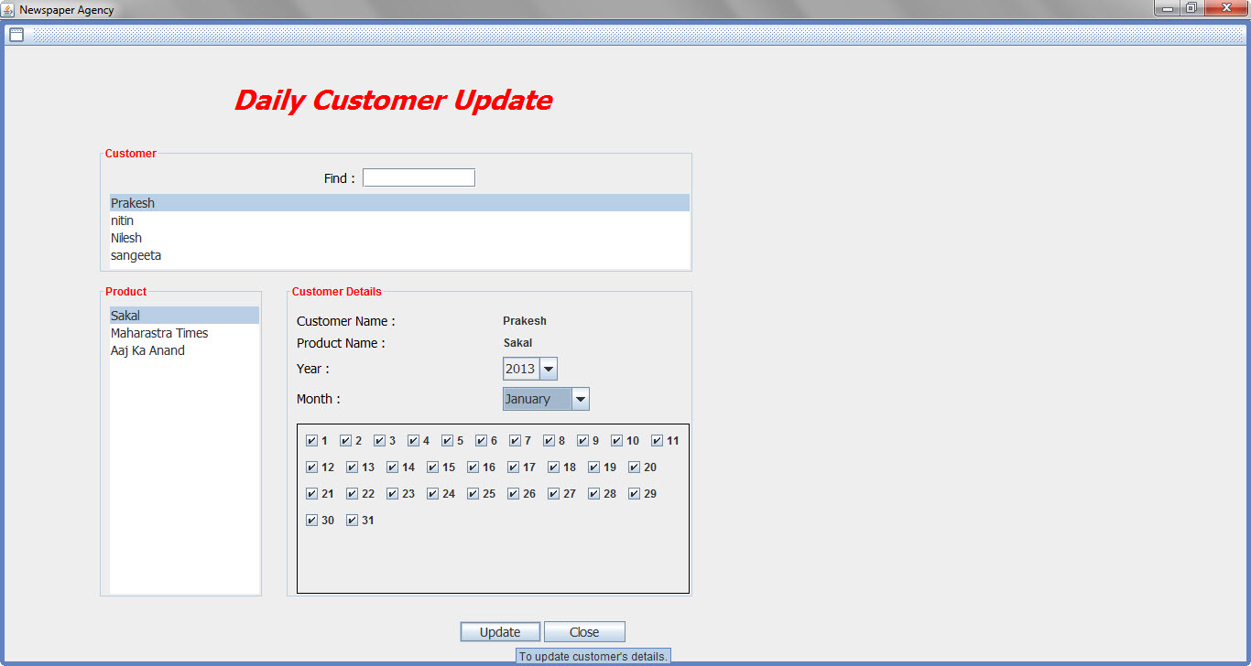

Daily Stock Update:

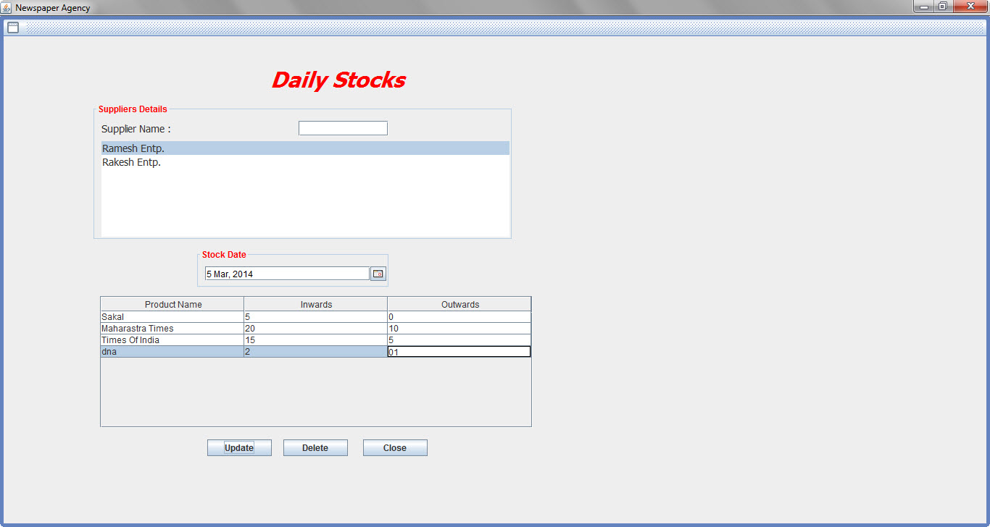

Product Report :

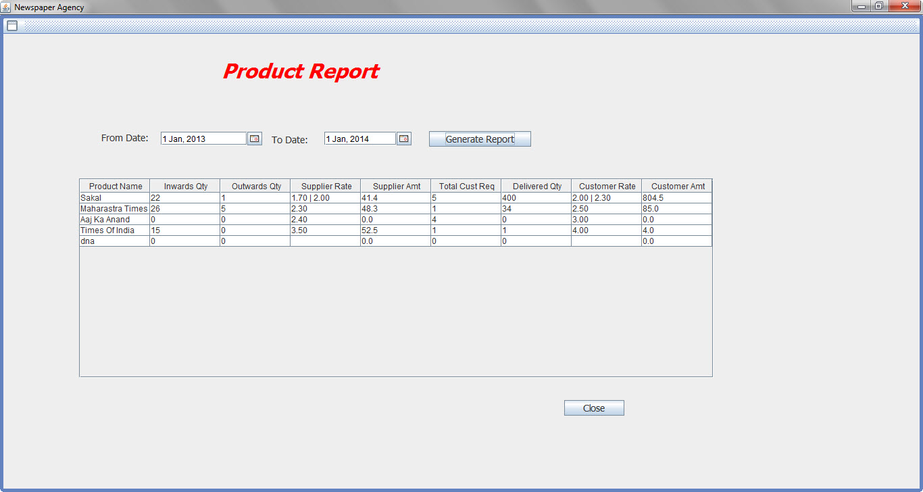

Customer Bill:

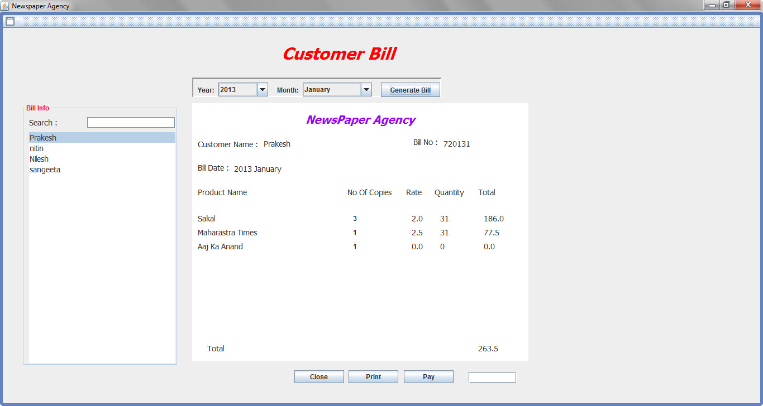

Register(New User):

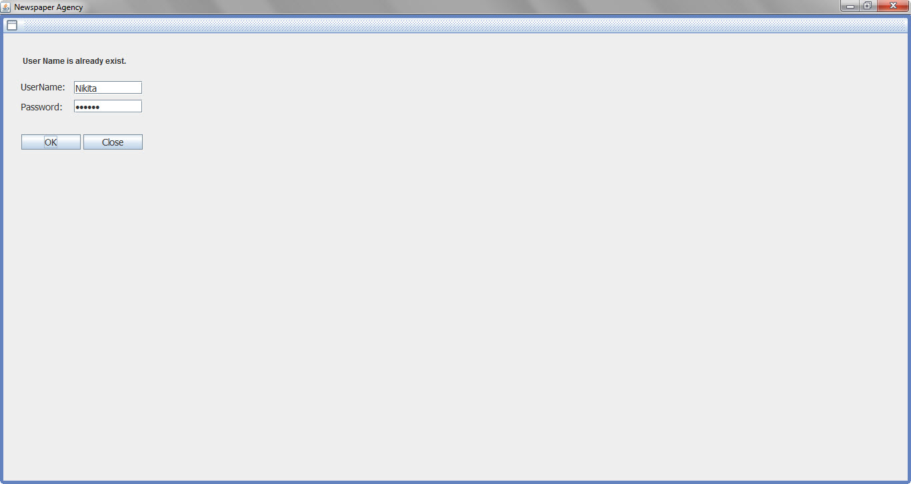

Change Password:

