**NEWSPAPER AGENCY**

**APPLICATION DEVELOPMENT – I**

**SOFTWARE REQUIREMENTS SPECIFICATION**

**Submitted in partial fulfilment for the award of the degree**

**Of**

**Master of Technology**

**In**

**Information Technology**

**By**

**SANKET SURESH PETHKAR**

**REG NO: 14MIN2879**

**School of Information Technology and Engineering**

**March, 2017**



**Table of Contents**

|  |  |  |
| --- | --- | --- |
| SR. NO. | TITLE |  |
| 1. | Introduction | 4 |
| 1.1 | Purpose | 4 |
| 1.2 | Scope | 4 |
| 1.3 | Defination,Acronym,Abbrevations | 5 |
| 1.4 | References | 5 |
| 1.5 | Overview | 5 |
| 2 | General Description | 7 |
| 2.1 | Product Perspective | 7 |
| 2.2 | Product Function | 7 |
| 2.3 | User Characteristic | 8 |
| 2.4 | General Constraints | 8 |
| 2.5 | Assumptions and Dependencies | 8 |
| 3 | Specific Requirements | 9 |
| 3.1 | External Interface Requirements | 9 |
| 3.1.1 | User Interfaces | 9 |
| 3.1.2 | Hardware Interfaces | 10 |
| 3.1.3 | Software Interfaces | 10 |
| 3.1.4 | Communication Interfaces | 12 |
| 3.2.1 | Functional Requirements | 12 |
| 3.2.1.1 | Introduction | 12 |
| 3.2.1.2 | Inputs | 12 |
| 3.2.1.3 | Processing | 12 |
| 3.2.1.4 | Outputs | 13 |
| 3.2.1.5 | Error Handling | 13 |
| 3.3 | Use Cases | 14 |
| 3.3.1 | Use Case 1 | 16 |
| 3.4 | Class/Objects | 18 |
| 3.4.1 | Class/Objects | 19 |
| 3.4.1.1 | Attributes | 20 |
| 3.5 | Non Functional Requirements | 20 |
| 3.5.1 | Performance | 20 |
| 3.5.2 | Reliability | 20 |
| 3.5.3 | Availability | 21 |
| 3.5.4 | Security | 21 |
| 3.5.5 | Maintainability | 21 |
| 3.6 | Design Constraint | 21 |
| 3.7 | Logical Database Requirement | 23 |
| 4 | Analysis Models | 27 |
| 4.1 | Sequence Diagrams | 27 |
| 4.2 | State Transaction Diagrams | 31 |
| 5 | Change Management Process | 34 |
| 6 | Appendices | 35 |

1. **INTRODUCTION**

The modern industrial world is very much advanced in technology and competition in the world is intense. The user of a computer is provided with the HARDWARE and SOFTWARE, the two source of the computer. Much of the software will be programs which facilities the fast automatic management of the computer system resource.

“The Newspaper agency System” is one can go into almost required solution regarding the newspaper agency. This software package provides guidance for all the newspaper shop purpose, as a perfect guide, the current demand for such software became needful. This project will provide for computerization of a small agency whose main goal is to keep the detail information about the customer, supplier, newspaper and billing process and wants to change from paper based work to computerized system.

* 1. **PURPOSE**
* **“The Newspaper agency System”** is one can go into almost required solution regarding the Newspaper shop.
* Software we can easily track all the customer detail, supplier detail, newspaper detail, stock detail, bill detail and also we can able generate report.
* The main goal of the software is build a good management tool.
* The newspaper agency system will make storing of the customer records, stock records, sales detail, employee information, expense detail and order details in the database it will generate bills and print the bills.
  1. **Scope**
* This software is used to maintain day to day activities for the newspaper agencies, like maintain customer details, requirement details, which paper needed for particular day, product master with day to day rate, daily requirement and stock entry, line and supplier details, transaction, creation of bills for single customer to all customer, payment collection, reports.
* It is totally self-contained and works efficiently.
* It provides simple database rather than complex ones for high requirements and it provides good and easy graphical user interface to both new as well as experienced user of the computer.
  1. **Definitions, Acronyms, and Abbreviations**

NPA: Newspaper Agency.

POC: Point Of Contact.

* 1. **References**
* <http://www.google.com>
* <http://stackoverflow.com/>
* <https://en.wikipedia.org/wiki/Swing_(Java)>
* <http://www.javatpoint.com/java-swing>
* <http://www.tutorialspoint.com/sql/>
* Java 2: The Complete Reference.
* Google search engine
  1. **Overview**

The modern industrial world is very much advanced in technology and competition in the world is intense. If we want healthy growth of business, one must keep business techniques up-to-date. Today computer is the mandatory part of every business in the world. That is why computer is used for major task like storing records, complex calculations, worldwide communication etc. since it is not possible to complete all these tasks by human itself in efficient way.

The Newspaper agency business is closely related to management of things like customer, stock, supplier, newspaper, and so on. So, if we select manpower to perform management of all these things, following problems may arise:

1. Paper based transaction has become old nowadays because it is time consuming and less secured/reliable.
2. The process of storing all these records also raises the issue of security and space.

Computerization solves all these problems and provides reliability and correctness in the process of management.

Performing operation with the help of computer will save the manual work of agent and so the billing work becomes easy no need for manual calculation. Security of data is maintained. We can retrieve or manage records instantly because of user friendly environment of computer.

The process which is carried out currently has certain drawbacks:-

* All work is carried on manually, hence increases the manpower.
* Also, the manual entries, increases the probability of human errors.
* There are lots of ways, through which the system might crack.
* Also there are separate formats required for different types of customers.

So we developed this Newspaper Agency.

* This project is to manage all the newspapers, their suppliers, customers, distributors, etc.
* It makes easy to generate and maintain bills, payments and auditing.

The prime goals of proposed system are:-

* To provide security of the software with the help of password facility.
* To provide User Friendly interface that will make various operations easier to perform.
* To provide automatic bill generation.
* To provide automatic stock inward outward.
* To provide automatic stock update after the selling process.
* To provide data validation.
* To provide facility of storing record of Employees, record of sold items, record of pending order, record of completed order, and record of expense.
* To provide facility of instant report generation.

**2. GENERAL Description**

**2.1 PRODUCT PERSPECTIVE:**

* Newspaper Agency acts as single stop portal for managing the product details, customer details and supplier details.
* It facilitates the user to add, delete and modify the customer, product and supplier details.
* It facilitates the user to generate the customer and product report.

**2.2 PRODUCT FUNCTION:**

* Access to Newspaper Agency is provided with username login and credentials.
* Username can be decided by the user.
* Change password facility is provided to maintain security constraints.
* The User will be able to insert customer requirements in the system.

**2.3 USER CHARACTERISTICS:**

* Login : It is the login session for
* Register: It is used to register new user.
* Change Password: A user can change the current password.
* Product Master: This is used to add, delete, modify and view product details.
* Supplier Master: This is used to add, delete, modify and view supplier details.
* Customer Master: This is used to add, delete, modify and view customer details.
* Customer requirements: It is used to add, delete and modify the customer requirements.
* Customer report: It helps to create customer report.
* Product report: It helps to create product report.
* Daily customer update: It is used to save the details of products taken by customer on daily basis.
* Daily stock update: It is used to save the status of stock on daily basis.
* Customer bill: It is used to generate the customer bill.

**2.4 GENERAL CONSTRAINTS:**

* There are no specific environmental constraints in Newspaper Agency.

**2.5 ASSUMPTIONS AND DEPENDENCIES:**

* As the Newspaper Agency is developed in Java it is platform in dependent.
* It does not require any external device.
* The application usage Knowledge transfer needs to be done to the user

**3. SPECIFIC REQUIREMENTS:**

**3.1 External Interface Requirements**

**3.1.1 User Interfaces:**

**Java Swing**:-

**Swing** is a GUI widget toolkit for Java. It is part of Oracle's Java Foundation Classes (JFC) – an API for providing a graphical user interface (GUI) for Java programs.

Swing was developed to provide a more sophisticated set of GUI components than the earlier Abstract Window Toolkit (AWT). Swing provides a native look and feel that emulates the look and feel of several platforms, and also supports a pluggable look and feel that allows applications to have a look and feel unrelated to the underlying platform. It has more powerful and flexible components than AWT. In addition to familiar components such as buttons, check boxes and labels, Swing provides several advanced components such as tabbed panel, scroll panes, trees, tables, and lists.

Unlike AWT components, Swing components are not implemented by platform-specific code. Instead, they are written entirely in Java and therefore are platform-independent. The term "lightweight" is used to describe such an element.

Though Swing is intended to be replaced by JavaFX, it will remain part of the Java SE specification for the foreseeable future.

**3.1.2 Hardware Interfaces**

* Pentium 3 processor or higher
* Hard disk of 2GB capacity or more
* 512MB RAM
* SVGA / Monochrome monitor with Standard output display (640X480)
* Standard QWERTY keyboard and any mouse.

**3.1.3 Software Interfaces**

* JDK 1.5.0 and above with JDBC connectivity.

The **Java Development Kit** (**JDK**) is an implementation of either one of the Java Platform, Standard Edition; Java Platform, Enterprise Edition or Java Platform, Micro Edition platforms released by Oracle Corporation in the form of a binary product aimed at Java developers on Solaris, Linux, Mac OS X or Windows. The JDK includes a private JVM and a few other resources to finish the development of a Java Application. Since the introduction of the Java platform, it has been by far the most widely used Software Development Kit (SDK). On 17 November 2006, Sun announced that they would release it under the GNU General Public License (GPL), thus making it free software. This happened in large part on 8 May 2007, when Sun contributed the source code to the OpenJDK.

* MySQL Database.

MySQL is an [open-source](https://en.wikipedia.org/wiki/Open-source) [relational database management system](https://en.wikipedia.org/wiki/Relational_database_management_system) (RDBMS). Its name is a combination of "My", the name of co-founder [Michael Widenius](https://en.wikipedia.org/wiki/Michael_Widenius)' daughter, and "[SQL](https://en.wikipedia.org/wiki/SQL)", the abbreviation for [Structured Query Language](https://en.wikipedia.org/wiki/Structured_Query_Language). The MySQL development project has made its [source code](https://en.wikipedia.org/wiki/Source_code) available under the terms of the [GNU General Public License](https://en.wikipedia.org/wiki/GNU_General_Public_License), as well as under a variety of [proprietary](https://en.wikipedia.org/wiki/Proprietary_software) agreements. MySQL was owned and sponsored by a single [for-profit](https://en.wikipedia.org/wiki/Business) firm, the [Swedish](https://en.wikipedia.org/wiki/Sweden) company [MySQL AB](https://en.wikipedia.org/wiki/MySQL_AB), now owned by [Oracle Corporation](https://en.wikipedia.org/wiki/Oracle_Corporation). For proprietary use, several paid editions are available, and offer additional functionality.

**3.1.4 Communications Interfaces**

No Communication interfaces are required.

**3.2 Functional Requirements**

**3.2.1 Functional Requirement 1**

**3.2.1.1 Introduction:**

This section includes the requirements that specify all the fundamental actions of the software system.

**3.2.1.2 Inputs**

* The entries for supplier, product and customer are added.
* The customer requirements are added into the system
* The daily updated are made for customer and stock

**3.2.1.3 Processing:**

* The customer will be delivered with the newspaper according to the requirements in the system.
* The daily customer entries will be recorded.
* The daily stock entries will be recorded.
* The number of products and the number of days will be calculated and bill will be generated.
* The payments done and pending will be calculated

**3.2.1.4 Outputs:**

* User can check the customer report and pending payments.
* He can check the product report and the status of the stock.
* He can check the bills of the customers and perform auditing.

**3.2.1.5 Error Handling:**

* When any error occurs while processing the query Error should be handle by System.
* The system provides validation for the entries of the user.
* User will be given appropriate error message on occurrence of any kind of error.

**3.3 Use Cases**

**3.3.1 Use Case:**

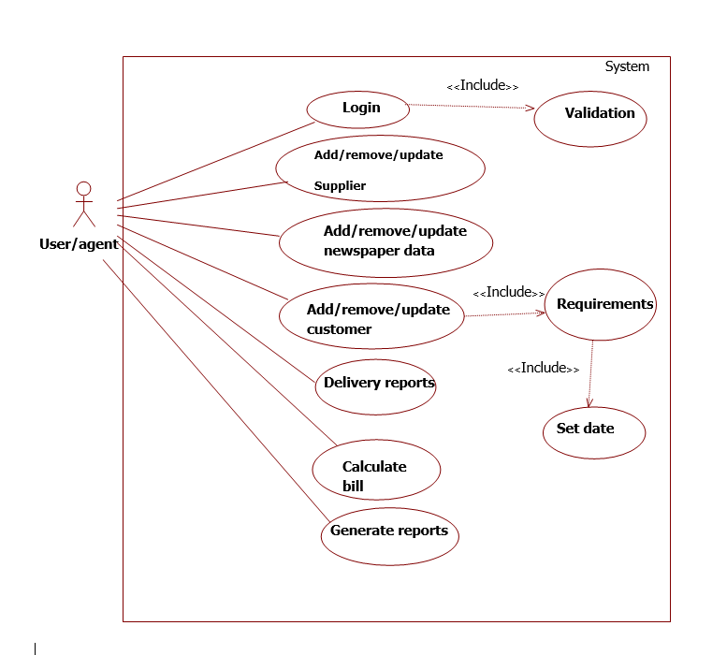

The above use case can be explained as follows:

NEWSPAPER AGENCY:

* It contains all details about the product in which we can add, delete, modify and search product detail.
* It can add, modify and delete the supplier details.
* It can add, modify and delete the customer details.
* Customer requirements will be added in the system and date would be set for the requirements of the product.
* The delivery reports of the newspaper will be updated daily.

**3.4 Classes / Objects**

CLASS DIAGRAM:

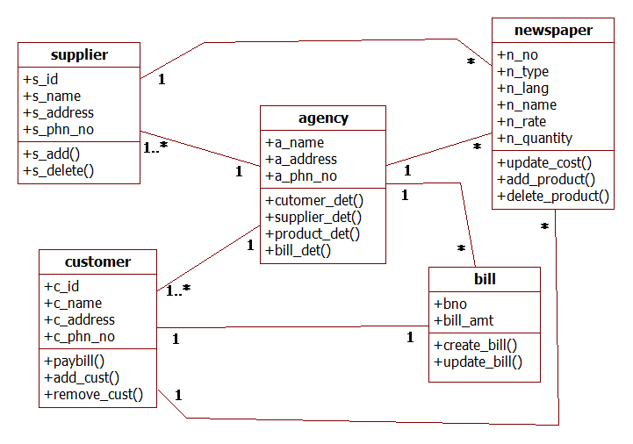

OBJECT DIAGRAM:

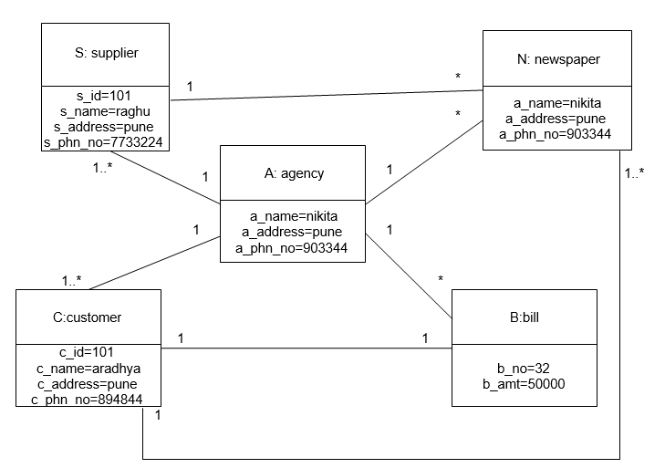

**3.4.1 Class/Objects:**

* Agency: This class has the detail of Newspaper agency.
* Supplier: This class stores the detail of supplier along with its unique id.
* Customer: This class holds the details of customers and is linked to the bill class.
* Newspaper: This class holds the data of newspaper products supplied by the various suppliers.
* Bill: This class holds the billing details of the customer who buy the newspaper.

**3.4.1.1 Attributes:**

* Agency: The attributes of this class are a_name(Agency Name), a_address(Address of agency), a_ph_no(Agency Phone number)
* Supplier: The attributes of this class are s_id (Supplier ID) and s_name (Supplier name), s_address(Address of supplier), s_ph_no(Supplier Phone number)
* Customer: The attributes of this class are c_id (Customer ID) and c_name (Customer name), c_address(Address of Customer), c_ph_no(Customer Phone number)
* Newspaper: The attributes of this class are n_id, n_name, rate.
* Bill: The attributes of this class are bill_no, bill_amount.

**3.5 Non-Functional Requirements**

**3.5.1 Performance:**

Proposed system is beneficial only if it can be turned into management

System that will meet the need of the client’s operating requirements.

The proposed system is operationally feasible due to the following reasons:

* The system is easy to use and is very simple.
* The proposed system will cost no harm to the company
* The new system will avoid confusion and resistance by catching the user’s attention, as it is presentable

3.5.2 Reliability:

* Newspaper Agency system is reliable software.
* All the data will be stored easily.

**3.5.3 Availability:**

* The system is available for use 24*7.
* Java is open source and easily available on the official site. It can be used in any operating system.
* The data can be retrieved at any time the organization wants to.

**3.5.4 Security:**

* The data is secured from all interference.
* The data cannot be hacked. All security measures have been taken.
* Java is very strong language and it is secure. The code is converted into byte code so no possibility of hacking or stealing it.
* Security is the degree of resistance to, or protection from, harm

**3.5.5 Maintainability:**

* No maintenance currently needed as such.
* Future maintenance is affordable is easier.

**3.7 Design Constraints:**

The Constraint report studied the Constraint of the project and plays a major role in the analysis of the system. The very decision of whether to design a system or not depends in the Constraint study.

The Constraint study can be categorized as follows:

* Technical Constraint

It determines whether the technology needed for the proposed system is available and how this technology can be integrated into organization. Technical evaluation must also assess if the existing system can be upgraded to use the new technology and whether the organization has the expertise to use it. The company must be equipped with the pre-mentioned hardware and software requirements.

* Operational Constraint

There are two aspects of operational feasibility for the system. One is that of technical performance and other is the acceptance. Technical performance determines whether a system can provide correct and timely data required for the company’s personnel. Computerizing the existing system will ensure that it will provide accurate, timely and up-to-minute data to the management.

The new system will automate the existing manual system and make it user-friendly. The proposed system will cut down unnecessary paperwork and time delay offered by the existing system.

* Economic Constraint

The economic feasibility of the system is mainly concerned with its financial aspects. It explains whether the project is economically feasible.

In other words it determines whether the investment that goes into the implementation of the project is recoverable or not. The cost benefit analysis is a commonly used method in evaluating the effectiveness of the system.

As the hardware and software are already available and no further investment is to be made in that direction, the only cost involved is that of implementing the system.

The system will be economically feasible considering the following aspects.

* The system will save a lot of stationary.
* It will save time, which is otherwise wasted in manual process.
* At the same time the system will require less manual power as compared to the current system.
* The storage and the handling problem with respect to records and registers will be solved.
* Motivational Constraint

The users who want to install this software will obviously know the advantages of using computerized system. Since the new system will be simple and user friendly, the office won’t have any problem in switching over to computerized system. That is why this system is motivationally feasible.

**3.8 Logical Database Requirements:**

Database design is the process of producing a detailed [data model](https://en.wikipedia.org/wiki/Data_model) of a [database](https://en.wikipedia.org/wiki/Database). This [logical data model](https://en.wikipedia.org/wiki/Logical_data_model) contains all the needed logical and physical design choices and physical storage parameters needed to generate a design in a [data definition language](https://en.wikipedia.org/wiki/Data_definition_language), which can then be used to create a database. A fully attributed data model contains detailed attributes for each entity.

The term database design can be used to describe many different parts of the design of an overall [database system](https://en.wikipedia.org/wiki/Database_system)

LIST OF TABLES WITH ATTRIBUTES

1. npa.supplier:

|  |  |  |
| --- | --- | --- |
| Fields | Data Type | Description |
| Supplier ID | Int | This auto generated unique id |
| Name | String |  |
| Address | String |  |
| Phone No. | Int |  |

2. npa.productType:

|  |  |  |
| --- | --- | --- |
| Fields | Data Type | Description |
| Product Type ID | Int | This auto generated unique id |
| Name | String |  |

3. npa.language:

|  |  |  |
| --- | --- | --- |
| Fields | Data Type | Description |
| Language ID | Int | This auto generated unique id |
| Language | String |  |

4. npa.productInfo:

|  |  |  |
| --- | --- | --- |
| Fields | Data Type | Description |
| Product ID | Int | This auto generated unique id |
| Product Type | Int | Foreign Key of Product Type |
| Language | Int | Foreign key of Language |
| Name | String |  |
| Supplier ID | Int | Foreign Key of Supplier |

5. npa.productRate:

|  |  |  |
| --- | --- | --- |
| Fields | Data Type | Description |
| Product ID | Int | Foreign key of Product Master |
| Effective Date | Date |  |
| Rate | Float |  |

6. npa.customer:

|  |  |  |
| --- | --- | --- |
| Fields | Data Type | Description |
| Customer ID | Int | This auto generated unique id |
| Name | String |  |
| Address | String |  |

7. npa.week:

|  |  |  |
| --- | --- | --- |
| Fields | Data Type | Description |
| Week ID | Int | This auto generated unique id |
| Name | String |  |

8. npa.custRequirements:

|  |  |  |
| --- | --- | --- |
| Fields | Data Type | Description |
| ID | Int | This auto generated unique id |
| Customer ID | Int |  |
| Product ID | Int |  |
| No of Copies | Int |  |
| Start Date | Date |  |
| Close Date | Date |  |

9. npa.custMaster:

|  |  |  |
| --- | --- | --- |
| Fields | Data Type | Description |
| Master ID | Int | This auto generated unique id |
| Customer ID | Int | Foreign key of customer |
| Product ID | Int | Foreign key of product |
| Received Date | Date |  |

10. npa.stockInfo:

|  |  |  |
| --- | --- | --- |
| Fields | Data Type | Description |
| ID | Int | This auto generated unique id |
| Supplier ID | Int | Foreign key of supplier |
| Product ID | Int | Foreign key of product |
| Date | Date |  |
| Quantity | Int |  |
| Return | Int |  |

**4. Analysis Models**

**4.1 Sequence Diagrams:**

Newspaper Agency

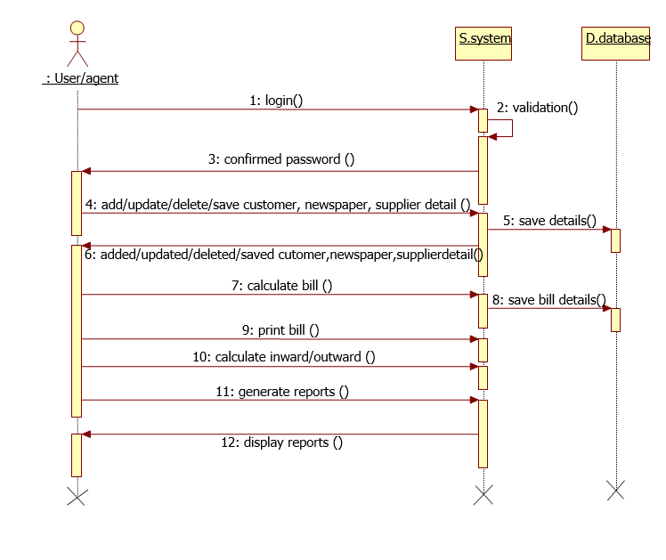

The above sequence diagram can be explained as:

VISITOR MANAGEMENT SUBSYSTEM:

* User will login the system.
* User will add, delete, and update customer, supplier and product details.
* User will be able to calculate and generate the customer bill.
* User will be able to generate product and customer reports.

**4.2 State-Transition Diagrams (STD):**

Newspaper Agency:

The above state chart can be explained as:

* When a visitor arrives, he is verified by the admin (guard in this case).
* The admin checks whether the visitor’s information is already present in database.
* If no information is found, he adds the information else updates the information if required.
* The admin then ask the concerned employee about the visitor.
* If the employee signals a yes the visitor is allowed to enter the organization else his entry is rejected

CONTRACTOR MANAGEMENT SUBSYSTEM:

Verify contcrtor

New?

Add Contrator

Being searched

Update Contrator details

Ask emp availability

Available?

Send contractor

Reject contractor

NO

YES

YES

NO

The above state chart can be explained as:

* When a contractor arrives, he is verified by the admin (guard in this case).
* The admin checks whether the contractor‘s information is already present in database.
* If no information is found, he adds the information else updates the information if required.
* The admin then ask the concerned employee about the contractor.
* If the employee signals a yes the contractor is allowed to enter the organization else his entry is rejected.

EMPLOYEE MANAGEMENT SUBSYSTEM:

Verify employee

New?

Add employee

Being searched

Update employee details

The above state chart can be explained as :

* When a employee enters admin has rights to check the details of the employee in the database.
* If the employee Is present his/her details are updated else new employee data is added.

T

**5. Change Management Process**

* Intranet messenger that can be used by the security person to chat with the employee to get the confirmation of the visitor.
* A method to keep a track of the co-workers that are accompanied with the contractors.
* A facility of messaging the visitor when his data is entered can be added to VMS

1. **APPENDICES.**

**APPENDIX A - TIME LINE**

**Month One**

* + Advertising of Project staff positions
  + Meetings with community leaders
  + Meeting with university administrators

**Month Two**

* + Interviewing of candidates for Project staff positions
  + Finalizing location of Center

**Month Three**

* + Selection/hiring of Project staff members
  + Preparation for Center operation

**Month Four - Six**

* + Preliminary advertising of Center operation
  + Hosting community meetings at Center
  + Collection of baseline data on mothers of young children
  + Recruitment/selection/training of student volunteers

**Month Seven - Twelve**

* + Conducting of regular formative evaluation
  + Final summative evaluation at end of twelfth month

**APPENDIX B – Project**

* Visitor management system is the future.
* Even today it is being used in foreign contries for security.
* The application is seamless.
* There is increasing use of it even in the corporate companies.
* We here try to make use of the same for having more secure environment.
* Our efforts try keep track of visitors easier and faster.
* This project can be implemented in a wide number of applications.
* Some of the examples being hospitals, colleges, schools, offices, banks etc.
* The range of application of the project is very wide.
* This is different from just simple queries asked to the computer.