HW1_1 in 123 reference frame
close all;
clear all;
clc;

Set variable
Use 123 frame as a reference frame
syms b s s_dot c th th_dot w
assume(th, 'real');
R = 0;
R_dot = 0;
R_dot2 = 0;
rho = [b+(s+c)*sin(th);...
0 ;...
(s+c)*cos(th)];
v_rel = [(s+c)*th_dot*cos(th)+s_dot*sin(th);...
0 ;...
-(s+c)*sin(th)*th_dot+s_dot*cos(th)];
a_rel = [-(s+c)*th_dot^2*sin(th)+2*s_dot*th_dot*cos(th);...
0 ;...
-(s+c)*th_dot^2*cos(th)-2*s_dot*th_dot*sin(th)];
ang_vel = [0 -w 0 ;...
w 0 0 ;...
0 0 0 ];
ang_acc = 0;
velocity = vel(R_dot,v_rel,ang_vel,rho);
acceleration = acc(R_dot2,a_rel,ang_vel,rho,ang_acc,v_rel);
velocity
acceleration

Substitution
b = 0.1; %m
s_dot = 1; %m/s
c = 0.5; %m
th_dot = 5; %rad/s
w = 10; %rad/s
time = [0:0.01:10]; %s
for i = 1:length(time);
th = th_dot*time(i); %rad
s = s_dot*time(i); %m
vel_subs = subs(velocity);
acc_subs = subs(acceleration);
vel_mag(i) = norm(vel_subs);
acc_mag(i) = norm(acc_subs);
end
vel_mag = double(vel_mag);
acc_mag = double(acc_mag);

Plot
plot(time,vel_mag,time,acc_mag);
legend('velocity [m/s]','acceleration [m/s^2]','Location','northwest');
grid on;
xlabel('Time[s]');
title ('v-t, a-t');
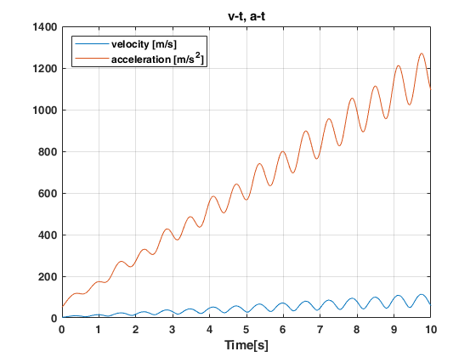

Set function
function v = vel(R_dot,v_rel,ang_vel,rho)
v = R_dot+v_rel+ang_vel*rho;
end
function a = acc(R_dot2,a_rel,ang_vel,rho,ang_acc,v_rel)
a = R_dot2+a_rel+ang_vel*ang_vel*rho+ang_acc*rho+2*ang_vel*v_rel;
end
velocity =
s_dot*sin(th) + th_dot*cos(th)*(c + s)
w*(b + sin(th)*(c + s))
s_dot*cos(th) - th_dot*sin(th)*(c + s)
acceleration =
- sin(th)*(c + s)*th_dot^2 + 2*s_dot*cos(th)*th_dot + (- b - sin(th)*(c + s))*w^2
2*w*(s_dot*sin(th) + th_dot*cos(th)*(c + s))
- cos(th)*(c + s)*th_dot^2 - 2*s_dot*sin(th)*th_dot
Published with MATLAB® R2018a

HW1_1 in rtheta2 reference frame
close all;
clear all;
clc;

Set variable
Use rtheta2 frame as a reference frame
syms b s s_dot c th th_dot w
assume(th, 'real');
R = [b;0;0];
R_dot = [0;b*w;0];
R_dot2 = [-b*w^2;0;0];
rho = [s+c;0;0];
v_rel = [s_dot;0;0];
a_rel = 0;
ang_vel = [ 0 -w th_dot;...
w 0 0 ;...
-th_dot 0 0 ];
ang_acc = [ 0 0 0 ;...
0 0 w*th_dot ;...
0 -w*th_dot 0 ];
T = [sin(th) 0 cos(th) ;...
cos(th) 0 -sin(th) ;...
0 1 0 ];
rho = T'*[s+c;0;0]; %change frame rt2->123
v_rel = T'*[s_dot;0;0]; %change frame rt2->123
velocity = vel(R_dot,v_rel,ang_vel,rho);
acceleration = acc(R_dot2,a_rel,ang_vel,rho,ang_acc,v_rel);
velocity
acceleration

Substitution
b = 0.1; %m
s_dot = 1; %m/s
c = 0.5; %m
th_dot = 5; %rad/s
w = 10; %rad/s
time = [0:0.01:10]; %s
for i = 1:length(time);
th = th_dot*time(i); %rad
s = s_dot*time(i); %m
vel_subs = subs(velocity);
acc_subs = subs(acceleration);
vel_mag(i) = norm(vel_subs);
acc_mag(i) = norm(acc_subs);
end
vel_mag = double(vel_mag);
acc_mag = double(acc_mag);

Plot
plot(time,vel_mag,time,acc_mag);
legend('velocity [m/s]','acceleration [m/s^2]','Location','northwest');
grid on;
xlabel('Time[s]');
title ('v-t, a-t');

Set function
function v = vel(R_dot,v_rel,ang_vel,rho)
v = R_dot+v_rel+ang_vel*rho;
end
function a = acc(R_dot2,a_rel,ang_vel,rho,ang_acc,v_rel)
a = R_dot2+a_rel+ang_vel*ang_vel*rho+ang_acc*rho+2*ang_vel*v_rel;
end
velocity =
s_dot*sin(th) + th_dot*cos(th)*(c + s)
b*w + w*sin(th)*(c + s)
s_dot*cos(th) - th_dot*sin(th)*(c + s)
acceleration =
2*s_dot*th_dot*cos(th) - b*w^2 - sin(th)*(th_dot^2 + w^2)*(c + s)
2*s_dot*w*sin(th) + 2*th_dot*w*cos(th)*(c + s)
- cos(th)*(c + s)*th_dot^2 - 2*s_dot*sin(th)*th_dot
Published with MATLAB® R2018a

HW1_2 in x2y2z2 reference frame
close all;
clear all;
clc;

Set variable
Use x2y2z2 frame as a reference frame
syms a t w0 L
assume(t, 'real');
alpha = a*sin(3*t);
alpha_dot = 3*a*cos(3*t);
alpha_dot2 = -9*a*sin(3*t);
R = 0;
R_dot = 0;
R_dot2 = 0;
rho = [0;0;L];
v_rel = zeros(3,1);
a_rel = zeros(3,1);
ang_vel = [ 0 -w0*cos(alpha) w0*sin(alpha) ;...
w0*cos(alpha) 0 -alpha_dot ;...
-w0*sin(alpha) alpha_dot 0 ];
ang_acc = [ 0 alpha_dot*w0*sin(alpha) alpha_dot*w0*cos(alpha);...
-alpha_dot*w0*sin(alpha) 0 -alpha_dot2 ;...
-alpha_dot*w0*cos(alpha) -alpha_dot2 0 ];
velocity = vel(R_dot,v_rel,ang_vel,rho);
acceleration = acc(R_dot2,a_rel,ang_vel,rho,ang_acc,v_rel);
velocity
acceleration

Substitution
L = 1; %m
a = 1; %1/s
w0 = 5; %rad/s
time = [0:0.01:10]; %s
for i = 1:length(time);
t = time(i);
vel_subs = subs(velocity);
acc_subs = subs(acceleration);
vel_mag(i) = norm(vel_subs);
acc_mag(i) = norm(acc_subs);
end
vel_mag = double(vel_mag);
acc_mag = double(acc_mag);

Plot
plot(time,vel_mag,time,acc_mag);
legend('velocity [m/s]','acceleration [m/s^2]');
grid on;
xlabel('Time[s]');
title ('v-t, a-t');
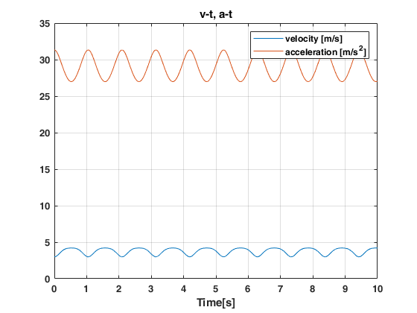

Set function
function v = vel(R_dot,v_rel,ang_vel,rho)
v = R_dot+v_rel+ang_vel*rho;
end
function a = acc(R_dot2,a_rel,ang_vel,rho,ang_acc,v_rel)
a = R_dot2+a_rel+ang_vel*ang_vel*rho+ang_acc*rho+2*ang_vel*v_rel;
end
velocity =
L*w0*sin(a*sin(3*t))
-3*L*a*cos(3*t)
0
acceleration =
6*L*a*w0*cos(3*t)*cos(a*sin(3*t))
L*cos(a*sin(3*t))*sin(a*sin(3*t))*w0^2 + 9*L*a*sin(3*t)
-L*(w0^2*sin(a*sin(3*t))^2 + 9*a^2*cos(3*t)^2)
Published with MATLAB® R2018a

HW1_3 in xyz reference frame
close all;
clear all;
clc;

Set variable
Use xyz frame as a reference frame
syms a b w0 w1 w2 phi
assume(phi, 'real');
R = [b;0;0];
R_dot = [0;0;-w2*b];
R_dot2 = [-w2^2*b;0;0];
rho = [-a*sin(phi) ;...
a*cos(phi) ;...
0 ];
v_rel = [-a*w0*cos(phi) ;...
-a*w0*sin(phi) ;...
0 ];
a_rel = [a*w0^2*sin(phi);...
-a*w0^2*cos(phi);...
0 ];
ang_vel = [0 0 w2 ;...
0 0 w1 ;...
-w2 -w1 0 ];
ang_acc = zeros(3);
velocity = vel(R_dot,v_rel,ang_vel,rho);
acceleration = acc(R_dot2,a_rel,ang_vel,rho,ang_acc,v_rel);
velocity
acceleration

Substitution
a = 0.1; %m
b = 1; %m
w0 = 10; %rad/s
w1 = 5; %rad/s
w2 = 15; %rad/s
time = [0:0.01:10]; %s
for i = 1:length(time);
phi = w0*time(i); %rad
vel_subs = subs(velocity);
acc_subs = subs(acceleration);
vel_mag(i) = norm(vel_subs);
acc_mag(i) = norm(acc_subs);
end
vel_mag = double(vel_mag);
acc_mag = double(acc_mag);

Plot
plot(time,vel_mag,time,acc_mag);
legend('velocity [m/s]','acceleration [m/s^2]');
grid on;
xlabel('Time[s]');
title ('v-t, a-t');
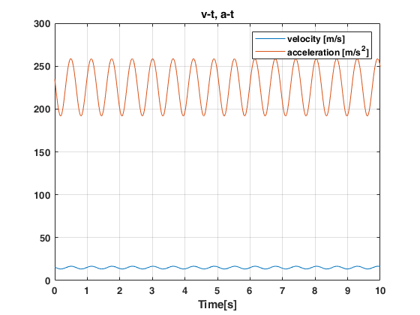

Set function
function v = vel(R_dot,v_rel,ang_vel,rho)
v = R_dot+v_rel+ang_vel*rho;
end
function a = acc(R_dot2,a_rel,ang_vel,rho,ang_acc,v_rel)
a = R_dot2+a_rel+ang_vel*ang_vel*rho+ang_acc*rho+2*ang_vel*v_rel;
end
velocity =
-a*w0*cos(phi)
-a*w0*sin(phi)
a*w2*sin(phi) - a*w1*cos(phi) - b*w2
acceleration =
a*w0^2*sin(phi) - b*w2^2 + a*w2^2*sin(phi) - a*w1*w2*cos(phi)
- a*cos(phi)*w0^2 - a*cos(phi)*w1^2 + a*w2*sin(phi)*w1
2*a*w0*w2*cos(phi) + 2*a*w0*w1*sin(phi)
Published with MATLAB® R2018a

