Genpath simulation program using simulink
clear all;
close all;
clc;

Set Parameter
constant parameter
r1 = 0.75*10^-2; %m
r2 = 3*10^-2; %m
k = 350; %N/m
Jp = 10^-5; %kgm^2
m = 0.16; %kg
RG = 50; %Ohm
L = 10^-3; %H
Kt = 0.048; %Vs/rad
% variable parameter
Jg = (r1^4/r2^4)*Jp; %kgm^2
RL = 400; %Ohm
M = m+Jp/(r2^2)+Jg/(r1^2);

Run simulation
t = 0:0.00001:0.8; %time for simulation 0.06993
sim('Genpath_simulink',t);

Power Output
Vg = Kt*wg;
Irms = rms(I);
Pavg = Irms^2*RL;
fprintf('Power generate = %6.8f Watt\n',Pavg);
Power generate = 0.17278336 Watt

Loop various RL
Pd = 0; %collect Pavg
Rd = 0; %collect RL
ic = 25; %increase step
for i = 1:2000/ic;
Rd(i+1) = Rd(i)+ic;
RL = Rd(i+1);
sim('Genpath_simulink',t);
Pd(i+1) = rms(I)^2*RL;
end
plot(Rd,Pd);
xlabel('RL [Ohm]');
ylabel('Pavg [Watt]');
title('Pavg at various RL');
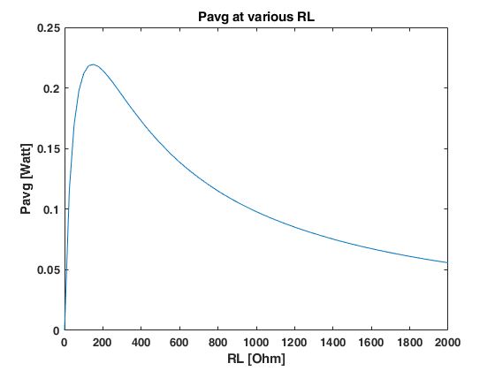
Published with MATLAB® R2018b

