

HospItal finder

Mobile Applications Development Assignment - 2



April 28, 2021

Joel scaria

CSE - B | 106118042

**Hospital Finder** is a convenient app which helps you to locate any hospitals or doctors in your vicinity in case of a medical emergency. It uses your device GPS to accurately find your location and show you relevant hospitals near you.

Hospital Finder works in all parts of the world. This application requires a working internet connection and access to GPS.

Features**:**

* Find the hospitals near you irrespective of your location
* Filter your search using a variety of parameters
* Search for Hospitals, Doctors or Dentists
* Provides access to details like ratings, website, and pictures of the location
* One tap access to call and navigation to the hospital

Description:

* On opening for the first time, app asks for location permission. After allowing, toast is displayed to restart the app
* On opening the app again, beautiful loading **animation** starts. After loading the data, the home activity is displayed which is a map indicating the user’s precise locations along with nearby health facilities
* The 3 dots on the corner contains the privacy policy
* The action bar also contains the **search** functionality. On pressing the magnifying glass, the search box expands, and the user can enter the keyword. The app then displays a list of health facilities with the given name
* On the bottom, there are two more options, **filter**, and **details**
* The details button takes the user to a list of health facilities near him. Each item on the list contains the following information:
* Name of the hospital
* Address
* Distance from it
* Duration taken to reach the hospital by car
* The filter button allows the user to filter the details list according to specific preferences like hospital **type** and **sorting** order
* On clicking any of the results from the details list, the user is taken to another activity which contains details about the hospital like
* **Name** of the hospital
* A **picture** of the hospital
* The hospital’s **website**
* **Address** of the hospital
* **Phone number** of the hospital
* **Rating** of the hospital
* **Opening** time
* **Closing** time
* At the bottom of this activity are two more buttons, **call** and **directions**
* The call button opens the phone’s in-built dialler and automatically pastes the phone number of the hospital
* The directions button opens the phone’s in-built maps application and automatically starts a journey with the user’s current position as the initial position and the said hospital as the final location

Known Bugs:

* Distance and duration not available when finding hospitals through Search function

NB:

* For source code and signed apk, check zip file

Screenshots:

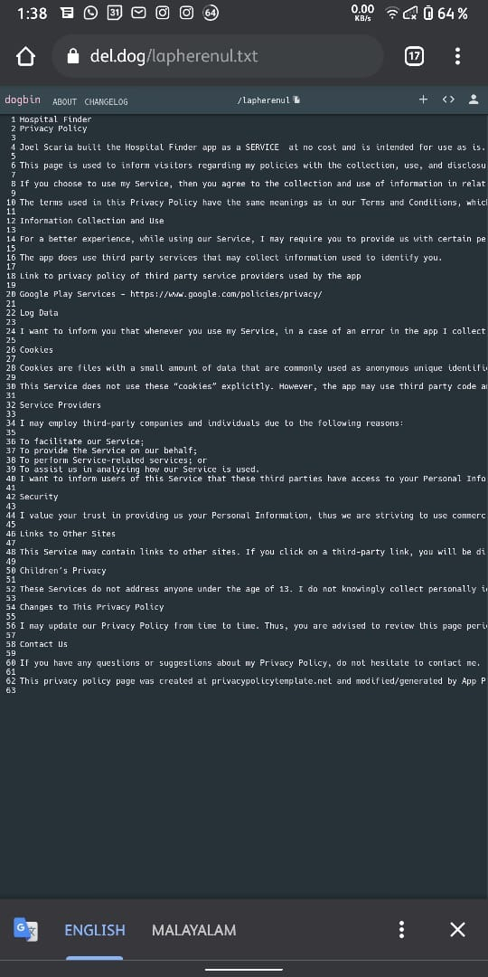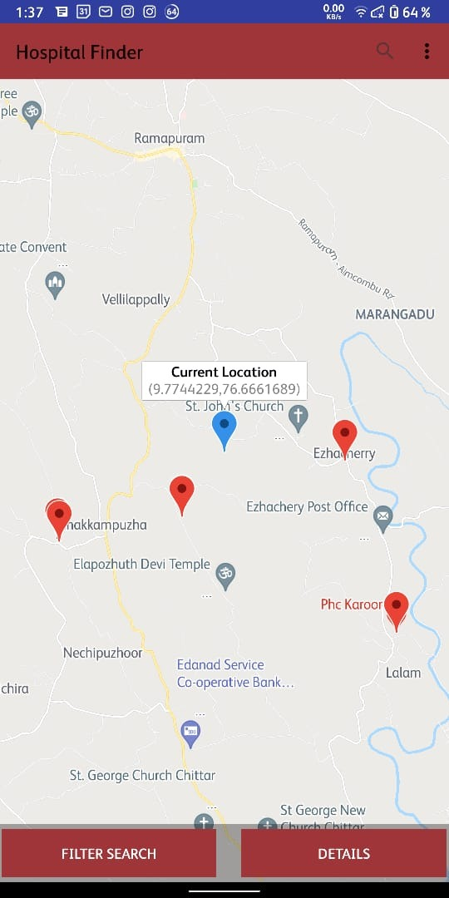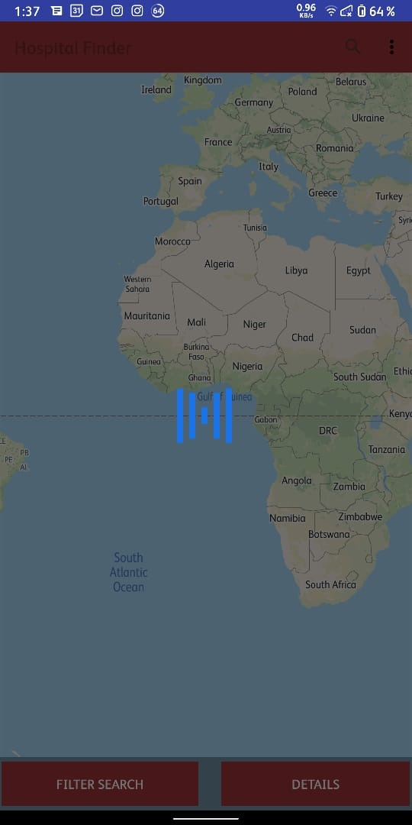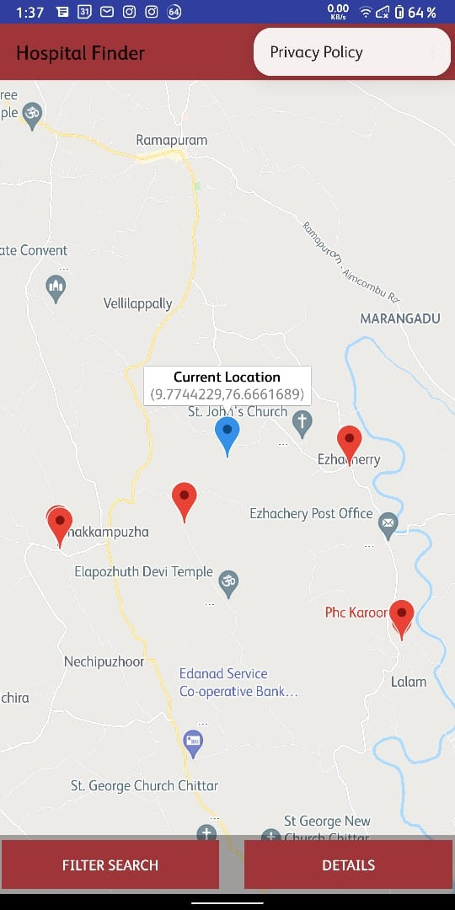

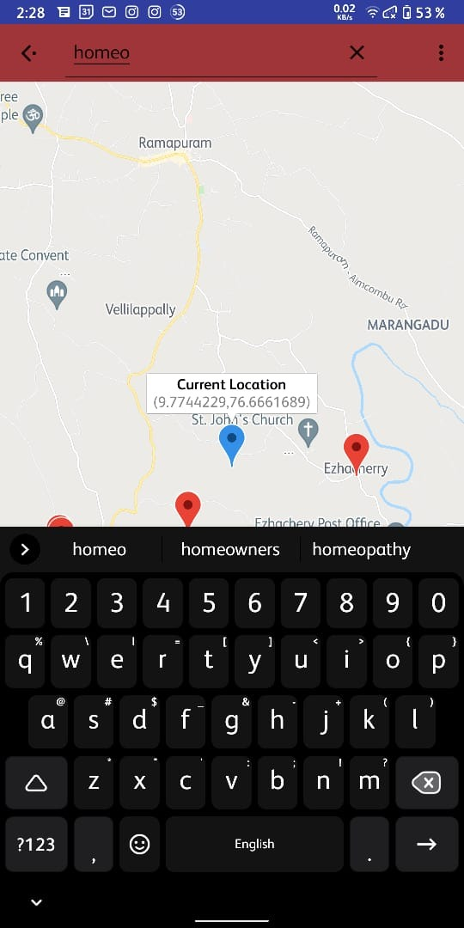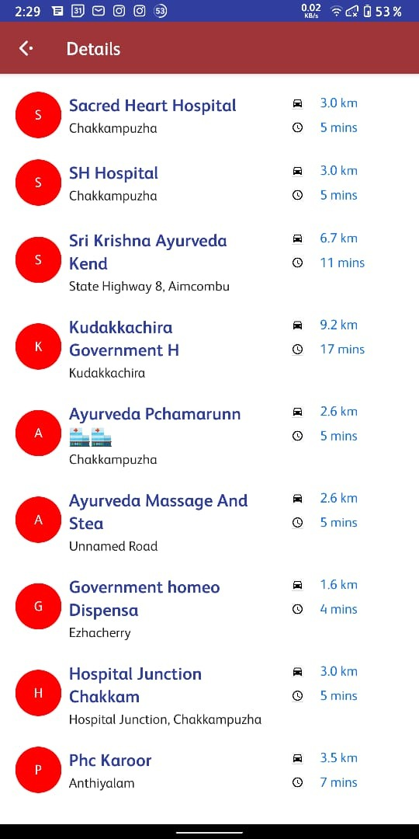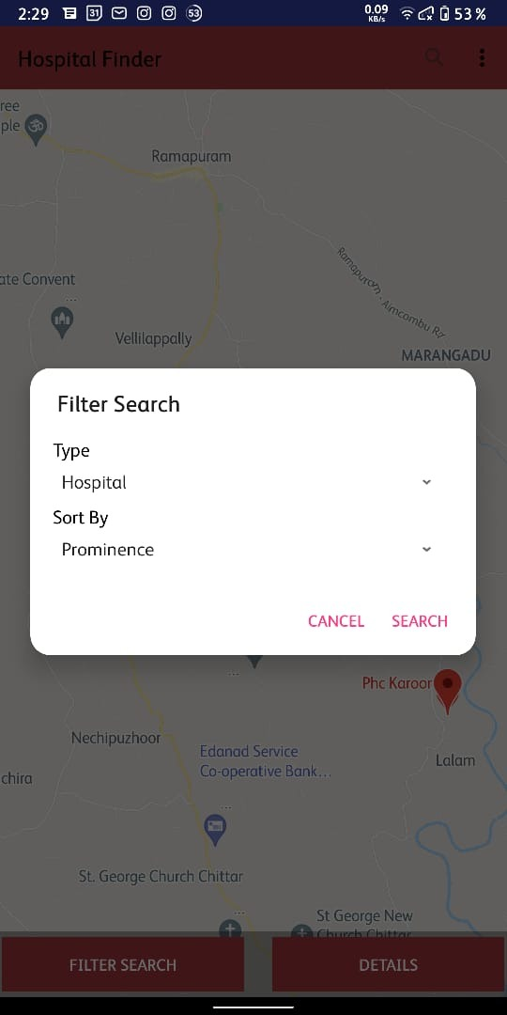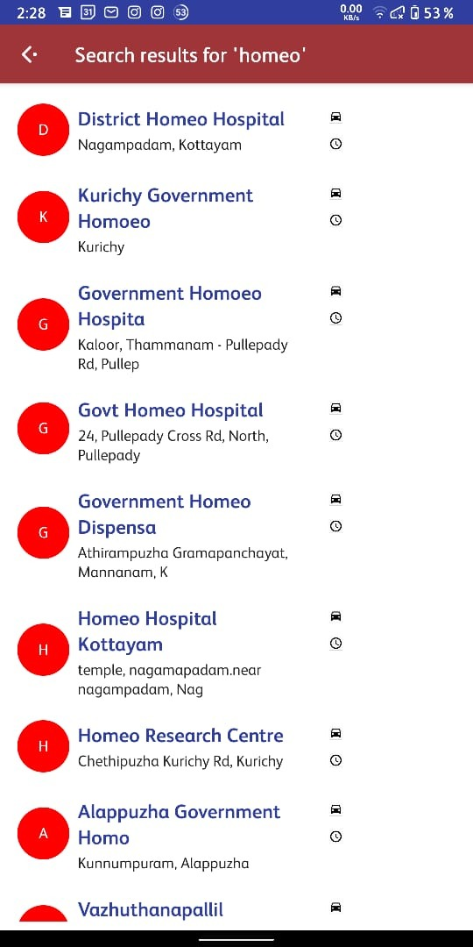

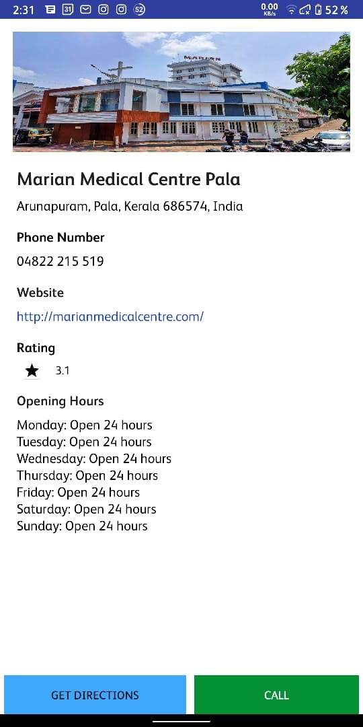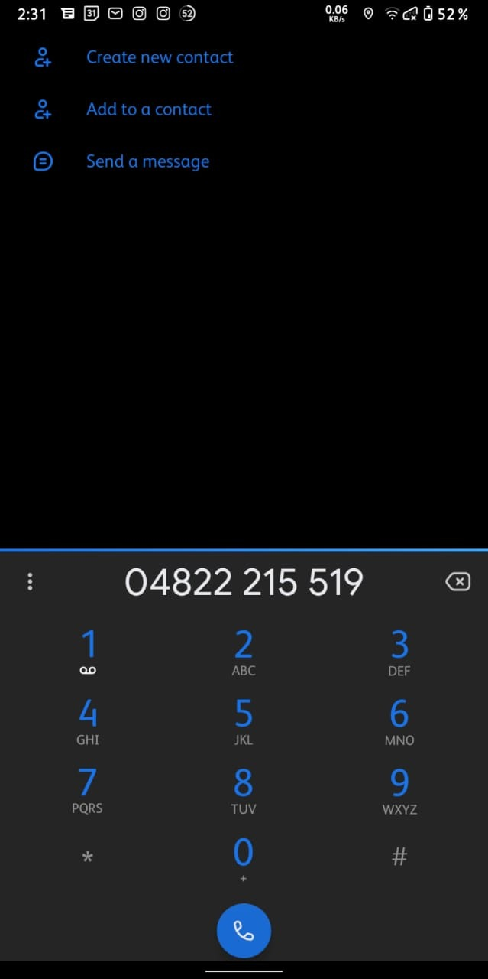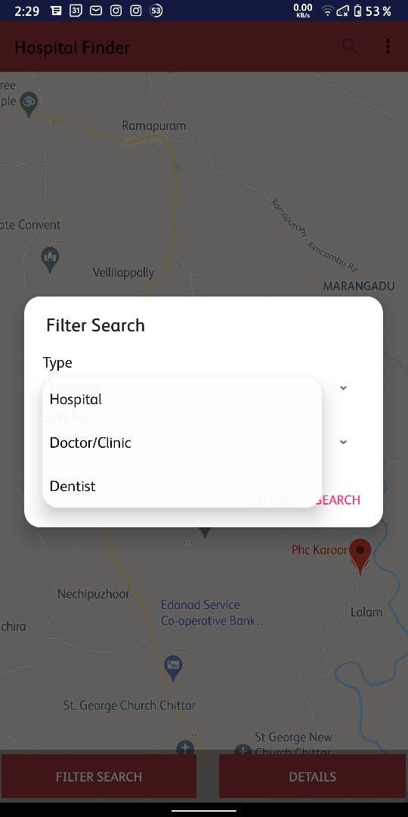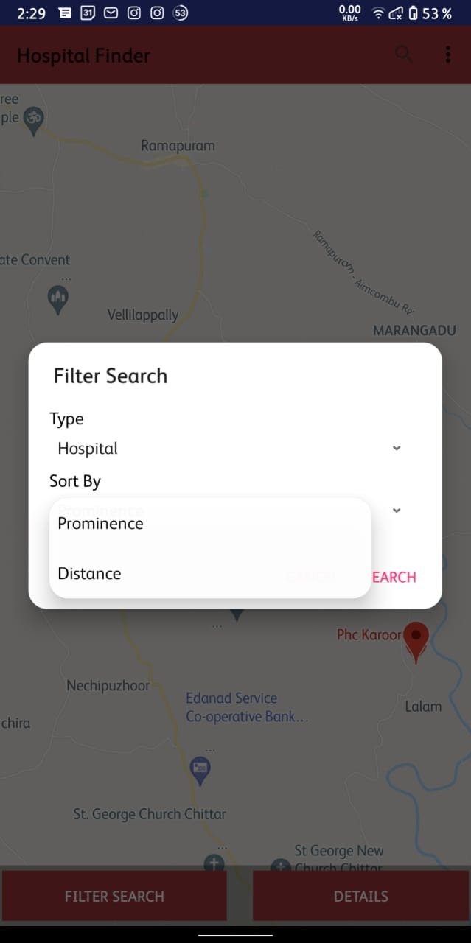

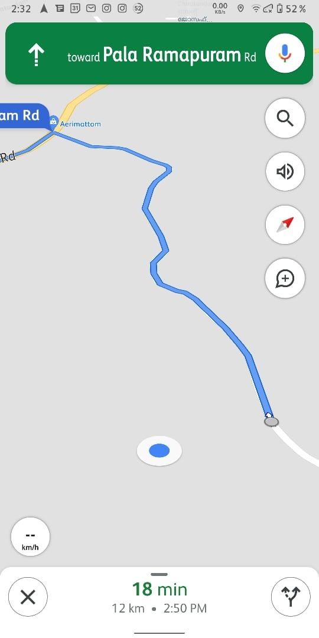

**Thank you !!**