1. Build the utility
2. Before running the utility, there needs to be a setting done in app.config of the utility . (Important)
   1. When you open the B2T.exe.config there are comments added that will let you know what to do :

<add key="BugzillaLoginNumberInCookie" value="115"/> <!-- refer 'Finding Cookie.png' in this project-->

<add key="BugzillaLoginCodeInCookie" value="dxYBy011pD"/> <!-- refer 'Finding Cookie.png' in this project-->

<add key="OutputFileLocation" value="C:\BugImportFirstTry" />    <!—specify the location where you want to download the bugs from bugzilla in xml format-->

The 'Finding Cookie.png' is available at /BugzillaToTFS/B2TUtility

* 1. Also make sure the target TFS server, the target project and the work item type settings :

<add key="TFSUri" value="http://mycompanyTFS.com:8080/tfs/xxx%20collection" />

<add key="ProjectName" value="BugzillaMigrationTest" />

<add key="WorkItemTypeName" value="Bug" />

1. Once you are done with the config part. Open the utility.

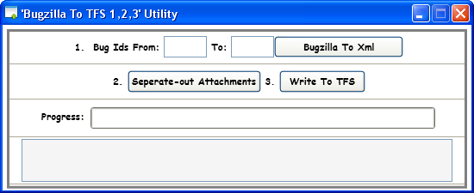

1. The utility have three steps that need to be followed sequentially :
   1. **First Step:** Specify the bugzilla bug ids “From” , “To” fields and click on  “Bugzilla To  Xml”  . This executes the first step of downloading the bugs from bugzilla to specified location set in <add key="OutputFileLocation" value="C:\BugImportFirstTry" />
      1. If you are downloading bugs in chunks (let us say from bug ids 1 to 5000 in one chunck and 5001 to  9391) then for the next chunk a message box will popup:

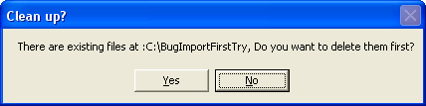

Click “No” to avoid deletion of existing xmls in the folder set in <add key="OutputFileLocation" value="C:\BugImportFirstTry" />

* + 1. For your information : Each bug download has a sleep of 1 sec.
    2. If the cookie settings in the B2T.exe.config are wrong then the xml files will have error messages and it will be a invalid file for next step. Please follow the point # 2.a above.
    3. Find out last bugzilla bug id, please query for ids higher than last one to make sure we are right.
  1. **Second Step :** Once you are done with all the download of the bugs (step 1), next click on the “Separate-out Attachments” button. This step separates out the attachments data present in all the xml bug file in the folder.
     1. If any xml file is invalid, the utility will skip that file. Please make sure the cookie setting
     2. This step separates out the attachments data for all the xmls in the folder and it **has no relevance to the “From” and “To” field of step 1**
  2. **Third Step:** Click the “Write To TFS”. This steps writes all the bugs present in the xml format to TFS.
     1. This step also adds all the attachments related to Bug to the TFS.
     2. This step add every bug present in the folder to TFS (has no relevance to the “From” and “To” field of step 1)
     3. **Before you run this step make sure the settings (Point #2.b) for targeted TFS are correct.**
     4. **Also make sure the template is in compliance with the fields used in the source code of the utility.**