Universität Leipzig
Wirtschaftswissenschaftliche Fakultät
Professur für Nachhaltige Immobilien- und Stadtentwicklung
Prof. Melanie Krause Ph. D.

„Predicting AirBnB Prices in a City - London“
Seminar Paper

Submitted by: Wagner, Steven; König, Felix; Grahl, Eliano
Matrikelnummer: 3788519, 3759917, 3786297
E-Mail: pa19duxu@studserv.uni-leipzig.de, gt59owug@studserv.uni-leipzig.de, ts21egoh@studserv.uni-leipzig.de
Leipzig, den 12.07.2026

Table of Contents
Table of Contents 1
Index of Tables 2
Index of Figures 2
Abbreviations 3
1. Overview: Topic and involved variables 5
1.1 Research Question 6
1.2 Relevance and Contribution of the Research Question 7
1.3 Choice of the Unit of Observation 7
1.4 Justification of variable selection 8
1.5 Strength and weaknesses of data set 11
2. Descriptive and inferential statistics 11
2.1 Data Preparation and Feature Construction 12
2.2 Descriptive Statistics 13
2.3 Inferential Statistics: The Superhost Premium 14
2.4 SHAP Decomposition of the OLS Model 16
3. Machine learning analytics 16
3.1 Models 17
3.2 Evaluation Protocol 17
3.3 Predictive Results 18
3.4 Explaining the Predictions 19
4. Critical evaluation and discussion 20
4.1 Predictive Quality 21
4.2 Case-Based Evaluation 21
4.3 Limitations 22
4.4 Implications and Outlook 22
4.5 Conclusion 23
Bibliography 23
Appendix 24
Appendix A: Tables 25
Appendix B: Figures 31

Index of Tables
Table 1: Results of Regression Analysis Fehler! Textmarke nicht definiert.

Index of Figures
Figure 1: Conceptual Model for Your Study Fehler! Textmarke nicht definiert.

Abbreviations

Overview: Topic and involved variables
The prediction of Airbnb prices in London is relevant from both a scientific and a practical perspective: the city is one of the largest Airbnb markets in the world and is characterized by a particularly dynamic regulatory environment (Hübscher and Kallert, 2021). Prices are shaped by professional as well as non-professional hosts (Camatti et al., 2024), which makes the London market a complex data basis for analysing and predicting pricing.

Research Question
This paper investigates how accurately Airbnb prices in London can be predicted from observable characteristics of individual listings. The dependent variable is the nightly listing price; the explanatory variables cover physical, geographical, and reputational characteristics as well as regulatory factors such as the 90-day limit on short-term rentals introduced in 2015 (Hübscher and Kallert, 2021; Cheung, 2024; Löw and Lüth, 2021).
The research question rests on the assumption that Airbnb prices are not random but reflect systematic differences between accommodations, such as size, amenities, guest capacity, location, and host characteristics (Camatti et al., 2024; Islam et al., 2022). This corresponds to the hedonic logic in which the price of a good is composed of its observable characteristics (Camatti et al., 2024; Gao, 2025). For Airbnb, this logic applies only partially, because the platform combines a high degree of provider heterogeneity with flexible individual pricing decisions: in 2020, roughly 49 percent of all London listings were offered by professional or multi-hosts, while 51 percent came from non-professional hosts (Hübscher and Kallert, 2021).
The study deliberately focuses on prediction rather than causal analysis: the aim is to forecast price differences between individual listings with statistical and machine learning methods. London is well suited for this purpose because of its high tourist demand and pronounced spatial heterogeneity (Hübscher and Kallert, 2021).

Relevance and Contribution of the Research Question
The relevance of the research question stems from the growing economic, methodological, and urban-policy significance of pricing on short-term rental platforms. Unlike in traditional hotel markets, prices on Airbnb are not set by centralized revenue management systems; hosts retain a high degree of autonomy (Camatti et al., 2024; Gao, 2025). The result is substantial price heterogeneity, which makes the analysis of price drivers relevant.
Accurate price prediction is of practical interest to several groups. Hosts can price their listings more in line with the market; inefficient pricing can cause revenue losses of approximately 46 percent (Camatti et al., 2024; Kanakaris and Karacapilidis, 2023). Guests gain transparency, because a prediction shows whether an offer is cheap or expensive relative to comparable accommodations (Islam et al., 2022; Wang, 2025). For platform operators, price forecasts can form the basis of dynamic recommendation and pricing systems (Löw and Lüth, 2021).
The question also has urban-policy implications: short-term rentals can remove housing from the regular rental market. In London, an estimated 2 percent of apartments had been withdrawn in favor of short-term rentals by 2018 (Hübscher and Kallert, 2021; Shabrina et al., 2022). The study thus combines an economic perspective on price determinants with a methodological focus on machine learning.

Choice of the Unit of Observation
The unit of observation is the individual Airbnb listing in London. Each observation corresponds to one accommodation with its nightly price and its physical, geographic, reputation-related, and host-related characteristics (Zhang, 2025). This choice follows directly from the research question: the study predicts the price of individual listings, not average prices at the city, borough, or host level. The dependent variable and almost all explanatory variables are measured at the listing level, so differences between accommodations can be linked systematically to price differences (Islam et al., 2022; Zhang, 2025).
Higher-level information is not treated as a separate unit of observation but enters as listing-level features: host characteristics are assigned to each of a host’s listings, and location is captured by the 33 London boroughs and the metric distance to the city center. This is essential for London, where prices vary not only between center and periphery but also within boroughs (Zhang, 2025); aggregation at the borough level would obscure exactly this variation (Gao, 2025). After data preparation, the final dataset comprises 45,608 listings.

Justification of variable selection
This section justifies the selection of the independent variables used to predict the dependent variable, the price of the Airbnb listings.
In peer-to-peer accommodation markets, trust and reputation are decisive for converting a potential guest’s attention into a booking, and platforms use reputation systems to reduce information asymmetries (Teubner et al., 2017). The Superhost badge is the most prominent of these signals and, in terms of signaling theory, a particularly reliable one: it is verified by Airbnb itself and requires hosts to continuously meet strict performance benchmarks such as high response rates, a large share of 5-star ratings, and zero cancellations (Liang et al., 2017; Teubner et al., 2017). The badge therefore serves as a credible indicator of quality and reliability.
The room type is the fundamental baseline of Airbnb pricing: hedonic models consistently show that entire homes command the highest prices, followed by private rooms and shared rooms (Wang and Nicolau, 2017).
The maximum guest capacity measures the overall size of a listing and has a robust positive price effect, because it directly reflects the physical space provided (Gibbs et al., 2018). Wang and Nicolau (2017) estimate an average increase of 6.1 percent per additional guest, and machine learning studies identify capacity as one of the key drivers of predicted prices (Tang et al., 2023).
The number of bathrooms is a further physical feature with a consistently positive and significant effect (Voltes-Dorta and Sánchez-Medina, 2020); Wang and Nicolau (2017) report a premium of roughly 10.8 percent per additional bathroom. The distinction between private and shared bathrooms is also price-relevant, particularly since the COVID-19 pandemic increased the value of privacy and hygiene (Boros et al., 2020).
The number of bedrooms is among the strongest price determinants (Guttentag et al., 2017; Tang et al., 2023): separate bedrooms allow travel groups and families to divide the space, which is a central motive for choosing Airbnb over hotels (Guttentag et al., 2017), and guests value real bedrooms considerably higher than makeshift sleeping arrangements (Tussyadiah and Zach, 2016).
Amenities form a further category of price determinants: Wang and Nicolau (2017) identify them as significant price factors, and review analyses show that physical facilities directly shape perceived quality (Tussyadiah and Zach, 2016).
Finally, geographic location is critical. Prices decrease systematically with distance from the center (Wang and Nicolau, 2017), and for London, Quattrone et al. (2016) show that high-priced listings cluster around several historical centers with a high density of sights.
The number of beds was deliberately excluded: its correlation of 0.805 with the guest capacity would introduce multicollinearity and destabilize the models.

Strength and weaknesses of data set
The use of a city-specific dataset with over 45,000 London listings has clear methodological advantages. Pooling data across cities or countries would mix different legal frameworks, tax systems, and climatic conditions into the predictive model; a single-city dataset holds this background constant, so the effects of the listing characteristics can emerge more clearly. Quattrone et al. (2016) argue that neighborhood effects are highly localized phenomena and explicitly use London data to capture such fine-grained micro-geographies. A regional dataset also matches the regulatory reality: short-term rentals are governed largely at the municipal level, as London’s 90-day rule illustrates (Ferreri and Sanyal, 2018).
The corresponding weakness is limited external validity. Airbnb markets behave differently depending on city type and tourism profile (Adamiak, 2018); London is a global center and thus an extreme market environment, so price drivers identified here cannot simply be transferred to smaller cities or rural areas. In addition, a single-city snapshot is vulnerable to local shocks: Gyódi (2019) compares several European cities precisely to avoid this dependence on one place and one point in time, since one-off events can distort the entire pricing structure of a single market. Cross-regional panel data could mitigate these weaknesses.

Descriptive and inferential statistics
This chapter documents the path from the raw data to the analysis dataset (Section 2.1), describes the central patterns in the data (Section 2.2), tests the price premium of Superhosts and estimates a hedonic regression as the interpretable baseline of this study (Section 2.3), and translates this regression into SHAP values for the later comparison with the machine learning models (Section 2.4).

Data Preparation and Feature Construction
The analysis is based on the public Inside Airbnb snapshot of London from September 16, 2025, which contains 96,871 listings with 79 raw columns (Inside Airbnb, 2025); because the data are scraped from the public website, the price field reflects the advertised nightly rate on the scraping date rather than transacted booking prices. Sixteen structured, price-relevant columns were selected; identifiers, URLs, and free-text fields were discarded. Rows with a missing value in any selected column were then removed entirely. This listwise deletion avoids imputation assumptions, but it removes about 52 percent of all rows; the resulting bias toward established, fully documented listings is discussed in Chapter 4.
Three groups of filters were applied afterwards; Table 1 summarizes the resulting data funnel. Hotel and shared rooms were removed (a combined share of roughly 0.3 percent), so the scope of the study is entire homes and private rooms. Implausible extreme values were excluded by restricting nightly prices to the range from $10 to $1,000 (the top 0.8 percent, with prices up to $74,100 per night, points to data errors rather than market prices) and by dropping listings with more than ten bedrooms or more than eight bathrooms. Finally, listings whose calendar was never bookable during the following year were dropped because they carry no market-relevant nightly price, as were twelve listings without any amenity information.
Several features were constructed from the raw columns. The 33 London boroughs were one-hot encoded, and the coordinates of each listing were converted into the straight-line distance to the city center (51.51, −0.12) with the Haversine formula, so that the models receive both a categorical and a continuous location signal. The free-text amenity list was parsed into a total count and four binary flags for a pool, a hot tub, a bathtub, and a balcony or patio; two further candidate flags, wifi and kitchen, were discarded as quasi-constant. The number of beds was excluded for the multicollinearity reasons discussed in Section 1.4 (Wooldridge, 2020), and hosts with ten or more active listings were marked as professional hosts.
The dependent variable is the logarithm of the nightly price, log(1 + price): raw prices are heavily right-skewed, while the transformed distribution is approximately normal and coefficients can be read as percentage effects (Wooldridge, 2020). Predictions are converted back to dollars with the smearing estimator of Duan (1983), which corrects the systematic underestimation that a naive back-transformation would produce. The final dataset contains 45,608 listings and 51 model features: 18 direct features and 33 borough indicators (Table 2; the complete list ordered by model influence is provided in Table 9).

Descriptive Statistics
Table 3 reports summary statistics for the central variables: the average listing accommodates 3.5 guests in 1.5 bedrooms, lies 7.5 kilometers from the city center, and is offered at $164 per night, while the median price is $130. Figure 2 shows why the price enters all models in logs: the raw distribution is heavily right-skewed, with most listings between $50 and $200 and a thin tail stretching toward the $1,000 cap, while the log-transformed distribution is close to a bell shape.
Price formation in London is strongly local. Figure 3 maps every listing with its nightly price: prices peak in the central boroughs of Westminster and Kensington and Chelsea and decline toward the periphery, with smaller expensive pockets around secondary centers. This pattern is consistent with the polycentric structure of the London market (Quattrone et al., 2016) and motivates the combination of the borough indicators with the continuous distance-to-center feature.
Figure 4 plots the nightly price against four candidate drivers and confirms the expected directions: the price rises with guest capacity and with the location rating and falls with distance to the center. None of these relationships is a straight line, however: the capacity effect flattens beyond roughly eight guests, prices decay convexly with distance, and the location rating becomes price-relevant mainly in the narrow band between 4.5 and 5.0 where most ratings lie. This curvature is the first indication that the linear model of Section 2.3 will describe the market only approximately.
Figure 5 completes the descriptive picture with the correlation matrix of the retained features. Beyond the excluded beds variable, the size block remains visibly intercorrelated (accommodates and bedrooms at 0.78, bedrooms and bathrooms at 0.60), a structure that Section 2.3 quantifies with variance inflation factors and that Section 3.4 revisits when importance is attributed to individual size features.

Inferential Statistics: The Superhost Premium
As a first formal question, we test whether listings of Superhosts obtain higher prices. Superhost listings cost on average $178.88 per night (n = 13,131), compared to $158.65 for all other listings (n = 32,477), a raw difference of 12.7 percent, and a Welch t-test rejects equality of the means (t = 13.73, p < 0.001; Welch, 1947). The comparison is nevertheless unadjusted: Superhosts might simply operate larger or better located properties.
To adjust for observable characteristics, we estimate a hedonic regression in the tradition of Rosen (1974), in which the log price is explained by all listing characteristics simultaneously. Categorical variables enter with k−1 indicators: private rooms serve as the reference for the room type and the alphabetically first borough, Barking and Dagenham, as the reference borough. Estimated by ordinary least squares (OLS) on all 45,608 listings, the model explains 74.4 percent of the variance in log prices (adjusted R² = 0.743). Multicollinearity is unproblematic (the largest variance inflation factor is 3.3, far below the conventional threshold of 10), but a Breusch-Pagan test detects pronounced heteroskedasticity (LM = 1,108.9, p < 0.001; Breusch and Pagan, 1979). Table 4 therefore reports heteroskedasticity-robust HC3 standard errors (MacKinnon and White, 1985); no conclusion changes under this correction.
Because the dependent variable is in logs, exp(β)−1 gives the percentage association of each feature with the price, and the estimates match the hedonic expectations derived in Chapter 1. An entire home is priced 57.2 percent above an otherwise identical private room, each additional guest corresponds to 6.8 percent, each additional bedroom adds 14.3 percent and each additional bathroom 10.7 percent, while a shared bathroom reduces the price by 23.8 percent. Two of these magnitudes replicate independent cross-city evidence almost exactly: Wang and Nicolau (2017) report 6.1 percent per additional guest and 10.8 percent per additional bathroom. One additional point on the location rating corresponds to a premium of 10.8 percent, and prices fall by about 4.5 percent per kilometer of distance from the center. Conditional on all of these controls, the Superhost coefficient implies a premium of 12.2 percent, barely below the raw gap. Because the badge is earned through high ratings and reliable service, it is selected on precisely the quality the data do not record; the 12.2 percent is therefore a conditional association and an upper bound on any causal badge effect.
The residuals remain heavy-tailed (Jarque-Bera = 19,345, p < 0.001), which already locates the segment, unusual and expensive listings, where any model restricted to these features will struggle. The regression’s central limitation is structural: it forces every association to be linear and additive, although Section 2.2 documented curvature. This motivates the machine learning analysis in Chapter 3.

SHAP Decomposition of the OLS Model
Before turning to more flexible models, we express the regression results in the measure that will later be used to explain the machine learning models: SHAP values, which assign to each feature its fair contribution to an individual prediction, based on the Shapley value from cooperative game theory (Shapley, 1953; Lundberg and Lee, 2017). For a linear model this decomposition is exact: the contribution of feature j to the prediction for listing i equals βⱼ (xᵢⱼ − x̄ⱼ), and averaging the absolute contributions over all listings yields a global importance measure that is directly comparable to the tree-based SHAP values in Chapter 3.
Figures 6 and 7 present this decomposition in two complementary views. Figure 6 shows the summary plot in the same form as the XGBoost summary in Chapter 3, with the twenty most influential features displayed individually; Figure 7 and Table 7 aggregate the 33 borough indicators into one group, so that the total influence of location becomes visible. In this aggregated view, the borough indicators carry the largest global influence on the log price (mean |SHAP| = 0.251), followed by the entire-home indicator (0.194), the distance to the center (0.178), guest capacity (0.110), and bedrooms (0.098). Coefficients and SHAP importances answer different questions: the location rating has a sizable coefficient of 11 percent per rating point, but because most ratings cluster between 4.6 and 5.0, its global influence on predictions is small (0.026); the Superhost badge behaves similarly (0.047). In the linear view, the dominant sources of price variation are location and physical size; this ranking is the reference point for the model comparison in Chapter 3.

Machine learning analytics
The hedonic regression describes the market in interpretable percentage effects, but it imposes linearity: the fifth guest must be worth as much as the second, and the value of a bedroom must not depend on the borough. The descriptive evidence in Section 2.2 contradicts these restrictions. This chapter therefore asks whether prediction accuracy improves when nonlinearity and feature interactions are allowed, holding the data and the features fixed.

Models
The five model families span the bias-variance spectrum from a restricted linear estimator to a high-capacity boosting ensemble, so that performance gaps between adjacent families isolate the value of individual modeling assumptions. Ridge regression, a linear regression whose coefficients are shrunk by an L2 penalty (Hoerl and Kennard, 1970), is the predictive counterpart of the OLS from Chapter 2: any gain over Ridge measures what nonlinearity and interactions contribute, not what regularization contributes. Random Forest relaxes linearity by averaging many deep decision trees fitted on bootstrap samples (Breiman, 2001); Extra Trees additionally randomizes the split points, accepting slightly more bias for a further reduction in variance (Geurts et al., 2006). XGBoost fits trees sequentially, each on the residuals of the current ensemble, so the model concentrates capacity exactly where systematic error remains, disciplined by explicit regularization and early stopping (Chen and Guestrin, 2016). A multilayer perceptron completes the set as the representative of neural networks; benchmark evidence predicts that tree ensembles should dominate it on medium-sized tabular data with many binary features (Grinsztajn et al., 2022).

Evaluation Protocol
The protocol was designed so that no test information can influence any modeling step. Final performance is measured with five-fold cross-validation over all 45,608 listings, so that every listing is predicted exactly once out of sample (Hastie et al., 2009). Hyperparameters were tuned beforehand with the Optuna framework (Akiba et al., 2019) on a separate, fixed 80/20 split, so that the tuning never touches the test folds. For the scale-sensitive models, Ridge and the neural network, the standardization of the features is fitted inside each training fold only, which prevents data leakage; XGBoost additionally uses early stopping on an inner validation split of each training fold. All predictions are made on the log scale and converted back to dollars with the smearing correction of Duan (1983), whose correction factor is estimated from the training-fold residuals only. All random components are seeded, and Table 5 documents the search spaces and selected configurations for full reproducibility. Reported metrics are the root mean squared error (RMSE), the mean and the median absolute error (MAE, MedAE), the mean absolute percentage error (MAPE), R², and the share of predictions within 20 percent of the true price.

Predictive Results
Table 6 reports the results as means over the five folds. Against a naive baseline that predicts the training-fold mean price with the identical back-transformation, every model at least halves the error; XGBoost reduces it by 47.7 percent (RMSE $68.53 against $130.96) and explains 72.6 percent of the out-of-sample price variance. Against the linear benchmark, XGBoost lowers the RMSE by 16.2 percent ($68.53 against $81.76 for Ridge); because both models use identical features, folds, and back-transformation, this margin is a clean estimate of what nonlinearity and feature interactions are worth in this market. The ranking is stable at the fold level: XGBoost achieves the lowest RMSE in every fold, and its paired advantage over the next-best model, Extra Trees, amounts to $2.87 with a standard deviation of only $0.40; we report this dispersion instead of a formal significance test because cross-validation folds share training data (Nadeau and Bengio, 2003). The neural network trails the tree ensembles on every metric, confirming the tabular-data pattern documented by Grinsztajn et al. (2022).
Two numbers in this paper must not be confused: the OLS R² of 0.744 from Chapter 2 is an in-sample value on the log scale, while the 0.726 of XGBoost measures genuine prediction on unseen listings in dollars. The results also align with the directly comparable evidence for London: on the same Inside Airbnb source, Gao (2025) reports a test R² of 0.605 for a linear baseline and 0.763 for a tuned Random Forest, against 0.610 for Ridge and 0.726 for XGBoost here. That two independent implementations on the same market arrive at the same ordering, a linear ceiling near 0.61 and a tree-ensemble optimum near 0.73 to 0.76, indicates that both estimate a property of the market rather than an artifact of one pipeline. Part of the performance is attributable to the data rather than the algorithm: an earlier feature set that still contained the quasi-constant and redundant variables produced an XGBoost RMSE of $74.92 under a preliminary single-split evaluation. The comparison is therefore indicative rather than exact, but it suggests that careful feature construction contributes a margin of the same order as the choice of algorithm.

Explaining the Predictions
A model that predicts well but cannot be explained is of limited use for hosts or regulators, so the black box is opened with the instrument introduced in Section 2.4. For tree ensembles, SHAP values can be computed exactly and efficiently with the Tree-SHAP algorithm (Lundberg et al., 2020). To keep the explanations strictly out of sample, the final XGBoost model is refit on 80 percent of the data, and all SHAP values are computed for the 9,122 holdout listings the model has not seen. In the resulting summary plot (Figure 8), the strongest drivers are the entire-home indicator (mean |SHAP| = 0.233), guest capacity (0.139), distance to the center (0.136), and bedrooms (0.100); among the borough indicators, only Westminster and Kensington and Chelsea retain a visible individual influence. XGBoost’s own gain-based importance produces the same ordering but exaggerates the top feature (59.6 percent of the total importance against 21.1 percent under SHAP), because the entire-home indicator almost always forms the root split of each tree; SHAP distributes the contributions more evenly and is therefore used as the primary measure here.
Table 7 places the XGBoost SHAP importances next to the OLS SHAP importances from Section 2.4, with the borough indicators aggregated into one row. The same drivers dominate both columns: accommodation type, size, and location, followed by reputation. This triangulation is the central robustness result of the study: three methodologically independent views, the OLS coefficients, the linear SHAP decomposition, and the tree-based SHAP decomposition, identify the same price drivers, so the ranking is not an artifact of any single method. The differences are themselves informative: XGBoost shifts part of the borough influence to the continuous distance feature (aggregated boroughs 0.135 against 0.251 in the OLS), suggesting that the smooth distance gradient captures location more efficiently once nonlinearity is available. One caveat applies to both columns: Shapley attributions divide the credit for a joint effect among correlated features, and the size variables are substantially intercorrelated (0.51 to 0.78; Figure 5). The attribution to the size block as a whole is therefore more trustworthy than the exact split within it.

Critical evaluation and discussion
Chapter 3 established what the model achieves on average. This chapter evaluates the error structure (Section 4.1), individual holdout cases (Section 4.2), and the structural limits of the data (Section 4.3), before Section 4.4 returns to the market participants of Chapter 1.

Predictive Quality
An RMSE of $68.53 and a median absolute error of $20.46 describe two different populations of errors. Half of all listings are predicted within about $20 of their true price, and 56.0 percent of predictions lie within 20 percent of the truth (MAPE 23.0 percent). Because the RMSE squares the errors, its much larger value is driven by a small number of large mistakes concentrated at the expensive end of the market, exactly the segment that the heavy-tailed OLS residuals of Section 2.3 already identified. The model is therefore accurate for the broad middle of the market and unreliable in its upper tail. All metrics are stable across the five folds (RMSE ±$1.86), and an out-of-sample R² of 0.726 is high without being suspicious: values close to one on scraped cross-sectional data would indicate leakage rather than skill. Roughly 27 percent of the price variation remains unexplained; Section 4.3 attributes this residual to information the data do not contain rather than to insufficient optimization.

Case-Based Evaluation
Table 8 grounds these statistics in six listings from the holdout data. Where the observable features match the price, the predictions are nearly exact in every market segment: a budget room in Clapham ($58 actual, $57 predicted), a one-bedroom flat ($133, $132), and a five-bedroom family home ($676, $676). The three largest errors are analytically more valuable than the successes, because each isolates a distinct failure mode of the data rather than of the model. The first is measurement error in the target: a two-bedroom flat in Hackney listed at $999 is predicted at $176, and since no comparable flat in a non-premium borough obtains such a price, the model output is arguably the realistic value and the listing is overpriced. The second is label noise in the features: a six-bed hostel dormitory listed at $19 is predicted at $106, because it is recorded as a private room whose capacity describes the entire hostel. The third mirrors the first with reversed sign: a studio advertised as prime Chelsea at $36 is predicted at $162, the plausible rate for London’s most expensive area. In all three cases the residual flags a data problem: the model’s largest errors form an automated shortlist of mispriced or misclassified listings.
Figure 9 opens the model’s reasoning for the $999 case with a SHAP waterfall plot. The entire-home status and a capacity of five guests push the prediction up, the single bathroom and the Hackney location pull it down, and the contributions net out at about $176 per night. Nothing in the observable features supports $999, which localizes the boundary of the approach precisely: the model prices the measurable configuration of a listing, while unmeasured quality, such as photos, interior condition, or a view, lies outside its information set.

Limitations
The limitations follow directly from the design decisions documented in Section 2.1, most of which trade coverage for robustness. First, the scope is restricted to entire homes and private rooms within a price window of $10 to $1,000; genuine luxury properties are excluded, and the capped upper tail is exactly where the model is weakest. Second, listwise deletion removed about half of the raw listings, so the sample leans toward established, fully documented, and reviewed listings; newly listed properties without reviews are absent by construction. Third, location is measured only by borough and radial distance to the center; proximity to underground stations, parks, or attractions is invisible to the model. Fourth, the data are a single September snapshot of advertised prices, so seasonality, events, and actual transaction prices are outside the analysis. Fifth, all estimated relationships are correlations; whether a pool causes higher prices or expensive properties simply tend to have pools cannot be decided with cross-sectional data. Finally, the unexplained quarter of the price variation reflects unobserved quality, which no amount of hyperparameter tuning can recover.

Implications and Outlook
Despite these limits, the results support decisions on every side of the market described in Chapter 1. For hosts, a median error of about $20 on a median price of $130 is precise enough to anchor the nightly rate of a typical listing, and the SHAP decomposition turns the prediction into advice by naming the levers behind it: a shared bathroom costs roughly a quarter of the nightly price, while an entire home commands more than half again as much as a comparable private room. For the city, the borough-level concentration of listings and prices shows where short-term rental pressure on the housing stock is strongest, and therefore where London’s 90-day rule matters most for enforcement (cf. Hübscher and Kallert, 2021). For the platform and its guests, the largest residuals reliably flag mispriced or misclassified listings, so the model serves as a screening instrument for listing quality as much as a price benchmark. The outlook follows from the limitations, because each unobserved dimension corresponds to an available data source: review texts, photos, the distance to the nearest underground station, and a price calendar would each add information the current snapshot lacks. Progress on this problem runs through richer data, not larger models.

Conclusion
This study asked how accurately Airbnb prices in London can be predicted from observable listing characteristics. Location and physical size govern the market more than any other factor, consistently across descriptive statistics, the hedonic regression, and machine learning. The Superhost badge is associated with a moderate premium of about 12 percent among otherwise comparable listings. XGBoost predicts unseen listings with an R² of 0.726, reduces the error of the linear benchmark by 16.2 percent, and remains transparent through SHAP, from the global driver ranking down to the individual listing. The model is a reliable guide for ordinary listings but not for the rare luxury segment, and its largest errors typically point to mispriced or mislabeled listings rather than to model failure. Observable characteristics thus explain almost three quarters of the price variation in one of the world’s largest short-term rental markets; the remainder is quality that the data cannot see.

Bibliography
Adamiak, C. (2018). Mapping Airbnb supply in European cities. Annals of Tourism Research, 71, 67–71. https://doi.org/10.1016/j.annals.2018.02.008
Akiba, T., Sano, S., Yanase, T., Ohta, T., & Koyama, M. (2019). Optuna: A next-generation hyperparameter optimization framework. Proceedings of the 25th ACM SIGKDD International Conference on Knowledge Discovery & Data Mining, 2623–2631. https://doi.org/10.1145/3292500.3330701
Boros, L., Dudás, G., & Kovalcsik, T. (2020). The effects of COVID-19 on Airbnb. Hungarian Geographical Bulletin, 69(4), 363–381. https://doi.org/10.15201/hungeobull.69.4.3
Breiman, L. (2001). Random forests. Machine Learning, 45(1), 5–32. https://doi.org/10.1023/A:1010933404324
Breusch, T. S., & Pagan, A. R. (1979). A simple test for heteroscedasticity and random coefficient variation. Econometrica, 47(5), 1287–1294. https://doi.org/10.2307/1911963
Camatti, N., Di Tollo, G., Filograsso, G., & Ghilardi, S. (2024). Predicting Airbnb pricing: A comparative analysis of artificial intelligence and traditional approaches. Computational Management Science, 21(1), 30. https://doi.org/10.1007/s10287-024-00511-4
Chen, T., & Guestrin, C. (2016). XGBoost: A scalable tree boosting system. Proceedings of the 22nd ACM SIGKDD International Conference on Knowledge Discovery and Data Mining, 785–794. https://doi.org/10.1145/2939672.2939785
Cheung, K. S. (2024). Airbnb pricing and term structure: A temporal analysis of omitted variable bias and repeat sales method as remedies. Tourism Economics, 30(5), 1330–1338. https://doi.org/10.1177/13548166231191551
Crommelin, L., Troy, L., Martin, C., & Parkinson, S. (2018). Technological disruption in private housing markets: The case of Airbnb. AHURI Final Report, (305). https://doi.org/10.18408/ahuri-7115201
Duan, N. (1983). Smearing estimate: A nonparametric retransformation method. Journal of the American Statistical Association, 78(383), 605–610. https://doi.org/10.1080/01621459.1983.10478017
Ferreri, M., & Sanyal, R. (2018). Platform economies and urban planning: Airbnb and regulated deregulation in London. Urban Studies, 55(15), 3353–3368. https://doi.org/10.1177/0042098017751982
Gao, Y. (2025). Unravelling the What, How, and When of Airbnb Price Prediction: A Case Study of London Based on Machine Learning [Master Thesis]. Åbo Akademi University. https://www.doria.fi/bitstream/handle/10024/192821/gao_yan.pdf?sequence=2&isAllowed=y
Geurts, P., Ernst, D., & Wehenkel, L. (2006). Extremely randomized trees. Machine Learning, 63(1), 3–42. https://doi.org/10.1007/s10994-006-6226-1
Gibbs, C., Guttentag, D., Gretzel, U., Morton, J., & Goodwill, A. (2018). Pricing in the sharing economy: A hedonic pricing model applied to Airbnb listings. Journal of Travel & Tourism Marketing, 35, 1–11. https://doi.org/10.1080/10548408.2017.1308292
Grinsztajn, L., Oyallon, E., & Varoquaux, G. (2022). Why do tree-based models still outperform deep learning on typical tabular data? Advances in Neural Information Processing Systems, 35, 507–520.
Guttentag, D., Smith, S., Potwarka, L., & Havitz, M. (2017). Why Tourists Choose Airbnb: A Motivation-Based Segmentation Study. Journal of Travel Research, 57, 342–359. https://doi.org/10.1177/0047287517696980
Gyódi, K. (2019). Airbnb in European cities: Business as usual or true sharing economy? Journal of Cleaner Production, 221, 536–551. https://doi.org/10.1016/j.jclepro.2019.02.221
Hastie, T., Tibshirani, R., & Friedman, J. (2009). The Elements of Statistical Learning: Data Mining, Inference, and Prediction (2nd ed.). Springer. https://doi.org/10.1007/978-0-387-84858-7
Hoerl, A. E., & Kennard, R. W. (1970). Ridge regression: Biased estimation for nonorthogonal problems. Technometrics, 12(1), 55–67. https://doi.org/10.1080/00401706.1970.10488634
Hübscher, M., & Kallert, T. (2021, November). TAMING AIRBNB LOCALLY: ANALYSING REGULATIONS IN AMSTERDAM, BERLIN AND LONDON. Institute for Urban Development and Construction Management, Leipzig University, Leipzig, Germany.
Inside Airbnb. (2025). Get the data: London, United Kingdom (snapshot of September 16, 2025). https://insideairbnb.com/get-the-data/
Islam, M. D., Li, B., Islam, K. S., Ahasan, R., Mia, Md. R., & Haque, M. E. (2022). Airbnb rental price modeling based on Latent Dirichlet Allocation and MESF-XGBoost composite model. Machine Learning with Applications, 7, 100208. https://doi.org/10.1016/j.mlwa.2021.100208
Kanakaris, N., & Karacapilidis, N. (2023). Predicting prices of Airbnb listings via Graph Neural Networks and Document Embeddings: The case of the island of Santorini. Procedia Computer Science, 219, 705–712. https://doi.org/10.1016/j.procs.2023.01.342
Liang, S., Schuckert, M., Law, R., & Chen, C.-C. (2017). Be a “Superhost”: The importance of badge systems for peer-to-peer rental accommodations. Tourism Management, 60, 454–465. https://doi.org/10.1016/j.tourman.2017.01.007
Löw, F., & Lüth, H. (2021, May). QUALITY SIGNALS ON AIRBNB: A HEDONIC REGRESSION APPROACH [Diskussionspapier]. Helmut-Schmidt-University Hamburg. https://www.hsu-hh.de/fgvwl/forschung
Lundberg, S. M., & Lee, S.-I. (2017). A unified approach to interpreting model predictions. Advances in Neural Information Processing Systems, 30, 4765–4774.
Lundberg, S. M., Erion, G., Chen, H., DeGrave, A., Prutkin, J. M., Nair, B., Katz, R., Himmelfarb, J., Bansal, N., & Lee, S.-I. (2020). From local explanations to global understanding with explainable AI for trees. Nature Machine Intelligence, 2(1), 56–67. https://doi.org/10.1038/s42256-019-0138-9
MacKinnon, J. G., & White, H. (1985). Some heteroskedasticity-consistent covariance matrix estimators with improved finite sample properties. Journal of Econometrics, 29(3), 305–325. https://doi.org/10.1016/0304-4076(85)90158-7
Nadeau, C., & Bengio, Y. (2003). Inference for the generalization error. Machine Learning, 52(3), 239–281. https://doi.org/10.1023/A:1024068626366
Quattrone, G., Proserpio, D., Quercia, D., Capra, L., & Musolesi, M. (2016). Who Benefits from the ‘Sharing’ Economy of Airbnb? Proceedings of the 25th International Conference on World Wide Web, 1385–1394. https://doi.org/10.1145/2872427.2874815
Rosen, S. (1974). Hedonic prices and implicit markets: Product differentiation in pure competition. Journal of Political Economy, 82(1), 34–55. https://doi.org/10.1086/260169
Shabrina, Z., Arcaute, E., & Batty, M. (2022). Airbnb and its potential impact on the London housing market. Urban Studies, 59(1), 197–221. https://doi.org/10.1177/0042098020970865
Shapley, L. S. (1953). A value for n-person games. In H. W. Kuhn & A. W. Tucker (Eds.), Contributions to the Theory of Games II (pp. 307–317). Princeton University Press.
Tang, J., Cheng, J., & Zhang, M. (2023). Forecasting Airbnb prices through machine learning. Managerial and Decision Economics, 45, 148–160. https://doi.org/10.1002/mde.3985
Teubner, T., Hawlitschek, F., & Dann, D. (2017). Price Determinants on Airbnb: How Reputation Pays Off in the Sharing Economy. Journal of Self-Governance and Management Economics, 5, 53–80. https://doi.org/10.22381/JSME5420173
Tussyadiah, I., & Zach, F. (2016). Identifying salient attributes of peer-to-peer accommodation experience. Journal of Travel & Tourism Marketing, 34, 1–17. https://doi.org/10.1080/10548408.2016.1209153
Voltes-Dorta, A., & Sánchez-Medina, A. (2020). Drivers of Airbnb prices according to property/room type, season and location: A regression approach. Journal of Hospitality and Tourism Management, 45, 266–275. https://doi.org/10.1016/j.jhtm.2020.08.015
Wang, D., & Nicolau, J. (2017). Price determinants of sharing economy based accommodation rental: A study of listings from 33 cities on Airbnb.com. International Journal of Hospitality Management, 62, 120–131. https://doi.org/10.1016/j.ijhm.2016.12.007
Wang, M. (2025). Predicting Airbnb Prices: A Study of Key Features Using Machine Learning. Advances in Economics, Management and Political Sciences, 198(1), 192–200. https://doi.org/10.54254/2754-1169/2024.26844
Welch, B. L. (1947). The generalization of “Student’s” problem when several different population variances are involved. Biometrika, 34(1/2), 28–35. https://doi.org/10.2307/2332510
Wooldridge, J. M. (2020). Introductory Econometrics: A Modern Approach (7th ed.). Cengage Learning.
Zhang, L. (2025). Predicting Short-Term Rental Prices on Airbnb in London: A Comparative Analysis Based on Clustering and Multiple Machine Learning Models. Proceedings of the 2025 2nd International Conference on Economic Data Analytics and Artificial Intelligence, 574–578. https://doi.org/10.1145/3789297.3789388
Zhang, Z., Fu, R., Han, L., & Yang, L. (2017). Key Factors Affecting the Price of Airbnb Listings: A Geographically Weighted Approach. Sustainability, 9, 1635. https://doi.org/10.3390/su9091635

Appendix
All tables and figures referenced in Chapters 2 to 4 are collected in this appendix. Table 9 additionally reports the complete list of all 51 model features, ordered by their global influence in the XGBoost model (mean |SHAP| on the log(1 + price) scale), together with the corresponding influence in the OLS model.

Appendix A: Tables
Table 1: Data preparation funnel from raw data to the analysis dataset
Step | Listings removed | Listings remaining
Raw Inside Airbnb snapshot of London (September 16, 2025) | – | 96,871
Selection of 16 relevant columns; listwise deletion of rows with missing values | 50,121 | 46,750
Removal of hotel rooms (41) and shared rooms (111) | 152 | 46,598
Outlier limits: price $10–$1,000, bedrooms ≤ 10, bathrooms ≤ 8, bookable calendar | 978 | 45,620
Removal of listings without any amenity information | 12 | 45,608
Source: Own calculations based on Inside Airbnb (2025).
Table 2: List of all features used in the regression and machine learning models
Group | Feature | Type | Description
Type and size | is_entire_home | binary | Entire home/apartment (reference: private room)
 | accommodates | count | Maximum number of guests
 | bedrooms | count | Number of bedrooms
 | bathrooms | count | Number of bathrooms
 | is_shared_bath | binary | Bathroom is shared with others
Location | distance_to_center_m | metric | Straight-line distance to the city center in meters
 | nb_* (33 variables) | binary | One indicator per London borough
 | review_scores_location | metric | Guest rating of the location (1–5)
Amenities | amenity_count | count | Total number of listed amenities
 | has_pool | binary | Pool available (1.2% of listings)
 | has_hot_tub | binary | Hot tub available (1.9%)
 | has_bathtub | binary | Bathtub available (45.9%)
 | has_balcony | binary | Balcony or patio available (25.1%)
Host and reputation | host_is_superhost | binary | Airbnb Superhost badge
 | host_has_profile_pic | binary | Host profile picture available
 | is_professional_host | binary | Host operates ten or more listings
 | calculated_host_listings_count | count | Number of active listings of the host
Demand and availability | availability_365 | count | Days bookable within the next year
 | estimated_occupancy_l365d | count | Estimated occupancy days in the last year
Source: Own calculations based on Inside Airbnb (2025).
Table 3: Descriptive statistics of selected variables (n = 45,608)
Variable | Mean | Std. dev. | Min | Median | Max
Nightly price ($) | 164.48 | 130.96 | 10 | 130 | 999
accommodates | 3.50 | 2.12 | 1 | 3 | 16
bedrooms | 1.52 | 0.94 | 0 | 1 | 10
bathrooms | 1.33 | 0.61 | 0 | 1 | 8
distance_to_center_m | 7,541 | 4,931 | 59 | 6,293 | 29,135
review_scores_location | 4.72 | 0.42 | 1.00 | 4.83 | 5.00
availability_365 | 206.0 | 118.8 | 1 | 225 | 365
calculated_host_listings_count | 16.0 | 40.3 | 1 | 3 | 500
amenity_count | 33.4 | 14.0 | 1 | 34 | 96
Source: Own calculations based on Inside Airbnb (2025).
Table 4: Results of the hedonic OLS regression (dependent variable: log(1 + nightly price))
Variable | Coefficient β | Robust SE (HC3) | Price effect exp(β)−1 | p-value
Constant | 3.7954 | 0.0367 | – | < 0.001
is_entire_home | 0.4525 | 0.0060 | +57.2% | < 0.001
is_shared_bath | −0.2715 | 0.0067 | −23.8% | < 0.001
accommodates | 0.0655 | 0.0021 | +6.8% per guest | < 0.001
bedrooms | 0.1337 | 0.0046 | +14.3% per bedroom | < 0.001
bathrooms | 0.1016 | 0.0041 | +10.7% per bathroom | < 0.001
distance_to_center (km) | −0.0459 | 0.0009 | −4.5% per km | < 0.001
review_scores_location | 0.1023 | 0.0055 | +10.8% per rating point | < 0.001
host_is_superhost | 0.1151 | 0.0039 | +12.2% | < 0.001
is_professional_host | −0.0479 | 0.0048 | −4.7% | < 0.001
calculated_host_listings_count | 0.0013 | < 0.0001 | +0.13% per listing | < 0.001
host_has_profile_pic | 0.0300 | 0.0098 | +3.0% | 0.002
availability_365 | 0.0005 | < 0.0001 | +0.05% per day | < 0.001
estimated_occupancy_l365d | −0.0010 | < 0.0001 | −0.10% per day | < 0.001
amenity_count | 0.0019 | 0.0002 | +0.19% per amenity | < 0.001
has_pool | 0.1087 | 0.0192 | +11.5% | < 0.001
has_hot_tub | 0.0192 | 0.0154 | +1.9% | 0.212
has_bathtub | 0.0178 | 0.0038 | +1.8% | < 0.001
has_balcony | 0.0483 | 0.0041 | +5.0% | < 0.001
Source: Own calculations based on Inside Airbnb (2025). Notes: n = 45,608; R² = 0.744; adjusted R² = 0.743. Standard errors and p-values are heteroskedasticity-robust (HC3). The distance coefficient is rescaled to kilometers for readability. The 33 borough indicators (reference: Barking and Dagenham) are included in the model but omitted from the table.
Table 5: Hyperparameter search spaces and selected configurations
Model | Search space (Optuna, TPE sampler, seed 42) | Selected configuration
XGBoost (40 trials) | learning rate 0.01–0.3 (log); max. depth 3–10; subsample 0.5–1.0; column subsample 0.5–1.0; min. child weight 1–10; L1 and L2 penalty 10⁻⁸–1.0 (log); up to 1,000 trees, early stopping after 50 rounds | learning rate 0.024; depth 10; subsample 0.91; column subsample 0.68; min. child weight 7; L1 = 6.5·10⁻⁶; L2 = 1.4·10⁻³
Random Forest (25 trials) | 200–600 trees; max. depth 5–30; min. samples per leaf 1–10; feature fraction 0.3–1.0 | 390 trees; depth 24; min. leaf 2; feature fraction 0.30
Extra Trees (25 trials) | identical to Random Forest | 382 trees; depth 25; min. leaf 2; feature fraction 0.66
Neural network (25 trials) | 8 architectures (1–3 layers, 32–512 units); activation ReLU or tanh; initial learning rate 10⁻⁴–10⁻¹ (log); L2 penalty 10⁻⁵–10⁻¹ (log); max. 500 epochs, early stopping on a 10% validation share | layers 128-64-32; tanh; learning rate 4.7·10⁻⁴; L2 = 6.3·10⁻⁴
Ridge | α ∈ {0.01, 0.1, 1, 10, 100, 1000}, selected by inner 5-fold cross-validation | α chosen per training fold
Source: Own representation. Tuning on a fixed 80/20 split (36,486 / 9,122 listings) with Optuna (Akiba et al., 2019), strictly separate from the cross-validation test folds.
Table 6: Out-of-sample performance over five cross-validation folds (means; RMSE with fold-level standard deviation)
Model | RMSE ($) | MAE ($) | MedAE ($) | MAPE (%) | R² | Within ±20% (%)
XGBoost | 68.53 ± 1.86 | 38.10 | 20.46 | 23.0 | 0.726 | 56.0
Extra Trees | 71.39 ± 1.88 | 39.27 | 20.87 | 23.7 | 0.703 | 54.8
Random Forest | 72.05 ± 1.84 | 39.87 | 21.51 | 24.2 | 0.697 | 53.7
Neural Network | 73.92 ± 1.79 | 43.33 | 24.71 | 27.6 | 0.681 | 48.7
Ridge | 81.76 ± 2.12 | 47.54 | 27.41 | 31.0 | 0.610 | 44.3
Mean predictor (baseline) | 130.96 ± 1.72 | 92.08 | 75.76 | 89.9 | 0.000 | 21.7
Source: Own calculations based on Inside Airbnb (2025). Note: the baseline predicts the training-fold mean log price and applies the same Duan back-transformation as the models.
Table 7: Feature list ordered by global influence, mean |SHAP| in XGBoost and in the OLS model
Rank | Feature | Type | |SHAP| XGBoost | |SHAP| OLS
1 | is_entire_home | binary | 0.2328 | 0.1935
2 | accommodates | numeric | 0.1387 | 0.1096
3 | distance_to_center_m | numeric | 0.1364 | 0.1777
4 | Borough (33 indicators, aggregated) | binary | 0.1353 | 0.2508
5 | bedrooms | numeric | 0.1002 | 0.0982
6 | bathrooms | numeric | 0.0734 | 0.0478
7 | review_scores_location | numeric | 0.0623 | 0.0257
8 | is_shared_bath | binary | 0.0576 | 0.0790
9 | availability_365 | numeric | 0.0517 | 0.0492
10 | estimated_occupancy_l365d | numeric | 0.0507 | 0.0737
11 | amenity_count | numeric | 0.0329 | 0.0216
12 | host_is_superhost | binary | 0.0303 | 0.0472
13 | calculated_host_listings_count | numeric | 0.0246 | 0.0253
14 | has_balcony | binary | 0.0108 | 0.0182
15 | has_bathtub | binary | 0.0044 | 0.0088
16 | host_has_profile_pic | binary | 0.0033 | 0.0022
17 | is_professional_host | binary | 0.0020 | 0.0197
18 | has_pool | binary | 0.0014 | 0.0025
19 | has_hot_tub | binary | 0.0007 | 0.0007
Source: Own calculations based on Inside Airbnb (2025). Notes: mean absolute SHAP values on the log(1 + price) scale; XGBoost values from Tree-SHAP on a 20 percent holdout set, OLS values from the exact linear decomposition of Section 2.4.
Table 8: Predicted and actual prices for six listings from the holdout data
Listing | Actual ($) | Predicted ($) | Deviation
Cozy comfortable room, Clapham | 58 | 57 | −2%
Beautiful sunny one-bed flat | 133 | 132 | −1%
Family-friendly 5-bedroom home, Parsons Green | 676 | 676 | 0%
“Large 2 Bedroom Apt”, Hackney | 999 | 176 | −82%
“The Queens Hostel”, 6-bed mixed dorm | 19 | 106 | +458%
“Prime Chelsea Studio” | 36 | 162 | +350%
Source: Own calculations based on Inside Airbnb (2025).
Table 9: Complete feature list ordered by global influence in the XGBoost model
Rank | Feature | Type | |SHAP| XGBoost | |SHAP| OLS
1 | is_entire_home | binary | 0.2328 | 0.1935
2 | accommodates | numeric | 0.1387 | 0.1096
3 | distance_to_center_m | numeric | 0.1364 | 0.1777
4 | bedrooms | numeric | 0.1002 | 0.0982
5 | bathrooms | numeric | 0.0734 | 0.0478
6 | review_scores_location | numeric | 0.0623 | 0.0257
7 | is_shared_bath | binary | 0.0576 | 0.0790
8 | availability_365 | numeric | 0.0517 | 0.0492
9 | estimated_occupancy_l365d | numeric | 0.0507 | 0.0737
10 | amenity_count | numeric | 0.0329 | 0.0216
11 | nb_Westminster | borough | 0.0319 | 0.0159
12 | nb_Kensington and Chelsea | borough | 0.0314 | 0.0196
13 | host_is_superhost | binary | 0.0303 | 0.0472
14 | calculated_host_listings_count | numeric | 0.0246 | 0.0253
15 | has_balcony | binary | 0.0108 | 0.0182
16 | nb_Southwark | borough | 0.0070 | 0.0235
17 | nb_Lambeth | borough | 0.0069 | 0.0226
18 | nb_Hammersmith and Fulham | borough | 0.0063 | 0.0050
19 | nb_Camden | borough | 0.0059 | 0.0109
20 | nb_Lewisham | borough | 0.0058 | 0.0145
21 | nb_Richmond upon Thames | borough | 0.0049 | 0.0059
22 | has_bathtub | binary | 0.0044 | 0.0088
23 | nb_Wandsworth | borough | 0.0043 | 0.0103
24 | host_has_profile_pic | binary | 0.0033 | 0.0022
25 | nb_Tower Hamlets | borough | 0.0028 | 0.0220
26 | nb_Hackney | borough | 0.0024 | 0.0207
27 | nb_Croydon | borough | 0.0024 | 0.0047
28 | nb_Newham | borough | 0.0023 | 0.0037
29 | nb_Brent | borough | 0.0021 | 0.0050
30 | is_professional_host | binary | 0.0020 | 0.0197
31 | nb_Hounslow | borough | 0.0018 | 0.0019
32 | nb_Bexley | borough | 0.0015 | 0.0005
33 | nb_Islington | borough | 0.0014 | 0.0131
34 | has_pool | binary | 0.0014 | 0.0025
35 | nb_Waltham Forest | borough | 0.0014 | 0.0076
36 | nb_Merton | borough | 0.0012 | 0.0008
37 | nb_Bromley | borough | 0.0012 | 0.0011
38 | nb_Barnet | borough | 0.0012 | 0.0074
39 | nb_Greenwich | borough | 0.0012 | 0.0035
40 | nb_Kingston upon Thames | borough | 0.0010 | 0.0017
41 | nb_City of London | borough | 0.0009 | 0.0012
42 | nb_Haringey | borough | 0.0009 | 0.0092
43 | nb_Ealing | borough | 0.0009 | 0.0040
44 | nb_Sutton | borough | 0.0008 | 0.0009
45 | nb_Havering | borough | 0.0008 | 0.0022
46 | has_hot_tub | binary | 0.0007 | 0.0007
47 | nb_Redbridge | borough | 0.0006 | 0.0016
48 | nb_Barking and Dagenham | borough | 0.0006 | –
49 | nb_Hillingdon | borough | 0.0006 | 0.0077
50 | nb_Enfield | borough | 0.0005 | 0.0017
51 | nb_Harrow | borough | 0.0003 | 0.0005
Source: Own calculations based on Inside Airbnb (2025). Note: Barking and Dagenham is the reference borough of the k−1-coded OLS model and therefore has no separate OLS contribution.

Appendix B: Figures
Figure 2: Distribution of nightly prices before and after the log transformation
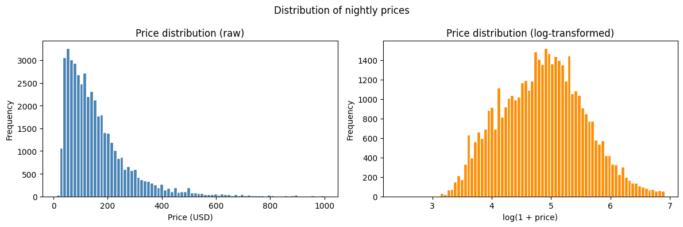
Source: Own illustration based on Inside Airbnb (2025).
Figure 3: Geographic distribution of nightly prices across London
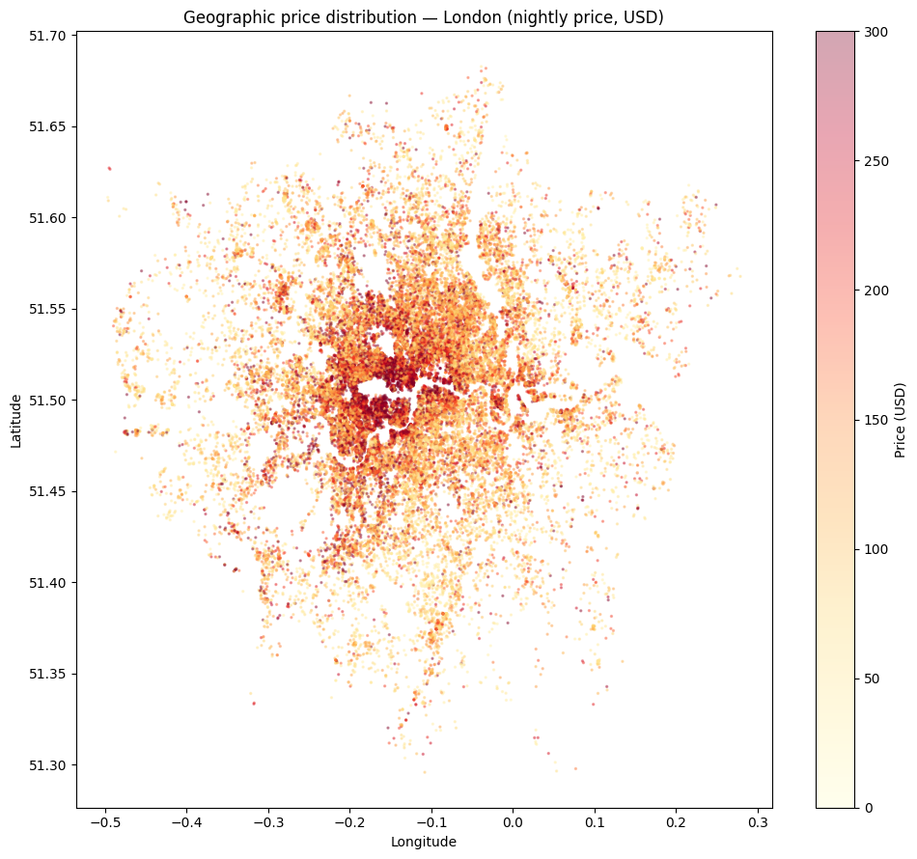
Source: Own illustration based on Inside Airbnb (2025).
Figure 4: Nightly price against guest capacity, distance to the center, location rating, and number of amenities
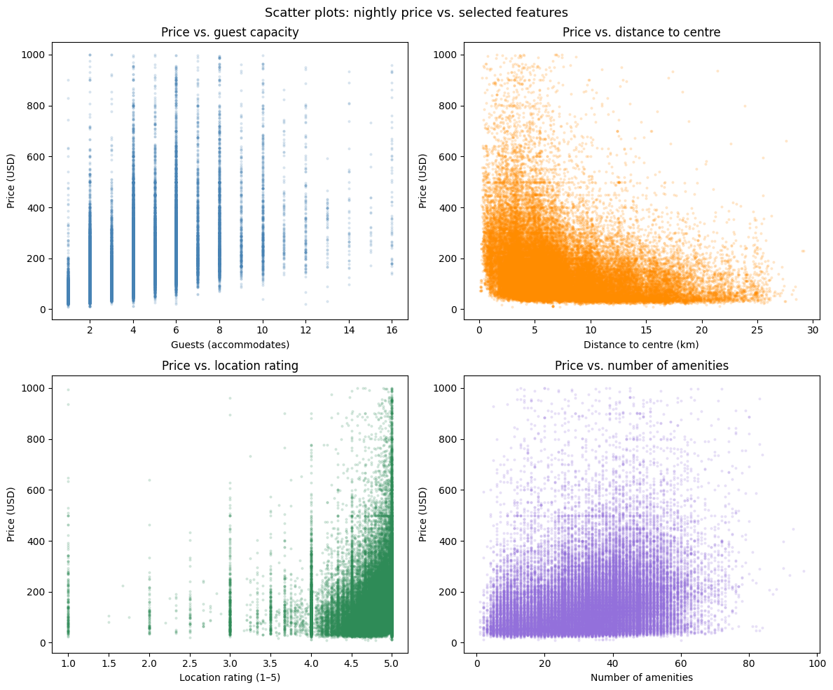
Source: Own illustration based on Inside Airbnb (2025).
Figure 5: Correlation matrix of the retained model features (borough indicators excluded)
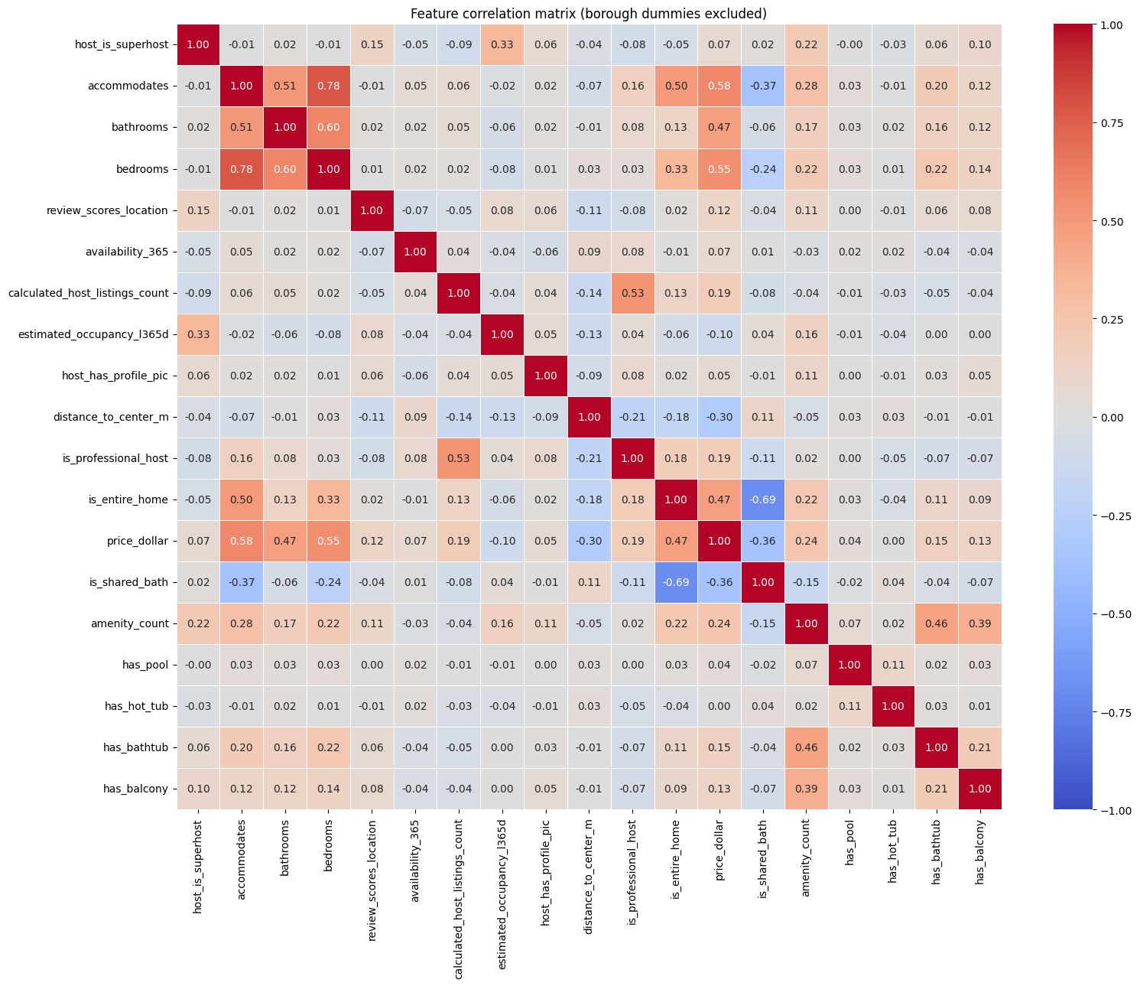
Source: Own illustration based on Inside Airbnb (2025).
Figure 6: SHAP summary plot of the OLS model (top 20 features, borough indicators shown individually)
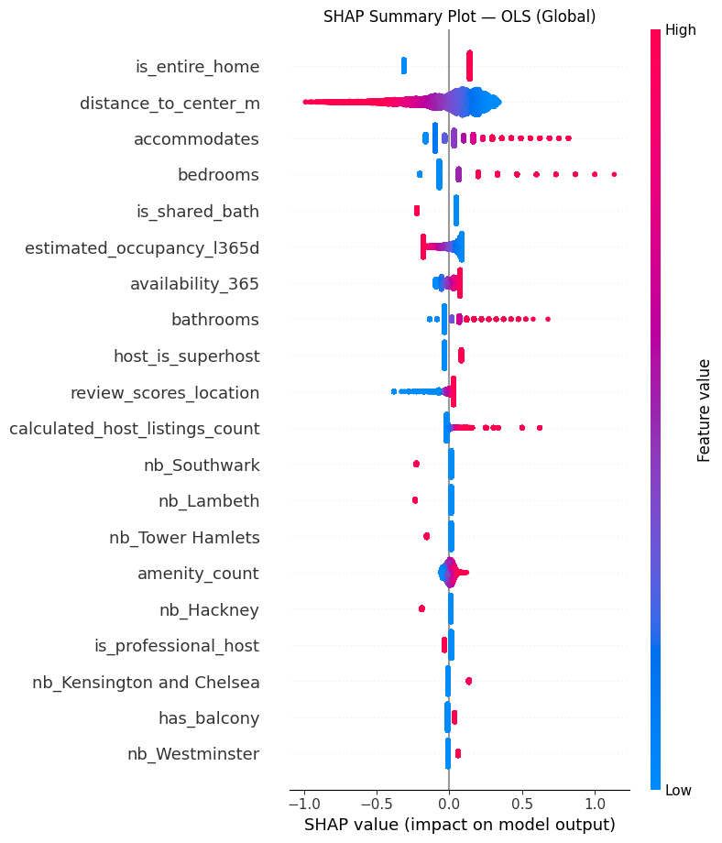
Source: Own illustration based on Inside Airbnb (2025).
Figure 7: Global feature influence in the OLS model (mean |SHAP|, borough indicators aggregated into one group as in Table 7)
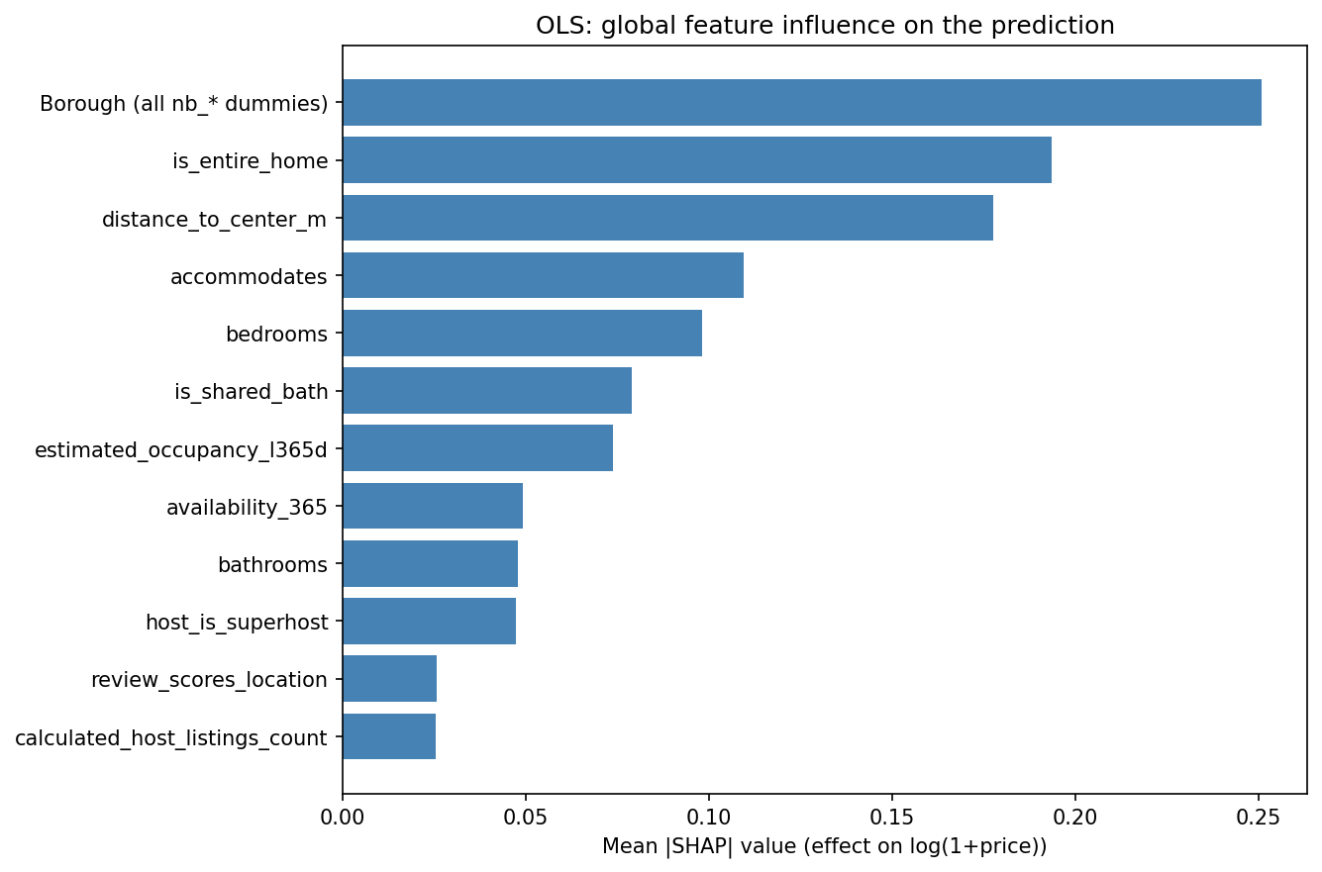
Source: Own illustration based on Inside Airbnb (2025).
Figure 8: SHAP summary plot of the XGBoost model (top 20 of 51 features)
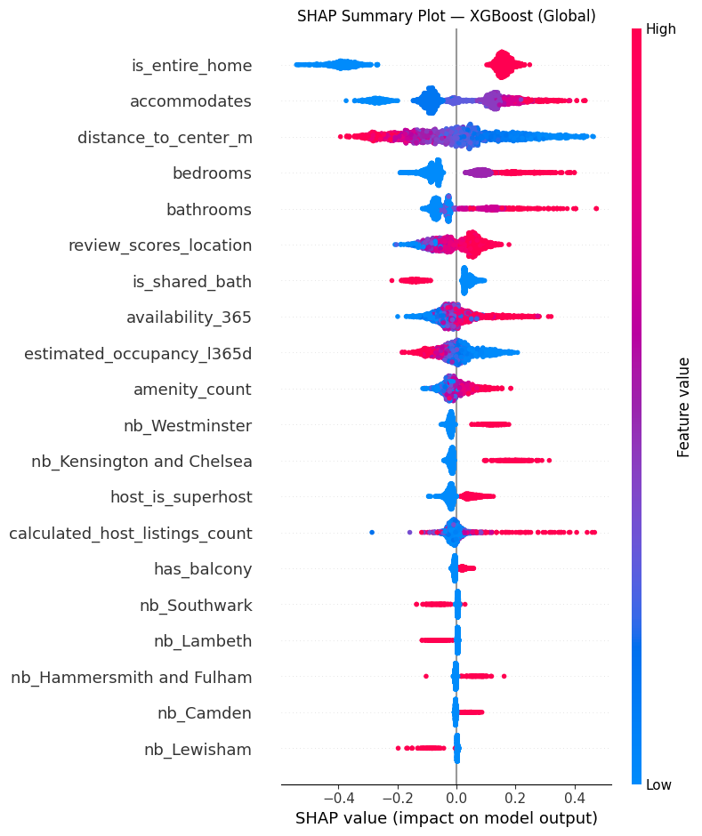
Source: Own illustration based on Inside Airbnb (2025).
Figure 9: SHAP waterfall decomposition of the prediction for the $999 listing
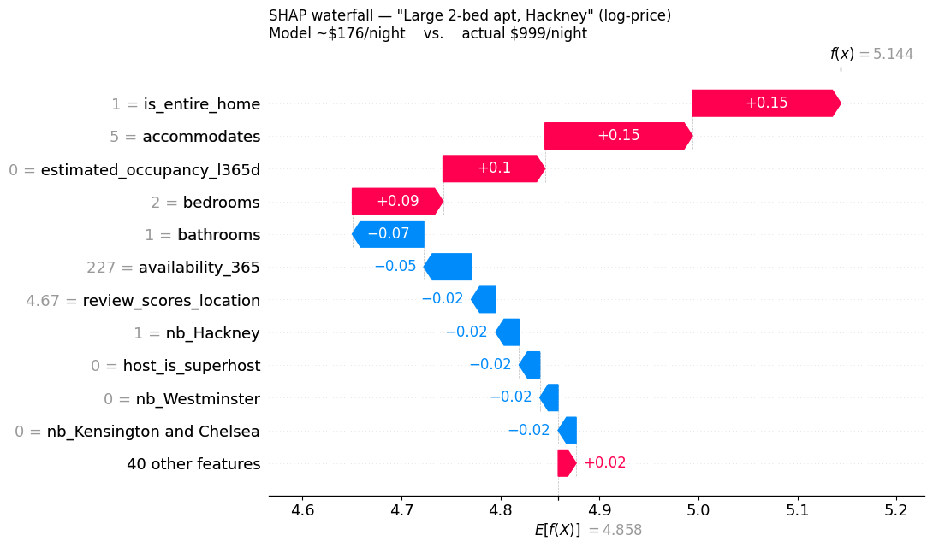
Source: Own illustration based on Inside Airbnb (2025).

