How Clang supports our workload graphs
Kernel data sharing, transfer volumes and runtime adaptation
Clang provides the abstract syntax tree. Our Python analyzers use that tree to identify supported memory accesses and construct the transfer graph. The current graph describes one source and configuration scenario; it does not observe live GPU memory or automatically update when runtime inputs change.

The current source to graph flow
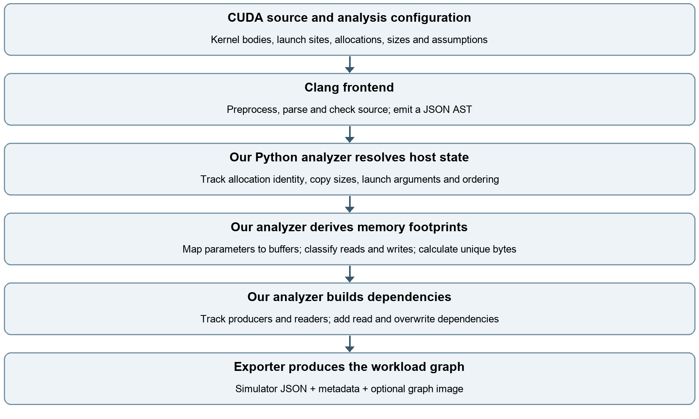

What Clang contributes
The AST contains declarations and types, expressions and array subscripts, assignments, function calls, kernel launch expressions and references to declarations. Our command uses --cuda-host-only, -fsyntax-only and -Xclang -ast-dump=json. An analysis-only CUDA header supplies supported API declarations; no GPU execution or CUDA toolkit is required for this path. [1, 5]

What our analyzer adds
The analyzer evaluates supported sizes and bounds, maps launch arguments to kernel parameters, derives byte footprints, and applies dependency rules. Clang itself does not emit our simulator graph. Nodes represent transfers; edges represent prerequisites, and vol is an integer byte count. [1–3]

How two kernels are linked through data
The test is whether their arguments resolve to the same tracked device allocation and whether either access writes that allocation. Matching variable names or matching data values is not the criterion. Current dependency tracking is conservative at whole-buffer granularity. [1–3]

A concrete example from pipeline cu
vectorAdd(d_A, d_B, d_C, N) writes its parameter C into allocation d_C. scaleVector(d_C, d_D, 2.0f, N) reads its parameter C from that same allocation. Following the actual arguments connects the two kernels even if their parameter names are different. [4]
Transfer chain: vectorAdd write C (acc → mem) → scaleVector read C (mem → acc) → scaleVector write D (acc → mem). The first write also waits for vectorAdd’s A and B reads. These are transfer nodes, not separate compute-only kernel nodes.

The dependency rules
- Read then read: no edge solely because the buffer is shared. Each read still depends on the buffer producer.
- Write then read: the consumer waits for the producer write.
- Read then write: the overwrite waits for earlier readers to finish.
- Write then write: the later write waits for the earlier write.

The state retained per allocation
The analyzer stores the latest writer, readers since that write, and initialized bytes. A read receives an edge from the latest writer and is added to the reader set. A write waits for the previous writer, outstanding readers and its kernel input reads; it then becomes the latest writer and clears the reader set. [2, 3]

What this does and does not prove
The default affine path accepts direct buffer arguments and rejects unsupported aliases. The configured Rodinia path tracks supported pointer offsets and swaps by allocation identity, but emitted footprints must still be contiguous from offset zero and writes must cover the allocation. Disjoint regions in one allocation are not generally independent in this model. Unsupported patterns fail rather than receiving guessed edges. [2, 3]
For supported explicit streams, conflicting accesses require provable ordering through stream order, event waits or host synchronization. Missing ordering is rejected. Logical edges omit some ordering between unrelated buffers, so the graph alone does not reproduce a CUDA execution timeline. [1, 2]

What happens when the volume changes at runtime
A saved graph is a snapshot of the analyzed scenario. Changing a runtime size does not change an existing JSON file. First distinguish a change in byte count from a change in which launches execute or which allocations they access.

Only the size changes
For a contiguous float buffer accessed once over N elements, the logical footprint is 4 × N bytes. In pipeline.cu, N = 1,048,576 gives 4,194,304 bytes per full-buffer transfer. Doubling N doubles those volumes if the access pattern and launches remain the same. Merely changing data values leaves this footprint unchanged. [4]
Today, regenerate the graph after changing a supported source size or configured parameter. The configured path accepts explicit inputs, such as the Rodinia record count; it does not discover those inputs from execution. Its bounded thread enumeration also limits how large a scenario can be analyzed. [1, 3]

Control flow or addresses change
If an input changes the number of iterations, selects another kernel, swaps buffers or changes indirect indices, updating vol alone may be wrong. The graph may need different launch instances, nodes and dependency edges. General data-dependent addressing is beyond the current implementation.

Proposed runtime extension
Here dynamic sketching means collecting compact read and write summaries during execution. This is a design extension, not a feature currently implemented in this repository.
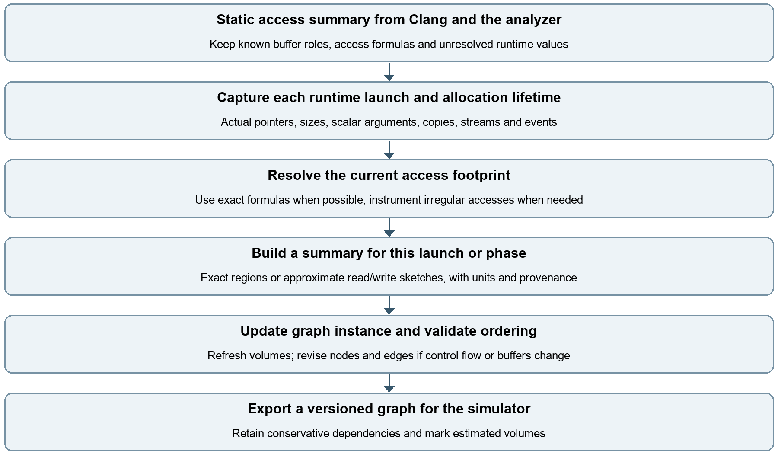

How to make dynamic sketching useful

Start with exact runtime parameters
Capture allocation and free events, actual pointer arguments, launch dimensions, scalar sizes, copy lengths, streams and synchronization. Resolve each pointer to an allocation identity plus offset; distinguish allocation lifetimes because an address can be reused after a free. For regular accesses, instantiate the static footprint formula using the current launch values. No approximate sketch is needed in that case.

Sketch only the unresolved accesses
For irregular indexing, a proposed instrumented kernel or binary analysis layer can record the addresses actually touched. Keep separate read and write summaries per launch and allocation. Define the unit explicitly, such as bytes or cache lines. An approximate distinct-address count estimates volume; an overlap summary helps identify possible sharing. A count alone cannot identify the shared addresses or prove a dependency.
Ordinary kernel and memcpy activity tracing supplies execution metadata, not by itself a complete set of per-kernel accessed addresses. CUPTI can provide tracing and callback infrastructure, but the proposed irregular-access summaries require a suitable additional collection mechanism. [6]

Keep uncertainty out of correctness decisions
Sampling can miss accesses. Therefore, missing sampled overlap must not remove a dependency. A fully populated Bloom-filter-style summary can conservatively indicate possible membership, with false positives; a sampled summary cannot guarantee absence. Retain whole-allocation dependencies when overlap is uncertain, and use approximate counts only as labeled volume estimates. Cache-line counts represent rounded footprints, not exact useful bytes.

Handle switches between phases
Maintain a separate graph instance or version for each observed launch sequence or phase. A size-only switch refreshes volumes; changed control flow or buffer bindings triggers dependency reconstruction. Reset or scope sketches per launch so earlier phases do not inflate later counts. Validate supported stream ordering before exporting a new instance.
A completed-launch sketch supports replay or future similar launches. It cannot reveal an unseen data-dependent footprint before that launch executes. Online scheduling must use available parameters and conservative bounds until actual observations arrive.

Keep the byte metric consistent
Our current vol counts unique global buffer bytes touched per kernel, separately for reads and writes. Repeated references within a kernel do not multiply that footprint. Instruction traffic and physical DRAM traffic are different metrics affected by reuse, caches and transactions; do not substitute them without changing the model. [1]

Sources and implementation anchors
[1] README.md, How we use Clang; workloads/TRANSFER_MODELS.md, scope and volume semantics.
[2] cuda_source_model.py: parse_source, kernel_accesses, StreamOrder, and analyze read/write bookkeeping.
[3] cuda_configured_model.py: Evaluator access collection, launch, read_buffer and write_buffer.
[4] workloads/pipeline.cu: vectorAdd, scaleVector and their launch arguments.
[5] Clang AST introduction: https://clang.llvm.org/docs/IntroductionToTheClangAST.html
[6] NVIDIA CUPTI documentation: https://docs.nvidia.com/cupti/

Currently unsupported traffic and future support
The analyzed GPU kernels in Nearest Neighbor and HotSpot3D do not contain an unresolved gather such as A[indices[i]]. Their supported GPU accesses are modeled. However, the current graph excludes selected host computations and file operations through explicit, hash-checked summaries. These exclusions are a scope boundary; they are not silently omitted GPU accesses.

Nearest Neighbor has data dependent CPU accesses
The euclid GPU kernel reads locations and writes distances using a thread-derived globalId. After the download, the CPU function findLowest compares distance values to choose minLoc, then reads and writes records[minLoc] and distances[minLoc]. The chosen locations depend on the computed data, so this is a concrete data-dependent access pattern in our workload.
Currently, findLowest is replaced by a host summary and its CPU memory accesses are absent from the graph. loadData and parseCommandline are also summarized; the record count is supplied by configuration instead of being discovered by reading the dataset. A summary does not mean that the underlying operation has no traffic.

How we could support Nearest Neighbor more fully
Extend the model to represent CPU memory transfers and place result selection after the GPU download. For a small validation case, instrument findLowest to record allocation-relative read and write addresses, including the selected minLoc values. Derive distinct-byte footprints from these observations and preserve dependencies on the downloaded distances. Capture the actual record count during loading to instantiate the GPU transfer sizes.
For larger cases, compact sketches could estimate unique host footprints. Keep read and write summaries separate, account for record sizes and fields, and retain conservative dependencies when overlap is uncertain. This requires a runtime observation path because the current evaluator keeps computed device data values unknown. A completed trace supports replay; it does not predict unseen selections before execution.

HotSpot3D excludes host work rather than an irregular GPU access
The GPU stencil uses calculated neighbor indices such as W and N, but they depend on grid coordinates and dimensions, not temperature values. Its stencil footprints, bounded iteration loop and pointer swaps are analyzed. The excluded functions are readinput, writeoutput, computeTempCPU, accuracy and get_time. CUDA cache-policy selection is recognized without modeling its cache or bandwidth effects.

How we could support HotSpot3D more fully
Add analysis or reviewed traffic summaries for the regular CPU reference stencil and accuracy scan, using the configured dimensions and iteration count. Model file input and output separately if end-to-end application traffic is required. Use runtime dimensions and observed iteration counts when they are not supplied in advance. Physical cache and DRAM traffic would require a separate memory-system model or measurements; unique-byte footprints alone cannot provide it.

A practical implementation sequence
First define CPU memory and file I/O endpoints with the simulator. Then implement exact host access collection for small cases, validate it against source behavior, and add graph nodes and dependencies. Introduce sketches only where exact collection becomes too costly, labeling estimated volumes and retaining exact or conservative dependency tracking.
Implementation evidence: workloads/rodinia/nn/nn_cuda.cu (euclid and findLowest); workloads/rodinia/nn/analysis.json (host_summaries); workloads/rodinia/hotspot3d/opt1.cu; workloads/rodinia/hotspot3d/analysis.json; workloads/rodinia/hotspot3d/README.md.

