**Release V1.0 of the Patriot Alliance Mod.**

PA3ANG, W8CQD, HB9MTN, KD0UTH, K2NG, K6HX, WD9GYM, W8TEE, WA4CDM, NA8E, K4JK, AE6RQ, K1EL and W2ROW

Patriot Alliance Mod V1.0 by Johan, PA3ANG. April 2015.

The Patriot Alliance Mod sketch is a sketch for the Ardinuo / chipKIT UNO32 running inside a Ten-Tec Open Source QRP transceiver called the Patriot. This transceiver can be modified and all details are Open Source. The base configuration is a 20 / 40 meter SSB / CW receiver / transmitter and the factory delivered sketch (firmware) is pretty basic. Straight key input, frequency tuning with 3 different tuning steps and 3 selectable bandwidth. The transceiver can be switched between 20 and 40 meter.

The first Open Source transceiver sold by Ten-Tec was the Rebel. This Rebel is a CW only transceiver and a group of ham operators and code enthusiasts prepared an improved sketch for the rebel. This software (firmware) was called the Rebel Alliance Mod.

Directly after the receiving the Patriot, I started rewriting the Rebel sketch into a Patriot sketch and called it Patriot Alliance Mod.

The sketch is based on the original Ten-Tec delivered code and has the following additional features:

* IAMBIC (type A or B) keyer with keyer speed on front panel ‘CW SPD’ (A7)
* Detection of Straight Keyer (middle ring 3.5mm stereo plug to ground)
* Automatic mode change to CW (Key) or SSB (Ptt)
* CW offset (parameter) during CW reception
* Frequency announce in CW when > .5 seconds SELECT
* Tune Carrier when > .5 FUNCTION
* CAT based on K3 protocol (tested with HRD)
* Added OLED 128 x 32 pixels

Furthermore we introduced a number of improvements:

* DDS offset compensation (parameter)
* Faster display routines (no updates when no changes)
* Improved display layout and added S-meter and CW speed
* Easy selection of starting band and default frequencies

In the code a number of parameters can be changed. First we have the standard 20 x 4 line Matrix LCD display. Original wired as 4 Bit , but you can change this to I2C by commenting and uncommenting the lines. (Note: add the appropriate Library in your MPIDE environment.)

//------------------------------- CHOOSE YOUR DISPLAY CONNECTION TYPE HERE --------------------------------

// 4BIT LCD 20 x 4 line display (LCD pins standard according Ten-tec documentation)

#include <Wire.h>

#include <LiquidCrystal.h>

LiquidCrystal lcd(26, 27, 28, 29, 30, 31); // Set de LCD pins

// I2C LCD 20 x 4 line display (I2C pins to LCD: addr, en,rw,rs,d4,d5,d6,d7,bl,blpol)

//#include <Wire.h>

//#include <LiquidCrystal_I2C.h>

//LiquidCrystal_I2C lcd(0x27, 2, 1, 0, 4, 5, 6, 7, 3, POSITIVE); // Set the LCD I2C address tp 0x27

//------------------------------- CHOOSE YOUR DISPLAY CONNECTION TYPE HERE --------------------------------

I added also the routine for an Adafruit type OLED display based on I2C (reset on digital pin 35) and you can switch the display on by uncomment the line #define OLED. You must add the Adafruit library as uploaded in the Yahoo directory as it contains the specific Ten-Tec Patriot start-up screen!

// ------------------------------ IF WANTED, ENABLE THE OLED TYPE DISPLAY HERE ------------------------------

// OLED 128 x 32 I2C (ADAFRUIT)

// enable OLED with uncomment #define OLED

// RST is pin 35 (optional)

//#define OLED

#ifdef OLED

// Load Library if no OLED then you can comment these 4 lines out

#include <Adafruit_GFX.h>

#include <Adafruit_SSD1306.h>

#define OLED_RESET 35

Adafruit_SSD1306 display(OLED_RESET);

#endif

// ------------------------------ IF WANTED, ENABLE THE OLED TYPE DISPLAY HERE ------------------------------

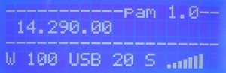 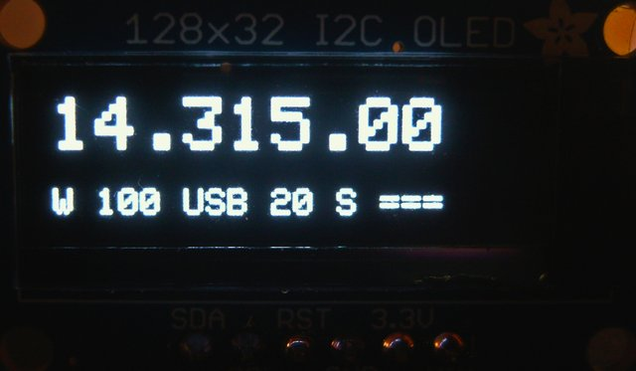

20 characters x 4 lines LCD Display OLED 128 x 32 px Display

The 2nd set of parameters to be changed are for offset and start-up:

//-------- OFFSET VALUES -- ADJUST TO YOUR PATRIOT DDS OFFSET AND CW PITCH -----------------------

long DDS_offset_value = 400 ; // << Offset for easy frequency tweaking added by HB9MTN

long CW_offset_value = 700 ; // << CW shift on RX

// ------- please here the default mode and band --------------------------

int mode = 0; // mode 1 = cw , mode 0 = ssb

int bsm = 0; // bsm = 0 is 40 meters , bsm = 1 is 20 meters

// ------- please here you start frequency per band -----------------------

const long meter_40 = 7077000; // ENTER YOUR STARTUP FREQUENCY HERE FOR 40 MTR IN Hz

const long meter_20 = 14285000; // ENTER YOUR STARUP FREQUENCY HERE FOR 20 MTR IN Hz

Changed if desired and reload the sketch to your Patriot.

In the code is also the possibility to changes the behavior of the IAMBIC keyer.

//------------------------------- CHANGE KEYER SETTINGS HERE -------------------------------------------------------------

#define PDLSWAP 0x00 // 0x00 for normal, 0x08 for swap

#define IAMBICB 0x10 // 0x00 for Iambic A, 0x10 for Iambic B

//------------------------------- CHANGE KEYER SETTINGS HERE -------------------------------------------------------------

The rest of the sketch is pretty much readable and comments are added. The CAT based on K3 protocol is running @ 38400 baud.

Note: I changed the tuning steps to 10Hz, 100Hz and 1kHz and the U3 function is disabled.

More info at: <https://groups.yahoo.com/neo/groups/TenTec507Patriot/info>