Radioberry pihpsdr cw-setup

The following picture shows how all the components are working together to make cw work for the combination of radioberry and the pihpsdr software.

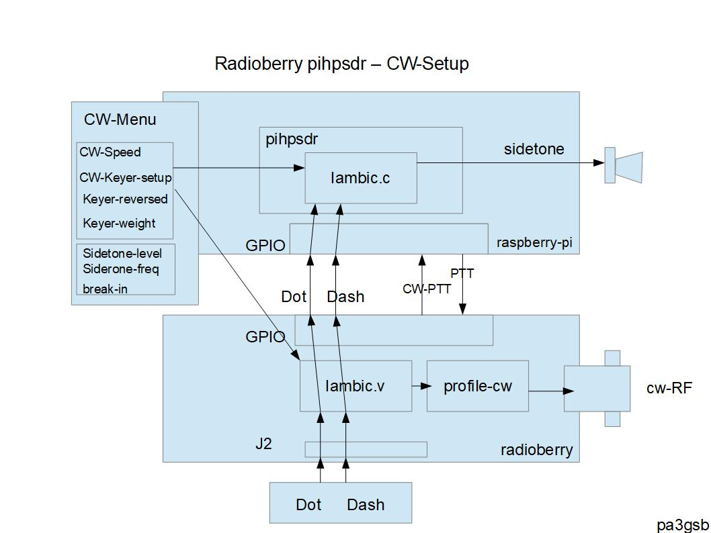

Hardware Setup

The dot and dash is connected to the J2 of the radioberry.
The fpga lines IO-15 and IO-16 are used to get the key commands to the firmware.

The dot and dash events are also directly routed to the gpio pins, 18 and 19 (fysical pins 12 and 35).

If keying the cw-ptt port is set (gpio pin 19, fysical pin 11). which enables the ptt (if cw-break in is checked in the cw setup menu), otherwise you have to switch to tx using the mox button.

Use of the gpio port can be found at:

https://github.com/pa3gsb/RadioBerry/wiki/GPIO-RPI---Radioberry-1.0

Software setup

When starting pihpsdr set the gpio ports. I unchecked all ports and added filled in the ports used for CWL and CWR

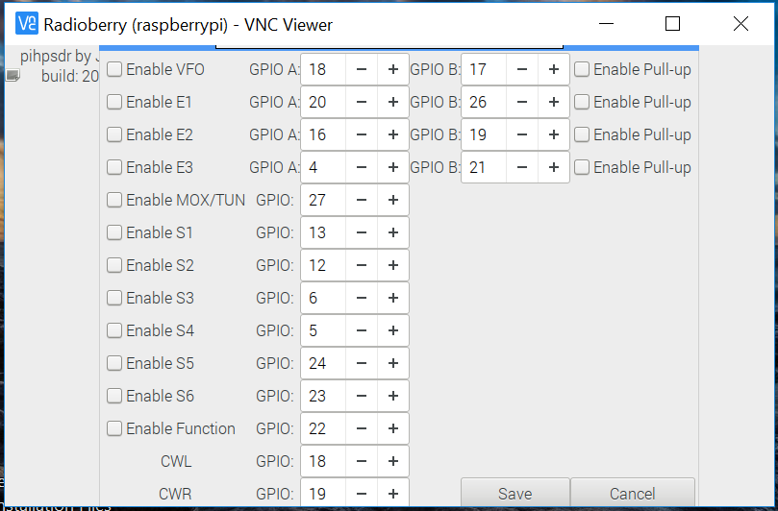

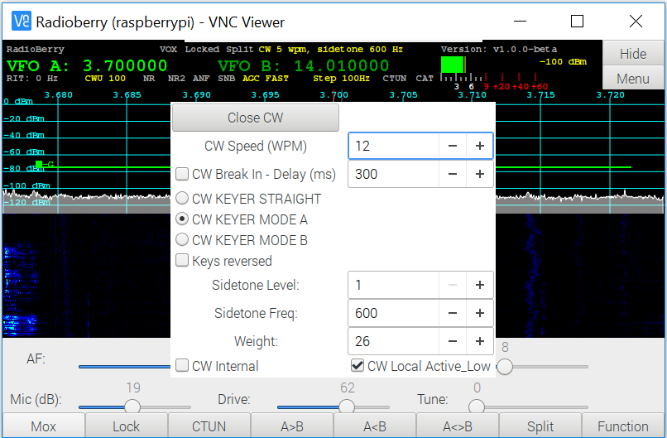

Running
After loading the radioberry.rbf firmware containing the latest firmware. It is possible to switch the radioberry into the cw mode.

Happy keying.

